UNITED STATES

SECURITIES AND EXCHANGE COMMISSION

WASHINGTON, D.C. 20549

FORM 10-Q

(Mark One)

x QUARTERLY REPORT PURSUANT TO SECTION 13 OR 15(d) OF THE SECURITIES EXCHANGE ACT OF 1934

For the quarterly period ended September 30, 2019

OR

- TRANSITION REPORT PURSUANT TO SECTION 13 OR 15(d) OF THE SECURITIES EXCHANGE ACT OF 1934

For the transition period from to

Commission file number: 1-07183


TEJON RANCH CO.

(Exact name of registrant as specified in its charter)

Delaware | 77-0196136
(State or other jurisdiction of incorporation or organization) | (I.R.S. Employer Identification No.)
P.O. Box 1000, Tejon Ranch, California 93243 | (661) 248-3000
(Address of principal executive offices) (Zip Code) | (Registrant’s telephone number, including area code)

Securities registered pursuant to Section 12(b) of the Act:

Title of each class |  | Trading symbol(s) |  | Name of each exchange on which registered
Common Stock, $0.50 par value |  | TRC |  | New York Stock Exchange

Indicate by check mark whether the registrant (1) has filed all reports required to be filed by Section 13 or 15(d) of the Securities Exchange Act of 1934 during the preceding 12 months (or for such shorter period that the registrant was required to file such reports), and (2) has been subject to such filing requirements for the past 90 days. Yes x No ☐

Indicate by check mark whether the registrant has submitted electronically every Interactive Data File required to be submitted pursuant to Rule 405 of Regulation S-T (§232.405 of this chapter) during the preceding 12 months (or for such shorter period that the registrant was required to submit such files). Yes x No ☐

Indicate by check mark whether the registrant is a large accelerated filer, an accelerated filer, a non-accelerated filer, a smaller reporting company, or an emerging growth company. See the definitions of “large accelerated filer,” “accelerated filer,” “smaller reporting company,” and “emerging growth company” in Rule 12b-2 of the Exchange Act.

Large accelerated filer | ☐ | Accelerated filer | x
Non-accelerated filer | ☐ | Smaller reporting company | x
 |  | Emerging growth company | ☐

If an emerging growth company, indicate by check mark if the registrant has elected not to use the extended transition period for complying with any new or revised financial accounting standards provided pursuant to Section 13(a) of the Exchange Act. ☐

Indicate by check mark whether the registrant is a shell company (as defined in Rule 12b-2 of the Exchange Act).

Yes ☐ No x

The number of the Company’s outstanding shares of Common Stock on October 31, 2019 was 26,048,952.

TEJON RANCH CO. AND SUBSIDIARIES

TABLE OF CONTENTS

 |  |  |  |  |  |  |  |  |  |  |  |  |  |  |  |  |  |  | Page
PART I. |  | FINANCIAL INFORMATION
Item 1. |  | Financial Statements
 |  | Unaudited Consolidated Statements of Operations for the Three and Nine Months Ended September 30, 2019 and 2018 |  |  |  |  |  |  |  |  |  |  |  |  |  |  |  |  |  | 3
 |  | Unaudited Consolidated Statements of Comprehensive (Loss) Income for the Three and Nine Months Ended September 30, 2019 and 2018 |  |  |  |  |  |  |  |  |  |  |  |  |  |  |  |  |  | 4
 |  | Consolidated Balance Sheets as of September 30, 2019 (unaudited) and December 31, 2018 |  |  |  |  |  |  |  |  |  |  |  |  |  |  |  |  |  | 5
 |  | Unaudited Consolidated Statements of Cash Flows for the Nine Months Ended September 30, 2019 and 2018 |  |  |  |  |  |  |  |  |  |  |  |  |  |  |  |  | 6
 |  | Unaudited Consolidated Statement of Changes in Equity and Noncontrolling Interests for the Three and Nine Months Ended September 30, 2019 and 2018 |  |  |  |  |  |  |  |  |  |  |  |  |  |  |  |  |  | 8
 |  | Notes to Unaudited Consolidated Financial Statements |  |  |  |  |  |  |  |  |  |  |  |  |  |  |  |  | 10
Item 2. |  | Management’s Discussion and Analysis of Financial Condition and Results of Operations |  |  |  |  |  |  |  |  |  |  |  |  |  |  |  |  | 37
Item 3. |  | Quantitative and Qualitative Disclosures About Market Risk |  |  |  |  |  |  |  |  |  |  |  |  |  |  |  |  | 60
Item 4. |  | Controls and Procedures |  |  |  |  |  |  |  |  |  |  |  |  |  |  |  |  | 63
PART II. |  | OTHER INFORMATION
Item 1. |  | Legal Proceedings |  |  |  |  |  |  |  |  |  |  |  |  |  |  |  |  | 63
Item 1A. |  | Risk Factors |  |  |  |  |  |  |  |  |  |  |  |  |  |  |  |  | 63
Item 2. |  | Unregistered Sales of Equity Securities and Use of Proceeds |  |  |  |  |  |  |  |  |  |  |  |  |  |  |  |  | 63
Item 3. |  | Defaults Upon Senior Securities |  |  |  |  |  |  |  |  |  |  |  |  |  |  |  |  | 63
Item 4. |  | Mine Safety Disclosures |  |  |  |  |  |  |  |  |  |  |  |  |  |  |  |  | 63
Item 5. |  | Other Information |  |  |  |  |  |  |  |  |  |  |  |  |  |  |  |  | 63
Item 6. |  | Exhibits |  |  |  |  |  |  |  |  |  |  |  |  |  |  |  |  | 64
SIGNATURES |  |  |  |  |  |  |  |  |  |  |  |  |  |  |  |  |  |  | 68
 |  | 2

PART I - FINANCIAL INFORMATION

ITEM 1. FINANCIAL STATEMENTS

TEJON RANCH CO. AND SUBSIDIARIES

UNAUDITED CONSOLIDATED STATEMENTS OF OPERATIONS

(In thousands, except per share amounts)

 | Three Months Ended September 30, |  |  |  |  |  |  | Nine Months Ended September 30,
 | 2019 |  |  | 2018 |  |  |  | 2019 |  |  | 2018
Revenues:
Real estate - commercial/industrial | $ | 2,620 |  | $ | 2,445 |  | $ | 12,041 |  | $ | 6,788
Mineral resources |  | 1,559 |  |  | 1,355 |  |  | 8,351 |  |  | 11,986
Farming |  | 4,602 |  |  | 10,836 |  |  | 6,303 |  |  | 12,573
Ranch operations |  | 876 |  |  | 796 |  |  | 2,570 |  |  | 2,624
Total revenues |  | 9,657 |  |  | 15,432 |  |  | 29,265 |  |  | 33,971
Costs and Expenses:
Real estate - commercial/industrial |  | 1,968 |  |  | 1,678 |  |  | 8,353 |  |  | 4,385
Real estate - resort/residential |  | 582 |  |  | 471 |  |  | 1,872 |  |  | 1,319
Mineral resources |  | 576 |  |  | 574 |  |  | 5,006 |  |  | 5,400
Farming |  | 5,979 |  |  | 6,541 |  |  | 8,402 |  |  | 9,570
Ranch operations |  | 1,260 |  |  | 1,353 |  |  | 4,003 |  |  | 4,090
Corporate expenses |  | 1,760 |  |  | 2,100 |  |  | 6,524 |  |  | 7,296
Total expenses |  | 12,125 |  |  | 12,717 |  |  | 34,160 |  |  | 32,060
Operating (loss) income |  | (2,468) |  |  | 2,715 |  |  | (4,895) |  |  | 1,911
Other Income:
Investment income |  | 294 |  |  | 351 |  |  | 972 |  |  | 980
Other income (loss), net |  | 19 |  |  | (16) |  |  | 67 |  |  | (40)
Total other income |  | 313 |  |  | 335 |  |  | 1,039 |  |  | 940
(Loss) income from operations before equity in earnings of unconsolidated joint
ventures |  | (2,155) |  |  | 3,050 |  |  | (3,856) |  |  | 2,851
Equity in earnings of unconsolidated joint ventures, net |  | 2,199 |  |  | 1,592 |  |  | 5,046 |  |  | 2,411
Income before income tax expense |  | 44 |  |  | 4,642 |  |  | 1,190 |  |  | 5,262
Income tax expense |  | 7 |  |  | 1,155 |  |  | 320 |  |  | 1,333
Net income |  | 37 |  |  | 3,487 |  |  | 870 |  |  | 3,929
Net loss attributable to non-controlling interest |  | (10) |  |  | (1) |  |  | (3) |  |  | (19)
Net income attributable to common stockholders | $ | 47 |  | $ | 3,488 |  | $ | 873 |  | $ | 3,948
Net income per share attributable to common stockholders, basic
 | $ | — |  | $ | 0.13 |  | $ | 0.03 |  | $ | 0.15
Net income per share attributable to common stockholders, diluted | $ | — |  | $ | 0.13 |  | $ | 0.03 |  | $ | 0.15

See accompanying notes.

3

TEJON RANCH CO. AND SUBSIDIARIES

UNAUDITED CONSOLIDATED STATEMENTS OF COMPREHENSIVE (LOSS) INCOME

(In thousands)

 | Three Months Ended September 30, |  |  |  |  |  |  | Nine Months Ended September 30,
 | 2019 |  |  | 2018 |  |  |  | 2019 |  |  | 2018
Net income | $ | 37 |  | $ | 3,487 |  | $ | 870 |  | $ | 3,929
Other comprehensive (loss) income:
Unrealized gain (loss) on available-for-sale securities |  | 59 |  |  | 47 |  |  | 443 |  |  | (323)
Unrealized (loss) gain on interest rate swap |  | (1,195) |  |  | 449 |  |  | (3,888) |  |  | 2,305
Other comprehensive (loss) income before taxes |  | (1,136) |  |  | 496 |  |  | (3,445) |  |  | 1,982
Benefit (provision) for income taxes related to other comprehensive income
items |  | 239 |  |  | (104) |  |  | 723 |  |  | (416)
Other comprehensive (loss) income |  | (897) |  |  | 392 |  |  | (2,722) |  |  | 1,566
Comprehensive (loss) income |  | (860) |  |  | 3,879 |  |  | (1,852) |  |  | 5,495
Comprehensive loss attributable to non-controlling interests |  | (10) |  |  | (1) |  |  | (3) |  |  | (19)
Comprehensive (loss) income attributable to common stockholders | $ | (850) |  | $ | 3,880 |  | $ | (1,849) |  | $ | 5,514

See accompanying notes.

4

TEJON RANCH CO. AND SUBSIDIARIES

CONSOLIDATED BALANCE SHEETS

(In thousands, except per share data)

 |  | September 30, 2019 |  |  | December 31, 2018
 |  | (unaudited)
ASSETS
Current Assets:
Cash and cash equivalents | $ | 9,113 |  | $ | 15,908
Marketable securities - available-for-sale |  | 47,423 |  |  | 63,749
Accounts receivable |  | 4,091 |  |  | 10,876
Inventories |  | 5,790 |  |  | 2,618
Prepaid expenses and other current assets |  | 3,558 |  |  | 3,348
Total current assets |  | 69,975 |  |  | 96,499
Real estate and improvements - held for lease, net |  | 18,771 |  |  | 18,953
Real estate development (includes $103,527 at September 30, 2019 and $100,311 at December 31, 2018, attributable to
Centennial Founders, LLC, Note 15) |  | 297,879 |  |  | 283,385
Property and equipment, net |  | 46,424 |  |  | 46,086
Investments in unconsolidated joint ventures |  | 42,177 |  |  | 28,602
Net investment in water assets |  | 54,363 |  |  | 51,832
Deferred tax assets |  | 1,952 |  |  | 1,229
Other assets |  | 2,219 |  |  | 2,462
TOTAL ASSETS | $ | 533,760 |  | $ | 529,048
LIABILITIES AND EQUITY
Current Liabilities:
Trade accounts payable | $ | 3,744 |  | $ | 6,037
Accrued liabilities and other |  | 4,498 |  |  | 3,575
Deferred income |  | 1,922 |  |  | 2,863
Revolving line of credit |  | 5,000 |  |  | —
Current maturities of long-term debt |  | 4,137 |  |  | 4,018
Total current liabilities |  | 19,301 |  |  | 16,493
Long-term debt, less current portion |  | 58,625 |  |  | 61,780
Long-term deferred gains |  | 5,185 |  |  | 3,405
Other liabilities |  | 16,223 |  |  | 12,698
Total liabilities |  | 99,334 |  |  | 94,376
Commitments and contingencies
Equity:
Tejon Ranch Co. Stockholders’ Equity
Common stock, $.50 par value per share:
Authorized shares - 30,000,000
Issued and outstanding shares - 26,041,530 at September 30, 2019 and 25,972,080 at December 31, 2018 |  | 13,021 |  |  | 12,986
Additional paid-in capital |  | 338,091 |  |  | 336,520
Accumulated other comprehensive loss |  | (7,579) |  |  | (4,857)
Retained earnings |  | 75,520 |  |  | 74,647
Total Tejon Ranch Co. Stockholders’ Equity |  | 419,053 |  |  | 419,296
Non-controlling interest |  | 15,373 |  |  | 15,376
Total equity |  | 434,426 |  |  | 434,672
TOTAL LIABILITIES AND EQUITY | $ | 533,760 |  | $ | 529,048
See accompanying notes.
5

TEJON RANCH CO. AND SUBSIDIARIES

UNAUDITED CONSOLIDATED STATEMENTS OF CASH FLOWS

(In thousands)

 | Nine Months Ended September 30,
 | 2019 |  |  | 2018
Operating Activities
Net income | $ | 870 |  | $ | 3,929
Adjustments to reconcile net income to net cash provided by operating activities:
Depreciation and amortization |  | 3,562 |  |  | 3,284
Amortization of premium/discount of marketable securities |  | (80) |  |  | 57
Equity in earnings of unconsolidated joint ventures, net |  | (5,046) |  |  | (2,411)
Non-cash retirement plan expense |  | 230 |  |  | 123
Non-cash profits recognized from land contribution |  | (1,667) |  |  | —
Loss on sale of property plant and equipment |  | — |  |  | 94
Deferred income taxes |  | — |  |  | 1
Stock compensation expense |  | 1,930 |  |  | 2,601
Excess tax benefit from stock-based compensation |  | 52 |  |  | 18
Distribution of earnings from unconsolidated joint ventures |  | — |  |  | 4,800
Changes in operating assets and liabilities:
Receivables, inventories, prepaids and other assets, net |  | 3,656 |  |  | (6,784)
Current liabilities, net |  | (2,952) |  |  | 3,117
Net cash provided by operating activities |  | 555 |  |  | 8,829
Investing Activities
Maturities and sales of marketable securities |  | 37,274 |  |  | 24,558
Funds invested in marketable securities |  | (20,425) |  |  | (23,451)
Real estate and equipment expenditures |  | (19,195) |  |  | (16,183)
Reimbursement proceeds from Community Facilities District |  | — |  |  | 1,385
Investment in unconsolidated joint ventures |  | (3,100) |  |  | —
Distribution of equity from unconsolidated joint ventures |  | 487 |  |  | 1,835
Investments in long-term water assets |  | (3,553) |  |  | (2,659)
Net cash used in investing activities |  | (8,512) |  |  | (14,515)
Financing Activities
Borrowings of short-term debt |  | 5,000 |  |  | —
Repayments of long-term debt |  | (2,994) |  |  | (3,018)
Rights offering costs |  | — |  |  | (166)
Taxes on vested stock grants |  | (844) |  |  | (1,063)
Net cash provided by (used in) financing activities |  | 1,162 |  |  | (4,247)
Decrease in cash and cash equivalents |  | (6,795) |  |  | (9,933)
Cash and cash equivalents at beginning of period |  | 15,908 |  |  | 20,107
Cash and cash equivalents at end of period | $ | 9,113 |  | $ | 10,174

6

Non-cash investing activities
Accrued capital expenditures included in current liabilities | $ | 191 |  | $ | 347
Contribution to unconsolidated joint venture¹
Contribution to unconsolidated joint venture¹ | $ | 5,854 |  | $ | —
Long term deferred profit on land contribution¹ | $ | 1,532 |  | $ | —

¹In April 2019, the Company contributed land with a fair value of $5.9 million to TRC-MRC 3, LLC an unconsolidated joint venture formed to pursue the development, construction, leasing, and management of a
579,040 square foot industrial building on the Company's property at TRCC-East. The total cost of the land, inclusive of transaction costs was $2.9 million. The Company recognized $1.5 million in profit and deferred

$1.5 million after applying the five-step revenue recognition model in accordance with Accounting Standards Codification (ASC) Topic 606 — Revenue From Contracts With Customers and ASC Topic 323, Investments

— Equity Method and Joint Ventures. Historically, cash outflows related to land development expenditures were accounted for within investing activities. For consistency, the Company will continue to classify cash outflows and cash inflows related to land development as investing activities.

See accompanying notes.

7

TEJON RANCH CO. AND SUBSIDIARIES

UNAUDITED CONSOLIDATED STATEMENT OF CHANGES IN EQUITY AND NONCONTROLLING INTERESTS

(In thousands, except shares outstanding)

 | Common Stock |  |  |  |  |  |  |  | Accumulated Other |  |  |  |  |  |  | Total
 | Shares |  |  | Common |  |  | Additional |  |  | Comprehensive |  |  | Retained |  |  | Stockholders' |  |  | Noncontrolling
 | Outstanding |  |  | Stock |  | Paid-In Capital |  |  |  | (Loss) Income |  |  | Earnings |  |  | Equity |  |  | Interest |  | Total Equity
Balance, June 30, 2019 | 26,033,402 |  | $ | 13,017 |  | $ | 337,870 |  | $ | (6,682) |  | $ | 75,473 |  | $ | 419,678 |  | $ | 15,383 |  | $ | 435,061
Net income (loss) | — |  |  | — |  |  | — |  |  | — |  |  | 47 |  |  | 47 |  |  | (10) |  |  | 37
Other comprehensive loss | — |  |  | — |  |  | — |  |  | (897) |  |  | — |  |  | (897) |  |  | — |  |  | (897)
Restricted stock issuance | 8,128 |  |  | 4 |  |  | (4) |  |  | — |  |  | — |  |  | — |  |  | — |  |  | —
Stock compensation | — |  |  | — |  |  | 225 |  |  | — |  |  | — |  |  | 225 |  |  | — |  |  | 225
Shares withheld for taxes and tax benefit
of vested shares | — |  |  | — |  |  | — |  |  | — |  |  | — |  |  | — |  |  | — |  |  | —
Balance, September 30, 2019 | 26,041,530 |  | $ | 13,021 |  | $ | 338,091 |  | $ | (7,579) |  | $ | 75,520 |  | $ | 419,053 |  | $ | 15,373 |  | $ | 434,426
Balance, June 30, 2018 | 25,952,943 |  | $ | 12,976 |  | $ | 321,307 |  | $ | (4,090) |  | $ | 70,852 |  | $ | 401,045 |  | $ | 28,550 |  | $ | 429,595
Net income (loss) | — |  |  | — |  |  | — |  |  | — |  |  | 3,488 |  |  | 3,488 |  |  | (1) |  |  | 3,487
Other comprehensive income | — |  |  | — |  |  | — |  |  | 392 |  |  | — |  |  | 392 |  |  | — |  |  | 392
Restricted stock issuance | 7,319 |  |  | 4 |  |  | (3) |  |  | — |  |  | — |  |  | 1 |  |  | — |  |  | 1
Stock compensation | — |  |  | — |  |  | 1,015 |  |  | — |  |  | — |  |  | 1,015 |  |  | — |  |  | 1,015
Balance, September 30, 2018 | 25,960,262 |  | $ | 12,980 |  | $ | 322,319 |  | $ | (3,698) |  | $ | 74,340 |  | $ | 405,941 |  | $ | 28,549 |  | $ | 434,490

See accompanying notes.

8

TEJON RANCH CO. AND SUBSIDIARIES

UNAUDITED CONSOLIDATED STATEMENT OF CHANGES IN EQUITY AND NONCONTROLLING INTERESTS

(In thousands, except shares outstanding)

 | Common Stock |  |  |  |  |  |  |  | Accumulated Other |  |  |  |  |  |  | Total
 | Shares |  |  | Common |  |  | Additional |  |  | Comprehensive |  |  | Retained |  |  | Stockholders' |  |  | Noncontrolling
 | Outstanding |  |  | Stock |  | Paid-In Capital |  |  |  | (Loss) Income |  |  | Earnings |  |  | Equity |  |  | Interest |  | Total Equity
Balance, December 31, 2018 | 25,972,080 |  | $ | 12,986 |  | $ | 336,520 |  | $ | (4,857) |  | $ | 74,647 |  | $ | 419,296 |  | $ | 15,376 |  | $ | 434,672
Net income | — |  |  | — |  |  | — |  |  | — |  |  | 873 |  |  | 873 |  |  | (3) |  |  | 870
Other comprehensive loss | — |  |  | — |  |  | — |  |  | (2,722) |  |  | — |  |  | (2,722) |  |  | — |  |  | (2,722)
Restricted stock issuance | 114,599 |  |  | 57 |  |  | (57) |  |  | — |  |  | — |  |  | — |  |  | — |  |  | —
Stock compensation | — |  |  | — |  |  | 2,450 |  |  | — |  |  | — |  |  | 2,450 |  |  | — |  |  | 2,450
Shares withheld for taxes and tax benefit of
vested shares | (45,149) |  |  | (22) |  |  | (822) |  |  | — |  |  | — |  |  | (844) |  |  | — |  |  | (844)
Balance, September 30, 2019 | 26,041,530 |  | $ | 13,021 |  | $ | 338,091 |  | $ | (7,579) |  | $ | 75,520 |  | $ | 419,053 |  | $ | 15,373 |  | $ | 434,426
Balance, December 31, 2017 | 25,894,773 |  | $ | 12,947 |  | $ | 320,167 |  | $ | (5,264) |  | $ | 70,392 |  | $ | 398,242 |  | $ | 28,568 |  | $ | 426,810
Net income (loss) | — |  |  | — |  |  | — |  |  | — |  |  | 3,948 |  |  | 3,948 |  |  | (19) |  |  | 3,929
Other comprehensive income | — |  |  | — |  |  | — |  |  | 1,566 |  |  | — |  |  | 1,566 |  |  | — |  |  | 1,566
Rights offering costs | — |  |  | — |  |  | (166) |  |  | — |  |  | — |  |  | (166) |  |  | — |  |  | (166)
Restricted stock issuance | 110,907 |  |  | 56 |  |  | (55) |  |  | — |  |  | — |  |  | 1 |  |  | — |  |  | 1
Stock compensation | — |  |  | — |  |  | 3,413 |  |  | — |  |  | — |  |  | 3,413 |  |  | — |  |  | 3,413
Shares withheld for taxes and tax benefit of
vested shares | (45,418) |  |  | (23) |  |  | (1,040) |  |  | — |  |  | — |  |  | (1,063) |  |  | — |  |  | (1,063)
Balance, September 30, 2018 | 25,960,262 |  | $ | 12,980 |  | $ | 322,319 |  | $ | (3,698) |  | $ | 74,340 |  | $ | 405,941 |  | $ | 28,549 |  | $ | 434,490

See accompanying notes.

9

TEJON RANCH CO. AND SUBSIDIARIES

NOTES TO UNAUDITED CONSOLIDATED FINANCIAL STATEMENTS

1. BASIS OF PRESENTATION

The summarized information of Tejon Ranch Co. and its subsidiaries (the Company or Tejon), provided pursuant to Part I, Item 1 of Form 10-Q, is unaudited and reflects all adjustments which are, in the opinion of the Company’s management, necessary for a fair statement of the results for the interim period. All such adjustments are of a normal recurring nature. The Company has evaluated subsequent events through the date of issuance of the consolidated financial statements.

The periods ending September 30, 2019 and 2018 include the consolidation of Centennial Founders, LLC’s statement of operations within the resort/residential real estate development segment and statements of cash flows. The Company’s September 30, 2019 and December 31, 2018 balance sheets and statements of changes in equity and noncontrolling interests are presented on a consolidated basis, including the consolidation of Centennial Founders, LLC.

The Company has identified five reportable segments: commercial/industrial real estate development, resort/residential real estate development, mineral resources, farming, and ranch operations. Information for the Company’s reportable segments are presented in its Consolidated Statements of Operations. The Company’s reportable segments follow the same accounting policies used for the Company’s consolidated financial statements. The Company uses segment profit or loss and equity in earnings of unconsolidated joint ventures as the primary measures of profitability to evaluate operating performance and to allocate capital resources.

The results of the period reported herein are not indicative of the results to be expected for the full year due to the seasonal nature of the Company’s agricultural activities, water activities, timing of real estate sales and leasing activities. Historically, the Company’s largest percentages of farming revenues are recognized during the third and fourth quarters of the fiscal year.

For further information and a summary of significant accounting policies, refer to the Consolidated Financial Statements and notes thereto included in the Company’s Annual Report on Form 10-K for the year ended December 31, 2018.

Recent Accounting Pronouncements

Allowance for Credit Losses

In June 2016, the Financial Accounting Standards Board, or FASB, issued Accounting Standards Update, or ASU, No. 2016-13, "Financial Instruments — Credit Losses (Topic 326)," changing the impairment model for most financial instruments by requiring companies to recognize an allowance for expected losses, rather than incurred losses as required currently by the other-than-temporary impairment model. The ASU will apply to most financial assets measured at amortized cost and certain other instruments, including trade and other receivables, loans, available-for-sale and held-to-maturity debt securities, net investments in leases, and off-balance-sheet credit exposures. The ASU is effective for the Company on January 1, 2020, and will be applied as a cumulative adjustment to retained earnings as of the effective date.

10

The Company is currently in the process of evaluating the impact of the adoption of this ASU on its consolidated financial statements. The Company's implementation efforts include, but are not limited to, identifying key interpretive issues, assessing its policies and processes, and evaluating related control activities to determine if modifications or enhancements may be required. The Company's accounts receivable balance is primarily composed of crop receivables. Based on historical experience with current customers and periodic credit evaluations of their financial conditions, the Company believes its credit risk is minimal. With regards to marketable securities, as the Company limits its investment to securities with investment grade ratings from Moody's or Standard and Poor's, and it generally does not sell securities before recovery of their amortized cost basis, the Company does not expect this ASU to have any material impact on its accounting of marketable securities.

Fair Value of Financial Instruments

In August 2018, the FASB issued ASU No. 2018-13, "Fair Value Measurement (Topic 820): Disclosure Framework - Changes to the Disclosure Requirements for Fair Value Measurement." This ASU removes certain disclosure requirements related to the fair value hierarchy, such as disclosure of amounts and reasons for transfers between Level 1 and Level 2, and adds new disclosure requirements, such as disclosure of the range and weighted average of significant unobservable inputs used to develop Level 3 fair value measurement. For the Company, the new standard will be effective on January 1, 2020. The Company does not expect this ASU to have any material impact on its consolidated financial statements, as the Company does not have financial instruments classified as Level 3.

Retirement Benefits

In August 2018, the FASB issued ASU No. 2018-14, "Changes to the Disclosure Requirements for Defined Benefit Plans." This ASU removes certain disclosure requirements, including the amounts in accumulated other comprehensive income expected to be recognized as components of net periodic benefit cost over the next fiscal year and the amount and timing of plan assets expected to be returned to the employer. This ASU also requires additional disclosures for the weighted average interest crediting rates for cash balance plans and explanations for significant gains and losses related to changes in the benefit plan obligation. This ASU is effective for fiscal years beginning after December 15, 2020. The Company does not expect this ASU to have any material impact on its consolidated financial statements and related disclosures.

Disclosure Simplification

In July 2019, the FASB issued ASU No. 2019-07, "Codification Updates to SEC Sections - Amendments to SEC Paragraphs Pursuant to SEC Final Rule Releases No. 33-10532, Disclosure Update and Simplification, and Nos. 33-10231 and 33-10442, Investment Company Reporting Modernization and Miscellaneous Updates (SEC Update)." This ASU clarifies or improves the disclosure and presentation requirements of a variety of codification topics by aligning them with the SEC’s regulations, thereby eliminating redundancies and making the codification easier to apply. This ASU was effective upon issuance and did not have a significant impact on the Company’s consolidated financial statements and disclosures.

11

Newly Adopted Accounting Pronouncements

Lease Accounting

In February 2016, the FASB issued ASU No. 2016-02, "Leases." From the lessee's perspective, the new standard establishes a right-of-use, or ROU, model that requires a lessee to record a ROU asset and a lease liability on the balance sheet for all leases with terms longer than 12 months. Leases will be classified as either finance or operating, with classification affecting the pattern of expense recognition in the income statement for a lessee. From the lessor's perspective, the new standard requires a lessor to classify leases as either sales-type, finance or operating. Entities are prohibited from using a full retrospective transition approach to adopt this guidance, and a modified retrospective approach is required to be used for all leases that exist at or commence after the beginning of the earliest comparative period presented. Entities are permitted to elect a package of expedients where an entity need not reassess (i) whether any expired or existing contracts are or contain leases, (ii) lease classification for any expired or existing leases, or (iii) initial direct costs for any existing leases.

In January 2018, the FASB issued ASU No. 2018-01, "Land Easement Practical Expedient for Transition to Topic 842," which permits entities to elect a transition practical expedient to not assess land easements that exist or expired before the adoption of the new standard in order to reduce the costs and complexity of complying with the transition provisions. If this practical expedient is elected, entities are effectively allowed to grandfather the accounting for easements entered into prior to the adoption of the new standards.

In July 2018, the FASB issued ASU No. 2018-11, "Targeted Improvements to Leases (Topic 842)," which allows entities to not apply the new leases standard in the comparative periods they present in their financial statements. Under this transition option, entities can continue to apply the legacy guidance in the comparative periods presented in the year they adopt the new standard. ASU No. 2018-11 also provides a practical expedient for lessors to combine the lease and non-lease components under certain circumstances to simplify the lessor's implementation of the new guidance.

The Accounting Standards Codification Topic 842: Leases, or ASC Topic 842, became effective on January 1, 2019. The Company adopted the new standards using the modified retrospective method on January 1, 2019. The optional transition method was elected during this transition, and comparative information is not restated and will continue to be reported under the legacy guidance. The Company also elected the package of practical expedients and will account for its existing leases under the new guidance without reassessing its prior conclusions of lease identification, lease classification and initial direct costs.

Lessee Impact:

The Company currently leases several office copiers under 48-month lease terms. On January 1, 2019, an operating lease ROU asset and an operating lease liability were recorded on the consolidated balance sheets, both in the amount of $52,000, as a result of adopting the new guidance. The $52,000 was determined by calculating the present value of the future annual cash lease payments using a discount rate of 4.11%. The 4.11% discount rate represents the Company's incremental borrowing rate as of January 1, 2019. The implementation of the new standards did not have any impact on the consolidated statements of operations or the opening balance of retained earnings on the consolidated statements of equity.

Lessor Impact:

The Company elected the land easement practical expedient upon adoption of the new guidance and is thus permitted to continue its current accounting policy for land easements that exist or expired before the

12

effective date of the adoption. As of the adoption date, the Company evaluates new or modified land easements under ASC Topic 842.

Additionally, the Company elected the lessor's practical expedient and combined the lease and non-lease components due to the following criteria being met: (i) the timing and pattern of recognizing revenue for the lease components are the same as its associated non-lease components, (ii) the lease component, if accounted for separately, would be classified as an operating lease, and (iii) the lease component is the predominant component within the contract. The Company believes that combining the lease component, which is the lease revenue, and non-lease components such as common area maintenance revenue and provisions of real estate taxes and insurance, will provide more meaningful information as it is more reflective of the predominant component in the lease contracts.

The Company does not expect significant differences in the timing and pattern of revenue recognition under the new lease guidance for all existing leases from the lessor's perspective. For new leases originated after the adoption date, the Company expects to capitalize less initial direct cost, as the definition of initial direct cost is narrower under the new guidance. Certain costs, such as legal costs incurred, were eligible for capitalization under the legacy guidance, but are no longer eligible for capitalization under the new standards. The amounts capitalized as legal costs have been de minimis in the past and would not have a material impact to the results of operations.

Derivatives and Hedging

In August 2017, the FASB issued ASU No. 2017-12, "Derivatives and Hedging (Topic 815): Targeted Improvements to Accounting for Hedging Activities," which amends the hedge accounting model and allows entities to better portray the economics of their risk management activities in their financial statements. This guidance eliminates the requirement to separately measure and report hedge ineffectiveness and requires the entire change in the fair value of a hedging instrument to be presented in the same income statement line as hedged item. The Company adopted ASU No. 2017-12 on January 1, 2019 using a modified retrospective approach. The Company utilizes an interest rate swap to hedge its exposure to variable interest rate associated with borrowings based on London Interbank Offered Rate (LIBOR). The Company does not expect the transition away from LIBOR to impact the designation of the interest rate swap. The interest rate swap is designated as a cash flow hedge, and the hedge has been highly effective since inception. Therefore, no cumulative effective adjustment of previously recognized ineffectiveness was required to be recorded as a result of adopting this new guidance. The adoption of this guidance did not have an impact on the Company's consolidated financial statements.

In October 2018, the FASB issued ASU No. 2018-16, "Derivatives and Hedging (Topic 815): Inclusion of the Secured Overnight Financing Rate (SOFR) Overnight Index Swap (OIS) Rate as a Benchmark Interest Rate for Hedge Accounting Purposes." This ASU identified SOFR as the preferred reference rate alternative to LIBOR. The Company adopted this new guidance on January 1, 2019, and the adoption did not have an impact on the Company's consolidated financial statements. For a more detailed discussion of the benchmark interest rate, see Part I, Item 1A, "Risk Factors" included in the Annual Report on Form 10-K for the year ended December 31, 2018.

13

Reclassification of Certain Tax Effects from Accumulated Other Comprehensive Income

In February 2018, the FASB issued ASU No. 2018-02, "Income Statement — Reporting Comprehensive Income (Topic 220): Reclassification of Certain Tax Effects from Accumulated Other Comprehensive Income," which allows a reclassification from accumulated other comprehensive income, or AOCI, to retained earnings for stranded tax effects resulting from the U.S. government’s comprehensive tax legislation enacted in December 2017, commonly referred to as U.S. Tax Reform. The guidance became effective for the Company on January 1, 2019, and the Company adopted the provisions of the guidance as of the effective date. The Company did not make an election to reclassify the income tax effects of the U.S Tax Reform from AOCI to retained earnings.

Please also refer to Critical Accounting Policies in Part I, Item 2 of this report for discussion on changes to critical accounting policies.

2. EQUITY

Earnings Per Share (EPS)

Basic net income per share attributable to common stockholders is based upon the weighted average number of shares of common stock outstanding during the year. Diluted net income per share attributable to common stockholders is based upon the weighted average number of shares of common stock outstanding and the weighted average number of shares outstanding assuming the vesting of restricted stock grants per ASC Topic 260, “Earnings Per Share.”

 | Three Months Ended September 30, |  |  |  | Nine Months Ended September 30,
 | 2019 |  | 2018 |  | 2019 |  | 2018
Weighted average number of shares outstanding:
Common stock | 26,041,353 |  | 25,959,546 |  | 26,022,022 |  | 25,941,243
Common stock equivalents | 195,957 |  | 20,881 |  | 194,699 |  | 31,716
Diluted shares outstanding | 26,237,310 |  | 25,980,427 |  | 26,216,721 |  | 25,972,959
 | 14

- MARKETABLE SECURITIES

ASC Topic 320, “Investments – Debt and Equity Securities” requires that an enterprise classify all debt securities as either held-to-maturity, trading or available-for-sale. The Company has elected to classify its securities as available-for-sale and therefore is required to adjust securities to fair value at each reporting date. All costs and both realized and unrealized gains and losses on securities are determined on a specific identification basis. The following is a summary of available-for-sale securities at:

($ in thousands) |  |  | September 30, 2019 |  |  |  |  |  | December 31, 2018
 | Fair Value
Marketable Securities: | Hierarchy |  | Cost |  |  | Fair Value |  |  | Cost |  |  | Fair Value
Certificates of deposit
with unrecognized losses for less than 12 months | $ |  | 748 |  | $ | 747 |  | $ | 250 |  | $ | 248
with unrecognized losses for more than 12 months |  |  | 805 |  |  | 804 |  |  | 3,861 |  |  | 3,812
with unrecognized gains |  |  | 2,299 |  |  | 2,305 |  |  | — |  |  | —
Total Certificates of deposit | Level 1 |  | 3,852 |  |  | 3,856 |  |  | 4,111 |  |  | 4,060
U.S. Treasury and agency notes
with unrecognized losses for less than 12 months |  |  | 6,615 |  |  | 6,611 |  |  | 3,112 |  |  | 3,105
with unrecognized losses for more than 12 months |  |  | 2,659 |  |  | 2,658 |  |  | 23,564 |  |  | 23,415
with unrecognized gains |  |  | 14,058 |  |  | 14,076 |  |  | 3 |  |  | 4
Total U.S. Treasury and agency notes | Level 2 |  | 23,332 |  |  | 23,345 |  |  | 26,679 |  |  | 26,524
Corporate notes
with unrecognized losses for less than 12 months |  |  | 2,003 |  |  | 2,002 |  |  | 13,696 |  |  | 13,665
with unrecognized losses for more than 12 months |  |  | 1,670 |  |  | 1,669 |  |  | 12,542 |  |  | 12,431
with unrecognized gains |  |  | 13,466 |  |  | 13,493 |  |  | — |  |  | —
Total Corporate notes | Level 2 |  | 17,139 |  |  | 17,164 |  |  | 26,238 |  |  | 26,096
Municipal notes
with unrecognized losses for less than 12 months |  |  | — |  |  | — |  |  | 2,994 |  |  | 2,982
with unrecognized losses for more than 12 months |  |  | — |  |  | — |  |  | 4,116 |  |  | 4,087
with unrecognized gains |  |  | 3,046 |  |  | 3,058 |  |  | — |  |  | —
Total Municipal notes | Level 2 |  | 3,046 |  |  | 3,058 |  |  | 7,110 |  |  | 7,069
 | $ |  | 47,369 |  | $ | 47,423 |  | $ | 64,138 |  | $ | 63,749

The Company evaluates its securities for other-than-temporary impairment based on the specific facts and circumstances surrounding each security valued below its cost. Factors considered include the length of time the securities have been valued below cost, the financial condition of the issuer, industry reports related to the issuer, the severity of any decline, the Company's intention not to sell the security, and the Company's assessment as to whether it is not more likely than not that we will be required to sell the security before a recovery of its amortized cost basis. The Company will then segregate the loss between the amounts representing a decrease in cash flows expected to be collected, or the credit loss, which is recognized through earnings, and the balance of the loss, which is recognized through other comprehensive income. At September 30, 2019, the fair market value of investment securities was $54,000 above their cost basis. The Company’s gross unrealized holding gains equaled $63,000 and gross unrealized holding losses equaled $9,000. The Company has determined that any unrealized losses in the portfolio were temporary as of September 30, 2019. As of September 30, 2019, the adjustment to accumulated other comprehensive loss reflected an improvement in market value of $443,000, including estimated taxes of $93,000.

15

The following tables summarize the maturities, at par, of marketable securities as of:
 |  |  |  |  | September 30, 2019
($ in thousands) |  | 2019 |  |  | 2020 |  |  | 2021 |  |  | Total
Certificates of deposit | $ | 1,801 |  | $ | 2,049 |  | $ | — |  | $ | 3,850
U.S. Treasury and agency notes |  | 9,235 |  |  | 13,641 |  |  | 500 |  |  | 23,376
Corporate notes |  | 2,558 |  |  | 14,185 |  |  | 400 |  |  | 17,143
Municipal notes |  | 1,050 |  |  | 2,000 |  |  | — |  |  | 3,050
 | $ | 14,644 |  | $ | 31,875 |  | $ | 900 |  | $ | 47,419
 |  |  |  |  | December 31, 2018
($ in thousands) |  | 2019 |  |  | 2020 |  |  | 2021 |  |  | Total
Certificates of deposit | $ | 2,311 |  | $ | 1,799 |  | $ | — |  | $ | 4,110
U.S. Treasury and agency notes |  | 17,574 |  |  | 9,174 |  |  | — |  |  | 26,748
Corporate notes |  | 18,671 |  |  | 7,150 |  |  | 400 |  |  | 26,221
Municipal notes |  | 5,111 |  |  | 2,000 |  |  | — |  |  | 7,111
 | $ | 43,667 |  | $ | 20,123 |  | $ | 400 |  | $ | 64,190

The Company’s investments in corporate notes are with companies that have an investment grade rating from Standard & Poor’s.

4. REAL ESTATE
($ in thousands) |  |  | September 30, 2019 |  |  | December 31, 2018
Real estate development
Mountain Village | $ |  | 141,035 |  | $ | 137,571
Centennial |  |  | 103,527 |  |  | 100,311
Grapevine |  |  | 33,823 |  |  | 31,175
Tejon Ranch Commerce Center |  |  | 19,494 |  |  | 14,328
Real estate development |  |  | 297,879 |  |  | 283,385
Real estate and improvements - held for lease
Tejon Ranch Commerce Center |  |  | 21,435 |  |  | 21,327
Less accumulated depreciation |  |  | (2,664) |  |  | (2,374)
Real estate and improvements - held for lease, net | $ |  | 18,771 |  | $ | 18,953
 | 16

- LONG-TERM WATER ASSETS

Long-term water assets consist of water and water contracts held for future use or sale. The water is held at cost, which includes the price paid for the water and the cost to pump and deliver the water from the California aqueduct into the water bank. Water is currently held in a water bank on Company land in southern Kern County and by Tejon-Castac Water District (TCWD) in Kern Water Banks.

The Company has also have secured State Water Project, or SWP, entitlement under long-term SWP water contracts within the Tulare Lake Basin Water Storage District and the Dudley-Ridge Water District, totaling 3,444 acre-feet of SWP entitlement annually, subject to SWP allocations. These contracts extend through 2035 and have been transferred to AVEK for use in the Antelope Valley. In 2013, the Company acquired a contract to purchase water that obligates the Company to purchase 6,693 acre-feet of water each year from Nickel Family, LLC, or Nickel, a California limited liability company that is located in Kern County.

The initial term of the water purchase agreement with Nickel runs to 2044 and includes a Company option to extend the contract for an additional 35 years. The purchase cost of water in 2019 is $769 per acre-foot. The purchase cost is subject to annual cost increases based on the greater of the consumer price index or 3%.

Water purchases will ultimately be used in the development of the Company’s land for commercial/industrial real estate development, resort/residential real estate development, and farming. Interim uses may include the sale of portions of this water to third-party users on an annual basis until this water is fully allocated to Company uses, as just described.

Water revenues and cost of sales were as follows ($ in thousands):

 |  | September 30, 2019 |  |  | September 30, 2018
Acre-Feet Sold |  | 4,445 |  |  | 7,442
Revenues | $ | 3,980 |  | $ | 7,992
Cost of sales |  | 3,187 |  |  | 3,679
Profit | $ | 793 |  | $ | 4,313
The costs assigned to water assets held for future use were as follows ($ in thousands):
 |  | September 30, 2019 |  |  | December 31, 2018
Banked water and water for future delivery | $ | 25,265 |  | $ | 24,597
Transferable water |  | 2,921 |  |  | 36
Total water held for future use at cost | $ | 28,186 |  | $ | 24,633
17

Intangible Water Assets

The Company's carrying amounts of its purchased water contracts were as follows ($ in thousands):

 |  | September 30, 2019 |  |  |  |  |  | December 31, 2018
 |  |  |  |  |  |  |  |  |  |  | Accumulated
 |  | Costs |  |  | Accumulated Depreciation |  |  | Costs |  |  | Depreciation
Dudley-Ridge water rights | $ | 12,203 | $ |  | (4,112) |  | $ | 12,203 | $ |  | (3,860)
Nickel water rights |  | 18,740 |  |  | (3,800) |  |  | 18,740 |  |  | (3,320)
Tulare Lake Basin water rights |  | 5,857 |  |  | (2,711) |  |  | 5,857 |  |  | (2,421)
 | $ | 36,800 | $ |  | (10,623) |  | $ | 36,800 | $ |  | (9,601)
Net cost of purchased water contracts |  | 26,177 |  |  |  |  |  | 27,199
Total cost water held for future use |  | 28,186 |  |  |  |  |  | 24,633
Net investments in water assets | $ | 54,363 |  |  |  |  | $ | 51,832

Water contracts with the Wheeler Ridge Maricopa Water Storage District, (WRMWSD), and the Tejon-Castac Water District, (TCWD), are also in place, but were entered into with each district at inception of the contract, were not purchased later from third parties, and do not have a related financial value on the books of the Company. Therefore, there is no amortization expense related to these contracts. Total water resources, including both recurring and one-time usage, are:

(in acre-feet, unaudited) | September 30, 2019 |  | December 31, 2018
Water held for future use
Company water bank | 50,349 |  | 48,826
Transferable water | 2,904 |  | 500
Total water held for future use | 53,253 |  | 49,326
Purchased water contracts
Water Contracts (Dudley-Ridge, Nickel and Tulare) | 10,137 |  | 10,137
WRMWSD - Contracts with Company | 15,547 |  | 15,547
TCWD - Contracts with Company | 5,749 |  | 5,749
TCWD - Banked water owned by Company | 60,877 |  | 52,547
Total purchased water contracts | 92,310 |  | 83,980
Total water held for future use and purchased water contracts | 145,563 |  | 133,306

The Company entered into a Water Supply Agreement with Pastoria Energy Facility, L.L.C. (PEF) in 2015. PEF is a current lessee under a power plant lease. Pursuant to the Water Supply Agreement, PEF may purchase from the Company up to 3,500 acre-feet of water per year from January 1, 2017 through July 31, 2030, with an option to extend the term. PEF is under no obligation to purchase water from the Company in any year but is required to pay the Company an annual option payment equal to 30% of the maximum annual payment. The price of the water under the Water Supply Agreement for 2019 is $1,120 per acre-foot, subject to 3% annual increases over the life of the contract. The Water Supply Agreement contains other customary terms and conditions, including representations and warranties, which are typical for agreements of this type. The Company's commitments to sell water can be met through current water assets.

18

6. ACCRUED LIABILITIES AND OTHER

Accrued liabilities and other consists of the following:

($ in thousands) |  | September 30, 2019 |  |  | December 31, 2018
Accrued vacation | $ | 793 |  | $ | 761
Accrued paid personal leave |  | 424 |  |  | 416
Accrued bonus |  | 1,834 |  |  | 2,071
Property tax payable |  | 1,043 |  |  | —
Other |  | 404 |  |  | 327
 | $ | 4,498 |  | $ | 3,575
7. LINE OF CREDIT AND LONG-TERM DEBT
Debt consists of the following:
($ in thousands) |  | September 30, 2019 |  |  | December 31, 2018
Revolving line of credit | $ | 5,000 |  | $ | —
Notes payable |  | 62,919 |  |  | 65,901
Other borrowings |  | — |  |  | 14
Total short-term and long-term debt | $ | 67,919 |  | $ | 65,915
Less: line-of-credit and current maturities of long-term debt |  | (9,137) |  |  | (4,018)
Less: deferred loan costs |  | (157) |  |  | (117)
Long-term debt, less current portion | $ | 58,625 |  | $ | 61,780

In August 2019, the Company amended the Term Note (Amended Term Note) and extended its maturity to June 5, 2029. The Amended Term Note had an outstanding balance of $59,717,000 as of September 30, 2019, whereas the Term Note had an outstanding balance of $62,483,000 as of December 31, 2018. The interest rate per annum applicable to the Amended Term Note is LIBOR (as defined in the Term Note) plus a margin of 170 basis points. The interest rate for the Amended Term Note has been fixed at 4.16% through the use of an interest rate swap agreement. The Amended Term Note requires monthly amortization payments, with the outstanding principal amount due June 5, 2029. The Amended Term Note is secured by the Company's farmland and farm assets, which include equipment, crops and crop receivables; the PEF power plant lease and lease site; and related accounts and other rights to payment and inventory.

In August 2019, the Company increased the capacity of the Revolving Line of Credit, or RLC, to $35,000,000 from $30,000,000 and extended the maturity to October 5, 2024. The RLC had an outstanding balance of $5,000,000 as of September 30, 2019 and no outstanding balance as of December 31, 2018. The outstanding balance at September 30, 2019 was paid off during October 2019. At the Company’s option, the interest rate on this line of credit can float at 1.50% over a selected LIBOR rate or can be fixed at 1.50% above LIBOR for a fixed rate term. During the term of this RLC, the Company can borrow at any time and partially or wholly repay any outstanding borrowings and then re-borrow, as necessary.

Any future borrowings under the RLC will be used for ongoing working capital requirements and other general corporate purposes. To maintain availability of funds under the RLC, undrawn amounts under the RLC will accrue a commitment fee of 10 basis points per annum. The Company's ability to borrow

19

additional funds in the future under the RLC is subject to compliance with certain financial covenants and making certain representations and warranties, which are typical in this type of borrowing arrangement.

The Amended Note and RLC, collectively the Amended Credit Facility, requires compliance with three financial covenants: (i) total liabilities divided by tangible net worth not greater than 0.75 to 1.0 at each quarter end; (ii) a debt service coverage ratio not less than 1.25 to 1.00 as of each quarter end on a rolling four quarter basis; and (iii) maintain liquid assets equal to or greater than $20,000,000, including availability on RLC. At September 30, 2019 and December 31, 2018, the Company was in compliance with all financial covenants.

The Amended Credit Facility also contains customary negative covenants that limit the ability of the Company to, among other things, make capital expenditures, incur indebtedness and issue guaranties, consummate certain assets sales, acquisitions or mergers, make investments, pay dividends or repurchase stock, or incur liens on any assets.

The Amended Credit Facility contains customary events of default, including: failure to make required payments; failure to comply with terms of the Amended Credit Facility; bankruptcy and insolvency; and a change in control without consent of the bank (which consent will not be unreasonably withheld). The Amended Credit Facility contains other customary terms and conditions, including representations and warranties, which are typical for credit facilities of this type.

In 2013, Tejon entered into a promissory note agreement, secured by real estate, with CMFG Life Insurance Company to pay a principal amount of $4,750,000 with

principal and interest due monthly starting on October 1, 2013. The interest rate on this promissory note is 4.25% per annum, with monthly principal and interest

payments of $36,000 ending on September 1, 2028. The proceeds from this promissory note were used to eliminate debt that had been previously used to provide

long-term financing for a building being leased to Starbucks and provide additional working capital for future investment. The current balance on the note was

$3,202,000 on September 30, 2019. The balance of this long-term debt instrument included in "Notes payable" above approximates the fair value of the instrument.

- OTHER LIABILITIES

Other liabilities consist of the following:

($ in thousands) |  | September 30, 2019 |  |  | December 31, 2018
Pension liability (Note 13) | $ | 1,939 |  | $ | 2,148
Interest rate swap liability (Note 10)¹ |  | 3,795 |  |  | —
Supplemental executive retirement plan liability (Note 13) |  | 7,628 |  |  | 7,750
Excess joint venture distributions and other |  | 2,861 |  |  | 2,800
Total | $ | 16,223 |  | $ | 12,698

¹The Company's interest rate swap had an asset balance of $93,000 as of December 31, 2018 and is recorded under the caption Other Assets on the Consolidated Balance Sheets.

For the captions presented in the table above, please refer to the respective Notes to Unaudited Consolidated Financial Statements for further detail.

20

- STOCK COMPENSATION - RESTRICTED STOCK AND PERFORMANCE SHARE GRANTS

The Company’s stock incentive plans provide for the making of awards to employees based upon a service condition or through the achievement of performance-related objectives. The Company has issued three types of stock grant awards under these plans: restricted stock with service condition vesting; performance share grants that only vest upon the achievement of specified performance conditions, such as corporate cash flow goals, or Performance Condition Grants; and performance share grants that include threshold, target, and maximum achievement levels based on the achievement of specific performance measures, or Performance Milestone Grants. The Company has also granted performance share grants that contain both performance-based and market-based conditions. Compensation cost for these awards is recognized based on either the achievement of the performance-based conditions, if they are considered probable, or if they are not considered probable, on the achievement of the market-based condition. Failure to satisfy the threshold performance conditions will result in the forfeiture of shares. Forfeiture of share awards with service conditions or performance-based restrictions will result in a reversal of previously recognized share-based compensation expense. Forfeiture of share awards with market-based restrictions do not result in a reversal of previously recognized share-based compensation expense.

The following is a summary of the Company's Performance Condition Grants as of the nine months ended September 30, 2019:

 | Performance Condition Grants
Below threshold performance | —
Threshold performance | 185,440
Target performance | 420,412
Maximum performance | 638,203

The following is a summary of the Company’s stock grant activity, both time and performance share grants, assuming target achievement for outstanding performance grants for the nine months ended September 30, 2019:

 |  | September 30, 2019
Stock Grants Outstanding Beginning of Period at Target Achievement | 538,599
New Stock Grants/Additional Shares due to Achievement in Excess of Target | 160,471
Vested Grants | (88,786)
Expired/Forfeited Grants |  | (92,565)
Stock Grants Outstanding End of Period at Target Achievement | 517,719
 | 21

The unamortized cost associated with unvested stock grants and the weighted average period over which it is expected to be recognized as of September 30, 2019 were $3,985,000 and 17 months, respectively. The fair value of restricted stock with time-based vesting features is based upon the Company’s share price on the date of grant and is expensed over the service period. Fair value of performance grants that cliff vest based on the achievement of performance conditions is based on the share price of the Company’s stock on the day of grant once the Company determines that it is probable that the award will vest. This fair value is expensed over the service period applicable to these grants. For performance grants that contain a range of shares from zero to a maximum, the Company determined based on historic and projected results, the probability of (1) achieving the performance objective and (2) the level of achievement. Based on this information, the Company determines the fair value of the award and measure the expense over the service period related to these grants. Because the ultimate vesting of all performance grants is tied to the achievement of a performance condition, the Company estimates whether the performance condition will be met and over what period of time. Ultimately, the Company will adjust stock compensation costs according to the actual outcome of the performance condition.

Under the Non-Employee Director Stock Incentive Plan, or NDSI Plan, each non-employee director receives his or her annual compensation in stock. The stock is granted at the end of each quarter based on the quarter-end stock price.

The following table summarizes stock compensation costs for the Company's 1998 Stock Incentive Plan, or the Employee Plan, and NDSI Plan for the following periods:

($ in thousands) |  |  | Nine Months Ended September 30,
Employee Plan: |  |  | 2019 |  |  | 2018
Expensed | $ |  | 1,523 |  | $ | 2,072
Capitalized |  |  | 520 |  |  | 812
 |  |  | 2,043 |  |  | 2,884
NDSI Plan - Expensed |  |  | 407 |  |  | 529
Total Stock Compensation Costs | $ |  | 2,450 |  | $ | 3,413
 | 22

- INTEREST RATE SWAP

In October 2014, the Company entered into an interest rate swap agreement to reduce its exposure to fluctuations in the floating interest rate tied to LIBOR under the Term Note as discussed in Note 7 (Line of Credit and Long-Term Debt). On June 21, 2019, the Company amended the interest rate swap agreement to continue to hedge a portion of its exposure to interest rate risk from the Term Note, and, subsequently, the Amended Term Note. The original hedging relationship was de-designated, and the amended interest rate swap was re-designated simultaneously. The amended interest rate swap qualified as an effective cash flow hedge at the initial assessment based upon a regression analysis and is recorded at fair value.

During the quarter ended September 30, 2019, the interest rate swap agreement was deemed highly effective. Changes in fair value, including accrued interest and adjustments for non-performance risk, that qualify as cash flow hedges are classified in AOCI. Amounts classified in AOCI are subsequently reclassified into earnings in the period during which the hedged transactions affect earnings.

As of September 30, 2019, the fair value of the interest rate swap agreement was less than its cost basis and as such is recorded within Other Liabilities on the Consolidated Balance Sheets. The Company had the following outstanding interest rate swap agreement designated as an interest rate cash flow hedge as of September 30, 2019 ($ in thousands):

Effective Date | Maturity Date | Fair Value Hierarchy | Interest Rate | Fair Value | Notional Amount
July 5, 2019 | June 5, 2029 | Level 2 | 4.16% | $(3,795) | $59,717

- INCOME TAXES

For the nine months ended September 30, 2019, the Company's income tax expense was $320,000 compared to $1,333,000 for the nine months ended September 30, 2018. Effective tax rates were 27% and 25% for the nine months ended September 30, 2019 and 2018, respectively. As of September 30, 2019, the Company had income tax receivables of $256,000. The Company classifies interest and penalties incurred on tax payments as income tax expense. During the nine months

ended September 30, 2019, the Company made income tax payments of $1,645,000. The Company did not record a provisional adjustment for the nine months ended September 30, 2019.

23

- COMMITMENTS AND CONTINGENCIES

The Company's land is subject to water contracts with minimum annual payments. During the nine months ended September 30, 2019, the Company paid $8,794,000 related to these water contracts. The Company does not expect to make any more payments for the remainder of 2019. These water contract payments consist of SWP, contracts with Wheeler Ridge Maricopa Water Storage District, TCWD, Tulare Lake Basin Water Storage District, Dudley-Ridge Water Storage District and the Nickel water contract. The SWP contracts run through 2035 and the Nickel water contract runs through 2044, with an option to extend an additional 35 years. As discussed in Note 5 (Long-Term Water Assets), the Company purchased the assignment of a contract to purchase water in late 2013. The assigned water contract is with Nickel and obligates the Company to purchase 6,693 acre-feet of water annually through the term of the contract. Contractual obligations for future water payments was $250,219,000 as of September 30, 2019.

The Company is obligated to make payments of approximately $800,000 per year through 2021 to the Tejon Ranch Conservancy as prescribed in the Conservation Agreement entered into with five major environmental organizations in 2008. Advances to the Tejon Ranch Conservancy are dependent on the occurrence of certain events and their timing and are therefore subject to change in amount and period. These amounts paid will be capitalized in real estate development for the Centennial, Grapevine and Mountain Village, or MV, projects.

The Company exited a consulting contract during the second quarter of 2014 related to the Grapevine Development, or Grapevine project, and is obligated to pay an earned incentive fee at the time of successful receipt of litigated project entitlements and at a value measurement date five-years after litigated entitlements have been achieved for Grapevine. The final amount of the incentive fees will not be finalized until the future payment dates. The Company believes that net savings from exiting the contract over this future time period will more than offset the incentive payment costs.

The Tejon Ranch Public Facilities Financing Authority, or TRPFFA, is a joint powers authority formed by Kern County and TCWD to finance public infrastructure within the Company’s Kern County developments. For the development of the Tejon Ranch Commerce Center, or TRCC, TRPFFA has created two Community Facilities Districts, or CFDs: the West CFD and the East CFD. The West CFD has placed liens on 420 acres of the Company’s land to secure payment of special taxes related to $28,620,000 of bond debt sold by TRPFFA for TRCC-West. The East CFD has placed liens on 1,931 acres of the Company’s land to secure payments of special taxes related to $55,000,000 of bond debt sold by TRPFFA for TRCC-East. At TRCC-West, the West CFD has no additional bond debt approved for issuance. At TRCC-East, the East CFD has approximately $65,000,000 of additional bond debt authorized by TRPFFA that can be sold in the future.

In connection with the sale of bonds, there is a standby letter of credit for $4,468,000 related to the issuance of East CFD bonds. The standby letter of credit is in place to provide additional credit enhancement and cover approximately two years' worth of interest on the outstanding bonds. This letter of credit will not be drawn upon unless the Company, as the largest landowner in the CFD, fails to make its property tax payments. The Company believes that the letter of credit will never be drawn upon. The letter of credit is for two years and will be renewed in two-year intervals as necessary. The annual cost related to the letter of credit is approximately $68,000.

The Company is obligated, as a landowner in each CFD, to pay its share of the special taxes assessed each year. The secured lands include both the TRCC-West and TRCC-East developments. Proceeds from the sale of West CFD bonds went to reimburse the Company for public infrastructure costs related to the TRCC-West development. At September 30, 2019 there were no additional improvement funds remaining from the West CFD bonds. There are $4,180,000 in improvement funds within the East CFD bonds for reimbursement of public infrastructure costs during 2019 and future years. During 2019 the Company expects to pay approximately $2,570,000 in special taxes. As development continues to occur at TRCC,

24

new owners of land and new lease tenants, through triple net leases, will bear an increasing portion of the assessed special tax. This amount could change in the future based on the amount of bonds outstanding and the amount of taxes paid by others. The assessment of each individual property sold or leased is not determinable at this time because it is based on the current tax rate and the assessed value of the property at the time of sale or on its assessed value at the time it is leased to a third-party. Accordingly, the Company is not required to recognize an obligation at September 30, 2019.

Tehachapi Uplands Multiple Species Habitat Conservation Plan Litigation

In July 2014, the Company received a copy of a Notice of Intent to Sue, dated July 17, 2014 indicating that the Center for Biological Diversity, or CBD, the Wishtoyo Foundation and Dee Dominguez (collectively the TUMSHCP Plaintiffs) intended to initiate a lawsuit against the U.S. Fish and Wildlife Service, or USFWS, challenging USFWS's approval of the Company's Tehachapi Uplands Multiple Species Habitat Conservation Plan, or TMSHCP, and USFWS's issuance of an Incidental Take Permit, or ITP, for the take of federally listed species. The TUMSHCP approval and ITP issuance by the USFWS occurred in 2013. These approvals authorize, among other things, the removal of California condor habitat associated with the Company's potential future development of MV.

On April 25, 2019, the TUMSHCP Plaintiffs filed suit against the USFWS in the U.S. District Court for the Central District of California in Los Angeles (Case No. 2:19-CV-3322), or TUMSHCP Suit. While the Company was not initially named as a party in the TUMSHCP Suit, it brought a motion to intervene, which the court granted. The TUMSHCP Suit seeks to invalidate the TUMSHCP as it pertains to the protection of the California condor (an endangered species), as well as the ITP.

The primary allegations in the TUMSHCP Suit are that California condors or their habitat are “Traditional Cultural Properties” within the meaning of the National Historic Preservation Act (NHPA) and that the USFWS failed to adequately consult with affected Native American tribes or their representatives with respect to the impact of the TUMSHCP and ITP on these “Traditional Cultural Properties.”

Management considers the allegations in the TUMSHCP Suit to be beyond the scope of the law and regulations referenced in the TUMSHCP Suit, and believes that the issues raised by the TUMSHCP Plaintiffs were adequately addressed by USFWS during the consultation process with Native American tribes. The Company is supporting USFWS's efforts to vigorously defend this matter. On August 13, 2019 the Company filed a motion seeking dismissal of the TUMSHCP Suit on the grounds that the TUMSHCP Plaintiffs lack standing and failed to file their action within the applicable statute of limitations. The USFWS also filed a motion to dismiss on the grounds that the TUMSHCP Plaintiffs lack standing and that, as a matter of law, the California condor and its habitat do not constitute “traditional cultural properties” under NHPA. On October 16, 2019, the court issued an order granting the Company’s motion to dismiss the TUMSHCP Suit; the court held that the TUMSHCP Plaintiffs had not alleged facts establishing standing to challenge the USFWS’s consultation process under NHPA. That same day in a separate minute order, the court also ruled that the USFWS’s motion to dismiss was moot, based on granting the Company’s motion to dismiss. The court gave the TUMSHCP Plaintiffs fourteen days to amend their pleadings. On October 30, 2019, the TUMSHCP Plaintiffs filed an amended complaint in response to the court’s order; the amended complaint filed by the TUMSHCP Plaintiffs attempts to assert standing to raise the claims alleged in the TUMSHCP Suit; the Company and the UFSW are reviewing this amended complaint and have until November 13 (unless extension is sought) to file a responsive pleading.

For point of reference, the TUMSHCP Plaintiffs raised essentially the same arguments regarding the Native American consultation process and the California condor in state court litigation. In that litigation, the California Court of Appeal rejected the TUMSHCP Plaintiffs’ arguments as lacking merit. See Center for Biological Diversity, et al.v. Kern County, 2012 WL 1417682 (Case No. F061908). That state appellate court decision was issued on April 25, 2012.

25

As of September 30, 2019, the Company believes the TUMSHCP Suit does not impede on the ability to start or complete the development of MV development. National Cement

The Company leases land to National Cement Company of California Inc., or National, for the purpose of manufacturing Portland cement from limestone deposits on the leased acreage. The California Regional Water Quality Control Board, or RWQCB, for the Lahontan Region issued orders in the late 1990s with respect to environmental conditions on the property currently leased to National.

The Company's former tenant Lafarge Corporation, or Lafarge, and current tenant National, continue to remediate these environmental conditions consistent with the RWQCB orders.

The Company is not aware of any failure by Lafarge or National to comply with directives of the RWQCB. Under current and prior leases, National and Lafarge are obligated to indemnify the Company for costs and liabilities arising out of their use of the leased premises. The remediation of environmental conditions is included within the scope of the National or Lafarge indemnity obligations. If the Company were required to remediate the environmental conditions at its own cost, it is unlikely that the amount of any such expenditure by the Company would be material and there is no reasonable likelihood of continuing risk from this matter.

Antelope Valley Groundwater Cases

On November 29, 2004, a conglomerate of public water suppliers filed a cross-complaint in the Los Angeles Superior Court seeking a judicial determination of the rights to groundwater within the Antelope Valley basin, including the groundwater underlying the Company’s land near the Centennial project. Four phases of a multi-phase trial have been completed. Upon completion of the third phase, the court ruled that the groundwater basin was in overdraft and established a current total sustainable yield. The fourth phase of trial occurred in the first half of 2013 and resulted in confirmation of each party’s groundwater pumping for 2011 and 2012. The fifth phase of the trial commenced in February 2014, and concerned 1) whether the United States has a federal reserved water right to basin groundwater, and 2) the rights to return flows from imported water. The court heard evidence on the federal reserved right but continued the trial on the return flow issues while most of the parties to the adjudication discussed a settlement, including rights to return flows. In February 2015, more than 140 parties representing more than 99% of the current water use within the adjudication boundary agreed to a settlement. On March 4, 2015, the settling parties, including Tejon, submitted a Stipulation for Entry of Judgment and Physical Solution to the court for approval. On December 23, 2015, the court entered judgment approving the Stipulation for Entry of Judgment and Physical Solution, or Judgment. The Company’s water supply plan for the Centennial project anticipated reliance on, among other sources, a certain quantity of groundwater underlying the Company’s lands in the Antelope Valley. The Company’s allocation in the Judgment is consistent with that amount. Prior to the Judgment becoming final, on February 19 and 22, 2016, several parties, including the Willis Class and Phelan Pinon Hills Community Services District, filed notices of appeal from the Judgment. The Appeal has been transferred from the Fourth Appellate District to the Fifth Appellate District.

Appellate briefing began in 2019 and is scheduled to continue into the first quarter of 2020. Notwithstanding the appeals, the parties, with assistance from the Court have established the Watermaster Board, hired the Watermaster Engineer and Watermaster Legal Counsel, and begun administering the Physical Solution, consistent with the Judgment.

26

Summary and Status of Kern Water Bank Lawsuits

On June 3, 2010, the Central Delta and South Delta Water Agencies and several environmental groups, including CBD, or collectively, Central Delta Petitioners, filed a complaint in the Sacramento County Superior Court, or Central Delta Action, against the California Department of Water Resources, or DWR, Kern County Water Agency, or KCWA, and a number of “real parties in interest,” including the Company and TCWD. The lawsuit challenges certain amendments to the SWP contracts that were originally approved in 1995, known as the Monterey Amendments. The Central Delta Petitioners sought to invalidate the DWR's approval of the Monterey Amendments and also the 2010 environmental impact report, or 2010 EIR, regarding the Monterey Amendments prepared pursuant to the California Environmental Quality Act, or CEQA, pertaining to the Kern Water Bank, or KWB. Pursuant to the Monterey Amendments, DWR transferred approximately 20,000 acres in Kern County owned by DWR, or KWB property, to the KCWA.

A separate but parallel lawsuit, or Central Delta II, was also filed by the Central Delta Petitioners in Kern County Superior Court on July 2, 2010, against KCWA, also naming the Company and TCWD as real parties in interest. Central Delta II challenged the validity of the transfer of the KWB property from the KCWA to the Kern Water Bank Authority, or KWBA. The petitioners in this case alleged that (i) the transfer of the KWB property by KCWA to the KWBA was an unconstitutional gift of public funds, and (ii) the consideration for the transfer of the KWB property to the KWBA was unconscionable and illusory. This case has been stayed pending the outcome of the Central Delta Action.

In addition, another lawsuit was filed in Kern County Superior Court on June 3, 2010, by two districts adjacent to the KWB, namely Rosedale Rio Bravo and Buena Vista Water Storage Districts, (collectively, the Rosedale Petitioners), asserting that the 2010 EIR did not adequately evaluate potential impacts arising from operations of the KWB, or Rosedale Action, but this lawsuit did not name the Company; it only named TCWD. TCWD has a contract right for water stored in the KWB and rights to recharge and withdraw water. This lawsuit was moved to the Sacramento County Superior Court.

In the Central Delta Action and Rosedale Action, the trial courts concluded that the 2010 EIR for the Monterey Amendments was insufficient with regard to the EIR's evaluation of the potential impacts of the operation of the KWB, particularly on groundwater and water quality, and ruled that DWR was required to prepare a remedial EIR (which is further described below). In the Central Delta Action, the trial court also concluded that the challenges to DWR’s 1995 approval of the Monterey Amendments were barred by statutes of limitations and laches. The Central Delta Petitioners filed an appeal of the Sacramento County Superior Court Judgment, and certain real parties filed a cross-appeal. No party appealed the Kern County Superior Court Judgment in the Rosedale Action.

On November 24, 2014, the Sacramento County Superior Court in the Central Delta Action issued a writ of mandate, or 2014 Writ, that required DWR to prepare a revised EIR (described herein as the 2016 EIR because it was certified in 2016) regarding the Monterey Amendments evaluating the potential operational impacts of the KWB. The 2014 Writ, as revised by the court, required DWR to certify the 2016 EIR and file the response to the 2014 Writ by September 28, 2016. On September 20, 2016, the Director of DWR (a) certified the 2016 EIR prepared by DWR, as in compliance with CEQA, (b) adopted findings, a statement of overriding considerations, and a mitigation, monitoring and reporting program as required by CEQA, (c) made a new finding pertaining to carrying out the Monterey Amendments through continued use and operation of the KWB by the KWBA, and (d) caused a notice of determination to be filed with the Office of Planning and Resources of the State of California on September 22, 2016. On September 28, 2016, DWR filed with the Sacramento County Superior Court its return to the 2014 Writ in the Central Delta Action.

27

On October 21, 2016, the Central Delta Petitioners and a new party, the Center for Food Safety, (CFS), (collectively, the CFS Petitioners), filed a new lawsuit in Sacramento County Superior Court, (the CFS Action), against DWR and naming a number of real parties in interest, including KWBA and TCWD (but not including the Company). The CFS Action challenges DWR’s (i) certification of the 2016 EIR, (ii) compliance with the 2014 Writ and CEQA, and (iii) finding concerning the continued use and operation of the KWB by KWBA. On October 2, 2017, the Sacramento County Superior Court issued a ruling that the court shall deny the CFS petition and shall discharge the 2014 Writ. The CFS Petitioners appealed the Sacramento County Superior Court judgment denying the CFS petition. The Third Appellate District of the Court of Appeal granted DWR’s motion to consolidate the CFS Action appeal for hearing with the pending appeals in the Central Delta Action. Briefing on all of the appeals and cross-appeals is now complete. At this time, the Company anticipates having a ruling from the Court of Appeal on these consolidated appeals of the CFS Action and the Central Delta Action sometime in 2020.

Grapevine

On December 6, 2016, the Kern County Board of Supervisors unanimously granted entitlement approval for the Grapevine project. On January 5, 2017, the CBD, and the CFS, filed an action in Kern County Superior Court pursuant to CEQA, against Kern County and the Kern County Board of Supervisors, or collectively, the County, concerning the County’s granting of the 2016 approvals for the Grapevine project, including certification of the final EIR. The Company is named as real parties in interest in this action. The action alleges that the County failed to properly follow the procedures and requirements of CEQA, including failure to identify, analyze and mitigate impacts to air quality, greenhouse gas emissions, biological resources, traffic, water supply and hydrology, growth inducing impacts, failure to adequately consider project alternatives and to provide support for the County’s findings and statement of overriding considerations in adopting the EIR and failure to adequately describe the environmental setting and project description. Petitioners sought to invalidate the County’s approval of the project, the environmental approvals and require the Company and the County to revise the environmental documentation.

On July 27, 2018, the court held a hearing on the petitioners’ claims. At that hearing, the court rejected all of petitioners’ claims raised in the litigation, except petitioners’ claims that (i) the project description was inadequate and (ii) such inadequacy resulted in aspects of certain environmental impacts being improperly analyzed. As to the claims described in “(i)” and “(ii)” in the foregoing sentence, the court determined that the EIR was inadequate. In that regard, the court determined the Grapevine project description contained in the EIR allowed development to occur in the time and manner determined by the real parties in interest and, as a consequence, such development flexibility could result in the project’s internal capture rate, or ICR - the percent of vehicle trips remaining within the project - actually being lower than the projected ICR levels used in the EIR and that lower ICR levels warranted supplemental traffic, air quality, greenhouse gas emissions, noise, public health and growth inducing impact analyses.

28

On December 11, 2018, the court ruled that portions of the EIR required corrections and supplemental environmental analysis and ordered that the County rescind the Grapevine project approvals until such supplemental environmental analysis was completed. The court issued a final judgment consistent with its ruling on February 15, 2019 and, on March 12, 2019, the County rescinded the Grapevine project approvals. Following the County’s rescission of the Grapevine project approvals, the Company filed new applications to re-entitle the Grapevine project, or re-entitlement. The re-entitlement application involves processing project approvals that are substantively similar to the Grapevine project that was unanimously approved by the Kern County Board of Supervisors in December 2016. As part of the re-entitlement, supplemental environmental analysis has been prepared to address the court’s ruling. Following a public comment and review period, the Kern County Planning Commission will hold a hearing to make a recommendation to the Kern County Board of Supervisors on the re-entitlement of the Grapevine project. Thereafter, the Kern County Board of Supervisors will hold a hearing to consider the supplemental environmental analysis and whether to act to approve the re-entitlement of the Grapevine project. The Company anticipates possible Kern County Board of Supervisors action will occur in late 2019 or early 2020. Following the Board of Supervisors’ action, further litigation could challenge the re-entitlement.

Centennial

On April 30, 2019 the Los Angeles County Board of Supervisors granted final entitlement approval for the Centennial project. On May 15, 2019 Climate Resolve filed an action in Los Angeles Superior Court (the Climate Resolve Action) pursuant to CEQA and the California Planning and Zoning Law, against the County of Los Angeles and the Los Angeles County Board of Supervisors (collectively, LA County) concerning the LA County’s granting of approvals for the Centennial project, including certification of the final environmental impact report and related findings (Centennial EIR); approval of associated general plan amendments; adoption of associated zoning; adoption of the Centennial Specific Plan; approval of a subdivision map for financing purposes; and adoption of a development agreement, among other approvals (collectively, the Centennial Approvals). Separately, on May 28, 2019 CBD and the California Native Plant Society (CNPS) filed an action in Los Angeles County Superior Court (the CBD/CNPS Action) against LA County; like the Climate Resolve Action, the CBD/CNPS Action also challenges the Centennial Approvals. The Company, its wholly owned subsidiary Tejon Ranchcorp, and Centennial Founders, LLC are named as real parties-in-interest in both the Climate Resolve Action and the CBD/CNPS Action.

The Climate Resolve Action and the CBD/CNPS Action collectively allege that LA County failed to properly follow the procedures and requirements of CEQA and the California Planning and Zoning Law. The Climate Resolve Action and the CBD/CNPS Action have been deemed “related” and have been consolidated for adjudication before the judge presiding over the Climate Resolve Action. As of the date of this filing, there have been no substantive hearings on this matter, and neither LA County nor the real parties in interest have filed their responsive pleadings. The Climate Resolve Action and CBD/CNPS Action seek to invalidate the Centennial Approvals and require LA County to revise the environmental documentation related to the Centennial project.

Proceedings Incidental to Business

From time to time, the Company is involved in other proceedings incidental to its business, including actions relating to employee claims, real estate disputes, contractor disputes and grievance hearings before labor regulatory agencies.

29

The outcome of these other proceedings is not predictable. However, based on current circumstances, the Company does not believe that the ultimate resolution of these other proceedings will have a material adverse effect on the Company's financial position, results of operations or cash flows either individually or in the aggregate.

13. RETIREMENT PLANS

The Company sponsors a defined benefit retirement plan, or Benefit Plan, that covers eligible employees hired prior to February 1, 2007. The benefits are based on years of service and the employee’s five-year final average salary. Contributions are intended to provide for benefits attributable to service both to date and expected to be provided in the future. The Company funds the plan in accordance with the Employee Retirement Income Security Act of 1974, (ERISA). In April 2017, the Company froze the Benefit Plan as it relates to future benefit accruals for participants. The Company contributed $165,000 to the Benefit Plan in 2019.

Benefit Plan assets consist of equity, debt and short-term money market investment funds. The Benefit Plan’s current investment policy changed during the third quarter of 2018. The policy's strategy seeks to minimize the volatility of the funding ratio. This objective will result in a prescribed asset mix between "return seeking" assets (e.g., stocks) and a bond portfolio (e.g., long duration bonds) according to a pre-determined customized investment strategy based on the Benefit Plan's funded status as the primary input. This path will be used as a reference point as to the mix of assets, which by design will de-emphasize the return seeking portion as the funded status improves. At September 30, 2019, the investment mix was approximately 65% equity, 34% debt, and 1% money market funds. At December 31, 2018, the investment mix was approximately 64% equity, 35% debt, and 1% money market funds. Equity investments comprise of value, growth, large cap, small cap and international stock funds. Debt investments consist of U.S. Treasury securities and investment grade corporate debt. The weighted average discount rate used in determining the periodic pension cost is 4.2% in 2019 and 2018. The expected long-term rate of return on plan assets is 7.3% and 7.5% in 2019 and 2018, respectively. The long-term rate of return on Benefit Plan assets is based on the historical returns within the plan and expectations for future returns.

Total pension and retirement expense for the Benefit Plan was as follows:

 |  |  | Nine Months Ended September 30,
($ in thousands) |  |  | 2019 |  |  | 2018
Earnings (cost) components:
Interest cost | $ |  | (291) |  | $ | (273)
Expected return on plan assets |  |  | 393 |  |  | 438
Net amortization and deferral |  |  | (57) |  |  | (48)
Total net periodic pension earnings | $ |  | 45 |  | $ | 117
 | 30

The Company has a Supplemental Executive Retirement Plan, or SERP, to restore to executives designated by the Compensation Committee of the Board of Directors the full benefits under the pension plan that would otherwise be restricted by certain limitations now imposed under the Internal Revenue Code. The SERP is currently unfunded. The Company in April 2017 froze the SERP as it relates to the accrual of additional benefits.

The pension and retirement expense for the SERP was as follows:

 |  | Nine Months Ended September 30,
($ in thousands) |  | 2019 |  |  | 2018
Cost components:
Interest cost | $ | (228) |  | $ | (192)
Net amortization and other |  | (48) |  |  | (48)
Total net periodic pension cost | $ | (276) |  | $ | (240)

14. REPORTING SEGMENTS AND RELATED INFORMATION

The Company currently operate in five reporting segments: commercial/industrial real estate development, resort/residential real estate development, mineral resources, farming, and ranch operations. For further details of the revenue components within each reporting segment, see Results of Operations by Segment in Item 7, "Management's Discussion and Analysis of Financial Condition and Results of Operations".

Real estate - Commercial/Industrial

Commercial/Industrial revenue consists of land sale revenues, land and building leases to tenants at the Company's commercial retail developments, base and percentage rents from the PEF power plant lease, communication tower leases, and easement leases. The following table summarizes revenues, expenses and operating income from this segment for the periods ended:

 |  | Three Months Ended September 30, |  |  |  |  |  | Nine Months Ended September 30,
($ in thousands) |  | 2019 |  |  | 2018 |  |  | 2019 |  |  | 2018
Commercial revenues | $ | 2,620 |  | $ | 2,445 |  | $ | 12,041 |  | $ | 6,788
Equity in earnings of unconsolidated joint ventures |  | 2,199 |  |  | 1,592 |  |  | 5,046 |  |  | 2,411
Commercial revenues and equity in earnings of
unconsolidated joint ventures |  | 4,819 |  |  | 4,037 |  |  | 17,087 |  |  | 9,199
Commercial expenses |  | 1,968 |  |  | 1,678 |  |  | 8,353 |  |  | 4,385
Operating results from commercial and unconsolidated joint | $ | 2,851 |  | $ | 2,359 |  | $ | 8,734 |  | $ | 4,814
ventures | $ | 2,851 |  | $ | 2,359 |  | $ | 8,734 |  | $ | 4,814

Real Estate - Resort/Residential

The Resort/Residential real estate development segment is actively involved in pursuing land entitlement and development process both internally and through joint ventures. The segment incurs costs and expenses related to land management activities on land held for future development, but currently generates no revenue. The segment generates losses of $582,000 and $471,000 for the three months ended September 30, 2019 and 2018, and $1,872,000 and $1,319,000 for the nine months ended September 30, 2019 and 2018, respectively.

31

Mineral Resources

The mineral resources segment receives oil and mineral royalties from the exploration and development companies that extract or mine the natural resources from the Company's land and receives revenue from water sales. The following table summarizes revenues, expenses and operating results from this segment for the periods ended:

 | Three Months Ended September 30, |  |  |  |  |  | Nine Months Ended September 30,
($ in thousands) | 2019 |  |  | 2018 |  |  | 2019 |  |  |  | 2018
Mineral resources revenues | $ | 1,559 |  | $ | 1,355 |  | $ | 8,351 |  | $ | 11,986
Mineral resources expenses |  | 576 |  |  | 574 |  |  | 5,006 |  |  | 5,400
Operating results from mineral resources | $ | 983 |  | $ | 781 |  | $ | 3,345 |  | $ | 6,586

Farming

Farming segment revenues include the sale of almonds, pistachios, wine grapes, and hay. The following table summarizes revenues, expenses and operating results from this segment for the periods ended:

 |  | Three Months Ended September 30, |  |  |  |  |  | Nine Months Ended September 30,
($ in thousands) |  | 2019 |  |  | 2018 |  |  | 2019 |  |  | 2018
Farming revenues | $ | 4,602 |  | $ | 10,836 |  | $ | 6,303 |  | $ | 12,573
Farming expenses |  | 5,979 |  |  | 6,541 |  |  | 8,402 |  |  | 9,570
Operating results from farming | $ | (1,377) |  | $ | 4,295 |  | $ | (2,099) |  | $ | 3,003

Ranch Operations

The ranch operations segment consists of game management revenues and ancillary land uses such as grazing leases. The following table summarizes revenues, expenses and operating results from this segment for the periods ended:

 |  | Three Months Ended September 30, |  |  |  |  |  | Nine Months Ended September 30,
($ in thousands) |  | 2019 |  |  | 2018 |  |  | 2019 |  |  | 2018
Ranch operations revenues | $ | 876 |  | $ | 796 |  | $ | 2,570 |  | $ | 2,624
Ranch operations expenses |  | 1,260 |  |  | 1,353 |  |  | 4,003 |  |  | 4,090
Operating results from ranch operations | $ | (384) |  | $ | (557) |  | $ | (1,433) |  | $ | (1,466)
 |  | 32

15. INVESTMENT IN UNCONSOLIDATED AND CONSOLIDATED JOINT VENTURES

The Company maintains investments in joint ventures. The Company accounts for its investments in unconsolidated joint ventures using the equity method of accounting unless the venture is a variable interest entity, or VIE, and meets the requirements for consolidation. The Company’s investment in its unconsolidated joint ventures as of September 30, 2019 was $42,177,000. Equity in earnings from unconsolidated joint ventures was $5,046,000 for the nine months ended September 30, 2019. The unconsolidated joint ventures have not been consolidated as of September 30, 2019, because the Company does not control the investments. The Company’s current joint ventures are as follows:

- Petro Travel Plaza Holdings LLC – Petro Travel Plaza Holdings LLC is an unconsolidated joint venture with TravelCenters of America that develops and manages travel plazas, gas stations, convenience stores, and fast food restaurants throughout TRCC. The Company has 50% of the voting rights but participates in 60% of all profits and losses. The Company does not control the investment due to having only 50% of the voting rights. The Company's partner is the managing partner and performs all of the day-to-day operations and has significant decision-making authority over key business components such as fuel inventory and pricing at the facilities. The Company's investment in this joint venture was $24,145,000 as of September 30, 2019.

- Majestic Realty Co. – Majestic Realty Co. (Majestic), is a privately-held developer and owner of master planned business parks throughout the United States. The Company has formed three 50/50 joint ventures with Majestic to acquire, develop, manage, and operate industrial real estate at TRCC. The partners have equal voting rights and equally share in the profit and loss of the joint ventures. The Company and Majestic guarantee the performance of all outstanding debt.

  - In November 2018, TRC-MRC 3, LLC was formed to pursue the development, construction, leasing, and management of a 579,040 square foot industrial building located within TRCC-East. The Company anticipates construction will be completed in the fourth quarter of 2019, and plan to deliver the space in 2019 to a tenant that has leased 67% of the rentable space. In March 2019, the joint venture entered into a promissory note with a financial institution to finance the construction of the building. The note matures on May 1, 2030 and had an outstanding principal balance of $23,327,000 as of September 30, 2019. On April 1, 2019, the Company contributed land with a fair value of $5,854,000 to TRC-MRC 3, LLC in accordance with the limited liability agreement. The land contribution met the criteria of a land sale under ASC Topic 606, "Revenue from Contracts with Customers." As such, the Company recognized profit of $1,533,000 and deferred $1,532,000 of profit in accordance with ASC Topic 323, "Investment - Equity Method and Joint Ventures" on the date the land was contributed. The Company's investment in this joint venture was $5,954,000 as of September 30, 2019.

33

  - TRC-MRC 2, LLC was formed to acquire, lease, and maintain a fully occupied warehouse at TRCC-West. The partnership acquired the 651,909 square foot building for $24,773,000 that was largely financed through a promissory note guaranteed by both partners. The promissory note was refinanced on June 1, 2018 with a $25,240,000 promissory note. The note matures on July 1, 2028 and has an outstanding principal balance of $24,597,000 as of September 30, 2019. Since its inception, the Company has received excess distributions resulting in a deficit balance of $2,499,000. In accordance with the applicable accounting guidance, the Company reclassified excess distributions to Other Liabilities within the Consolidated Balance Sheets. The Company will continue to record equity in earnings as a debit to the investment account and if it were to become positive, the Company will reclassify the liability to an asset. If it becomes obvious that any excess distribution may not be returned (upon joint venture liquidation or otherwise), the Company will immediately recognize the liability as income.

  - TRC-MRC 1, LLC was formed to develop and operate a 480,480 square foot industrial building at TRCC-East. The facility is currently leased to Dollar General and L’Oréal USA, the largest subsidiary of L’Oréal. Since its inception, the Company has received excess distributions resulting in a deficit balance of $354,000. In accordance with the applicable accounting guidance, the Company reclassified excess distributions to Other Liabilities within the Consolidated Balance Sheets. The Company will continue to record equity in earnings as a debit to the investment account and if it were to become positive, the Company will reclassify the liability to an asset. If it becomes obvious that any excess distribution may not be returned (upon joint venture liquidation or otherwise), the Company will immediately recognize the liability as income. The joint venture refinanced its construction loan in December 2018 with a mortgage loan. The original balance of the mortgage loan was $25,030,000, of which $24,667,000 was outstanding as of September 30, 2019.

- Rockefeller Joint Ventures – The Company has three joint ventures with Rockefeller Group Development Corporation, or Rockefeller. At September 30, 2019, the Company’s combined equity investment balance in these three joint ventures was $12,078,000.

  - Two joint ventures are for the development of buildings on approximately 91 acres of land and are part of an agreement for the potential development of up to 500 acres of land in TRCC that are tied to a Foreign Trade Zone designation. The Company owns a 50% interest in each of the joint ventures. Currently, the Five West Parcel LLC joint venture owns and leases a 606,000 square foot building to Dollar General, which has now been extended to July 2022, and includes an option for an additional three years. The Five West Parcel LLC joint venture currently has an outstanding term loan with a balance of $8,769,000 that matures on May 5, 2022. The Company and Rockefeller guarantee up to 25% of the performance of the debt. The second of these joint ventures, 18-19 West LLC, was formed in August 2009 through the contribution of 63.5 acres of land by the Company, which is being held for future development. Both of these joint ventures are being accounted for under the equity method due to both members having significant participating rights in the management of the ventures.

34

  - The third joint venture is the TRCC/Rock Outlet Center LLC joint venture that was formed in of 2013 to develop, own, and manage a net leasable

326,000 square foot outlet center on land at TRCC-East. The Company controls 50% of the voting interests of TRCC/Rock Outlet Center LLC; thus, it does not control the joint venture by voting interest alone. The Company is the named managing member. The managing member's responsibilities relate to the routine day-to-day activities of TRCC/Rock Outlet Center LLC. However, all operating decisions during the development period and ongoing operations, including the setting and monitoring of the budget, leasing, marketing, financing and selection of the contractor for any construction, are jointly made by both members of the joint venture. Therefore, the Company concluded that both members have significant participating rights that are sufficient to overcome the presumption of the Company controlling the joint venture through it being named the managing member. Therefore, the investment in TRCC/Rock Outlet Center LLC is being accounted for under the equity method. The TRCC/Rock Outlet Center LLC joint venture has a term note with a financial institution that matures on September 5, 2021. As of September 30, 2019, the outstanding balance of the term note was $39,393,000. The Company and Rockefeller guarantee the performance of the debt.

- Centennial Founders, LLC – Centennial Founders, LLC, (CFL), is a joint venture that was initially formed with TRI Pointe Homes, Lewis Investment Company, (Lewis), and CalAtlantic to pursue the entitlement and development of land that the Company owns in Los Angeles County. Based on the Second Amended and Restated Limited Company Agreement of CFL and the change in control and funding that resulted from the amended agreement, CFL qualified as a VIE beginning in 2009, and the Company was determined to be the primary beneficiary. As a result, CFL is now consolidated into the Company's financial statements. The Company's partners retained a noncontrolling interest in the joint venture. On November 30, 2016, CFL and Lewis entered a Redemption and Withdrawal Agreement, whereby Lewis irrevocably and unconditionally withdrew as a member of CFL, and CFL redeemed Lewis' entire interest for no consideration. As a result, the Company's noncontrolling interest balance was reduced by $11,039,000. On December 31, 2018, CFL and CalAtlantic entered a Redemption and Withdrawal Agreement, whereby CalAtlantic irrevocably and unconditionally withdrew as a member of CFL, and CFL redeemed CalAtlantic's entire interest for no consideration. As a result, the noncontrolling interest balance was reduced by $13,172,000. At September 30, 2019, the Company owned 92.50% of CFL.

The Company’s investment balance in its unconsolidated joint ventures differs from its respective capital accounts in the respective joint ventures. The difference represents the difference between the cost basis of assets contributed by the Company and the agreed upon fair value of the assets contributed.

35

Unaudited condensed statement of operations for the three and nine months ended September 30, 2019 and condensed balance sheet information of the Company’s unconsolidated joint ventures as of September 30, 2019 and December 31, 2018 are as follows:

 |  |  |  |  |  |  |  |  |  |  |  |  |  | Three Months Ended September 30,
 |  |  |  | 2019 |  |  |  |  | 2018 |  |  |  |  | 2019 |  |  |  |  | 2018 |  |  |  |  | 2019 |  |  |  |  | 2018
 |  |  |  |  |  |  |  |  | Joint Venture |  |  |  |  |  |  |  |  |  |  |  |  |  |  | TRC
 | ($ in thousands) |  |  | Revenues |  |  |  |  |  |  |  |  |  | Earnings(Loss) |  |  |  |  |  |  |  |  |  | Equity in Earnings(Loss)
 | Petro Travel Plaza Holdings, LLC | $ |  | 31,215 |  | $ |  |  | 33,260 |  | $ |  |  | 3,741 |  | $ |  |  | 3,531 |  | $ |  |  | 2,244 |  | $ |  |  | 2,119
 | Five West Parcel, LLC |  |  | 780 |  |  |  |  | 662 |  |  |  |  | 321 |  |  |  |  | 180 |  |  |  |  | 160 |  |  |  |  | 90
 | 18-19 West, LLC |  |  | 5 |  |  |  |  | 4 |  |  |  |  | (26) |  |  |  |  | (24) |  |  |  |  | (13) |  |  |  |  | (12)
 | TRCC/Rock Outlet Center, LLC¹ |  |  | 1,667 |  |  |  |  | 1,455 |  |  |  |  | (730) |  |  |  |  | (958) |  |  |  |  | (364) |  |  |  |  | (479)
 | TRC-MRC 1, LLC |  |  | 781 |  |  |  |  | 417 |  |  |  |  | 30 |  |  |  |  | (324) |  |  |  |  | 14 |  |  |  |  | (162)
 | TRC-MRC 2, LLC |  |  | 1,008 |  |  |  |  | 1,044 |  |  |  |  | 317 |  |  |  |  | 74 |  |  |  |  | 158 |  |  |  |  | 36
 | Total |  | $ | 35,456 |  |  |  | $ | 36,842 |  |  |  | $ | 3,653 |  |  |  | $ | 2,479 |  |  |  | $ | 2,199 |  |  |  | $ | 1,592
 | Centennial Founders, LLC |  | $ | 97 |  |  |  | $ | 199 |  |  |  | $ | (128) |  |  |  | $ | (12) |  |  |  |  | Consolidated
 | (1) Revenues for TRCC/Rock Outlet Center are presented net of non-cash tenant allowance amortization of $0.4 million as of September 30, 2019 and 2018.
 |  |  |  |  |  |  |  |  |  |  |  |  |  | Nine Months Ended September 30,
 |  |  |  | 2019 |  |  |  |  | 2018 |  |  |  |  | 2019 |  |  |  |  | 2018 |  |  |  |  | 2019 |  |  |  |  | 2018
 |  |  |  |  |  |  |  |  | Joint Venture |  |  |  |  |  |  |  |  |  |  |  |  |  |  | TRC
($ in thousands) |  |  |  | Revenues |  |  |  |  |  |  |  |  |  | Earnings(Loss) |  |  |  |  |  |  |  |  |  | Equity in Earnings(Loss)
Petro Travel Plaza Holdings, LLC |  | $ |  | 88,015 |  | $ |  |  | 88,321 |  | $ |  |  | 9,534 |  | $ |  |  | 6,375 |  | $ |  |  | 5,720 |  | $ |  |  | 3,825
Five West Parcel, LLC |  |  |  | 2,200 |  |  |  |  | 2,057 |  |  |  |  | 732 |  |  |  |  | 597 |  |  |  |  | 366 |  |  |  |  | 298
18-19 West, LLC |  |  |  | 12 |  |  |  |  | 10 |  |  |  |  | (80) |  |  |  |  | (77) |  |  |  |  | (40) |  |  |  |  | (38)
TRCC/Rock Outlet Center, LLC¹ |  |  |  | 4,878 |  |  |  |  | 4,962 |  |  |  |  | (2,849) |  |  |  |  | (3,312) |  |  |  |  | (1,424) |  |  |  |  | (1,656)
TRC-MRC 1, LLC |  |  |  | 2,283 |  |  |  |  | 556 |  |  |  |  | 51 |  |  |  |  | (426) |  |  |  |  | 25 |  |  |  |  | (213)
TRC-MRC 2, LLC |  |  |  | 2,988 |  |  |  |  | 3,001 |  |  |  |  | 799 |  |  |  |  | 391 |  |  |  |  | 399 |  |  |  |  | 195
 | Total | $ |  | 100,376 |  | $ |  |  | 98,907 |  | $ |  |  | 8,187 |  | $ |  |  | 3,548 |  | $ |  |  | 5,046 |  | $ |  |  | 2,411
Centennial Founders, LLC |  | $ |  | 333 |  | $ |  |  | 210 |  | $ |  |  | (36) |  | $ |  |  | (224) |  |  |  |  | Consolidated

- Revenues for TRCC/Rock Outlet Center are presented net of non-cash tenant allowance amortization of $1.3 million and $1.2 million as of September 30, 2019 and 2018, respectively.

36

 |  |  |  | September 30, 2019 |  |  |  |  |  |  |  |  | December 31, 2018
 |  |  |  | Joint Venture |  |  |  | TRC |  |  |  |  | Joint Venture |  |  |  | TRC
($ in thousands) |  | Assets |  | Debt |  | Equity |  | Equity |  |  | Assets |  | Debt |  | Equity |  | Equity
Petro Travel Plaza Holdings,
LLC | $ | 78,570 | $ | (15,286) | $ | 60,909 | $ | 24,145 |  | $ | 69,096 | $ | (15,283) | $ | 51,377 | $ | 18,426
Five West Parcel, LLC |  | 15,651 |  | (8,769) |  | 6,482 |  | 3,057 |  |  | 15,157 |  | (9,173) |  | 5,751 |  | 2,691
18-19 West, LLC |  | 4,632 |  | — |  | 4,627 |  | 1,743 |  |  | 4,654 |  | — |  | 4,654 |  | 1,783
TRCC/Rock Outlet Center, LLC |  | 71,271 |  | (39,393) |  | 30,682 |  | 7,278 |  |  | 75,194 |  | (46,826) |  | 27,531 |  | 5,702
TRC-MRC 1, LLC |  | 29,118 |  | (24,667) |  | 3,839 |  | — |  |  | 29,692 |  | (25,030) |  | 4,018 |  | —
TRC-MRC 2, LLC |  | 20,255 |  | 24,597 |  | (7,746) |  | — |  |  | 20,362 |  | (25,014) |  | (5,763) |  | —
TRC-MRC 3, LLC |  | 31,378 |  | (23,327) |  | 6,054 |  | 5,954 |  |  | — |  | — |  | — |  | —
Total | $ | 250,875 | $ | (86,845) | $ | 104,847 | $ | 42,177 |  | $ | 214,155 | $ | (121,326) | $ | 87,568 | $ | 28,602
Centennial Founders, LLC | $ | 95,789 | $ | — | $ | 95,462 |  | *** |  | $ | 93,840 | $ | — | $ | 93,188 |  | ***

  - Centennial Founders, LLC is consolidated within the Company's financial statements.

- RELATED PARTY TRANSACTIONS

TCWD is a not-for-profit governmental entity, organized on December 28, 1965, pursuant to Division 13 of the Water Code, State of California. TCWD is a landowner voting district, which requires an elector, or voter, to be an owner of land located within the district. TCWD was organized to provide the water needs for future municipal and industrial development. The Company is the largest landowner and taxpayer within TCWD and currently has one member of the Company's management on the board of directors of TCWD. The Company has a water service contract with TCWD that entitles us to receive substantially all of TCWD’s State Water Project entitlement and all of TCWD’s banked water. TCWD is also entitled to make assessments of all taxpayers within the district, to the extent funds are required to cover expenses and to charge water users within the district for the use of water. From time to time, Tejon transacts with TCWD in the ordinary course of business.

ITEM 2. MANAGEMENT'S DISCUSSION AND ANALYSIS OF FINANCIAL CONDITION AND RESULTS OF OPERATIONS

Forward-Looking Statements

This Quarterly Report on Form 10-Q contains forward-looking statements, including without limitation statements regarding strategic alliances, the almond, pistachio and grape industries, the future plantings of permanent crops, future yields, prices and water availability for our crops and real estate operations, future prices, production and demand for oil and other minerals, future development of our property, future revenue and income of our jointly-owned travel plaza and other joint venture operations, potential losses to the Company as a result of pending environmental proceedings, the adequacy of future cash flows to fund our operations, market value risks associated with investment and risk management activities and with respect to inventory, accounts receivable and our own outstanding indebtedness, ongoing negotiations and other future events and conditions. In some cases these statements are

identifiable through the use of words such as “anticipate,” “believe,” “estimate,” “expect,” “intend,” “plan,” “project,” “target,” “can,” “could,” “may,” “will,” “should,” “would,” “likely,” and similar expressions such as “in the process.” In addition, any statements that refer to projections of our future financial performance, our anticipated growth, and trends in our business and other characterizations of future events or circumstances are forward-looking statements. We caution you not to place undue reliance on these forward-looking statements. These forward-looking statements are not a guarantee of future performances and are subject to assumptions and involve known and unknown risks, uncertainties and other important factors that could cause the actual results, performance or achievements of the Company, or industry results, to differ materially from any future results, performance, or achievement implied by such forward-looking statements. These risks, uncertainties and important factors include, but are not limited to, weather, market and economic forces, availability of financing for land development activities, competition and success in obtaining various governmental approvals and entitlements for land development activities. No assurance can be given that the actual future results will not differ materially from the forward-looking statements that we make for a number of reasons, including those described above and in the section entitled “Risk Factors” in this report and our most recent Annual Report on Form 10-K.

OVERVIEW

We are a diversified real estate development and agribusiness company committed to responsibly using our land and resources to meet the housing, employment, and lifestyle needs of Californians and to create value for our shareholders. In support of these objectives, we have been investing in land planning and entitlement activities for new industrial and residential land developments and in infrastructure improvements within our active industrial development. Our prime asset is approximately 270,000 acres of contiguous, largely undeveloped land that, at its most southerly border, is 60 miles north of Los Angeles and, at its most northerly border, is 15 miles east of Bakersfield.

Business Objectives and Strategies

Our primary business objective is to maximize long-term shareholder value through the monetization of our land-based assets. A key element of our strategy is to entitle and then develop large-scale mixed use master planned residential and commercial/industrial real estate development projects to serve the growing populations of Southern and Central California. Our mixed use master planned residential developments have been, or are in the process of being, approved or re-approved, to collectively include up to 34,783 housing units, and more than 35 million square feet of commercial space. We have obtained entitlements on Mountain Village at Tejon Ranch (MV). We are working with Kern County on re-entitlement efforts by preparing supplemental environmental documentation for Grapevine at Tejon Ranch, or Grapevine. On April 30, 2019, the Los Angeles County Board of Supervisors gave final approval to the specific plan for Centennial. The specific plan includes 19,333 residential units and more than 10.1 million square feet of commercial space. We are currently engaged in entitlement, construction, commercial sales and leasing at our fully operational commercial/industrial center Tejon Ranch Commerce Center, or TRCC. All of these efforts are supported by diverse revenue streams generated from other operations, including commercial real estate, farming, mineral resources, ranch operations, and our various joint ventures.

Our Business

We currently operate in five reporting segments: commercial/industrial real estate development; resort/residential real estate development; mineral resources; farming; and ranch operations.

Activities within the commercial/industrial real estate development segment include: entitling, planning, and permitting of land for development; construction of infrastructure; construction of pre-leased buildings; construction of buildings to be leased or sold; and the sale of land to third parties for their own

37

development. The commercial/industrial segment generates revenues from land sales, building and land lease activities, power plant leases, communications leases, and landscape maintenance services. The primary commercial/industrial development is TRCC. TRCC includes developments east and west of Interstate 5 at TRCC-East and TRCC-West, respectively.

We are also involved in multiple joint ventures with several partners that help us expand our commercial/industrial business activities within TRCC:

- Our joint venture with TravelCenters of America, or TA/Petro, owns and operates two travel and truck stop facilities, and also operates five separate gas stations with convenience stores and fast food restaurants within TRCC-West and TRCC-East.

- Three joint ventures with Rockefeller Development Group, or Rockefeller:

  - Five West Parcel LLC owns a 606,000 square foot building in TRCC-West that is fully leased;

  - 18-19 West LLC owns 63.5 acres of land for future development within TRCC-West;

  - TRCC/Rock Outlet Center LLC operates the Outlets at Tejon, a net leasable 326,000 square foot shopping experience in TRCC-East;

- Three joint ventures with Majestic Realty Co., or Majestic, to develop, manage, and operate industrial buildings within TRCC:

  - TRC-MRC 1, LLC was formed to develop and operate a 480,480 square foot industrial building in TRCC-East, which was completed during 2017 and is fully leased;

  - TRC-MRC 2, LLC owns a 651,909 square foot building in TRCC-West that is fully leased;

  - TRC-MRC 3, LLC was formed to pursue the development, construction, leasing and management of a 579,040 square foot industrial building in TRCC-East. During the first quarter of 2019, and prior to the completion of the building, the joint venture executed a lease for 67% of the building. We anticipate construction will be completed during the fourth quarter of 2019.

The resort/residential real estate development segment is actively involved in the land entitlement and development process internally and through a joint venture.

Our active developments within resort/residential are MV, Centennial, and Grapevine.

- MV encompasses a total of 26,417 acres, of which 5,082 acres will be used for the mixed-use development that will include housing, retail, and commercial components. MV is entitled for 3,450 homes, 160,000 square feet of commercial development, 750 hotel keys, and more than 21,335 acres of open space. The tentative tract map for the first four phases of residential development has also been approved.

- The Centennial development is a mixed-use master planned community development encompassing 12,323 acres of our land within Los Angeles County. Upon completion of Centennial, it is estimated that the community will include approximately 19,333 homes and 10.1 million square feet of commercial development.

- Grapevine is an 8,010-acre potential development area located on the San Joaquin Valley floor area of our lands, adjacent to TRCC. Upon completion of Grapevine, the community will include 12,000 homes, 5.1 million square feet for commercial development, and more than 3,367 acres of open space and parks.

Please refer to our Annual Report on Form 10-K for the year ended December 31, 2018, for a more detailed description of our active developments within the resort/residential segment.

38

Our mineral resources segment generates revenues from oil and gas royalty leases, rock and aggregate mining leases, a lease with National Cement Company of California Inc., and water sales.

The farming segment produces revenues from the sale of wine grapes, almonds, and pistachios.

Lastly, the ranch operations segment consists of game management revenues and ancillary land uses such as grazing leases and filming.

For the first nine months of 2019 we had net income attributable to common stockholders of $873,000 compared to $3,948,000 for the first nine months of 2018. The

leading drivers for this decrease were a $6,270,000 decrease in farming revenues resulting from the down bearing year of our pistachio crop and timing of almond

sales, by comparison, we sold 1,238,000 pounds of pistachios in the first nine months of 2019 compared to 3,500,000 pounds for the same period last year; and a

$3,635,000 decrease in mineral resources revenue resulting from fewer water sale opportunities in 2019 and lower prices as a result of an increase in California State

Water Project, or SWP, water allocation due to above average winter rain and snow fall. The above decreases were partially offset by a $2,635,000 increase in equity

in earnings of unconsolidated joint ventures resulting from an increase in our share of earnings from the TA/Petro joint venture, and a $1,285,000 improvement in

commercial profit, which was primarily driven by $1,533,000 in profit recognized on a land contribution to the Company's TRC-MRC 3 joint venture.

This Management’s Discussion and Analysis of Financial Condition and Results of Operations provides a narrative discussion of our results of operations. It contains the results of operations for each reporting segment of the business and is followed by a discussion of our financial position. It is useful to read the reporting segment information in conjunction with Note 14 (Reporting Segments and Related Information) of the Notes to Unaudited Consolidated Financial Statements.

Critical Accounting Policies

The preparation of our interim financial statements in accordance with generally accepted accounting principles in the United States, or GAAP, requires us to make estimates and judgments that affect the reported amounts for assets, liabilities, revenues and expenses, and related disclosure of contingent assets and liabilities. We consider an accounting estimate to be critical if: (1) the accounting estimate requires us to make assumptions about matters that were highly uncertain at the time the accounting estimate was made, and (2) changes in the estimates that are likely to occur from period to period, or use of different estimates that we reasonably could have used in the current period, would have a material impact on our financial condition or results of operations. On an ongoing basis, we evaluate our estimates, including those related to revenue recognition, impairment of long-lived assets, capitalization of costs, allocation of costs related to land sales and leases, stock compensation, our future ability to utilize deferred tax assets, and defined benefit retirement plan. We base our estimates on historical experience and on various other assumptions that are believed to be reasonable under the circumstances, the results of which form the basis for making judgments about the carrying values of assets and liabilities that are not readily apparent from other sources. Actual results may differ from these estimates under different assumptions or conditions.

During the nine months ended September 30, 2019, our critical accounting policies have not changed since the filing of our Annual Report on Form 10-K for the year ended December 31, 2018. Please refer to that filing for a description of our critical accounting policies. Please also refer to Note 1 (Basis of Presentation) in the Notes to Unaudited Consolidated Financial Statements in this report for newly adopted accounting principles.

39

Results of Operations by Segment

We evaluate the performance of our reporting segments separately to monitor the different factors affecting financial results. Each reporting segment is subject to review and evaluation as we monitor current market conditions, market opportunities, and available resources. The performance of each reporting segment is discussed below:

Real Estate – Commercial/Industrial:
 |  | Three Months Ended September 30, |  |  |  |  |  |  | Change
($ in thousands) |  | 2019 |  |  | 2018 |  |  |  | $ |  |  | %
Commercial revenues
Pastoria Energy Facility |  | $ | 1,088 |  | $ | 1,231 |  | $ | (143) |  |  | (12)%
TRCC Leasing |  |  | 427 |  |  | 431 |  |  | (4) |  |  | (1)%
TRCC management fees and reimbursements |  |  | 318 |  |  | 212 |  |  | 106 |  |  | 50 %
Commercial leases |  |  | 167 |  |  | 178 |  |  | (11) |  |  | (6)%
Communication leases |  |  | 223 |  |  | 215 |  |  | 8 |  |  | 4 %
Landscaping and other |  |  | 397 |  |  | 178 |  |  | 219 |  |  | 123 %
Total commercial revenues |  | $ | 2,620 |  | $ | 2,445 |  | $ | 175 |  |  | 7 %
Total commercial expenses |  | $ | 1,968 |  | $ | 1,678 |  | $ | 290 |  |  | 17 %
Operating income from commercial/industrial |  | $ | 652 |  | $ | 767 |  | $ | (115) |  |  | (15)%

- Commercial/industrial real estate development segment revenues were $2,620,000 for the three months ended September 30, 2019, an increase of $175,000, or 7%, from $2,445,000 for the three months ended September 30, 2018. The increase in commercial revenues is primarily attributed to a $219,000 increase in other revenues associated with a land purchase option arrangement.

- Commercial/industrial real estate development segment expenses were $1,968,000 for the three months ended September 30, 2019, an increase of $290,000, or 17%, from $1,678,000 for the three months ended September 30, 2018. The increase in expense is attributed to a $565,000 increase in Tejon-Castac Water District, or TCWD, fixed water assessments. This increase was offset by a $92,000 decrease in general and administrative overhead, a $59,000 decrease in marketing expenses, and a $44,000 decrease in stock compensation.

40

 | Nine Months Ended September 30, |  |  |  |  |  |  | Change
($ in thousands) | 2019 |  |  | 2018 |  |  |  | $ |  |  | %
Commercial revenues
Pastoria Energy Facility | $ | 3,487 |  | $ | 3,132 |  | $ | 355 |  |  | 11 %
TRCC Leasing |  | 1,295 |  |  | 1,267 |  |  | 28 |  |  | 2 %
TRCC management fees and reimbursements |  | 912 |  |  | 612 |  |  | 300 |  |  | 49 %
Commercial leases |  | 486 |  |  | 523 |  |  | (37) |  |  | (7)%
Communication leases |  | 695 |  |  | 696 |  |  | (1) |  |  | — %
Landscaping and other |  | 853 |  |  | 558 |  |  | 295 |  |  | 53 %
Land sale |  | 4,313 |  |  | — |  |  | 4,313 |  |  | 100 %
Total commercial revenues | $ | 12,041 |  | $ | 6,788 |  | $ | 5,253 |  |  | 77 %
Total commercial expenses | $ | 8,353 |  | $ | 4,385 |  | $ | 3,968 |  |  | 90 %
Operating income from commercial/industrial | $ | 3,688 |  | $ | 2,403 |  | $ | 1,285 |  |  | 53 %

- Commercial/industrial real estate development segment revenues were $12,041,000 for the first nine months of 2019, an increase of $5,253,000, or 77%, from $6,788,000 for the first nine months of 2018. The increase is primarily attributed to a $4,313,000 increase in land sales revenues associated with a land contribution to TRC-MRC 3 as discussed in Note 15 (Investment in Unconsolidated and Consolidated Joint Ventures). Other factors contributing to improved revenues include improved spark spread revenues from the Pastoria Energy Facility of $355,000, or 11%, resulting from higher than expected 2018 spark spread estimates. There was also an increase in TRCC management fees and reimbursements of $300,000 resulting from management fees earned through the ongoing development and construction of TRC-MRC 3. Lastly, the Company earned $200,000 from a land purchase option arrangement in 2019.

- Commercial/industrial real estate development segment expenses were $8,353,000 during the first nine months of 2019, an increase of $3,968,000, or 90%, from $4,385,000 during the first nine months of 2018. This increase is primarily attributed to increased land cost of sales of $2,780,000 tied to the land contribution described above and TCWD fixed water assessments of $1,255,000 as discussed previously.

For the three and nine months ended September 30, 2019, we had no leases that expired, nor did we have any material lease renewals.

The logistics operators currently located within TRCC have demonstrated success in serving all of California and the western region of the United States, and we are building from their success in our marketing efforts. We will continue to focus our marketing strategy for TRCC-East and TRCC-West on the significant labor and logistical benefits of our site, the pro-business approach of Kern County, and the demonstrated success of the current tenants and owners within our development. Our strategy fits within the logistics model that many companies are using, which favors large, centralized distribution facilities which have been strategically located to maximize the balance of inbound and outbound efficiencies, rather than a number of decentralized smaller distribution centers. The world class logistics operators located within TRCC have demonstrated success through utilization of this model. With access to markets of over 40 million people for next-day delivery service, they are also demonstrating success with e-commerce fulfillment.

41

Our Foreign Trade Zone (FTZ) designation allows businesses to secure the many benefits and cost reductions associated with streamlined movement of goods in and out of the zone. This FTZ designation is further supplemented by the Economic Development Incentive Policy, or EDIP, adopted by the Kern County Board of Supervisors. EDIP is aimed to expand and enhance the County's competitiveness by taking affirmative steps to attract new businesses and to encourage the growth and resilience of existing businesses. EDIP provides incentives such as assistance in obtaining tax incentives, building supporting infrastructure, and workforce development.

We believe that the FTZ and EDIP, along with our ability to provide fully-entitled, shovel-ready land parcels to support buildings of any size, especially buildings 1.0 million square feet or larger, can provide us with a potential marketing advantage in the future. We continue to expand our marketing efforts to include industrial users in the Santa Clarita Valley of northern Los Angeles County, and the northern part of the San Fernando Valley due to the limited availability of new product and high real estate costs in these locations. Tenants in these geographic areas are typically users of relatively smaller facilities. In pursuit of such opportunities, the Company is in the process of constructing a 579,040 square foot distribution facility with Majestic. The Company and Majestic have successfully leased 67% of this distribution facility prior to its completion, with the tenant taking possession in the fourth quarter of 2019. This new construction is building on the success in 2018 of fully leasing a 480,000 square foot building to Dollar General and to SalonCentric, L’Oréal USA’s professional salon distribution operation, in a partnership with Majestic.

A potential disadvantage to our development strategy is our distance from the ports of Los Angeles and Long Beach in comparison to the warehouse/distribution centers located in the Inland Empire, a large industrial area located east of Los Angeles, which continues its expansion eastward beyond Riverside and San Bernardino, to include Perris, Moreno Valley, and Beaumont. As development in the Inland Empire continues to move east and farther away from the ports, our potential disadvantage of our distance from the ports is being mitigated. Strong demand for large distribution facilities is driving development farther east in a search for large entitled parcels.

During the quarter ended September 30, 2019, vacancy rates in the Inland Empire fell 50 basis points to 2.6%, the lowest rate on record for this region. Construction completions totaled only 2.4 million square feet in the quarter ended September 30, 2019, which is below the 5.2 million square feet typically added each quarter for the past five years. The low vacancy rates have led to a year-over-year increase in lease rates of 14.7% within the Inland Empire. As lease rates increase in the Inland Empire, we may begin to have greater pricing advantages due to our lower land basis.

During the quarter ended September 30, 2019, vacancy rates in the northern Los Angeles industrial market, which includes the San Fernando Valley and Santa Clarita Valley, dropped 20 basis points to 1.5%. Rents remain at an all-time high and have well surpassed the previous peak seen in 2007. Average asking rents increased 8.8% year over year. Vacancies may rise in future quarters as new industrial space is delivered to the market. Conditions remain tight and tenants are finding it difficult to find space that meets their needs. Demand for industrial space in this market will also continue to be driven by domestic and global consumption levels. As industrial vacancy rates are at historic lows, industrial users seeking larger spaces are having to go further north into neighboring Kern County and particularly, TRCC, which has attracted increased attention as market conditions continue to tighten.

We expect the commercial/industrial segment to continue to experience costs, net of amounts capitalized, primarily related to professional service fees, marketing costs, commissions, planning costs, and staffing costs as we continue to pursue development opportunities. These costs are expected to remain consistent with current levels of expense with any variability in the future tied to specific absorption transactions in any given year.

42

The actual timing and completion of development is difficult to predict due to the uncertainties of the market. Infrastructure development and marketing activities and costs could continue over several years as we develop our land holdings. We will also continue to evaluate land resources to determine the highest and best uses for our land holdings. Future land sales are dependent on market circumstances and specific opportunities. Our goal in the future is to increase land value and create future revenue growth through planning and development of commercial and industrial properties.

Real Estate – Resort/Residential:

We are in the preliminary stages of property development for this segment; hence, no revenues or profits are attributed to this segment.

Resort/residential real estate segment expenses were $582,000 for the three months ended September 30, 2019, an increase of $111,000, or 24%, from $471,000 for

the three months ended September 30, 2018. The increase is primarily attributed to higher professional services related to project branding and consulting of

$259,000 incurred during the three months ended September 30, 2019. We expect to see continual increase in professional services throughout the remainder of the

year. The increase in professional service expense was partially offset by a $105,000 decrease in stock compensation-related costs as a result of management not

meeting certain performance measures.

Resort/residential real estate segment expenses were $1,872,000 for the first nine months of 2019, an increase of $553,000, or 42%, from $1,319,000 for the first nine months of 2018. The increase is primarily attributed to higher professional services, pertaining to project branding and consulting services for MV of $811,000, partially offset by a decrease in stock compensation-related costs of $307,000 for the same reasons discussed above.

Most of the expenditures and capital investment to be incurred within our resort/residential real estate segment will continue to focus on the following:

- For Centennial, the Los Angeles County Board of Supervisors gave final approval to the specific plan on April 30, 2019. The specific plan for Centennial includes 19,333 residential units and more than 10.1 million square feet of commercial space. The Company is working with the County of Los Angeles and the Los Angeles County Board of Supervisors to address the recently filed action in Los Angeles Superior Court. See Note 12 (Commitments and Contingencies) of the Notes to Unaudited Consolidated Financial Statements for further discussion.

- For Grapevine, in December 2018, the Kern County Superior Court ruled that portions of the environmental impact report required corrections and ordered that Kern County rescind the Grapevine project approvals until such supplemental environmental analysis was completed. The Company is working on filing new applications to re-entitle the Grapevine project.

- For MV, we have a fully entitled project and received approval of Tentative Tract Map 1 for our first four phases of development. The timing of the MV development in the coming years will depend on the strength of both the economy and the real estate market, including both primary and second home markets. In moving the project forward, we will focus on the preparation of engineering leading to the final map for the first phases of MV, consumer and market research studies and fine tuning of development business plans, as well as defining the possible capital funding sources for this development. Over the next several years, we expect to explore funding opportunities for the future development of our projects. Such funding opportunities could come from a variety of sources, such as joint ventures with financial partners, debt financing, or the Company’s issuance of additional common stock.

43

Mineral Resources:
 |  | Three Months Ended September 30, |  |  |  |  |  |  | Change
($ in thousands) |  | 2019 |  |  | 2018 |  |  |  | $ |  |  | %
Mineral resources revenues
Oil and gas |  | $ | 521 |  | $ | 584 |  | $ | (63) |  |  | (11)%
Cement |  |  | 579 |  |  | 481 |  |  | 98 |  |  | 20 %
Rock aggregate |  |  | 412 |  |  | 301 |  |  | 111 |  |  | 37 %
Exploration leases |  |  | 26 |  |  | 26 |  |  | — |  |  | — %
Water Sales |  |  | — |  |  | — |  |  | — |  |  | — %
Reimbursables and other |  |  | 21 |  |  | (37) |  |  | 58 |  |  | (157)%
Total mineral resources revenues |  | $ | 1,559 |  | $ | 1,355 |  | $ | 204 |  |  | 15 %
Total mineral resources expenses |  | $ | 576 |  | $ | 574 |  | $ | 2 |  |  | — %
Operating income from mineral resources |  | $ | 983 |  | $ | 781 |  | $ | 202 |  |  | 26 %

- Mineral resources segment revenues were $1,559,000 for the three months ended September 30, 2019, an increase of $204,000, or 15%, from $1,355,000 for the three months ended September 30, 2018. The increase is primarily attributed to improved cement and rock aggregate revenues as a result of increased production and pricing. Production is increasing as a result of road construction projects within California.

- Mineral resources segment expenses were $576,000 for the three months ended September 30, 2019, representing a de minimis increase of $2,000 when compared to the same period in 2018.

 | Nine Months Ended September 30, |  |  |  |  |  |  | Change
($ in thousands) | 2019 |  |  | 2018 |  |  |  | $ |  |  | %
Mineral resources revenues
Oil and gas | $ | 1,513 |  | $ | 1,745 |  | $ | (232) |  |  | (13)%
Cement |  | 1,395 |  |  | 1,309 |  |  | 86 |  |  | 7 %
Rock aggregate |  | 917 |  |  | 847 |  |  | 70 |  |  | 8 %
Exploration leases |  | 77 |  |  | 77 |  |  | — |  |  | — %
Water Sales |  | 3,980 |  |  | 7,992 |  |  | (4,012) |  |  | (50)%
Reimbursables and other |  | 469 |  |  | 16 |  |  | 453 |  |  | 2,831 %
Total mineral resources revenues | $ | 8,351 |  | $ | 11,986 |  | $ | (3,635) |  |  | (30)%
Total mineral resources expenses | $ | 5,006 |  | $ | 5,400 |  | $ | (394) |  |  | (7)%
Operating income from mineral resources | $ | 3,345 |  | $ | 6,586 |  | $ | (3,241) |  |  | (49)%

- Mineral resources segment revenues were $8,351,000 for the first nine months of 2019, a decrease of $3,635,000, or 30%, from $11,986,000 for the first nine months of 2018. The decrease is primarily attributed to decreased water sales revenue of $4,012,000, or 50%. California, during the winter of 2019, experienced above average rain and snow fall, which not only reduced water sales opportunities but also pricing. Partially offsetting the decrease above was a $453,000 improvement in reimbursables and other revenues as a result of charges to a local water district for use of one of the Company's water turnouts.

44

- Mineral resources segment expenses were $5,006,000 for the first nine months of 2019, a decrease of $394,000, or 7%, when compared to the same period in 2018. The decrease in expense is primarily associated with decreased water cost of sales of $492,000 as a result of the reduced 2019 water sales opportunities discussed above.

As anticipated changes come in the future related to groundwater management within California, such as limited pumping in the over drafted groundwater basins outside of our lands, we believe that water banking operations, ground water recharge programs, and access to water contracts as we have purchased in the past will become even more important and valuable in servicing our projects. Water sales opportunities for the remainder of 2019 will be limited because of above average winter rain and snow fall, which increased the SWP water allocation to 75%.

We do not expect increased oil production in 2019 if prices remain at current levels. We currently expect our largest tenant, California Resources Corporation, or CRC, to continue its program of producing from current active wells at lower levels with no near-term intent to begin new drilling programs until oil prices reach higher levels. CRC has approved permits and drill sites on our land and has delayed the start of drilling as it evaluates the market. A positive aspect of our lease with CRC is that the approved drill sites are in an area of the ranch where the development and production costs are moderate due to the depths being drilled.

Farming:
 |  |  | Three Months Ended September 30, |  |  |  |  |  |  | Change
 | ($ in thousands) |  | 2019 |  |  | 2018 |  |  |  | $ |  |  | %
 | Farming revenues
 | Almonds |  | $ | 598 |  | $ | 1,761 |  | $ | (1,163) |  |  | (66)%
 | Pistachios |  |  | 2,154 |  |  | 7,042 |  |  | (4,888) |  |  | (69)%
 | Wine grapes |  |  | 1,622 |  |  | 1,483 |  |  | 139 |  |  | 9 %
 | Hay |  |  | 96 |  |  | 199 |  |  | (103) |  |  | (52)%
 | Other |  |  | 132 |  |  | 351 |  |  | (219) |  |  | (62)%
 | Total farming revenues |  | $ | 4,602 |  | $ | 10,836 |  | $ | (6,234) |  |  | (58)%
 | Total farming expenses |  | $ | 5,979 |  | $ | 6,541 |  | $ | (562) |  |  | (9)%
 | Operating (loss) income from farming |  | $ | (1,377) |  | $ | 4,295 |  | $ | (5,672) |  |  | (132)%

- Farming segment revenues were $4,602,000 for the three months ended September 30, 2019, a decrease of $6,234,000, or 58%, from $10,836,000 during the same period in 2018. The changes are primarily attributed to:

  - For the quarter ended September 30, 2019, the Company sold 959,000 pounds of pistachios compared to 3,500,000 pounds for the same period last year resulting in a $4,888,000 decrease in revenues. The significant decrease in sales is driven by lower production as the 2019 crop year is a down bearing crop year for pistachios. Of the quantity sold, 819,000 pounds and 140,000 pounds pertain to the 2019 current crop and 2018 carryover crop, respectively. The Company has filed an insurance claim to recover a portion of the lost production.

45

  - Almond revenues decreased $1,163,000 as a result of a decrease in almond sales. Comparatively we sold 216,000 and 615,000 pounds of our current year crop as of September 30, 2019 and 2018, respectively. The decrease is attributed to timing differences in which almonds were processed and sold to our largest customer. In the quarters ended September 30, 2019 and 2018, we sold zero and 360,000 pounds of current year almonds, respectively, to our largest customer. We expect almond sales to be completed during the fourth quarter.

  - We experienced a $219,000 decrease in other revenues as a result of lower water usage reimbursements from a farm land tenant as a result of having fewer acres leased.

- Farming segment expenses were $5,979,000 for the three months ended September 30, 2019, a decrease of $562,000, or 9%, from $6,541,000 during the same period in 2018. The decrease in farming expenses is attributed to the following:

  - Pistachio cost of sales increased $926,000 as a result of selling our entire pistachio crop as of September 30, 2019. Total pistachio production costs remain consistent over the comparative period.

  - Almond cost of sales decreased $794,000 as a result of the timing of 2019 current year crop sales as discussed above.

  - Water holding costs from WRMWSD decreased $703,000 as a result of the heavier rainfalls discussed within our Mineral Resources section above.

 | Nine Months Ended September 30, |  |  |  |  |  |  | Change
($ in thousands) | 2019 |  |  | 2018 |  |  |  | $ |  |  | %
Farming revenues
Almonds | $ | 1,293 |  | $ | 2,935 |  | $ | (1,642) |  |  | (56)%
Pistachios |  | 2,799 |  |  | 7,126 |  |  | (4,327) |  |  | (61)%
Wine grapes |  | 1,632 |  |  | 1,483 |  |  | 149 |  |  | 10 %
Hay |  | 332 |  |  | 210 |  |  | 122 |  |  | 58 %
Other |  | 247 |  |  | 819 |  |  | (572) |  |  | (70)%
Total farming revenues | $ | 6,303 |  | $ | 12,573 |  | $ | (6,270) |  |  | (50)%
Total farming expenses | $ | 8,402 |  | $ | 9,570 |  | $ | (1,168) |  |  | (12)%
Operating (loss) income from farming | $ | (2,099) |  | $ | 3,003 |  | $ | (5,102) |  |  | (170)%

- Farming segment revenues were $6,303,000 for the first nine months of 2019, a decrease of $6,270,000, or 50%, from $12,573,000 during the same period in

2018. The changes are primarily attributed to:

  - Pistachio revenues decreased $4,327,000 for the same reasons discussed within our quarterly farming results. Comparatively we sold 819,000 and 3,500,000 pounds of our 2019 and 2018 current year crop, respectively. With respect to carryover crop, we sold 419,000 and 9,300, in 2019 and 2018, respectively.

  - Almond revenues decreased $1,642,000 for the same reasons discussed within our quarterly farming results. Comparatively we sold 216,000 and 578,000 pounds of our 2019 and 2018 current year crop, respectively. With respect to our carryover crop we sold 126,000 and 412,000 pounds of our prior year crop in 2019 and 2018, respectively.

46

  - Other revenues decreased $572,000 for the same reasons discussed within our quarterly farming results.

- Farming segment expenses were $8,402,000 for the first nine months of 2019, a decrease of $1,168,000, or 12%, from $9,570,000 when compared to the same period in 2018. We saw decreases in almond cost of sales of $1,471,000 as a result of the timing of the sale of almonds. We also saw decreases in WRMWSD of $630,000 for the same reasons discussed within our quarterly results. Lastly, we saw an increase in pistachio cost of sales of $942,000 for the same reasons discussed within the quarterly results.

Our almond, pistachio, and wine grape crop sales are highly seasonal with a majority of our sales occurring during the third and fourth quarters. Nut and grape crop markets are particularly sensitive to the size of each year’s world crop and the demand for those crops. Large crops in California and abroad can rapidly depress prices. Crop prices, especially almonds, are also adversely affected by a strong U.S. dollar, which makes U.S. exports more expensive and decreases demand for the products we produce. The low value of the U.S. dollar in prior years has helped to maintain strong almond prices in overseas markets. As of the nine months ended September 30, 2019, when compared to the same period in 2018, the U.S. dollar strengthened against the Chinese Yuan, while the Euro remains consistent. The full potential impact of an increasing U.S. dollar to our pricing and revenue is not known at this time. Additionally, increase in tariffs from China and India, which are major customers of almonds and pistachios, could make American products less competitive and push customers to switch to another producing country.

Our pistachio crop harvest is complete with yields being much lower than their 2018 record levels given that 2019 is an alternate down bearing crop year. Our preliminary harvest for almonds is complete. However it is unknown what edible yields will be until they are further processed. Lastly, our wine grape yields are expected to be consistent with prior years.

Lastly, the impact of new state ground water management laws on new plantings and continuing crop production remains unknown. Water delivery and water availability continues to be a long-term concern within California. Any limitation of delivery of SWP water and the absence of available alternatives during drought periods could potentially cause permanent damage to orchards and vineyards throughout California. While this could impact us, we believe we have sufficient water resources available to meet our requirements in 2019.

Ranch Operations:
 |  | Three Months Ended September 30, |  |  |  |  |  |  | Change
($ in thousands) |  | 2019 |  |  | 2018 |  |  |  | $ |  |  | %
Ranch Operations revenues
Game Management and other ¹ |  | $ | 471 |  | $ | 459 |  | $ | 12 |  |  | 3 %
Grazing |  |  | 405 |  |  | 337 |  |  | 68 |  |  | 20 %
Total Ranch Operations revenues |  | $ | 876 |  | $ | 796 |  | $ | 80 |  |  | 10 %
Total Ranch Operations expenses |  | $ | 1,260 |  | $ | 1,353 |  | $ | (93) |  |  | (7)%
Operating loss from Ranch Operations |  | $ | (384) |  | $ | (557) |  | $ | 173 |  |  | (31)%

- Game management and other revenues consist of revenues from hunting, filming, high desert hunt club (a premier upland bird hunting club), and other ancillary activities. 47

- Ranch operations revenues were $876,000 for the three months ended September 30, 2019, an increase of $80,000, or 10%, from $796,000 for the same period in 2018. The increase is primarily attributed to improved grazing revenues.

- Ranch operations expenses were $1,260,000 for the three months ended September 30, 2019, a decrease of $93,000, or 7%, from $1,353,000 for the same period in 2018. The primary driver of this improvement was a reduction in general and overhead costs of $42,000, stock compensation of $18,000 as a result of not meeting performance measures, and fuel costs of $9,000.

 | Nine Months Ended September 30, |  |  |  |  |  |  | Change
($ in thousands) | 2019 |  |  | 2018 |  |  |  | $ |  |  | %
Ranch Operations revenues
Game Management and other ¹ | $ | 1,353 |  | $ | 1,480 |  | $ | (127) |  |  | (9)%
Grazing |  | 1,217 |  |  | 1,144 |  |  | 73 |  |  | 6 %
Total Ranch Operations revenues | $ | 2,570 |  | $ | 2,624 |  | $ | (54) |  |  | (2)%
Total Ranch Operations expenses | $ | 4,003 |  | $ | 4,090 |  | $ | (87) |  |  | (2)%
Operating loss from Ranch Operations | $ | (1,433) |  | $ | (1,466) |  | $ | 33 |  |  | (2)%
  - Game management and other revenues consist of revenues from hunting, filming, high desert hunt club (a premier upland bird hunting club), and other ancillary activities.

- Ranch operations revenues were $2,570,000 for the first nine months of 2019, a decrease of $54,000, or 2%, from $2,624,000 for the same period in 2018. The decrease is primarily attributed to reduced hunting membership revenues of $170,000 offset by a $73,000 improvement in grazing leases and a $45,000 increase in filming location revenues.

- Ranch operations expenses were $4,003,000 for the first nine months of 2019, a decrease of $87,000, or 2%, from $4,090,000 for the same period in 2018. The decrease is primarily attributed to reduced payroll and salaries of $85,000.

Corporate and Other:

Corporate general and administrative costs were $1,760,000 for the three months ended September 30, 2019, a decrease of $340,000, or 16%, from $2,100,000 for the same period in 2018. The decrease is primarily attributed to reduced stock compensation of $375,000 as a result of management not meeting certain performance measures.

Corporate general and administrative costs were $6,524,000 for the first nine months of 2019, a decrease of $772,000, or 11%, from $7,296,000 for the same period in 2018. The decrease is primarily attributed to a decrease in stock compensation of $401,000 for the same reasons discussed above. We also had a decrease in depreciation and amortization and software expense of $160,000 and $129,000, respectively.

48

Joint Ventures:
 |  | Three Months Ended September 30, |  |  |  |  |  |  | Change
($ in thousands) |  | 2019 |  |  | 2018 |  |  |  | $ |  |  | %
Equity in earnings (loss)
Petro Travel Plaza Holdings, LLC |  | $ | 2,244 |  | $ | 2,119 |  | $ | 125 |  |  | 6 %
Five West Parcel, LLC |  |  | 160 |  |  | 90 |  |  | 70 |  |  | 78 %
18-19 West, LLC |  |  | (13) |  |  | (12) |  |  | (1) |  |  | 8 %
TRCC/Rock Outlet Center, LLC |  |  | (364) |  |  | (479) |  |  | 115 |  |  | (24)%
TRC-MRC 1, LLC |  |  | 14 |  |  | (162) |  |  | 176 |  |  | (109)%
TRC-MRC 2, LLC |  |  | 158 |  |  | 36 |  |  | 122 |  |  | 339 %
Total equity in earnings |  | $ | 2,199 |  | $ | 1,592 |  | $ | 607 |  |  | 38 %

- Equity in earnings were $2,199,000 for the three, months ended September 30, 2019 an increase of $607,000, or 38%, from $1,592,000 during the same period in

2018. The changes are primarily attributed to the following:

  - A $125,000 improvement for our TA/Petro joint venture resulting from improved fuel margins.

  - A $115,000 improvement for our TRCC/Rock Outlet Center joint venture resulting from lower depreciation and amortization, tenant allowance amortization, and receivable write-offs.

  - A $176,000 improvement for our TRC-MRC 1 joint venture as a result of the rent abatement period ending in June 2019.

  - A $122,000 improvement for our TRC-MRC 2 joint venture as a result of completing amortization of intangible assets during the first quarter of 2019. In contrast, the prior year had three months of amortization.

 | Nine Months Ended September 30, |  |  |  |  |  |  | Change
($ in thousands) | 2019 |  |  | 2018 |  |  |  | $ |  |  | %
Equity in earnings (loss)
Petro Travel Plaza Holdings, LLC | $ | 5,720 |  | $ | 3,825 |  | $ | 1,895 |  |  | 50 %
Five West Parcel, LLC |  | 366 |  |  | 298 |  |  | 68 |  |  | 23 %
18-19 West, LLC |  | (40) |  |  | (38) |  |  | (2) |  |  | 5 %
TRCC/Rock Outlet Center, LLC |  | (1,424) |  |  | (1,656) |  |  | 232 |  |  | (14)%
TRC-MRC 1, LLC |  | 25 |  |  | (213) |  |  | 238 |  |  | (112)%
TRC-MRC 2, LLC |  | 399 |  |  | 195 |  |  | 204 |  |  | 105 %
Total equity in earnings | $ | 5,046 |  | $ | 2,411 |  | $ | 2,635 |  |  | 109 %

- Equity in earnings were $5,046,000 for the nine, months ended September 30, 2019 an increase of $2,635,000, or 109%, from $2,411,000 during the same period in 2018. The changes are primarily attributed to the following:

  - A $1,895,000 improvement in our share of earnings from our TA/Petro joint venture as a result of improved fuel margins.

49

- A $232,000 improvement within our TRCC/Rock Outlet Center as a result of having fewer tenant allowance write-offs.

- A $442,000 improvement within our Majestic Joint ventures as of September 30, 2019 for the same reasons discussed within our quarterly results.

Please refer to "Non-GAAP Financial Measures" for further financial discussion on our joint ventures.

General Outlook

The operations of the Company are seasonal and future results of operations cannot be predicted based on quarterly results. Historically, the Company's largest percentages of farming revenues are recognized during the third and fourth quarters of the fiscal year. Real estate activity and leasing activities are dependent on market circumstances and specific opportunities and therefore are difficult to predict from period to period.

For further discussion of the risks and uncertainties that could potentially adversely affect us, please refer to Part I, Item 7 – “Management’s Discussion and Analysis of Financial Condition and Results of Operations” in the Company’s Annual Report on Form 10-K for the year ended December 31, 2018, or Annual Report, and to Part I, Item 1A - "Risk Factors" of our Annual Report. We continue to be involved in various legal proceedings related to leased acreage. For a further discussion, please refer to Note 12 (Commitments and Contingencies) of the Notes to Unaudited Consolidated Financial Statements in this report.

Income Taxes

For the nine months ended September 30, 2019, the Company had net income tax expense of $320,000 compared to $1,333,000 for the nine months

ended September 30, 2018. The effective tax rates approximated 27% and 25% for the nine months ended September 30, 2019 and 2018, respectively. As of September 30, 2019, income tax receivables were $256,000. The Company classifies interest and penalties incurred on tax payments as income tax expenses.

50

Cash Flow and Liquidity

Our financial position allows us to pursue our strategies of land entitlement, development, and conservation. Accordingly, we have established well-defined priorities for our available cash, including investing in core operating segments to achieve profitable future growth. We have historically funded our operations with cash flows from operating activities, investment proceeds, and short-term borrowings from our bank credit facilities. In the past, we have also issued common stock and used the proceeds for capital investment activities.

To enhance shareholder value, we will continue to make investments in our real estate segments to secure land entitlement approvals, build infrastructure for our developments, ensure adequate future water supplies, and provide funds for general land development activities. Within our farming segment, we will make investments as needed to improve efficiency and add capacity to its operations when it is profitable to do so.

Our cash, cash equivalents and marketable securities totaled $56,536,000 at September 30, 2019, a decrease of $23,121,000 from $79,657,000 as of December 31, 2018.

The following table shows our cash flow activities for the nine months ended September 30,

(in thousands) | 2019 |  |  |  | 2018
Operating activities | $ | 555 |  | $ | 8,829
Investing activities | $ | (8,512) |  | $ | (14,515)
Financing activities | $ | 1,162 |  | $ | (4,247)

Operating Activities

During the first nine months of 2019, the Company's operations provided $555,000. The primary drivers were $3,656,000 in receivables collections offset by payments on current liabilities of $2,952,000 . When compared to the prior year, the decrease in cash flows is primarily attributed to fewer water sales, lower pistachio yields due to the down-bearing crop year, and the timing of distributions of earnings from unconsolidated joint ventures, payable payments and accounts receivable collections.

During the first nine months of 2018, our operations generated $8,829,000 in cash largely due to the water sales discussed above and operating distributions of $4,800,000 from our TA/Petro joint venture.

Investing Activities

During the first nine months of 2019 investing activities used $8,512,000. The Company made capital expenditures, inclusive of capitalized interest and payroll (exclusive of stock compensation), of $19,195,000 which includes predevelopment activities for our master planned communities, consisting of general planning and permitting of $3,096,000 for MV; expenditures relating to re-entitlement and litigation of $2,969,000 for Grapevine, and costs related to obtaining final approval of the specific plan for Centennial of $3,437,000. At TRCC, we spent $7,106,000 on water treatment infrastructure improvements, general planning, and the construction of a new commercial multi-tenant building. Within our farming segment, we spent $2,301,000 developing new almond orchards and replacing machinery and equipment. Also within investing activities, we had investment security maturities of $37,274,000 of which we reinvested $20,425,000. The Company also contributed $3,100,000 to two joint ventures. Lastly, the Company used $3,553,000 to acquire long-term water assets.

During the first nine months of 2018, investing activities used $14,515,000 of cash, in part, as a result of $16,183,000 in capital expenditures. Capital expenditures, inclusive of capitalized interest and payroll (exclusive of stock compensation), include predevelopment activities for our master planned communities, including tentative tract maps, engineering and design for the first phase of MV totaling $3,842,000 for MV; expenditures relating to regulatory permits and litigation of $2,241,000 for

51

Grapevine, and costs related to approval of specific plan of $3,319,000 for Centennial. At TRCC, we spent $3,328,000 on water treatment facility improvements, water infrastructure improvements and planning. Within our farming segment, we spent $2,873,711 replacing old machinery and equipment along with developing new almond orchards. We also purchased marketable securities and water for $23,451,000 and $2,659,000, respectively. Our capital outlays were offset by distributions from unconsolidated joint ventures of $1,835,000, CFD reimbursements of $1,385,000 and proceeds from maturity of marketable securities of $24,558,000.

As we move forward, we will continue to use cash from operations, proceeds from the maturity of securities, and anticipated distributions from joint ventures to fund real estate project investments.

Our estimated capital investment for the remainder of 2019 is primarily related to our real estate projects. These estimated investments include approximately

$1,765,000 of infrastructure development at TRCC-East to support continued commercial retail and industrial development and to expand water facilities to support future anticipated absorption. We also plan to invest approximately $210,000 to continue the development of new almond orchards and replacing farm equipment. The farm investments are part of a long-term farm management program to redevelop declining orchards and vineyards to maintain and improve future farm revenues. Lastly, we expect to invest up to $3,723,000 for land planning, re-entitlement activities, litigation related to entitlement approvals, federal and state agency permitting activities, and development activities at MV, Centennial, and Grapevine during the remainder of 2019.

We capitalize interest cost as a cost of the project only during the period for which activities necessary to prepare an asset for its intended use are ongoing, provided that expenditures for the asset have been made and interest cost has been incurred. Capitalized interest for the nine months ended September 30, 2019 and 2018, was $2,116,000 and $2,221,000, respectively and is classified in real estate development. We also capitalized payroll costs related to development, pre-construction, and construction projects which aggregated $2,877,000 and $2,983,000 for the nine months ended September 30, 2019 and 2018, respectively. Expenditures for repairs and maintenance are expensed as incurred.

Financing Activities

During the first nine months of 2019, financing activities provided $1,162,000 as a result of drawing $5,000,000 on the Company's RLC. This was offset by long-term debt service of $2,994,000 and tax payments on vested share grants of $844,000.

During the first nine months of 2018, financing activities used $4,247,000 in cash primarily for servicing of long-term debt of $3,018,000 and tax payments on vested share grants of $1,063,000.

It is difficult to accurately predict cash flows due to the nature of our businesses and fluctuating economic conditions. Our earnings and cash flows will be affected from period to period by the commodity nature of our farming and mineral operations, the timing of sales and leases of property within our development projects, and the beginning of development within our residential projects. The timing of sales and leases within our development projects is difficult to predict due to the time necessary to complete the development process and negotiate sales or lease contracts. Often, the timing aspect of land development can lead to particular years or periods having more or less earnings than comparable periods. Based on our experience, we believe we will have adequate cash flows, cash balances, and availability on our line of credit (discussed below) over the next twelve months to fund internal operations. As we move forward with the completion of the litigation, permitting and engineering design for our master planned communities and prepare to move into the development stage, we will need to secure additional funding through the issuance of equity and secure other forms of financing such as joint ventures and possibly debt financing.

52

We continuously evaluate our short-term and long-term capital investment needs. Based on the timing of capital investments, we may supplement our current cash, marketable securities, and operational funding sources through the sale of common stock and the incurrence of additional debt.

Capital Structure and Financial Condition

At September 30, 2019, total capitalization at book value was $502,345,000, consisting of $67,919,000 of debt and $434,426,000 of equity, resulting in a debt-to-total-capitalization ratio of approximately 13.5%.

The Company has a Term Note and a Revolving Line of Credit Note (collectively, the Credit Facility) with Wells Fargo. The Credit Facility included a $70,000,000 term note, or Term Note, and a $30,000,000 revolving line of credit, or RLC. In August 2019, the Company amended the Term Note (Amended Term Note) to extend the maturity to June 5, 2029 and amended the RLC to expand the capacity from $30,000,000 to $35,000,000 and extend the maturity to October 5, 2024.

The Amended Term Note had a $59,717,000 balance as of September 30, 2019. The interest rate per annum applicable to the Amended Term Loan is LIBOR (as defined in the Amended Term Note) plus a margin of 170 basis points. The interest rate for the term of the Amended Term Note has been fixed through the use of an interest rate swap at a rate of 4.16%. The Amended Term Note requires monthly amortization payments pursuant to a schedule set forth in the Amended Term Note, with the final outstanding principal amount due June 5, 2029. The Amended Credit Facility is secured by the Company's farmland and farm assets, which include equipment, crops and crop receivables; the PEF power plant lease and lease site; and related accounts and other rights to payment and inventory.

The RLC had an outstanding balance of $5,000,000 as of September 30, 2019 and no outstanding balance as of December 31, 2018. The outstanding balance was paid off in October 2019. At the Company’s option, the interest rate on this line of credit can float at 1.50% over a selected LIBOR rate or can be fixed at 1.50% above LIBOR for a fixed rate term. During the term of this RLC (which matures in October 2024), we can borrow at any time and partially or wholly repay any outstanding borrowings and then re-borrow, as necessary.

Any future borrowings under the RLC will be used for ongoing working capital requirements and other general corporate purposes. To maintain availability of funds under the RLC, undrawn amounts under the RLC will accrue a commitment fee of 10 basis points per annum. The Company's ability to borrow additional funds in the future under the RLC is subject to compliance with certain financial covenants and making certain representations and warranties, which are typical in this type of borrowing arrangement.

The Amended Credit Facility requires compliance with three financial covenants: (a) total liabilities divided by tangible net worth not greater than 0.75 to 1.0 at each quarter end; (b) a debt service coverage ratio not less than 1.25 to 1.00 as of each quarter end on a rolling four quarter basis; and (c) maintain liquid assets equal to or greater than $20,000,000. At September 30, 2019 and December 31, 2018, we were in compliance with the financial covenants.

The Amended Credit Facility also contains customary negative covenants that limit the ability of TRC to, among other things, make capital expenditures, incur indebtedness and issue guaranties, consummate certain assets sales, acquisitions or mergers, make investments, pay dividends or repurchase stock, or incur liens on any assets.

The Amended Credit Facility contains customary events of default, including: failure to make required payments; failure to comply with terms of the Amended Credit Facility; bankruptcy and insolvency; and a change in control without consent of bank (which consent will not be unreasonably withheld). The Amended Credit Facility contains other customary terms and conditions, including representations and warranties, which are typical for credit facilities of this type.

53

We also have a $4,750,000 promissory note agreement whose principal and interest due monthly began October 1, 2013. The interest rate on this promissory note is 4.25% per annum, with principal and interest payments ending on September 1, 2028. The balance as of September 30, 2019 was $3,202,000. The proceeds from this promissory note were used to eliminate debt that had been previously used to provide long-term financing for a building being leased to Starbucks and provide additional working capital for future investment.

Our current and future capital resource requirements will be provided primarily from current cash and marketable securities, cash flow from ongoing operations, distributions from joint ventures, proceeds from the sale of developed and undeveloped parcels, potential sales of assets, additional use of debt or draw downs against our line of credit, proceeds from the reimbursement of public infrastructure costs through CFD bond debt (described below under “Off-Balance Sheet Arrangements”), and the issuance of additional common stock.

On April 25, 2019, we renewed our shelf registration statement on Form S-3, which went effective in May 2019. Under the shelf registration statement, we may offer and sell in the future one or more offerings of, common stock, preferred stock, debt securities, warrants or any combination of the foregoing. The shelf registration allows for efficient and timely access to capital markets and when combined with our other potential funding sources just noted, provides us with a variety of capital funding options that can then be used and appropriately matched to the funding needs of the Company.

At September 30, 2019, we had $56,536,000 in cash and securities and had $30,000,000 available on our RLC to meet any short-term liquidity needs. See Note 3 (Marketable Securities) and Note 7 (Line of Credit and Long-Term Debt) of the Notes to Unaudited Consolidated Financial Statements for more information.

We continue to expect that substantial investments will be required in order to develop our land assets. In order to meet these capital requirements, we may need to secure additional debt financing and continue to renew our existing credit facilities. In addition to debt financing, we will use other capital alternatives such as joint ventures with financial partners, sales of assets, and the issuance of common stock. We will use a combination of the above funding sources to properly match funding requirements with the assets or development project being funded. There is no assurance that we can obtain financing or that we can obtain financing at favorable terms. We believe we have adequate capital resources to fund our cash needs and our capital investment requirements in the near-term as described earlier in the cash flow and liquidity discussions.

54

Contractual Cash Obligations

The following table summarizes our contractual cash obligations and commercial commitments as of September 30, 2019, to be paid over the next five years and thereafter:

 |  |  |  |  | Payments Due by Period
(In thousands) |  | Total |  |  | One Year or Less |  |  | Years 2-3 |  |  | Years 4-5 |  |  | Thereafter
Contractual Obligations:
Estimated water payments | $ | 250,219 |  | $ | 9,091 |  | $ | 18,527 |  | $ | 19,175 |  | $ | 203,426
Long-term debt |  | 62,919 |  |  | 4,137 |  |  | 8,818 |  |  | 9,646 |  |  | 40,318
Interest on long-term debt |  | 16,150 |  |  | 2,528 |  |  | 4,520 |  |  | 3,750 |  |  | 5,352
Revolving line of credit borrowings |  | 5,000 |  |  | 5,000 |  |  | — |  |  | — |  |  | —
Cash contract commitments |  | 11,077 |  |  | 8,868 |  |  | 1,138 |  |  | — |  |  | 1,071
Defined Benefit Plan |  | 3,776 |  |  | 69 |  |  | 567 |  |  | 646 |  |  | 2,494
SERP |  | 4,934 |  |  | 132 |  |  | 1,042 |  |  | 1,022 |  |  | 2,738
Tejon Ranch Conservancy |  | 1,800 |  |  | 200 |  |  | 1,600 |  |  | — |  |  | —
Financing fees |  | 163 |  |  | 163 |  |  | — |  |  | — |  |  | —
Total contractual obligations | $ | 356,038 |  | $ | 30,188 |  | $ | 36,212 |  | $ | 34,239 |  | $ | 255,399

The categories above include purchase obligations and other long-term liabilities reflected on our balance sheet under GAAP. A “purchase obligation” is defined in Item 303(a)(5)(ii)(D) of Regulation S-K as “an agreement to purchase goods or services that is enforceable and legally binding on the registrant that specifies all significant terms, including: fixed or minimum quantities to be purchased; fixed, minimum or variable price provisions; and the approximate timing of the transaction.” Based on this definition, the table above includes only those contracts that include fixed or minimum obligations. It does not include normal purchases, which are made in the ordinary course of business.

Estimated water payments include the Nickel Family, LLC water contract, which obligates us to purchase 6,693 acre-feet of water annually through 2044 and SWP contracts with Wheeler Ridge Maricopa Water Storage District, TCWD, Tulare Lake Basin Water Storage District, and Dudley-Ridge Water Storage District. These contracts for the supply of future water run through 2035. Please refer to Note 5 (Long-Term Water Assets) of the Notes to Consolidated Financial Statements for additional information regarding water assets.

Our cash contract commitments consist of contracts in various stages of completion related to infrastructure development within our industrial developments and entitlement costs related to our industrial and residential development projects. Also included in the cash contract commitments are operating lease obligations. Our operating lease obligations are for office equipment. At the present time, we do not have any capital lease obligations or purchase obligations outstanding.

As discussed in Note 13 (Retirement Plans) of the Notes to Unaudited Consolidated Financial Statements, we have long-term liabilities for deferred employee compensation, including pension and supplemental retirement plans. Payments in the above table reflect estimates of future defined benefit plan contributions from the Company to the plan trust, estimates of payments to employees from the plan trust, and estimates of future payments to employees from the Company that are in the SERP program. We contributed $165,000 to our defined benefit plan in 2019.

55

Our financial obligations to the Tejon Ranch Conservancy are prescribed in the Conservation Agreement, as discussed in Note 12 (Commitments and Contingencies) of the Notes to Unaudited Consolidated Financial Statements. Our advances to the Tejon Ranch Conservancy are dependent on the occurrence of certain events and their timing, and are therefore subject to change in amount and period. The amounts included above are the minimum amounts we anticipate contributing through the year 2021, at which time our current contractual obligation terminates.

Off-Balance Sheet Arrangements

The following table shows contingent obligations we have with respect to certain bonds issued by the CFDs:

 |  |  |  |  | Amount of Commitment Expiration Per Period
($ in thousands) |  | Total |  |  | < 1 year |  |  | 2 -3 Years |  |  | 4 -5 Years |  |  | After 5 Years
Other Commercial Commitments:
Standby letter of credit | $ | 4,468 |  | $ | — |  | $ | 4,468 |  | $ | — |  | $ | —
Total other commercial commitments | $ | 4,468 |  | $ | — |  | $ | 4,468 |  | $ | — |  | $ | —

The Tejon Ranch Public Facilities Financing Authority, or TRPFFA, is a joint powers authority formed by Kern County and TCWD to finance public infrastructure within the Company’s Kern County developments. TRPFFA created two CFDs, the West CFD and the East CFD. The West CFD has placed liens on 420 acres of the Company’s land to secure payment of special taxes related to $28,620,000 of bond debt sold by TRPFFA for TRCC-West. The East CFD has placed liens on 1,931 acres of the Company’s land to secure payments of special taxes related to $55,000,000 of bond debt sold by TRPFFA for TRCC-East. At TRCC-West, the West CFD has no additional bond debt approved for issuance. At TRCC-East, the East CFD has approximately $65,000,000 of additional bond debt authorized by TRPFFA.

In connection with the sale of bonds there is a standby letter of credit for $4,468,000 related to the issuance of East CFD bonds. The standby letter of credit is in place to provide additional credit enhancement and cover approximately two years' worth of interest on the outstanding bonds. This letter of credit will not be drawn upon unless the Company, as the largest landowner in the CFD, fails to make its property tax payments. As development occurs within TRCC-East, there is a mechanism in the bond documents to reduce the amount of the letter of credit. The Company believes as of September 30, 2019, that the letter of credit will likely never be drawn upon. This letter of credit is for a two-year period of time and will be renewed in two-year intervals as necessary. The annual cost related to the letter of credit is approximately $68,000. The assessment of each individual property sold or leased within each CFD is not determinable at this time because it is based on the current tax rate and the assessed value of the property at the time of sale or on its assessed value at the time it is leased to a third-party. Accordingly, the Company is not required to recognize an obligation as of September 30, 2019.

At September 30, 2019, aggregate outstanding debt of unconsolidated joint ventures was $86,845,000. We provided a guarantee on $71,559,000 of this debt, relating to our joint ventures with Rockefeller and Majestic. Because of positive cash flow generation within the Rockefeller and Majestic joint ventures, we, as of September 30, 2019, do not expect the guarantee to ever be called upon. We do not provide a guarantee on the $15,286,000 of debt related to our joint venture with TA/Petro.

56

Non-GAAP Financial Measures

EBITDA represents earnings before interest, taxes, depreciation, and amortization, a non-GAAP financial measure, and is used by us and others as a supplemental measure of performance. We use Adjusted EBITDA to assess the performance of our core operations, for financial and operational decision making, and as a supplemental or additional means of evaluating period-to-period comparisons on a consistent basis. Adjusted EBITDA is calculated as EBITDA, excluding stock compensation expense. We believe Adjusted EBITDA provides investors relevant and useful information because it permits investors to view income from our operations on an unleveraged basis before the effects of taxes, depreciation and amortization, and stock compensation expense. By excluding interest expense and income, EBITDA and Adjusted EBITDA allow investors to measure our performance independent of our capital structure and indebtedness and, therefore, allow for a more meaningful comparison of our performance to that of other companies, both in the real estate industry and in other industries. We believe that excluding charges related to share-based compensation facilitates a comparison of our operations across periods and among other companies without the variances caused by different valuation methodologies, the volatility of the expense (which depends on market forces outside our control), and the assumptions and the variety of award types that a company can use. EBITDA and Adjusted EBITDA have limitations as measures of our performance. EBITDA and Adjusted EBITDA do not reflect our historical cash expenditures or future cash requirements for capital expenditures or contractual commitments. While EBITDA and Adjusted EBITDA are relevant and widely used measures of performance, they do not represent net income or cash flows from operations as defined by GAAP. Further, our computation of EBITDA and Adjusted EBITDA may not be comparable to similar measures reported by other companies.

 |  | Three Months Ended September 30, |  |  |  |  |  | Nine Months Ended September 30,
($ in thousands) |  | 2019 |  |  | 2018 |  |  | 2019 |  |  | 2018
Net income | $ | 37 |  | $ | 3,487 |  | $ | 870 |  | $ | 3,929
Net loss attributable to non-controlling interest |  | (10) |  |  | (1) |  |  | (3) |  |  | (19)
Net income attributable to common stockholders |  | 47 |  |  | 3,488 |  |  | 873 |  |  | 3,948
Interest, net
Consolidated |  | (294) |  |  | (351) |  |  | (972) |  |  | (980)
Our share of interest expense from unconsolidated joint ventures |  | 708 |  |  | 712 |  |  | 2,176 |  |  | 1,768
Total interest, net |  | 414 |  |  | 361 |  |  | 1,204 |  |  | 788
Income taxes |  | 7 |  |  | 1,155 |  |  | 320 |  |  | 1,333
Depreciation and amortization:
Consolidated |  | 1,426 |  |  | 1,604 |  |  | 3,562 |  |  | 3,284
Our share of depreciation and amortization from unconsolidated
joint ventures |  | 1,013 |  |  | 1,119 |  |  | 3,147 |  |  | 3,172
Total depreciation and amortization |  | 2,439 |  |  | 2,723 |  |  | 6,709 |  |  | 6,456
EBITDA |  | 2,907 |  |  | 7,727 |  |  | 9,106 |  |  | 12,525
Stock compensation expense |  | 338 |  |  | 825 |  |  | 1,930 |  |  | 2,601
Adjusted EBITDA | $ | 3,245 |  | $ | 8,552 |  | $ | 11,036 |  | $ | 15,126
 |  | 57

Net operating income (NOI) is a non-GAAP financial measure calculated as operating income, the most directly comparable financial measure calculated and presented in accordance with GAAP, excluding general and administrative expenses, interest expense, depreciation and amortization, and gain or loss on sales of real estate. We believe NOI provides useful information to investors regarding our financial condition and results of operations because it primarily reflects those income and expense items that are incurred at the property level. Therefore, we believe NOI is a useful measure for evaluating the operating performance of our real estate assets.

($ in thousands) |  | Three Months Ended September 30, |  |  |  |  |  | Nine Months Ended September 30,
Net operating income |  | 2019 |  |  | 2018 |  |  | 2019 |  |  | 2018
Pastoria Energy Facility | $ | 1,088 |  | $ | 1,230 |  | $ | 3,487 |  | $ | 3,131
TRCC |  | 375 |  |  | 355 |  |  | 1,071 |  |  | 1,070
Communication leases |  | 223 |  |  | 215 |  |  | 683 |  |  | 685
Other commercial leases |  | 159 |  |  | 175 |  |  | 461 |  |  | 519
Total Commercial/Industrial net operating income | $ | 1,845 |  | $ | 1,975 |  | $ | 5,702 |  | $ | 5,405
 |  | Three Months Ended September 30, |  |  |  |  |  | Nine Months Ended September 30,
($ in thousands) |  | 2019 |  |  | 2018 |  |  | 2019 |  |  | 2018
Commercial/Industrial operating income | $ | 652 |  | $ | 767 |  | $ | 3,688 |  | $ | 2,403
Plus: Commercial/Industrial depreciation and amortization |  | 144 |  |  | 127 |  |  | 432 |  |  | 458
Plus: General, administrative, cost of sales and other
expenses |  | 1,564 |  |  | 1,471 |  |  | 7,460 |  |  | 3,714
Less: Other revenues including land sales |  | (515) |  |  | (390) |  |  | (5,878) |  |  | (1,170)
Total Commercial/Industrial net operating income | $ | 1,845 |  | $ | 1,975 |  | $ | 5,702 |  | $ | 5,405
 |  | 58

The Company utilizes NOI of unconsolidated joint ventures as a measure of financial or operating performance that is not specifically defined by GAAP. We believe NOI of unconsolidated joint ventures provides investors with additional information concerning operating performance of our unconsolidated joint ventures. We also use this measure internally to monitor the operating performance of our unconsolidated joint ventures. Our computation of this non-GAAP measure may not be the same as similar measures reported by other companies. This non-GAAP financial measure should not be considered as an alternative to net income as a measure of the operating performance of our unconsolidated joint ventures or to cash flows computed in accordance with GAAP as a measure of liquidity, nor are they indicative of cash flows from operating and financial activities of our unconsolidated joint ventures.

The following schedule reconciles net income of unconsolidated joint ventures to NOI of unconsolidated joint ventures. Please refer to Note 15 (Investment in Unconsolidated and Consolidated Joint Ventures) of the Notes to Unaudited Consolidated Financial Statements for further discussion on joint ventures.

 |  | Three Months Ended September 30, |  |  |  |  |  | Nine Months Ended September 30,
($ in thousands) |  | 2019 |  |  | 2018 |  |  | 2019 |  |  | 2018
Net income of unconsolidated joint ventures | $ | 3,653 |  | $ | 2,479 |  | $ | 8,187 |  | $ | 3,548
Interest expense of unconsolidated joint ventures |  | 1,384 |  |  | 1,393 |  |  | 4,251 |  |  | 3,445
Operating income of unconsolidated joint ventures |  | 5,037 |  |  | 3,872 |  |  | 12,438 |  |  | 6,993
Depreciation and amortization of unconsolidated joint ventures |  | 1,901 |  |  | 2,110 |  |  | 5,920 |  |  | 5,954
Net operating income of unconsolidated joint ventures | $ | 6,938 |  | $ | 5,982 |  | $ | 18,358 |  | $ | 12,947
 |  | 59

ITEM 3. QUANTITATIVE AND QUALITATIVE DISCLOSURES ABOUT MARKET RISK

Market risk represents the risk of loss that may impact the financial position, results of operations, or cash flows of the Company due to adverse changes in financial or commodity market prices or rates. We are exposed to market risk in the areas of interest rates and commodity prices.

Financial Market Risks

Our exposure to financial market risks includes changes to interest rates and credit risks related to marketable securities, interest rates related to our outstanding indebtedness and trade receivables.

The primary objective of our investment activities is to preserve principal while at the same time maximizing yields and prudently managing risk. To achieve this objective and limit interest rate exposure, we limit our investments to securities with a maturity of less than five years and an investment grade rating from Moody’s or Standard and Poor’s. See Note 3 (Marketable Securities) of the Notes to Unaudited Consolidated Financial Statements.

The RLC had an outstanding balance of $5,000,000 as of September 30, 2019. The interest rate on the RLC can either float at 1.50% over a selected LIBOR rate or can be fixed at 1.50% above LIBOR for a fixed term for a limited period of time and change only at maturity of the fixed rate portion. The floating rate and fixed rate options within our RLC help us manage our interest rate exposure on any outstanding balances.

We are exposed to interest rate risk on our long-term debt. Long-term debt consists of two term loans, one of which was for $59,717,000 as of September 30, 2019 and is tied to LIBOR plus a margin of 1.70%. The interest rate for the term of this loan has been fixed through the use of an interest rate swap that fixed the rate

at 4.16%. The outstanding balance on the second term loan as of September 30, 2019 was $3,202,000 and has a fixed rate of 4.25%. We believe it is prudent at times to limit the variability of floating-rate interest payments and have from time to time entered into interest rate swap arrangements to manage those fluctuations, as we did with the first term loan (discussed here).

Market risk related to our farming inventories ultimately depends on the value of almonds, grapes, and pistachios at the time of payment or sale. Credit risk related to our receivables depends upon the financial condition of our customers. Based on historical experience with our current customers and our periodic credit evaluations of our customers’ financial conditions, we believe our credit risk is minimal. Market risk related to our farming inventories is discussed below in the section pertaining to commodity price exposure.

The following tables provide information about our financial instruments that are sensitive to changes in interest rates. The tables present our debt obligations and marketable securities and their related weighted average interest rates by expected maturity dates.

60

Interest Rate Sensitivity Financial Market Risks

Principal Amount by Expected Maturity

At September 30, 2019

(In thousands except percentage data)

 | 2019 |  | 2020 |  | 2021 |  | 2022 |  | 2023 |  | Thereafter |  | Total |  | Fair Value
Assets:
Marketable securities | $14,641 |  | $31,830 |  | $898 |  | $— |  | $— |  | $— |  | $47,369 |  | $47,423
Weighted average interest rate | 2.09% |  | 2.15% |  | 2.06% |  | —% |  | —% |  | —% |  | 2.13%
Liabilities:
Revolving line of credit | $5,000 |  | $— |  | $— |  | $— |  | $— |  | $— |  | $5,000 |  | $5,000
Weighted average interest rate | 3.55% |  | —% |  | —% |  | —% |  | —% |  | —% |  | 3.55%
Long-term debt ($4.75M note) | $73 |  | $302 |  | $315 |  | $328 |  | $343 |  | $1,841 |  | $3,202 |  | $3,202
Weighted average interest rate | 4.25% |  | 4.25% |  | 4.25% |  | 4.25% |  | 4.25% |  | 4.25% |  | 4.25%
Long-term debt (Amended Term Loan) | $949 |  | $3,881 |  | $4,051 |  | $4,221 |  | $4,429 |  | $42,186 |  | $59,717 |  | $59,717
Weighted average interest rate | 4.16% |  | 4.16% |  | 4.16% |  | 4.16% |  | 4.16% |  | 4.16% |  | 4.16%
 |  |  |  |  | 61

Interest Rate Sensitivity Financial Market Risks

Principal Amount by Expected Maturity

At December 31, 2018

(In thousands except percentage data)

 | 2019 |  | 2020 |  | 2021 |  | 2022 |  | 2023 |  | Thereafter |  | Total |  | Fair Value
Assets:
Marketable securities | $43,627 |  | $20,111 |  | $400 |  | $— |  | $— |  | $— |  | $64,138 |  | $63,749
Weighted average interest rate | 2.02% |  | 2.09% |  | 2.51% |  | —% |  | —% |  | —% |  | 2.04%
Liabilities:
Long-term debt ($4.75M note) | $289 |  | $302 |  | $315 |  | $328 |  | $343 |  | $1,841 |  | $3,418 |  | $3,418
Weighted average interest rate | 4.25% |  | 4.25% |  | 4.25% |  | 4.25% |  | 4.25% |  | 4.25% |  | 4.25%
Long-term debt ($70.0M note) | $3,715 |  | $3,881 |  | $4,051 |  | $4,221 |  | $4,429 |  | $42,186 |  | $62,483 |  | $62,483
Weighted average interest rate | 4.11% |  | 4.11% |  | 4.11% |  | 4.11% |  | 4.11% |  | 4.11% |  | 4.11%
Long-term debt (other) | $14 |  | $— |  | $— |  | $— |  | $— |  | $— |  | $14 |  | $14
Weighted average interest rate | 3.35% |  | —% |  | —% |  | —% |  | —% |  | —% |  | 3.35%

Commodity Price Exposure

Farming inventories and accounts receivables are exposed to adverse price fluctuations. Farming inventories consists of farming cultural and processing costs associated with crop production. Farming inventory costs are recorded as incurred. Historically, these costs have been recovered through crop sales occurring after harvest.

With respect to accounts receivables, the amount at risk primarily relates to farm crops. These receivables are recorded as estimates of the prices that ultimately will be received for the crops. The final price is generally not known for several months following the close of our fiscal year. Of the $4,091,000 of accounts receivable outstanding at September 30, 2019, $2,490,000, or 61%, is at risk to changing prices. Of the amount at risk to changing prices, $1,688,000 is attributable to pistachios and $220,000 is attributable to almonds.

The price estimated for the remaining accounts receivable for pistachios recorded at September 30, 2019 was $1.98 per pound and $2.01 per pound at December 31, 2018. For each $0.01 change in the price per pound of pistachios, our receivable for pistachios increases or decreases by $8,500. Although the final price per pound of pistachios, and therefore the extent of the risk is presently unknown, pricing over the past three years has ranged from $2.00 to $4.25. With respect to almonds, the price estimated for the remaining receivable was $2.36 per pound, as compared to $2.62 per pound at December 31, 2018. For each $0.01 change in the price of almonds, our receivable for almonds increases or decreases by $846. The range of final prices over the last three years for almonds has ranged from $2.58 to $3.67 per pound.

62

ITEM 4. CONTROLS AND PROCEDURES

- Evaluation of Disclosure Controls and Procedures

As of the end of the period covered by this report, our management carried out an evaluation, under the supervision and with the participation of our Chief Executive Officer and Chief Financial Officer, of the effectiveness of the design and operation of our disclosure controls and procedures pursuant to Rules 13a-15 and 15d-15 of the Securities Exchange Act of 1934, as amended, or the Exchange Act. Based upon that evaluation, the Chief Executive Officer and Chief Financial Officer concluded that our disclosure controls and procedures were effective in ensuring that all information required in the reports we file or submit under the Exchange Act was accumulated and communicated to our management, including our Chief Executive Officer and Chief Financial Officer, as appropriate to allow timely decisions regarding required disclosure and is recorded, processed, summarized and reported within the time period required by the rules and regulations of the SEC.

- Changes in Internal Control Over Financial Reporting

There have been no changes in our internal control over financial reporting identified in connection with the evaluation required by paragraph (d) of Rule 13a-15 or Rule 15d-15 under the Exchange Act that occurred during our last fiscal quarter that has materially affected, or is reasonably likely to materially affect, our internal control over financial reporting.

PART II - OTHER INFORMATION

Item 1. Legal Proceedings

Please refer to Note 12 (Commitments and Contingencies) in the Notes to Unaudited Consolidated Financial Statements in this report.

Item 1A. Risk Factors

There have been no material changes to the risk factors disclosed in item 1A or elsewhere in our most recent Annual Report on Form 10-K.

Item 2. Unregistered Sales of Equity Securities and Use of Proceeds

Not applicable.

Item 3. Defaults Upon Senior Securities

Not applicable.

Item 4. Mine Safety Disclosures

Not applicable.

Item 5. Other Information

Not applicable.

63

Item 6. Exhibits:
3.1 |  | Restated Certificate of Incorporation | FN 1
3.2 |  | Amended and Restated Bylaws | FN 2
4.3 |  | Registration and Reimbursement Agreement | FN 5
10.1 |  | Water Service Contract with Wheeler Ridge-Maricopa Water Storage District (without exhibits), amendments originally
 |  | filed under Item 11 to Registrant's Annual Report on Form 10-K | FN 6
10.7 |  | *Severance Agreement | FN 7
10.8 |  | *Director Compensation Plan | FN 7
10.9 |  | *Amended and Restated Non-Employee Director Stock Incentive Plan | FN 8
10.9(1) |  | *Stock Option Agreement Pursuant to the Non-Employee Director Stock Incentive Plan | FN 7
10.10 |  | *Amended and Restated 1998 Stock Incentive Plan | FN 9
10.10(1) |  | *Stock Option Agreement Pursuant to the 1998 Stock Incentive Plan | FN 7
10.12 |  | Ground Lease with Pastoria Energy Facility L.L.C. | FN 10
10.15 |  | Form of Securities Purchase Agreement | FN 11
10.16 |  | Form of Registration Rights Agreement | FN 12
10.17 |  | *2004 Stock Incentive Program | FN 13
10.18 |  | *Form of Restricted Stock Agreement for Directors | FN 13
10.19 |  | *Form of Restricted Stock Unit Agreement | FN 13
10.23 |  | Limited Liability Company Agreement of Tejon Mountain Village LLC | FN 14
10.24 |  | Tejon Ranch Conservation and Land Use Agreement | FN 15
10.25 |  | Second Amended and Restated Limited Liability Agreement of Centennial Founders, LLC | FN 16
10.26 |  | *Executive Employment Agreement - Allen E. Lyda | FN 17
10.27 |  | Limited Liability Company Agreement of TRCC/Rock Outlet Center LLC | FN 18
10.28 |  | Warrant Agreement | FN 19
10.29 |  | Amendments to Limited Liability Company Agreement of Tejon Mountain Village LLC | FN 20
10.30 |  | Membership Interest Purchase Agreement - TMV LLC | FN 21
10.31 |  | Amended and Restated Credit Agreement | FN 22
10.32 |  | Term Note | FN 22
10.33 |  | Revolving Line of Credit | FN 22
10.34 |  | Amendments to Lease Agreement with Pastoria Energy Facility L.L.C. | FN 23
10.35 |  | Water Supply Agreement with Pastoria Energy Facility L.L.C. | FN 24
10.37 |  | Limited Liability Company Agreement of TRC-MRC 2, LLC | FN 26
10.38 |  | Limited Liability Company Agreement of TRC-MRC 1, LLC | FN 27
10.39 |  | Centennial Founders LLC, Redemption and Withdrawal Agreement - Lewis Tejon Member, LLC | FN 28
10.40 |  | First Amendment to Second Amended and Restated Limited Liability Company Agreement of Centennial Founders, | FN 29
 |  | LLC
10.41 |  | Second Amendment to Second Amended and Restated Limited Liability Company Agreement of Centennial Founders, | FN 30
 |  | LLC
10.42 |  | Limited Liability Company Agreement of TRC-MRC 3, LLC | FN 31
10.43 |  | Fourth Amendment to Second Amended and Restated Limited Liability Company Agreement of Centennial Founders, | FN 32
 |  | LLC
 |  | 64

10.44 | Centennial Founders, LLC Redemption and Withdrawal Agreement - CalAtlantic | FN 33
10.45 | Amended Term Note | Filed herewith
10.46 | Amended Revolving Line of Credit | Filed herewith
31.1 | Certification as adopted pursuant to Section 302 of the Sarbanes-Oxley Act of 2002 | Filed herewith
31.2 | Certification as adopted pursuant to Section 302 of the Sarbanes-Oxley Act of 2002 | Filed herewith
32 | Certification Pursuant to 18 U.S.C. Section 1350, as Adopted Pursuant to Section 906 of the Sarbanes-Oxley Act of | Filed herewith
 | 2002
101.INS | XBRL Instance Document. | Filed herewith
101.SCH | XBRL Taxonomy Extension Schema Document. | Filed herewith
101.CAL | XBRL Taxonomy Extension Calculation Linkbase Document. | Filed herewith
101.DEF | XBRL Taxonomy Extension Definition Linkbase Document. | Filed herewith
101.LAB | XBRL Taxonomy Extension Label Linkbase Document. | Filed herewith
101.PRE | XBRL Taxonomy Extension Presentation Linkbase Document. | Filed herewith

- Management contract, compensatory plan or arrangement.

65

FN 1 | This document, filed with the Securities and Exchange Commission in Washington D.C. (file number 1-7183) under Item 14 to our Annual Report on
 | Form 10-K for year ended December 31, 1987, is incorporated herein by reference. This Exhibit was not filed with the Securities and Exchange
 | Commission in an electronic format.
FN 2 | This document, filed with the Securities and Exchange Commission in Washington, D.C. (file number 1-7183) as Exhibit 99.1 to our Current Report on
 | Form 8-K filed on September 20, 2017, is incorporated herein by reference.
FN 5 | This document, filed with the Securities and Exchange Commission in Washington, D.C. (file number 1-7183) as Exhibit 4.1 to our Current Report on
 | Form 8-K filed on December 20, 2005, is incorporated herein by reference.
FN 6 | This document, filed with the Securities and Exchange Commission in Washington D.C. (file number 1-7183) under Item 14 to our Annual Report on
 | Form 10-K for the year ended December 31, 1994, is incorporated herein by reference. This Exhibit was not filed with the Securities and Exchange
 | Commission in an electronic format.
FN 7 | This document, filed with the Securities and Exchange Commission in Washington D.C. (file number 1-7183) under Item 14 to our Annual Report on
 | Form 10-K for the year ended December 31, 1997, is incorporated herein by reference.
FN 8 | This document, filed with the Securities and Exchange Commission in Washington, D.C. (file number 1-7183) as Exhibit 10.9 to our Annual Report on
 | Form 10-K for the year ended December 31, 2008, is incorporated herein by reference.
FN 9 | This document, filed with the Securities and Exchange Commission in Washington, D.C. (file number 1-7183) as Exhibit 10.10 to our Annual Report
 | on Form 10-K for the year ended December 31, 2008, is incorporated herein by reference
FN 10 | This document filed with the Securities and Exchange Commission in Washington D.C. (file number 1-7183) as Exhibit 10.16 to our Annual Report on
 | Form 10-K for the year ended December 31, 2001, is incorporated herein by reference.
FN 11 | This document, filed with the Securities and Exchange Commission in Washington, D.C. (file number 1-7183) as Exhibit 4.1 to our Current Report on
 | Form 8-K filed on May 7, 2004, is incorporated herein by reference.
FN 12 | This document, filed with the Securities and Exchange Commission in Washington, D.C. (file number 1-7183) as Exhibit 4.2 to our Current Report on
 | Form 8-K filed on May 7, 2004, is incorporated herein by reference.
FN 13 | This document, filed with the Securities and Exchange Commission in Washington D.C. (file number 1-7183) as Exhibits 10.21-10.23 to our Annual
 | Report on Form 10-K for the year ended December 31, 2004, is incorporated herein by reference.
FN 14 | This document, filed with the Securities and Exchange Commission in Washington D.C. (file number 1-7183) as Exhibit 10.24 to our Current Report
 | on Form 8-K filed on May 24, 2006, is incorporated herein by reference.
FN 15 | This document, filed with the Securities and Exchange Commission in Washington, D.C. (file number 1-7183) as Exhibit 10.28 to our Current Report
 | on Form 8-K filed on June 23, 2008, is incorporated herein by reference.
FN 16 | This document, filed with the Securities and Exchange Commission in Washington, D.C. (file number 1-7183) as Exhibit 10.25 to our Quarterly Report
 | on Form 10-Q for the period ended June 30, 2009, is incorporated herein by reference.
FN 18 | This document, filed with the Securities and Exchange Commission in Washington, D.C. (file number 1-7183) as Exhibit 10.27 to our Current Report
 | on Form 8-K filed on June 4, 2013, is incorporated herein by reference.
FN 19 | This document, filed with the Securities and Exchange Commission in Washington, D.C. (file number 1-7183) as Exhibit 10.1 to our Current Report on
 | Form 8-K filed on August 8, 2013, is incorporated herein by reference.
 | 66

FN 20 This document, filed with the Securities and Exchange Commission in Washington, D.C. (file number 1-7183) as Exhibit 10.29 to our Amended Annual Report on Form 10-K/A for the year ended December 31, 2013, is incorporated herein by reference.

FN 21 This document, filed with the Securities and Exchange Commission in Washington, D.C. (file number 1-7183) as Exhibit 10.30 to our Current Report on Form 8-K filed on July 16, 2014, is incorporated herein by reference.

FN 22 This document, filed with the Securities and Exchange Commission in Washington, D.C. (file number 1-7183) as Exhibits 10.31-10.33 to our Current Report on Form 8-K filed on October 17, 2014, is incorporated herein by reference.

FN 23 This document, filed with the Securities and Exchange Commission in Washington, D.C. (file number 1-7183) as Exhibit 10.34 to our Annual Report on Form 10-K for the year ended December 31, 2014, is incorporated herein by reference.

FN 24 This document, filed with the Securities and Exchange Commission in Washington, D.C. (file number 1-7183) as Exhibit 10.35 to our Quarterly Report on Form 10-Q for the period ended June 30, 2015, is incorporated herein by reference.

FN 26 This document, filed with the Securities and Exchange Commission in Washington, D.C. (file number 1-7183) as Exhibit 10.37 to our Quarterly Report on Form 10-Q for the period ended June 30, 2016, is incorporated herein by reference.

FN 27 This document, filed with the Securities and Exchange Commission in Washington, D.C. (file number 1-7183) as Exhibit 10.38 to our Quarterly Report on Form 10-Q for the period ended September 30, 2016, is incorporated herein by reference.

FN 28 This document, filed with the Securities and Exchange Commission in Washington, D.C. (file number 1-7183) as Exhibit 10.39 to our Annual Report on Form 10-K for the year ended December 31, 2016, is incorporated herein by reference.

FN 29 This document, filed with the Securities and Exchange Commission in Washington, D.C. (file number 1-7183) as Exhibit 10.40 to our Annual Report on Form 10-K for the year ended December 31, 2016, is incorporated herein by reference.

FN 30 This document, filed with the Securities and Exchange Commission in Washington, D.C. (file number 1-7183) as Exhibit 10.41 to our Annual Report on Form 10-K for the year ended December 31, 2016, is incorporated herein by reference.

FN 31 This document, filed with the Securities and Exchange Commission in Washington, D.C. (file number 1-7183) as Exhibit 10.42 to our Quarterly Report on Form 10-Q for the period ended September 30, 2018, is incorporated herein by reference.

FN 32 This document, filed with the Securities and Exchange Commission in Washington, D.C. (file number 1-7183) as Exhibit 10.43 to our Annual Report on Form 10-K for the year ended December 31, 2018, is incorporated herein by reference.

FN 33 This document, filed with the Securities and Exchange Commission in Washington, D.C. (file number 1-7183) as Exhibit 10.44 to our Annual Report on Form 10-K for the year ended December 31, 2018, is incorporated herein by reference.

67

SIGNATURES

Pursuant to the requirements of the Securities Exchange Act of 1934, the registrant has duly caused this report to be signed on its behalf by the undersigned thereunto duly authorized.

 | TEJON RANCH CO.
November 6, 2019 | /s/ | Gregory S. Bielli
 | Gregory S. Bielli
 | President and Chief Executive Officer
 | (Principal Executive Officer)
November 6, 2019 | /s/ | Robert D. Velasquez
 | Robert D. Velasquez
 | Senior Vice President of Finance and Chief Financial Officer
 | (Principal Financial and Accounting Officer)

68

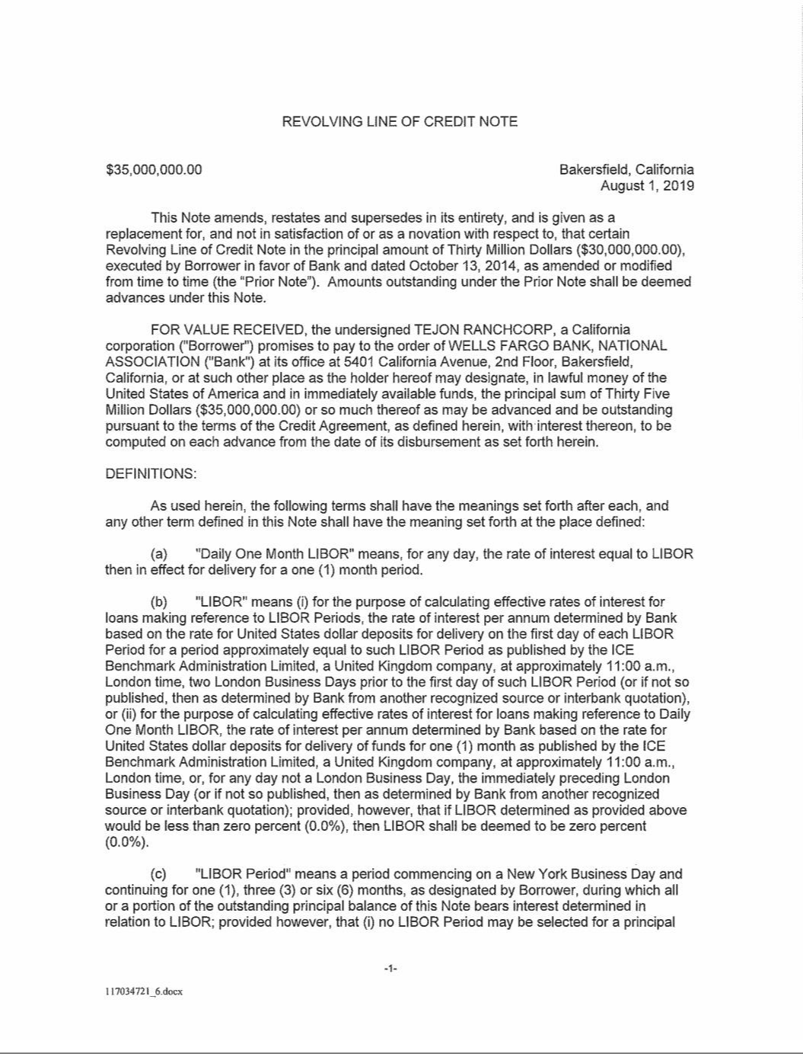

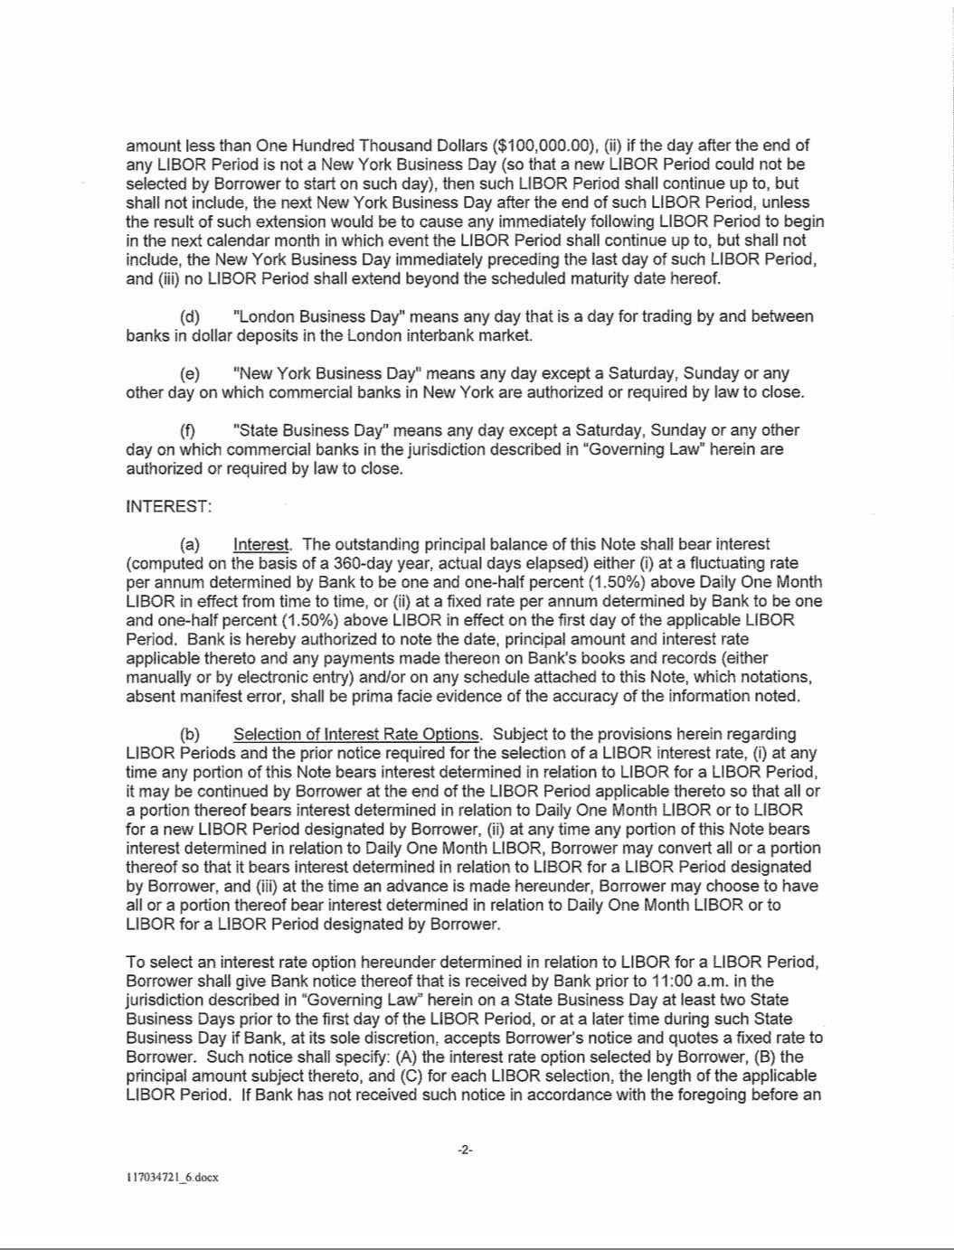

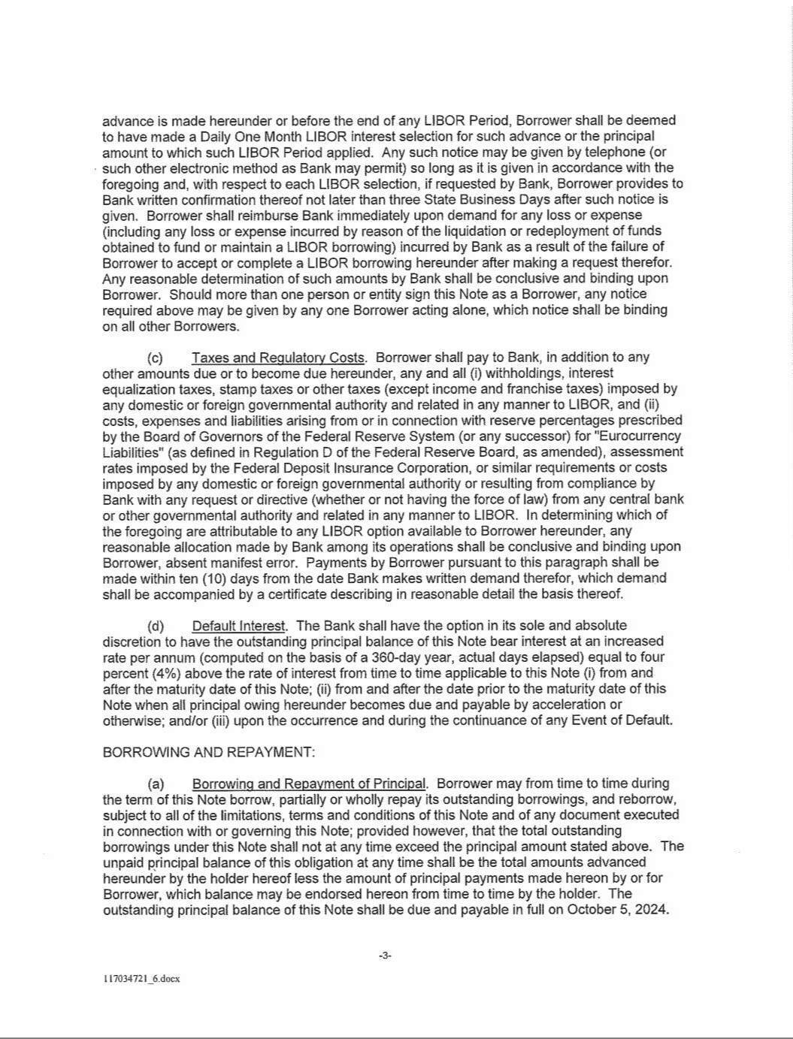

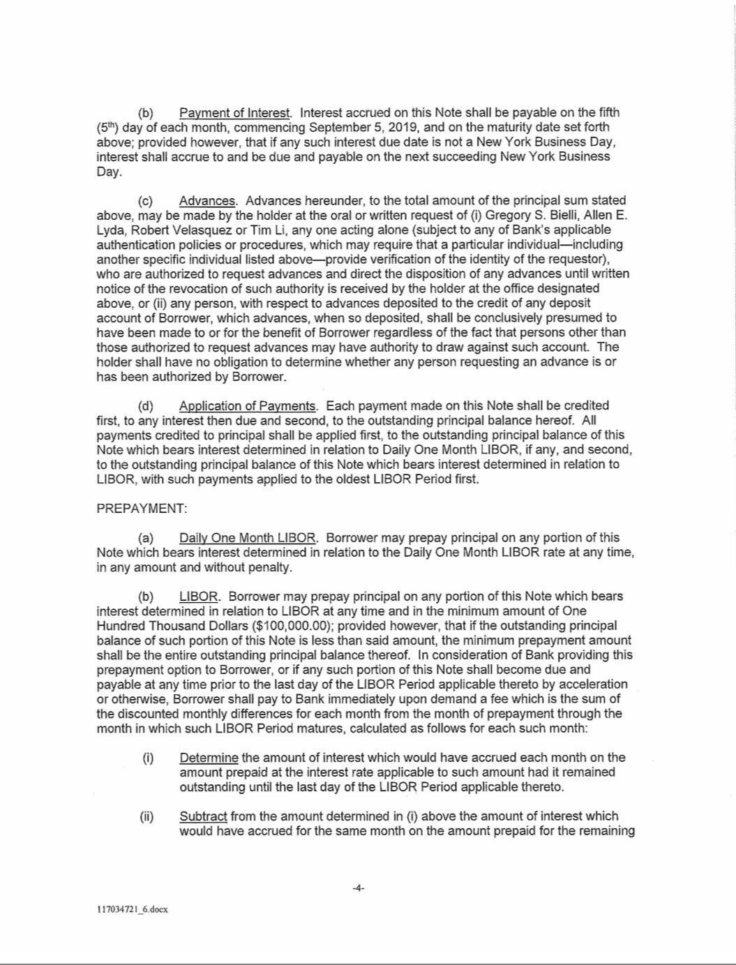

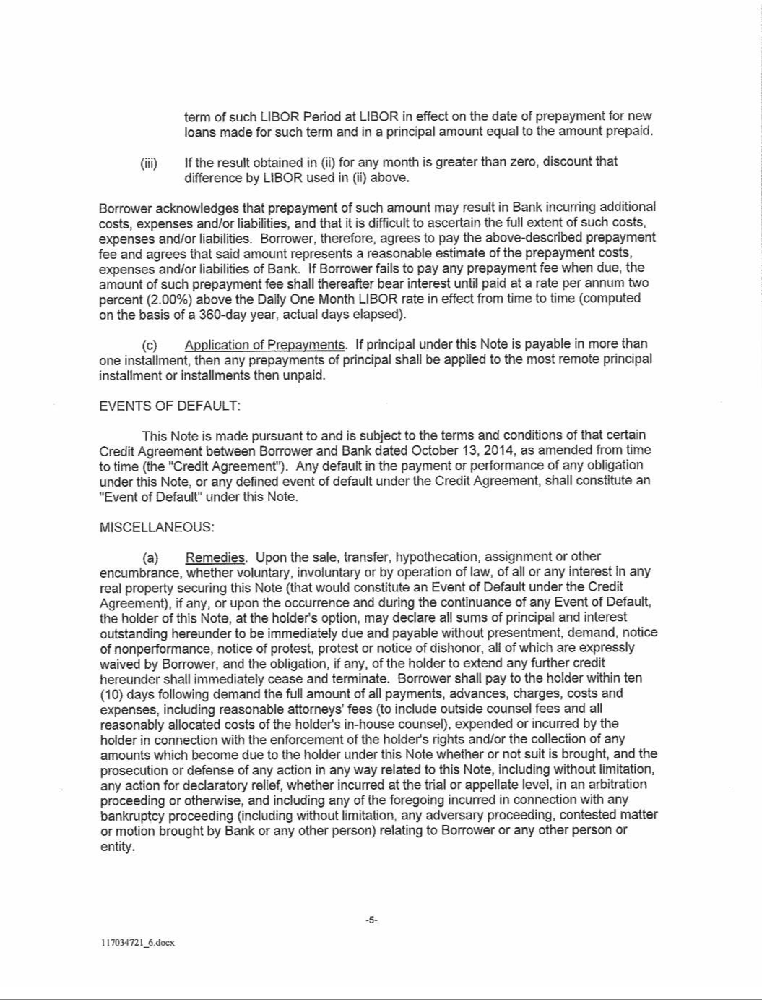

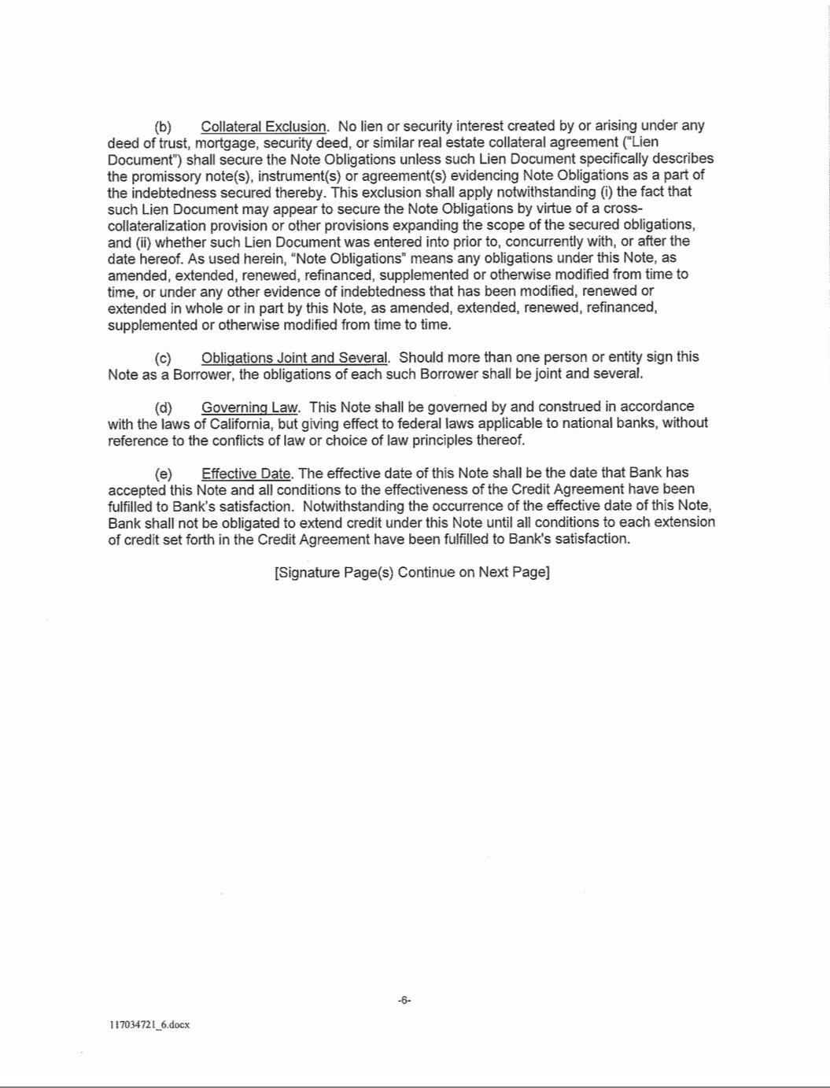



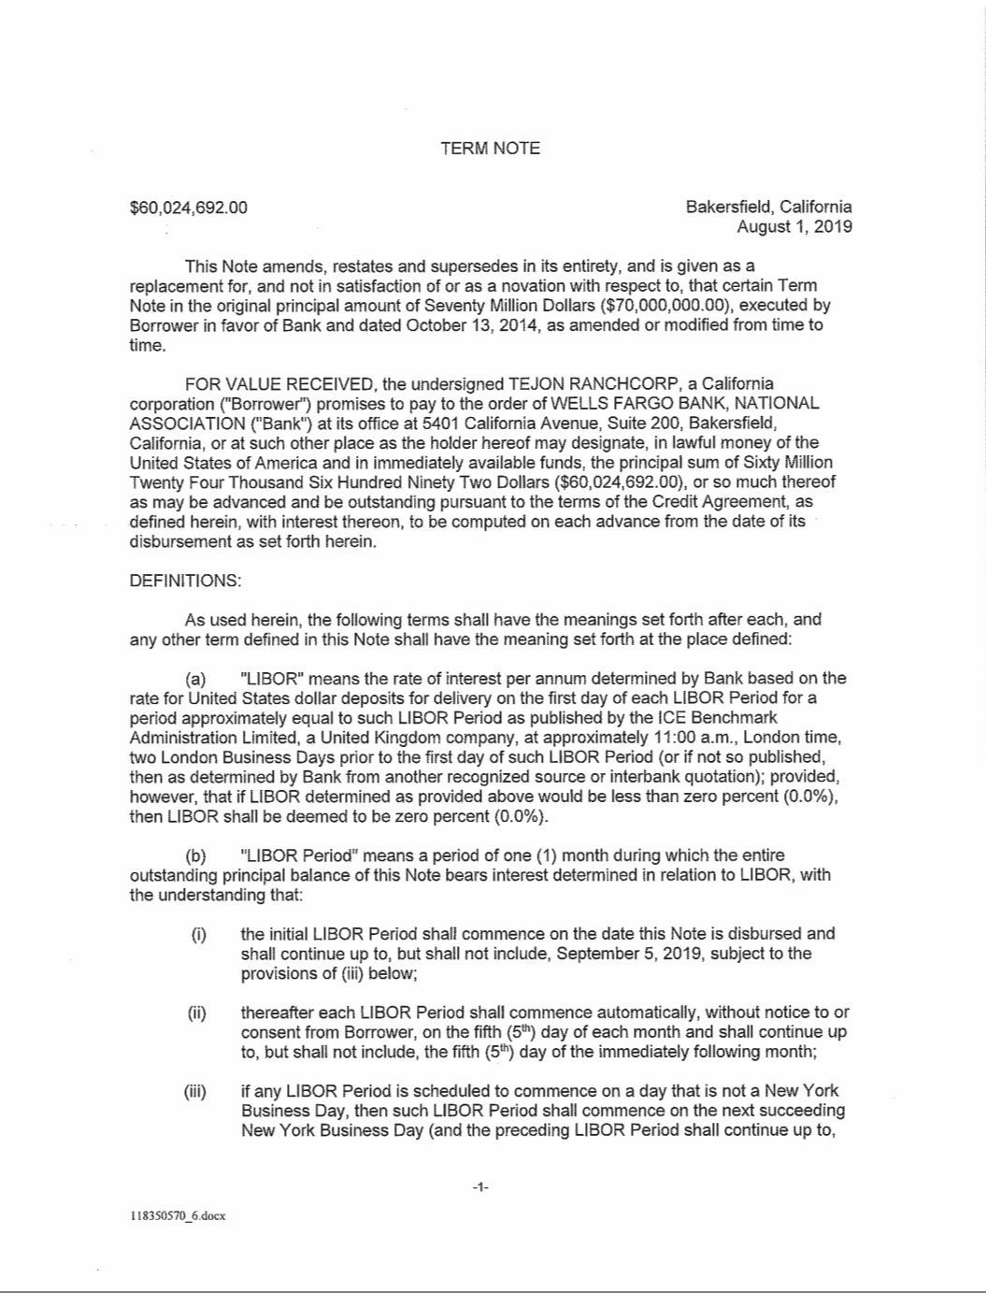

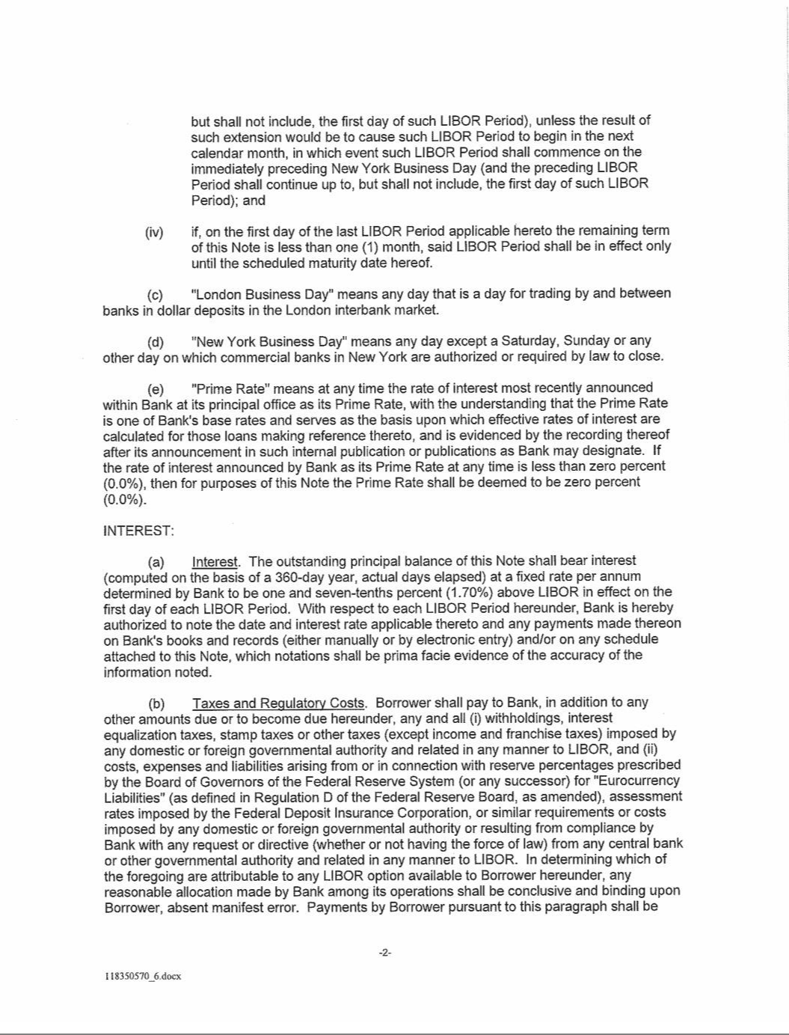

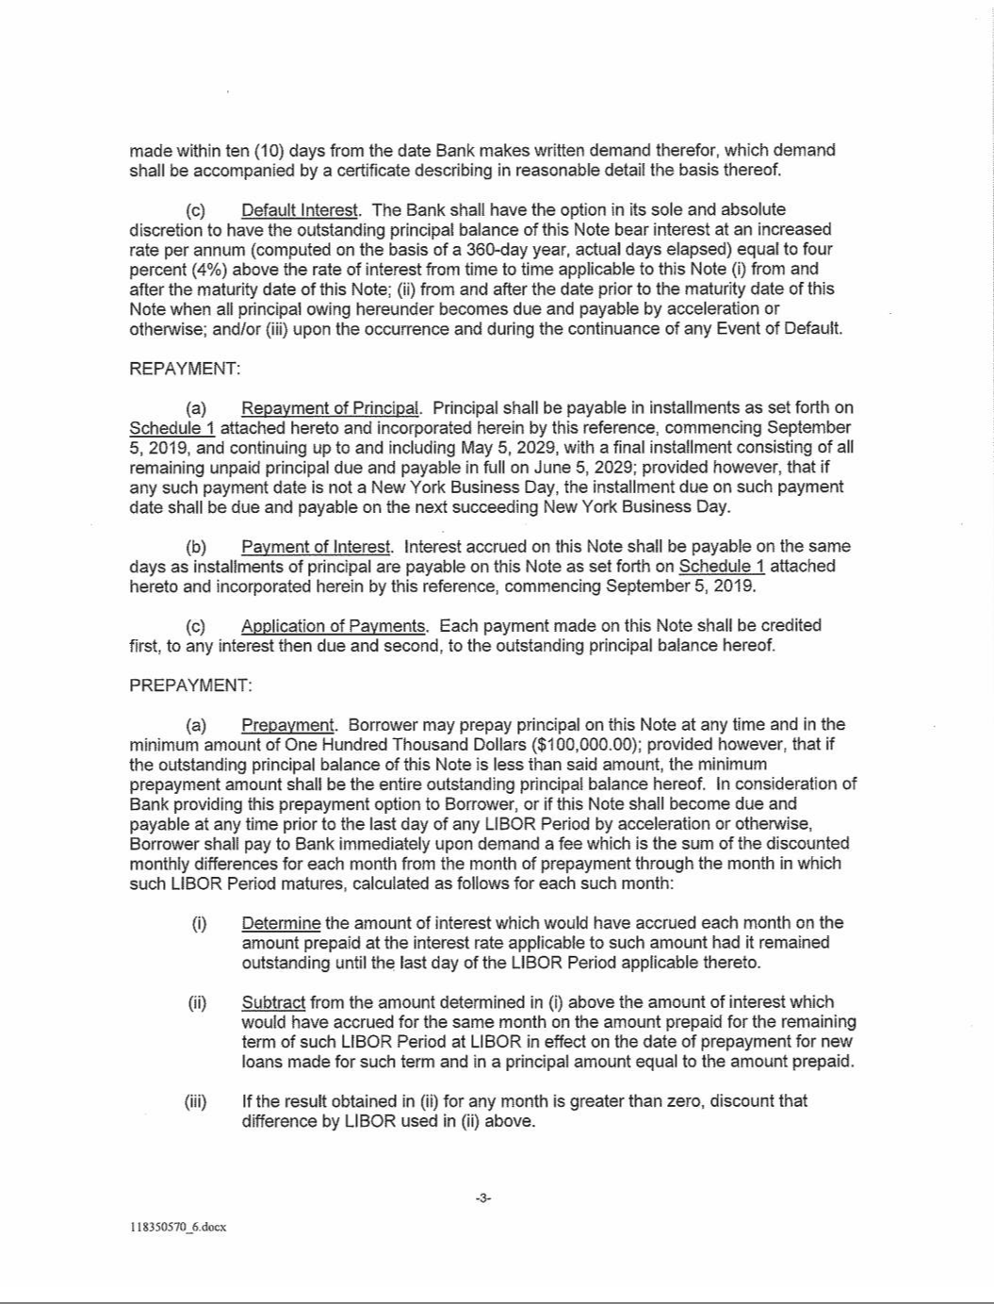

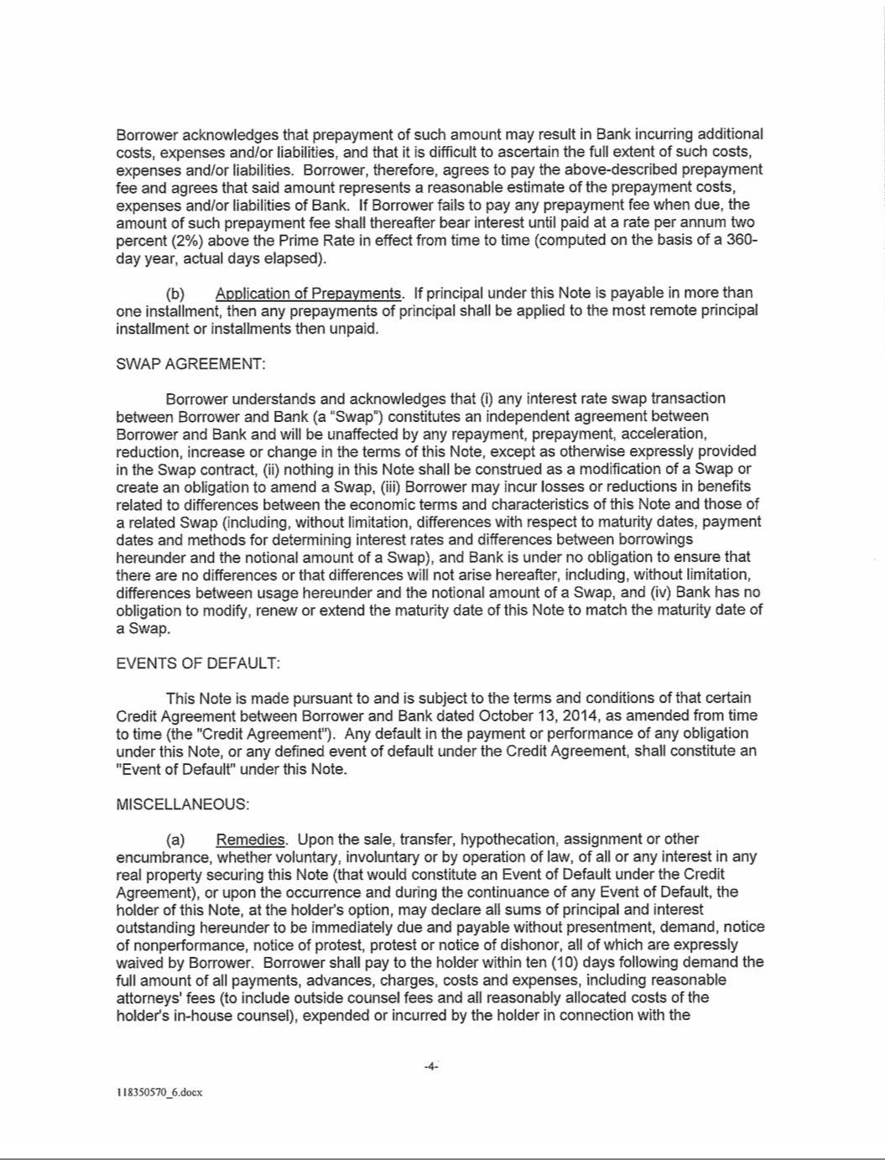

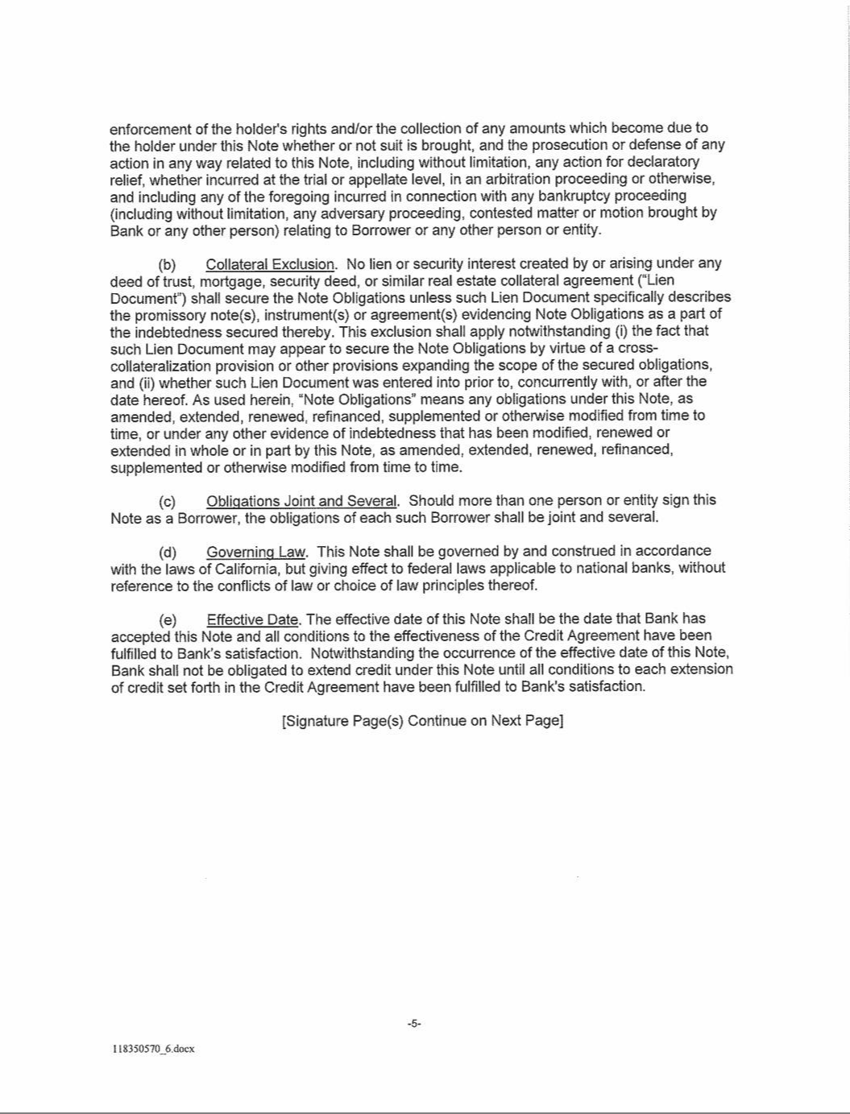

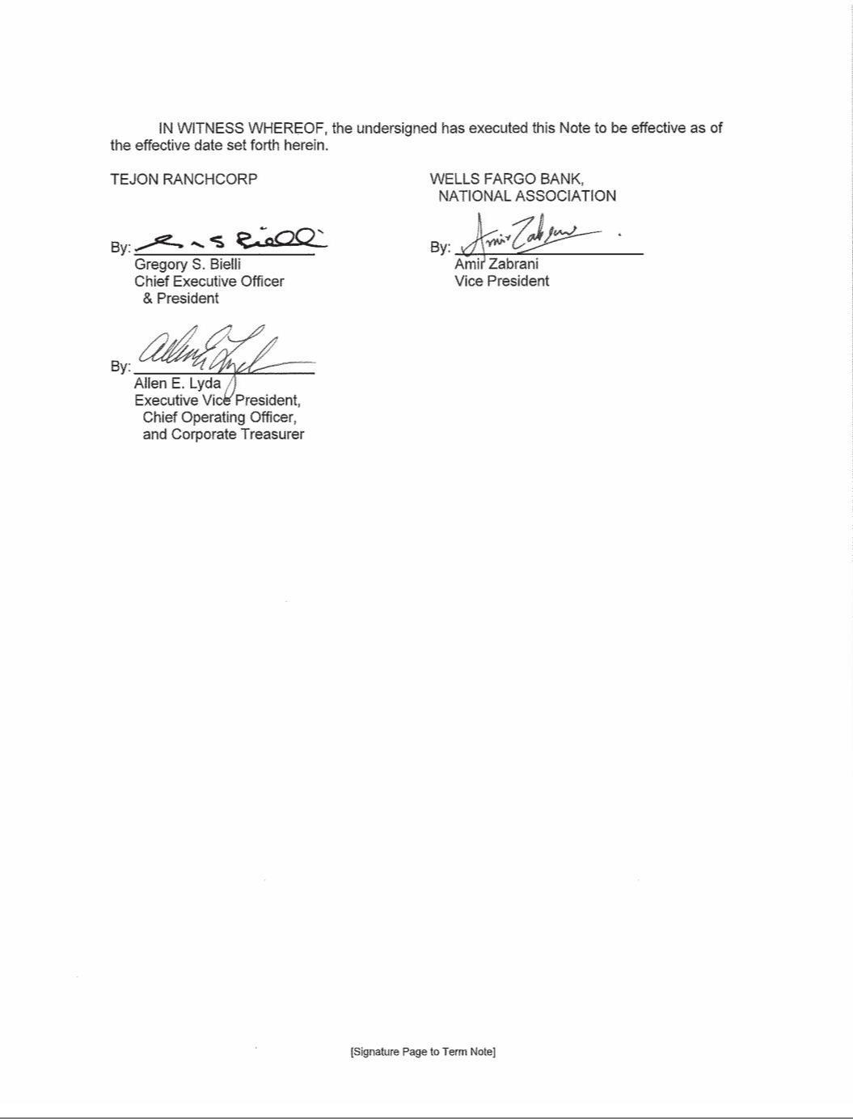

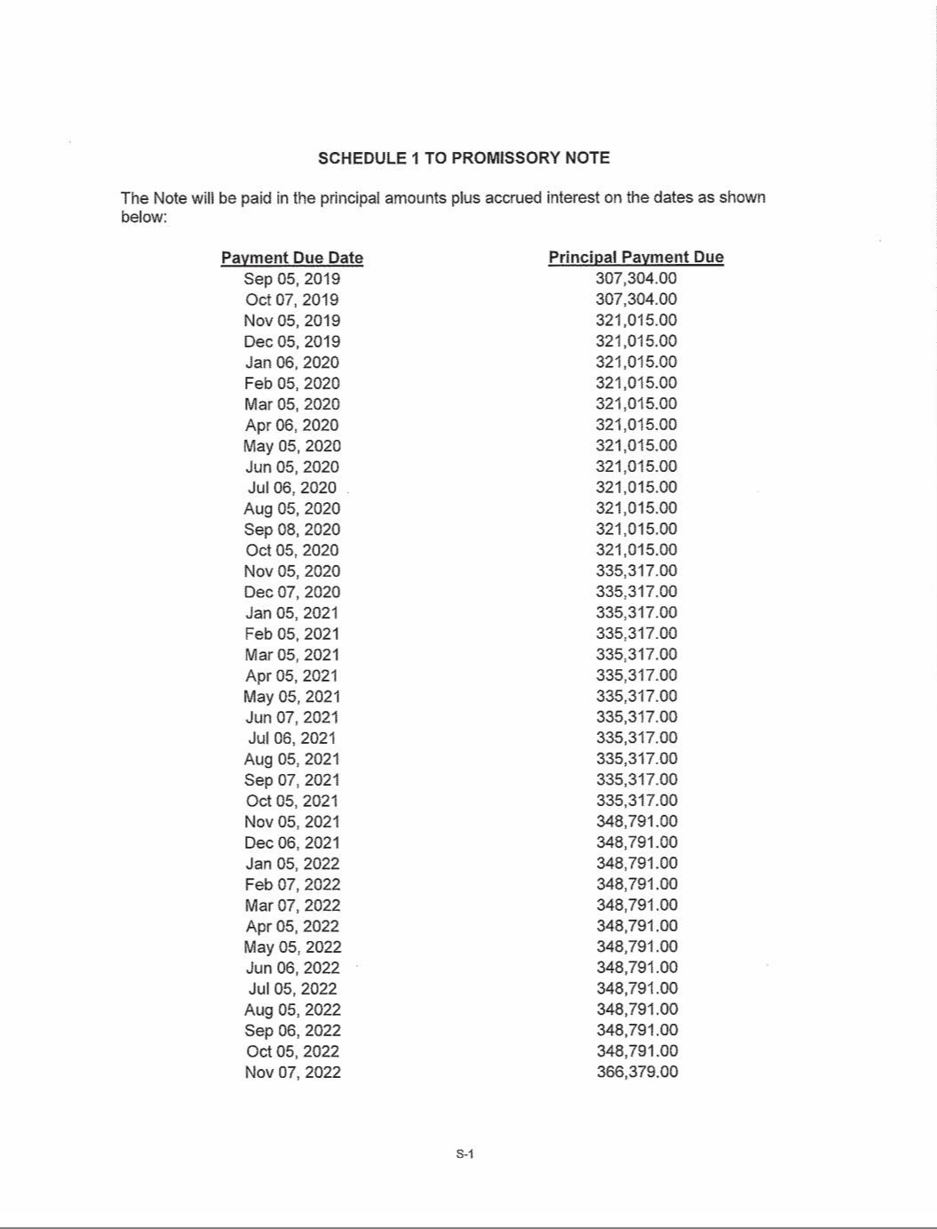

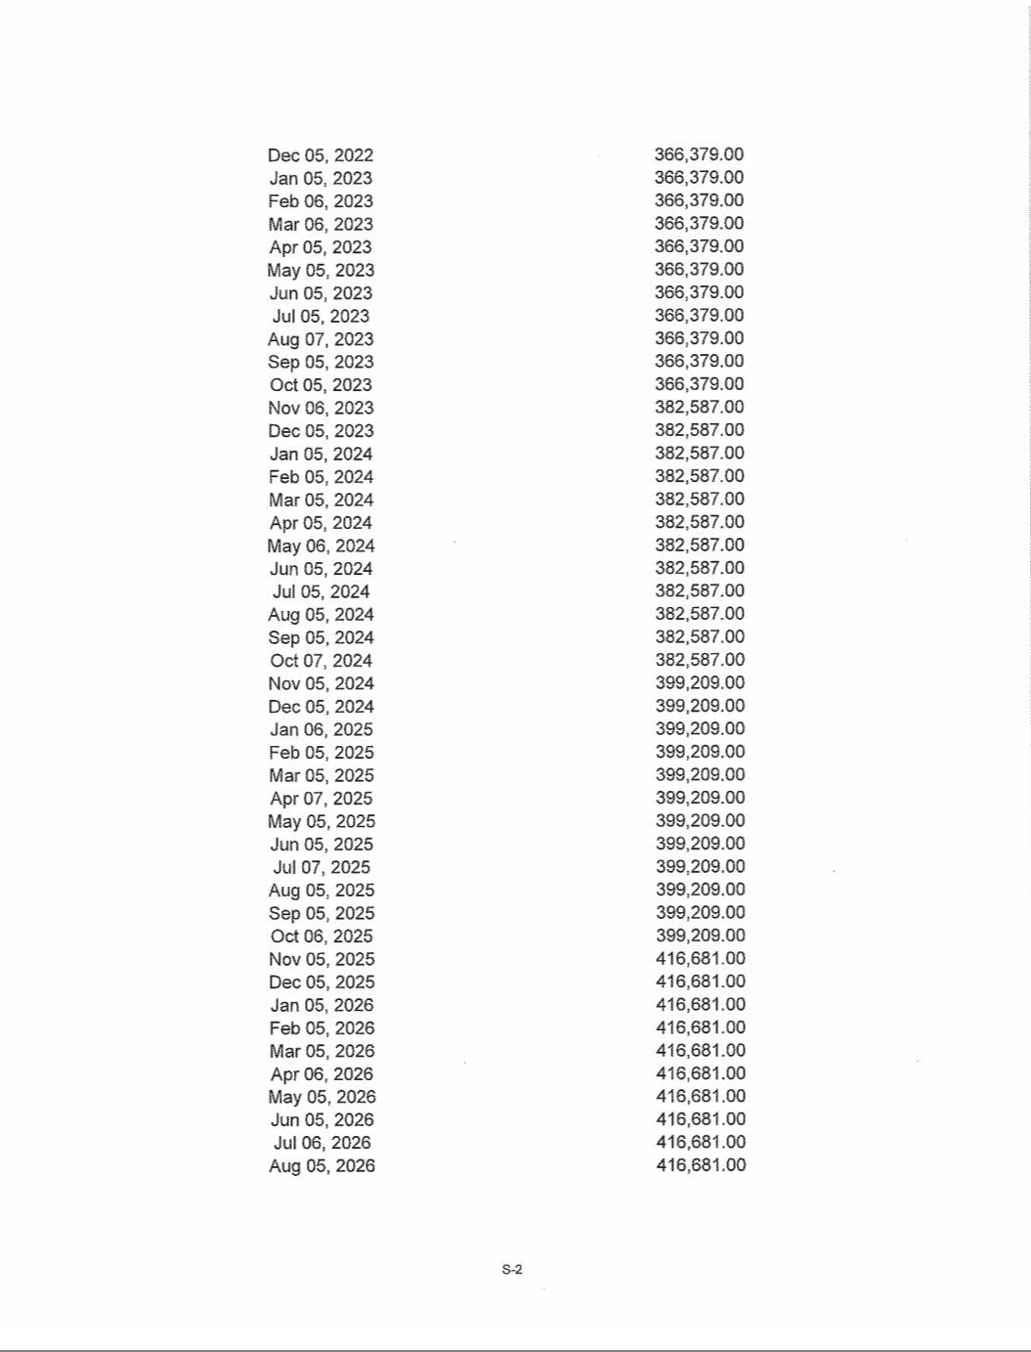

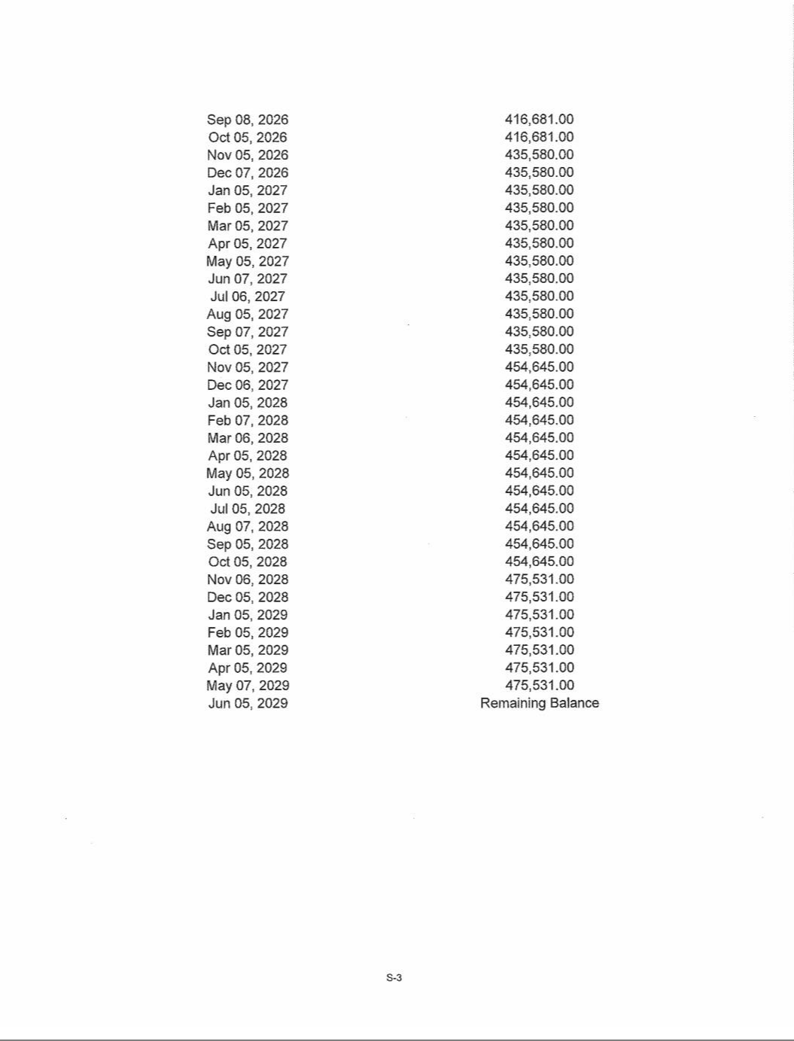

EXHIBIT 31.1

Certification of Chief Executive Officer Pursuant to

Securities Exchange Act Rules 13a-14(a) and 15d-14(a)

as Adopted Pursuant to

Section 302 of the Sarbanes-Oxley Act of 2002

I, Gregory S. Bielli, certify that:

- I have reviewed this quarterly report on Form 10-Q of Tejon Ranch Co.;

- Based on my knowledge, this report does not contain any untrue statement of a material fact or omit to state a material fact necessary to make the statements made, in light of the circumstances under which such statements were made, not misleading with respect to the period covered by this report;

- Based on my knowledge, the financial statements, and other financial information included in this report, fairly present in all material respects the financial condition, results of operations and cash flows of the registrant as of, and for, the periods presented in this report;

- The registrant’s other certifying officer and I are responsible for establishing and maintaining disclosure controls and procedures (as defined in Exchange Act Rules 13a-15(e) and 15d-15(e)) and internal control over financial reporting (as defined in Exchange Act Rules 13a-15(f) and 15(d)-15(f)) for the registrant and have:

  - Designed such disclosure controls and procedures, or caused such disclosure controls and procedures to be designed under our supervision, to ensure that material information relating to the registrant, including its consolidated subsidiaries, is made known to us by others within those entities, particularly during the period in which this report is being prepared;

  - Designed such internal control over financial reporting, or caused such internal control over financial reporting to be designed under our supervision, to provide reasonable assurance regarding the reliability of financial reporting and the preparation of financial statements for external purposes in accordance with generally accepted accounting principles;

  - Evaluated the effectiveness of the registrant’s disclosure controls and procedures and presented in this report our conclusions about the effectiveness of the disclosure controls and procedures, as of the end of the period covered by this report based on such evaluation; and

  - Disclosed in this report any change in the registrant’s internal control over financial reporting that occurred during the registrant’s most recent fiscal quarter (the registrant’s fourth fiscal quarter in the case of an annual report) that has materially affected, or is reasonably likely to materially affect, the registrant’s internal control over financial reporting; and

- The registrant’s other certifying officer and I have disclosed, based on our most recent evaluation of internal control over financial reporting, to the registrant’s auditors and the audit committee of the registrant’s board of directors (or persons performing the equivalent functions):

  - All significant deficiencies and material weaknesses in the design or operation of internal control over financial reporting which are reasonably likely to adversely affect the registrant’s ability to record, process, summarize and report financial information; and

  - Any fraud, whether or not material, that involves management or other employees who have a significant role in the registrant’s internal control over financial reporting.

Dated: November 6, 2019 /s/ Gregory S. Bielli

Gregory S. Bielli

President and Chief Executive Officer

EXHIBIT 31.2

Certification of Chief Executive Officer Pursuant to

Securities Exchange Act Rules 13a-14(a) and 15d-14(a)

as Adopted Pursuant to

Section 302 of the Sarbanes-Oxley Act of 2002

I, Robert D Velasquez, certify that:

- I have reviewed this quarterly report on Form 10-Q of Tejon Ranch Co.;

- Based on my knowledge, this report does not contain any untrue statement of a material fact or omit to state a material fact necessary to make the statements made, in light of the circumstances under which such statements were made, not misleading with respect to the period covered by this report;

- Based on my knowledge, the financial statements, and other financial information included in this report, fairly present in all material respects the financial condition, results of operations and cash flows of the registrant as of, and for, the periods presented in this report;

- The registrant’s other certifying officer(s) and I are responsible for establishing and maintaining disclosure controls and procedures (as defined in Exchange Act Rules 13a-15(e) and 15d-15(e)) and internal control over financial reporting (as defined in Exchange Act Rules 13a-15(f) and 15(d)-15(f)) for the registrant and have:

  - Designed such disclosure controls and procedures, or caused such disclosure controls and procedures to be designed under our supervision, to ensure that material information relating to the registrant, including its consolidated subsidiaries, is made known to us by others within those entities, particularly during the period in which this report is being prepared;

  - Designed such internal control over financial reporting, or caused such internal control over financial reporting to be designed under our supervision, to provide reasonable assurance regarding the reliability of financial reporting and the preparation of financial statements for external purposes in accordance with generally accepted accounting principles;

  - Evaluated the effectiveness of the registrant’s disclosure controls and procedures and presented in this report our conclusions about the effectiveness of the disclosure controls and procedures, as of the end of the period covered by this report based on such evaluation; and

  - Disclosed in this report any change in the registrant’s internal control over financial reporting that occurred during the registrant’s most recent fiscal quarter (the registrant’s fourth fiscal quarter in the case of an annual report) that has materially affected, or is reasonably likely to materially affect, the registrant’s internal control over financial reporting; and

- The registrant’s other certifying officer(s) and I have disclosed, based on our most recent evaluation of internal control over financial reporting, to the registrant’s auditors and the audit committee of the registrant’s board of directors (or persons performing the equivalent functions):

  - All significant deficiencies and material weaknesses in the design or operation of internal control over financial reporting which are reasonably likely to adversely affect the registrant’s ability to record, process, summarize and report financial information; and

  - Any fraud, whether or not material, that involves management or other employees who have a significant role in the registrant’s internal control over financial reporting.

Dated: November 6, 2019 /s/ Robert D. Velasquez

Robert D. Velasquez

Senior Vice President of Finance and Chief Financial Officer

EXHIBIT 32

CERTIFICATION PURSUANT TO

18 U.S.C. SECTION 1350,

AS ADOPTED PURSUANT TO

SECTION 906 OF THE SARBANES-OXLEY ACT OF 2002

Each of the undersigned hereby certifies, in his capacity as an officer of Tejon Ranch Co. (the “Company”), for purposes of 18 U.S.C. Section 1350, as adopted pursuant to Section 906 of the

Sarbanes-Oxley Act of 2002, that to his own knowledge:

- The Quarterly Report of the Company on Form 10-Q for the period ended September 30, 2019 fully complies with the requirements of Section 13(a) of the Securities Exchange Act of 1934; and
- The information contained in such report fairly presents, in all material respects, the financial condition and results of operation of the Company.

A signed original of this written statement required by Section 906 has been provided to Tejon Ranch Co. and will be retained by Tejon Ranch Co., and furnished to the Securities and Exchange Commission or its staff upon request.

Dated: November 6, 2019

/s/ Gregory S. Bielli

Gregory S. Bielli

President and Chief Executive Officer

/s/ Robert D. Velasquez

Robert D. Velasquez

Senior Vice President of Finance and Chief Financial Officer

