UNITED STATES

SECURITIES AND EXCHANGE COMMISSION

WASHINGTON, D.C. 20549

FORM 10-Q

(Mark One)

- QUARTERLY REPORT PURSUANT TO SECTION 13 OR 15(d) OF THE SECURITIES EXCHANGE ACT OF 1934 For the quarterly period ended June 30, 2025

OR

- TRANSITION REPORT PURSUANT TO SECTION 13 OR 15(d) OF THE SECURITIES EXCHANGE ACT OF 1934

For the transition period from to

Commission file number: 1-07183


TEJON RANCH CO.

(Exact name of registrant as specified in its charter)

Delaware

(State or other jurisdiction of incorporation or organization)

77-0196136

(I.R.S. Employer Identification No.)

4436 Lebec Road, P.O. Box 1000, Lebec, California 93243

(Address of principal executive offices) (Zip Code)

(661) 248-3000

(Registrant’s telephone number, including area code)

 | Securities registered pursuant to Section 12(b) of the Act:
Title of each class |  |  | Trading symbol(s) |  |  | Name of each exchange on which registered
Common Stock, $0.50 par value |  |  | TRC |  |  | New York Stock Exchange

Indicate by check mark whether the registrant (1) has filed all reports required to be filed by Section 13 or 15(d) of the Securities Exchange Act of 1934 during the preceding 12 months (or for such shorter period that the registrant was required to file such reports), and (2) has been subject to such filing requirements for the past 90 days. Yes ☒ No ☐

Indicate by check mark whether the registrant has submitted electronically every Interactive Data File required to be submitted pursuant to Rule 405 of Regulation S-T (§232.405 of this chapter) during the preceding 12 months (or for such shorter period that the registrant was required to submit such files). Yes ☒ No ☐

Indicate by check mark whether the registrant is a large accelerated filer, an accelerated filer, a non-accelerated filer, a smaller reporting company, or an emerging growth company. See the definitions of “large accelerated filer,” “accelerated filer,” “smaller reporting company,” and “emerging growth company” in Rule 12b-2 of the Exchange Act.

Large accelerated filer ☐

Accelerated filer ☐

Non-accelerated filer ☒

Smaller reporting company ☒

Emerging growth company ☐

If an emerging growth company, indicate by check mark if the registrant has elected not to use the extended transition period for complying with any new or revised financial accounting standards provided pursuant to Section 13(a) of the Exchange Act. ☐

Indicate by check mark whether the registrant is a shell company (as defined in Rule 12b-2 of the Exchange Act). Yes ☐ No ☒

The number of the Company’s outstanding shares of Common Stock on July 31, 2025 was 26,893,955.

TEJON RANCH CO. AND SUBSIDIARIES

TABLE OF CONTENTS

PART I. | FINANCIAL INFORMATION | Page
Item 1. | Financial Statements | 4
 | Consolidated Balance Sheets as of June 30, 2025 (unaudited) and December 31, 2024 | 4
 | Unaudited Consolidated Statements of Operations for the Three and Six Months Ended June 30, 2025 and 2024 | 5
 | Unaudited Consolidated Statements of Comprehensive (Loss) Income for the Three and Six Months Ended June 30, 2025 and 2024 | 6
 | Unaudited Consolidated Statements of Cash Flows for the Six Months Ended June 30, 2025 and 2024 | 7
 | Unaudited Consolidated Statements of Changes in Equity for the Three and Six Months Ended June 30, 2025 and 2024 | 8
 | Notes to Unaudited Consolidated Financial Statements | 10
Item 2. | Management’s Discussion and Analysis of Financial Condition and Results of Operations | 31
Item 3. | Quantitative and Qualitative Disclosures About Market Risk | 50
Item 4. | Controls and Procedures | 52
PART II. | OTHER INFORMATION
Item 1. | Legal Proceedings | 53
Item 1A. | Risk Factors | 53
Item 2. | Unregistered Sales of Equity Securities and Use of Proceeds | 53
Item 3. | Defaults Upon Senior Securities | 53
Item 4. | Mine Safety Disclosures | 53
Item 5. | Other Information | 53
Item 6. | Exhibits | 53
SIGNATURES |  | 57
 | 2

Glossary

The following initialisms or acronyms may be used in this document and shall be defined as set forth below:

AKIP | Advance Kern Incentive Program
ASC | Accounting Standards Codification
ASU | Accounting Standards Update
AVEK | Antelope Valley East Kern Water Agency
CFL | Centennial Founders, LLC
CBD | Center for Biological Diversity
CEQA | California Environmental Quality Act
CFD | Community Facilities District
CNPS | California Native Plant Society
EBITDA | Earnings Before Interest Taxes Depreciation and Amortization
EIR | Environmental Impact Report
FASB | Financial Accounting Standards Board
FTZ | Foreign Trade Zone
GAAP | Generally Accepted Accounting Principles
GHG | Greenhouse Gas
GSP | Groundwater Sustainability Plan
MV | Mountain Village at Tejon Ranch
NOI | Net Operating Income
NLER | Net Liabilities to Equity Ratio
PEF | Pastoria Energy Facility, LLC
RCL | Revolving Credit Line
RWA | Tejon Ranch Conservation and Land Use Agreement, a.k.a. Ranch Wide Agreement
SEC | Securities and Exchange Commission
SOFR | Secured Overnight Financing Rate
SWP | State Water Project
TA/Petro | Petro Travel Plaza Holdings, LLC
TCWD | Tejon-Castac Water District
TRC | Tejon Ranch Co.
TRCC | Tejon Ranch Commerce Center
TRPFFA | Tejon Ranch Public Facilities Financing Authority
WRMWSD | Wheeler Ridge Maricopa Water Storage District
 | 3

PART I - FINANCIAL INFORMATION

ITEM 1. FINANCIAL STATEMENTS

TEJON RANCH CO. AND SUBSIDIARIES

CONSOLIDATED BALANCE SHEETS

($ in thousands, except per share data)

 | June 30, 2025 |  |  |  | December 31, 2024
ASSETS | (unaudited)
Current Assets:
Cash and cash equivalents | $ | 2,500 |  | $ | 39,267
Marketable securities - available-for-sale |  | 17,554 |  |  | 14,441
Accounts receivable |  | 1,759 |  |  | 7,916
Inventories |  | 8,681 |  |  | 3,972
Prepaid expenses and other current assets |  | 2,770 |  |  | 3,806
Total current assets |  | 33,264 |  |  | 69,402
Real estate and improvements - held for lease, net |  | 40,762 |  |  | 16,253
Real estate development (includes $126,009 at June 30, 2025 and $124,136 at December 31, 2024, attributable to CFL (Note
14)) |  | 384,035 |  |  | 377,905
Property and equipment, net |  | 58,792 |  |  | 56,387
Investments in unconsolidated joint ventures |  | 31,264 |  |  | 28,980
Net investment in water assets |  | 65,480 |  |  | 55,091
Other assets |  | 4,944 |  |  | 3,980
TOTAL ASSETS | $ | 618,541 |  | $ | 607,998
LIABILITIES AND EQUITY
Current Liabilities:
Trade accounts payable | $ | 10,052 |  | $ | 9,085
Accrued liabilities and other |  | 2,373 |  |  | 5,549
Deferred income |  | 2,397 |  |  | 2,162
Total current liabilities |  | 14,822 |  |  | 16,796
Revolving line of credit |  | 81,942 |  |  | 66,942
Long-term deferred gains |  | 10,851 |  |  | 11,447
Deferred tax liability |  | 9,024 |  |  | 9,059
Other liabilities |  | 15,011 |  |  | 14,798
Total liabilities |  | 131,650 |  |  | 119,042
Commitments and contingencies (Note 11)
Equity:
Tejon Ranch Co. stockholders’ equity
Common stock, $0.50 par value per share:
Authorized shares - 50,000,000
Issued and outstanding shares - 26,880,668 at June 30, 2025 and 26,822,768 at December 31, 2024 |  | 13,441 |  |  | 13,412
Additional paid-in capital |  | 349,592 |  |  | 348,497
Accumulated other comprehensive income |  | 77 |  |  | 87
Retained earnings |  | 108,422 |  |  | 111,598
Total Tejon Ranch Co. stockholders’ equity |  | 471,532 |  |  | 473,594
Non-controlling interest |  | 15,359 |  |  | 15,362
Total equity |  | 486,891 |  |  | 488,956
TOTAL LIABILITIES AND EQUITY | $ | 618,541 |  | $ | 607,998

See accompanying notes.

4

TEJON RANCH CO. AND SUBSIDIARIES

UNAUDITED CONSOLIDATED STATEMENTS OF OPERATIONS

($ in thousands, except per share amounts)

 | Three Months Ended June 30, |  |  |  |  |  |  | Six Months Ended June 30,
Revenues: | 2025 |  |  | 2024 |  |  |  | 2025 |  |  | 2024
Real estate - commercial/industrial | $ | 5,107 |  | $ | 2,550 |  | $ | 7,861 |  | $ | 5,495
Mineral resources |  | 1,510 |  |  | 2,032 |  |  | 4,105 |  |  | 4,521
Farming |  | 607 |  |  | 142 |  |  | 2,163 |  |  | 1,007
Ranch operations |  | 1,083 |  |  | 965 |  |  | 2,387 |  |  | 2,072
Total revenues |  | 8,307 |  |  | 5,689 |  |  | 16,516 |  |  | 13,095
Costs and expenses:
Real estate - commercial/industrial |  | 3,536 |  |  | 1,990 |  |  | 5,383 |  |  | 3,917
Real estate - resort/residential |  | 304 |  |  | 427 |  |  | 690 |  |  | 1,988
Mineral resources |  | 790 |  |  | 1,115 |  |  | 2,875 |  |  | 3,231
Farming |  | 1,497 |  |  | 1,087 |  |  | 4,045 |  |  | 3,154
Ranch operations |  | 1,335 |  |  | 1,261 |  |  | 2,608 |  |  | 2,488
Corporate expenses |  | 4,900 |  |  | 3,357 |  |  | 9,136 |  |  | 5,849
Total costs and expenses |  | 12,362 |  |  | 9,237 |  |  | 24,737 |  |  | 20,627
Operating loss |  | (4,055) |  |  | (3,548) |  |  | (8,221) |  |  | (7,532)
Other income:
Investment income |  | 226 |  |  | 630 |  |  | 572 |  |  | 1,315
Other loss, net |  | (4) |  |  | (71) |  |  | (80) |  |  | (141)
Total other income, net |  | 222 |  |  | 559 |  |  | 492 |  |  | 1,174
Loss before equity in earnings of unconsolidated joint ventures and income tax
benefit |  | (3,833) |  |  | (2,989) |  |  | (7,729) |  |  | (6,358)
Equity in earnings of unconsolidated joint ventures, net |  | 2,555 |  |  | 2,769 |  |  | 3,713 |  |  | 4,282
Loss before income tax benefit |  | (1,278) |  |  | (220) |  |  | (4,016) |  |  | (2,076)
Income tax expense (benefit) |  | 435 |  |  | (1,176) |  |  | (837) |  |  | (2,118)
Net (loss) income |  | (1,713) |  |  | 956 |  |  | (3,179) |  |  | 42
Net loss attributable to non-controlling interest |  | (1) |  |  | (1) |  |  | (3) |  |  | (1)
Net (loss) income attributable to common stockholders | $ | (1,712) |  | $ | 957 |  | $ | (3,176) |  | $ | 43
Net (loss) income per share attributable to common stockholders, basic
 | $ | (0.06) |  | $ | 0.04 |  | $ | (0.12) |  | $ | 0.00
Net (loss) income per share attributable to common stockholders, diluted | $ | (0.06) |  | $ | 0.04 |  | $ | (0.12) |  | $ | 0.00

See accompanying notes.

5

TEJON RANCH CO. AND SUBSIDIARIES

UNAUDITED CONSOLIDATED STATEMENTS OF COMPREHENSIVE (LOSS) INCOME

(In thousands)

 | Three Months Ended June 30, |  |  |  |  |  |  | Six Months Ended June 30,
 | 2025 |  |  | 2024 |  |  |  | 2025 |  |  | 2024
Net (loss) income | $ | (1,713) |  | $ | 956 |  | $ | (3,179) |  | $ | 42
Other comprehensive (loss) income:
Unrealized (loss) gain on available-for-sale securities |  | (6) |  |  | 2 |  |  | (14) |  |  | (6)
Other comprehensive (loss) income before taxes |  | (6) |  |  | 2 |  |  | (14) |  |  | (6)
Income tax benefit related to other comprehensive loss items |  | 2 |  |  | — |  |  | 4 |  |  | 2
Other comprehensive (loss) income |  | (4) |  |  | 2 |  |  | (10) |  |  | (4)
Comprehensive (loss) income |  | (1,717) |  |  | 958 |  |  | (3,189) |  |  | 38
Comprehensive loss attributable to non-controlling interests |  | (1) |  |  | (1) |  |  | (3) |  |  | (1)
Comprehensive (loss) income attributable to common stockholders | $ | (1,716) |  | $ | 959 |  | $ | (3,186) |  | $ | 39

See accompanying notes.

6

TEJON RANCH CO. AND SUBSIDIARIES

UNAUDITED CONSOLIDATED STATEMENTS OF CASH FLOWS

(In thousands)

 |  | Six Months Ended June 30,
Operating Activities |  | 2025 |  |  | 2024
Net (loss) income | $ |  | (3,179) |  | $ |  |  | 42
Adjustments to reconcile net (loss) income to net cash used in operating activities:
Depreciation and amortization |  |  | 2,110 |  |  |  |  | 1,921
Amortization of discount of marketable securities |  |  | (130) |  |  |  |  | (352)
Equity in earnings of unconsolidated joint ventures, net |  |  | (3,713) |  |  |  |  | (4,282)
Non-cash retirement plan expense |  |  | 207 |  |  |  |  | 178
Gain on sale of property plant and equipment |  |  | (13) |  |  |  |  | (5)
Deferred income taxes |  |  | (31) |  |  |  |  | 1
Stock compensation expense |  |  | 1,290 |  |  |  |  | 2,354
Excess tax provision (benefit) from stock-based compensation |  |  | 31 |  |  |  |  | (1)
Distribution of earnings from unconsolidated joint ventures |  |  | 1,653 |  |  |  |  | 674
Changes in operating assets and liabilities:
Receivables, inventories, prepaids and other assets, net |  |  | 2,037 |  |  |  |  | (1,104)
Current liabilities |  |  | (1,988) |  |  |  |  | (452)
Net cash used in operating activities |  |  | (1,726) |  |  |  |  | (1,026)
Investing Activities
Maturities and sales of marketable securities |  |  | 23,655 |  |  |  |  | 76,869
Funds invested in marketable securities |  |  | (26,652) |  |  |  |  | (60,500)
Real estate and equipment expenditures |  |  | (37,146) |  |  |  |  | (22,077)
Reimbursement proceeds from Community Facilities District |  |  | — |  |  |  |  | 3,309
Proceeds from sale of property plant and equipment |  |  | 39 |  |  |  |  | 11
Investment in unconsolidated joint ventures |  |  | (238) |  |  |  |  | —
Distribution of equity from unconsolidated joint ventures |  |  | 310 |  |  |  |  | 5,811
Investments in water assets |  |  | (9,519) |  |  |  |  | (5,066)
Net cash used in investing activities |  |  | (49,551) |  |  |  |  | (1,643)
Financing Activities
Borrowings on line of credit |  |  | 15,000 |  |  |  |  | 4,000
Taxes on vested stock grants |  |  | (490) |  |  |  |  | (206)
Net cash provided by financing activities |  |  | 14,510 |  |  |  |  | 3,794
(Decrease) increase in cash, cash equivalents, and restricted cash |  |  | (36,767) |  |  |  |  | 1,125
Cash, cash equivalents, and restricted cash at beginning of period |  |  | 39,767 |  |  |  |  | 32,407
Cash, cash equivalents, and restricted cash at end of period |  | $ | 3,000 |  |  |  | $ | 33,532
Reconciliation to amounts on consolidated balance sheets:
Cash and cash equivalents | $ |  | 2,500 |  | $ |  |  | 33,032
Restricted cash (Shown in prepaid expenses and other current assets) |  |  | 500 |  |  |  |  | 500
Total cash, cash equivalents, and restricted cash |  | $ | 3,000 |  |  |  | $ | 33,532
Non-cash investing activities
Accrued capital expenditures included in current liabilities | $ |  | 2,865 |  | $ |  |  | 5,579
Accrued long-term water assets included in current liabilities | $ |  | 1,552 |  |  | $ |  | 1,286

See accompanying notes.

7

TEJON RANCH CO. AND SUBSIDIARIES

UNAUDITED CONSOLIDATED STATEMENTS OF CHANGES IN EQUITY

(In thousands, except shares outstanding)

 | Common Stock |  |  | Common |  |  | Additional |  | Accumulated Other |  |  |  | Retained |  |  | Total |  |  | Non-controlling
 | Shares |  |  |  |  |  | Paid-In |  |  | Comprehensive |  |  |  |  |  | Stockholders'
 | Outstanding |  |  | Stock |  |  | Capital |  |  | Income (Loss) |  |  | Earnings |  |  | Equity |  |  | Interest |  |  | Total Equity
Balance, March 31, 2025 | 26,867,600 |  | $ | 13,434 |  | $ | 348,829 |  | $ | 81 |  | $ | 110,134 |  | $ | 472,478 |  | $ | 15,360 |  | $ | 487,838
Net loss | — |  |  | — |  |  | — |  |  | — |  |  | (1,712) |  |  | (1,712) |  |  | (1) |  |  | (1,713)
Other comprehensive loss | — |  |  | — |  |  | — |  |  | (4) |  |  | — |  |  | (4) |  |  | — |  |  | (4)
Restricted stock issuance | 13,068 |  |  | 7 |  |  | (7) |  |  | — |  |  | — |  |  | — |  |  | — |  |  | —
Stock compensation | — |  |  | — |  |  | 770 |  |  | — |  |  | — |  |  | 770 |  |  | — |  |  | 770
Balance, June 30, 2025 | 26,880,668 |  | $ | 13,441 |  | $ | 349,592 |  | $ | 77 |  | $ | 108,422 |  | $ | 471,532 |  | $ | 15,359 |  | $ | 486,891
Balance, March 31, 2024 | 26,797,440 |  | $ | 13,400 |  | $ | 346,141 |  | $ | (177) |  | $ | 107,994 |  | $ | 467,358 |  | $ | 15,364 |  | $ | 482,722
Net income (loss) | — |  |  | — |  |  | — |  |  | — |  |  | 957 |  |  | 957 |  |  | (1) |  |  | 956
Other comprehensive income | — |  |  | — |  |  | — |  |  | 2 |  |  |  |  |  | 2 |  |  | — |  |  | 2
Restricted stock issuance | 8,969 |  |  | 4 |  |  | (4) |  |  | — |  |  | — |  |  | — |  |  | — |  |  | —
Stock compensation | — |  |  | — |  |  | 903 |  |  | — |  |  | — |  |  | 903 |  |  | — |  |  | 903
Balance, June 30, 2024 | 26,806,409 |  | $ | 13,404 |  | $ | 347,040 |  | $ | (175) |  | $ | 108,951 |  | $ | 469,220 |  | $ | 15,363 |  | $ | 484,583

See accompanying notes.

8

 |  | Common Stock |  |  | Common |  |  | Additional |  | Accumulated Other |  |  |  | Retained |  |  | Total |  |  | Non-controlling
 |  | Shares |  |  |  |  |  | Paid-In |  |  | Comprehensive |  |  |  |  |  | Stockholders'
 |  | Outstanding |  |  | Stock |  |  | Capital |  |  | Income (Loss) |  |  | Earnings |  |  | Equity |  |  | Interest |  |  | Total Equity
 | Balance, December 31, 2024 | 26,822,768 |  | $ | 13,412 |  | $ | 348,497 |  | $ | 87 |  | $ | 111,598 |  | $ | 473,594 |  | $ | 15,362 |  | $ | 488,956
 | Net loss | — |  |  | — |  |  | — |  |  | — |  |  | (3,176) |  |  | (3,176) |  |  | (3) |  |  | (3,179)
 | Other comprehensive loss | — |  |  | — |  |  | — |  |  | (10) |  |  | — |  |  | (10) |  |  | — |  |  | (10)
 | Restricted stock issuance | 89,403 |  |  | 45 |  |  | (45) |  |  | — |  |  | — |  |  | — |  |  | — |  |  | —
 | Stock compensation | — |  |  | — |  |  | 1,614 |  |  | — |  |  | — |  |  | 1,614 |  |  | — |  |  | 1,614
 | Shares withheld for taxes and tax benefit of
 | vested shares | (31,503) |  |  | (16) |  |  | (474) |  |  | — |  |  | — |  |  | (490) |  |  | — |  |  | (490)
 | Balance, June 30, 2025 | 26,880,668 |  | $ | 13,441 |  | $ | 349,592 |  | $ | 77 |  | $ | 108,422 |  | $ | 471,532 |  | $ | 15,359 |  | $ | 486,891
 | Balance, December 31, 2023 | 26,770,545 |  | $ | 13,386 |  | $ | 345,609 |  | $ | (171) |  | $ | 108,908 |  | $ | 467,732 |  | $ | 15,364 |  | $ | 483,096
 | Net income (loss) | — |  |  | — |  |  | — |  |  | — |  |  | 43 |  |  | 43 |  |  | (1) |  |  | 42
 | Other comprehensive loss | — |  |  | — |  |  | — |  |  | (4) |  |  | — |  |  | (4) |  |  | — |  |  | (4)
 | Restricted stock issuance | 54,319 |  |  | 27 |  |  | (27) |  |  | — |  |  | — |  |  | — |  |  | — |  |  | —
 | Stock compensation | — |  |  | — |  |  | 1,655 |  |  | — |  |  | — |  |  | 1,655 |  |  | — |  |  | 1,655
 | Shares withheld for taxes and tax benefit of
 | vested shares | (18,455) |  |  | (9) |  |  | (197) |  |  | — |  |  | — |  |  | (206) |  |  | — |  |  | (206)
 | Balance, June 30, 2024 | 26,806,409 |  | $ | 13,404 |  | $ | 347,040 |  | $ | (175) |  | $ | 108,951 |  | $ | 469,220 |  | $ | 15,363 |  | $ | 484,583
 |  |  |  |  |  |  |  | 9

TEJON RANCH CO. AND SUBSIDIARIES

NOTES TO UNAUDITED CONSOLIDATED FINANCIAL STATEMENTS

1. BASIS OF PRESENTATION

The summarized information of Tejon Ranch Co. and its subsidiaries (the Company, TRC or Tejon), provided pursuant to Part I, Item 1 of Form 10-Q, is unaudited and reflects all adjustments which are, in the opinion of the Company’s management, necessary for a fair statement of the results for the interim period. All such adjustments are of a normal, recurring nature. The Company has evaluated subsequent events through the date of issuance of its consolidated financial statements.

The periods ended June 30, 2025 and 2024 include the consolidation of CFL’s statements of operations within the resort/residential real estate development segment, statements of changes in equity, and statements of cash flows. The Company’s June 30, 2025 and December 31, 2024 balance sheets are presented on a consolidated basis, including the consolidation of CFL.

The Company has identified five reportable segments: commercial/industrial real estate development, resort/residential real estate development, mineral resources, farming, and ranch operations. Information for the Company’s reportable segments is presented in its Consolidated Statements of Operations. The Company’s reportable segments follow the same accounting policies used for the Company’s consolidated financial statements. The Company uses segment profit or loss and equity in earnings of unconsolidated joint ventures as the primary measures of profitability to evaluate operating performance and to allocate capital resources.

The results of the period reported herein are not indicative of the results to be expected for the full year due to the seasonal nature of the Company’s agricultural activities, water activities, and timing of real estate sales and leasing activities. Historically, the Company’s largest percentages of farming revenues are recognized during the third and fourth quarters of the fiscal year.

For further information and a summary of significant accounting policies, refer to the Consolidated Financial Statements and notes thereto included in the Company’s Annual Report on Form 10-K for the year ended December 31, 2024.

Financial Instruments

Certain financial instruments are carried on the consolidated balance sheets at cost or amortized cost basis, which approximates fair value due to their short-term and highly liquid nature. These instruments include cash and cash equivalents, restricted cash, time deposits, accounts receivable, security deposits held for customers, accounts payable, and other accrued liabilities. The fair value of the revolving line of credit also approximates its carrying value, as the interest rate is variable and approximates prevailing market interest rates for similar debt arrangements.

Restricted Cash

Restricted cash is included in Prepaid expenses and other current assets within the Consolidated Balance Sheets and primarily relates to funds held in escrow. The Company had $500,000 of restricted cash as of June 30, 2025 and December 31, 2024.

New Accounting Pronouncements Adopted

Business Combinations - Joint Venture Formations

In August 2023, FASB issued ASU No. 2023-05, "Business Combinations - Joint Venture Formations." This ASU addresses the accounting for contributions made to a joint venture, upon formation, in a joint venture's separate financial statements. The pronouncement requires a joint venture to initially measure contributions at fair value upon formation, which is more relevant than the carrying amounts of the contributed net assets and would reduce equity method basis differences. The ASU is effective prospectively for all joint venture formations with a formation date on or after January 1, 2025. This pronouncement did not have a material effect on our consolidated financial statements.

New Accounting Pronouncements and Climate Change Related Update by SEC Effective in Future Periods Income Taxes

In December 2023, the FASB issued ASU No. 2023-09, "Income Taxes (Topic740) - Improvements to Income Tax Disclosures". This ASU requires public business entities to disclose a tabular rate reconciliation of both percentages and reporting currency amounts on an annual basis. The ASU also requires disclosure of information on the amount of income taxes paid disaggregated by federal, state and foreign taxes. This ASU is effective for annual periods beginning after December 15, 2024. The pronouncement is not expected to have a material effect on our consolidated financial statements.

10

Rules to Enhance and Standardize Climate-related Disclosures for Investors

On March 6, 2024, the SEC adopted final rules to require registrants to disclose certain climate-related information in registration statements and annual reports. On April 4, 2024, the SEC issued an order staying the final rules pending completion of judicial review of the petitions challenging the final rules. The order does not amend the compliance dates contemplated by the final rules, which are applicable to the Company for fiscal years beginning with the Company’s annual report on Form 10-K for the fiscal year ending December 31, 2027; however, the SEC disclosed in its litigation filings that it would publish a new effective date for the rules at the conclusion of its stay. On February 11, 2025, the SEC also indicated it would ask the court to hold on scheduling further arguments while the SEC reassessed its position in the litigation. Subsequently, on March 27, 2025, the SEC voted to cease defending the rule in court. Despite withdrawing its defense, the SEC has not formally rescinded the rule. We are continuing to evaluate the implications of the pending adoption of these requirements in light of this development, including potential impacts on our financial statement disclosures.

Expense Disaggregation Disclosures

In November 2024, the FASB issued ASU No. 2024-03, "Income Statement - Reporting Comprehensive Income - Expense Disaggregation Disclosures (Subtopic 220-40)." This ASU requires public business entities to disclose specified information about certain costs and expenses, including the amounts of purchases of inventory, employee compensation, depreciation, intangible asset amortization and depreciation, depletion and amortization recognized as part of oil- and gas-producing activities included in each relevant expense caption. The ASU also requires disclosure of a qualitative description of the amounts remaining in relevant expense captions that are not separately disaggregated quantitatively. This ASU is effective for annual reporting periods beginning after December 15, 2026. We are currently evaluating the impact of these requirements on our financial statement disclosures.

2. EQUITY

Earnings Per Share (EPS)

Basic net income (loss) per share attributable to common stockholders is based upon the weighted-average number of shares of common stock outstanding during reporting periods. Diluted net income (loss) per share attributable to common stockholders is based upon the weighted-average number of shares of common stock outstanding and the weighted-average number of shares outstanding assuming the issuance of common stock upon exercise of stock options, warrants to purchase common stock, and the vesting of restricted stock grants per ASC Topic 260, “Earnings Per Share.”

 | Three Months Ended June 30, |  |  |  | Six Months Ended June 30,
Weighted-average number of shares outstanding: | 2025 |  | 2024 |  | 2025 |  | 2024
Common stock | 26,878,658 |  | 26,800,594 |  | 26,865,687 |  | 26,794,469
Common stock equivalents | — ¹ |  | 48,746 |  | — ¹ |  | 83,702
Diluted shares outstanding | 26,878,658 |  | 26,849,340 |  | 26,865,687 |  | 26,878,171
- For the three months ended June 30, 2025, 76,687 shares of restricted stock were excluded from the calculation of diluted net loss per share as the shares were antidilutive. For the six months ended June 30, 2025, 75,835 shares of restricted stock were excluded from the calculation of diluted net loss per share as the shares were antidilutive.

11

- MARKETABLE SECURITIES

ASC Topic 320, “Investments – Debt and Equity Securities,” requires that an enterprise classify all debt securities as either held-to-maturity, trading or available-for-sale. The Company has elected to classify its securities as available-for-sale and therefore is required to adjust securities to fair value at each reporting date. All costs and both realized and unrealized gains and losses on securities are determined on a specific identification basis. The following is a summary of available-for-sale securities at:

($ in thousands) | Fair Value |  | June 30, 2025 |  |  |  |  |  | December 31, 2024
Marketable Securities: | Hierarchy |  | Cost |  |  | Fair Value |  |  | Cost |  |  | Fair Value
Certificates of deposit
with unrealized losses for less than 12 months | $ |  | 496 |  | $ | 496 |  | $ | — |  | $ | —
with unrealized gains |  |  | 673 |  |  | 674 |  |  | 248 |  |  | 248
Total Certificates of deposit | Level 1 |  | 1,169 |  |  | 1,170 |  |  | 248 |  |  | 248
U.S. Treasury and agency notes
with unrealized losses for less than 12 months |  |  | 13,363 |  |  | 13,351 |  |  | 6,115 |  |  | 6,109
with unrealized gains |  |  | 1,941 |  |  | 1,942 |  |  | 7,573 |  |  | 7,583
Total U.S. Treasury and agency notes | Level 2 |  | 15,304 |  |  | 15,293 |  |  | 13,688 |  |  | 13,692
Corporate notes
with unrealized losses for less than 12 months |  |  | 331 |  |  | 331 |  |  | — |  |  | —
with unrealized gains |  |  | 248 |  |  | 248 |  |  | — |  |  | —
Total Corporate notes | Level 2 |  | 579 |  |  | 579 |  |  | — |  |  | —
Municipal notes
with unrealized losses for less than 12 months |  |  | 248 |  |  | 248 |  |  | 501 |  |  | 501
with unrealized gains |  |  | 264 |  |  | 264 |  |  | — |  |  | —
Total Municipal notes | Level 2 |  | 512 |  |  | 512 |  |  | 501 |  |  | 501
 | $ |  | 17,564 |  | $ | 17,554 |  | $ | 14,437 |  | $ | 14,441

The Company uses an allowance approach when recognizing credit loss for available-for-sale debt securities, measured as the difference between the security's amortized cost basis and the amount expected to be collected over the security's lifetime. Under this approach, at each reporting date, the Company records impairment related to credit losses through earnings offset with an allowance for credit losses, or ACL. At June 30, 2025, the Company has not recorded any credit losses.

As of June 30, 2025, the fair market value of investment securities was $10,000 below their cost basis. The Company’s gross unrealized holding gains equaled $2,000 and gross unrealized holding losses equaled $12,000. For the three months ended June 30, 2025, the adjustment to accumulated other comprehensive loss reflected a decrease in market value of $6,000, before the impact of an estimated tax benefit of $2,000. For the six months ended June 30, 2025, the adjustment to accumulated other comprehensive loss reflected a decline in market value of $14,000, before the impact of an estimated tax benefit of $4,000.

The Company elected to exclude applicable accrued interest from both the fair value and the amortized cost basis of the available-for-sale debt securities, and separately present the accrued interest receivable balance. The accrued interest receivables balance totaled $175,000 as of June 30, 2025 and was included within the Prepaid expenses and other current assets line item of the Consolidated Balance Sheets. The Company elected not to measure an allowance for credit losses on accrued interest receivable, as an allowance on possible uncollectible accrued interest is not warranted.

U.S. Treasury and agency notes

The unrealized losses on the Company's investments in U.S. Treasury and agency notes at June 30, 2025 and December 31, 2024 were caused by relative changes in interest rates since the time of purchase and not changes in credit quality. The contractual cash flows for these securities are guaranteed by U.S. government agencies. As of June 30, 2025 and December 31, 2024, the Company did not intend to sell these securities and it is not more-likely-than-not that the Company would be required to sell these securities before recovery of their cost basis. Therefore, these investments did not require an ACL as of June 30, 2025 and December 31, 2024.

12

Corporate notes

The unrealized losses on corporate notes are a function of changes in investment spreads and interest rate movements and not changes in credit quality. The Company expects to recover the entire amortized cost basis of these securities. As of June 30, 2025 and December 31, 2024, the Company did not intend to sell these securities and it is not more-likely-than-not the Company would be required to sell these securities before recovery of their cost basis. Therefore, these investments did not require an ACL as of June 30, 2025 and December 31, 2024.

The following tables summarize the maturities, at par, of marketable securities as of:
 |  |  |  |  |  | June 30, 2025
($ in thousands) |  | 2025 |  |  |  | 2026 |  |  |  |  | 2027 |  |  |  | Total
Certificates of deposit | $ | 248 |  |  | $ | 425 |  |  |  | $ | 496 |  |  | $ | 1,169
U.S. Treasury and agency notes |  | 6,105 |  |  |  | 8,500 |  |  |  |  | 737 |  |  |  | 15,342
Corporate notes |  | 144 |  |  |  | 191 |  |  |  |  | 248 |  |  |  | 583
Municipal notes |  | — |  |  |  | 250 |  |  |  |  | 260 |  |  |  | 510
Total | $ | 6,497 |  |  | $ | 9,366 |  |  |  | $ | 1,741 |  |  | $ | 17,604
 |  |  |  |  |  | December 31, 2024
($ in thousands) |  | 2025 |  |  |  | 2026 |  |  |  |  | 2027 |  |  |  | Total
Certificates of deposit | $ | 248 |  |  | $ | — |  |  |  | $ | — |  |  | $ | 248
U.S. Treasury and agency notes |  | 12,015 |  |  |  | 1,000 |  |  |  |  | 737 |  |  |  | 13,752
Municipal notes |  | 500 |  |  |  | — |  |  |  |  | — |  |  |  | 500
 | $ | 12,763 |  |  | $ | 1,000 |  |  |  | $ | 737 |  |  | $ | 14,500

The Company’s investments in corporate notes are with companies that have an investment grade rating from Standard & Poor’s as of June 30, 2025 and December 31, 2024.

- REAL ESTATE

Our accumulated real estate development costs by project consisted of the following:

($ in thousands) |  |  | June 30, 2025 |  |  | December 31, 2024
Real estate development
Mountain Village | $ |  | 159,736 |  | $ | 158,348
Centennial |  |  | 126,009 |  |  | 124,136
Grapevine |  |  | 43,798 |  |  | 42,456
Tejon Ranch Commerce Center
- Commercial |  |  | 27,066 |  |  | 23,724
- Residential |  |  | 27,426 |  |  | 29,241
Total Tejon Ranch Commerce Center |  |  | 54,492 |  |  | 52,965
Real estate development |  | $ | 384,035 |  | $ | 377,905
Real estate and improvements - held for lease
Tejon Ranch Commerce Center
- Commercial | $ |  | 20,616 |  | $ | 20,596
- Residential |  |  | 24,797 |  |  | —
Total Tejon Ranch Commerce Center |  | $ | 45,413 |  | $ | 20,596
Less accumulated depreciation |  |  | (4,651) |  |  | (4,343)
Real estate and improvements - held for lease, net |  | $ | 40,762 |  | $ | 16,253
 | 13

- LONG-TERM WATER ASSETS

Long-term water assets consist of water and water purchase contracts held for future use or sale. The water is held at cost, which includes the price paid for the water and the cost to pump and deliver the water from the California aqueduct into the water bank. Water is currently held in a water bank on Company land in southern Kern County and by TCWD in Kern County Water Banks.

The Company has secured SWP water purchase contracts from the Tulare Lake Basin Water Storage District and the Dudley-Ridge Water District, totaling 3,444 acre-feet of SWP water annually, subject to SWP allocations. These contracts extend through 2085 and have been transferred to AVEK for the Company's use in the Antelope Valley. In 2013, the Company acquired a contract to purchase water that obligates the Company to purchase 6,693 acre-feet of water each year from the Nickel Family, LLC, or Nickel, a California limited liability company that is located in Kern County.

The initial term of the water purchase agreement with Nickel runs to 2044 and includes a Company option to extend the contract for an additional 35 years. The purchase cost of water in 2025 is $986 per acre-foot. The purchase cost is subject to annual cost increases based on the greater of the Consumer Price Index or 3%.

The water purchased above will ultimately be used in the development of the Company’s land for commercial/industrial real estate development, resort/residential real estate development, and farming. Interim uses may include the sale of portions of this water to third-party users on an annual basis until this water is fully allocated to Company uses, as just described.

Water revenues and cost of sales were as follows for the six months ended ($ in thousands):

 | June 30, 2025 |  |  |  | June 30, 2024
Acre-Feet Sold |  | 1,100 |  |  | 1,325
Revenues | $ | 1,468 |  | $ | 1,660
Cost of sales |  | 1,183 |  |  | 1,415
Profit | $ | 285 |  | $ | 245

Costs assigned to water assets held for future use were as follows ($ in thousands):

 |  |  |  |  |  |  | June 30, 2025 |  |  |  |  |  | December 31, 2024
 | Banked water and water for future delivery |  |  |  |  |  | $ |  |  | 44,204 |  | $ |  |  | 36,048
 | Transferable water |  |  |  |  |  |  |  |  | 2,948 |  |  |  |  | 35
 | Total water held for future use at cost |  |  |  |  |  | $ |  |  | 47,152 |  | $ |  |  | 36,083
Intangible Water Assets
The Company’s carrying amounts of its purchased water contracts were as follows ($ in thousands):
 |  |  | June 30, 2025 |  |  |  |  |  |  |  |  | December 31, 2024
 |  | Costs |  |  |  | Accumulated Depreciation |  |  |  | Costs |  |  |  | Accumulated Depreciation
 | Dudley-Ridge water purchase contract * | $ | 11,581 |  | $ | (6,996) |  |  | $ |  |  | 11,581 |  | $ | (6,755)
 | Nickel water purchase contract * |  | 18,740 |  |  | (7,496) |  |  |  |  |  | 18,740 |  |  | (7,175)
 | Tulare Lake Basin water purchase contract * |  | 6,479 |  |  | (3,980) |  |  |  |  |  | 6,479 |  |  | (3,862)
 |  | $ | 36,800 |  | $ | (18,472) |  |  | $ |  |  | 36,800 |  | $ | (17,792)
 | Net cost of purchased water contracts |  | 18,328 |  |  |  |  |  |  |  |  | 19,008
 | Total cost of water held for future use |  | 47,152 |  |  |  |  |  |  |  |  | 36,083
 | Net investments in water assets | $ | 65,480 |  |  |  |  |  | $ |  |  | 55,091
 | *All water purchase contracts were acquired from third parties.

14

Water contracts with WRMWSD and TCWD are also in place, but were entered into with each district at inception of the contract and not purchased later from third parties, and do not have a related financial value on the books of the Company. Therefore, there is no amortization expense related to these contracts. Total water resources, including both recurring and one-time usage are:

(in acre-feet, unaudited) |  |  |  | June 30, 2025 |  |  |  | December 31, 2024
Water held for future use
 | TCWD - Banked water owned by the Company |  |  | 64,429 |  |  |  | 60,936
 | Company water bank |  |  | 54,728 |  |  |  | 54,728
 | Transferable water |  |  | 3,831 |  |  |  | 505
 | Recharged water |  |  | 6,797 |  |  |  | 6,797
 | Total water held for future use |  |  | 129,785 |  |  |  | 122,966
Purchased water contracts
 | Water Contracts (Dudley-Ridge, Nickel and Tulare) |  |  | 10,137 |  |  |  | 10,137
 | WRMWSD - Contracts with the Company |  |  | 15,547 |  |  |  | 15,547
 | TCWD - Contracts with the Company |  |  | 5,749 |  |  |  | 5,749
 | Total purchased water contracts |  |  | 31,433 |  |  |  | 31,433
Total water held for future use and purchased water contracts |  |  |  | 161,218 |  |  |  | 154,399
6. ACCRUED LIABILITIES AND OTHER CURRENT LIABILITIES
Accrued liabilities and other current liabilities consisted of the following:
 | ($ in thousands) |  |  | June 30, 2025 |  |  |  | December 31, 2024
 | Accrued vacation |  | $ | 588 |  |  | $ | 707
 | Accrued paid personal leave |  |  | 153 |  |  |  | 295
 | Accrued bonus |  |  | 1,250 |  |  |  | 2,425
 | Accrued stock compensation expense¹ |  |  | — |  |  |  | 1,831
 | Other |  |  | 382 |  |  |  | 291
 |  |  | $ | 2,373 |  |  | $ | 5,549
- Cash settled awards classified as liabilities.

- LINE OF CREDIT AND LONG-TERM DEBT Debt consisted of the following:
($ in thousands) | June 30, 2025 |  |  |  | December 31, 2024
Revolving line-of-credit¹ | $ | 81,942 |  | $ | 66,942
- Deferred loan costs for the revolving line-of-credit as of June 30, 2025 and December 31, 2024 were recorded under the caption "Other Assets" on the Consolidated Balance Sheets.

On November 17, 2023, the Company entered into a Credit Agreement with AgWest Farm Credit, PCA and certain other lenders (the Revolving Credit Facility). The Revolving Credit Facility provides TRC a RCL in the amount of $160,000,000. The RCL requires interest only payments and has a maturity date of January 1, 2029. As of June 30, 2025, the outstanding balance under the RCL was $81,942,000, and the interest rate was one-month term SOFR plus a margin of 2.25% for an effective rate of 6.60% before patronage, which for 2024 was 125 basis points, or bps, from AgWest and 100 bps from other participant lenders, for a net all-in rate of 5.44%.

15

- OTHER LIABILITIES

Other liabilities consisted of the following:

($ in thousands) |  | June 30, 2025 |  |  | December 31, 2024
Supplemental executive retirement plan liability (See Note 12) | $ | 5,636 |  | $ | 5,720
Excess joint venture distributions and other (See Note 14) |  | 9,375 |  |  | 9,078
Total | $ | 15,011 |  | $ | 14,798

- STOCK COMPENSATION - RESTRICTED STOCK AND PERFORMANCE SHARE GRANTS

The Company’s stock incentive plans provide for the making of awards to employees based upon a service condition or through the achievement of performance-related objectives. The Company has issued three types of stock grant awards under these plans: restricted stock with service condition vesting; performance share grants that only vest upon the achievement of specified performance conditions, such as corporate cash flow goals or share price, or Performance Condition Grants; and performance share grants that include threshold, target, and maximum achievement levels based on the achievement of specific performance measures, or Performance Milestone Grants. Performance Condition Grants with market-based conditions are based on the achievement of a target share price. The share price used to calculate the grant date fair value for market-based awards is determined using a Monte Carlo simulation. Failure to achieve the target share price will result in the forfeiture of shares. Forfeiture of share awards with service conditions or performance-based restrictions will result in a reversal of previously recognized share-based compensation expense. Forfeiture of share awards with market-based restrictions does not result in a reversal of previously recognized share-based compensation expense.

The following is a summary of the Company’s Performance Condition Grants outstanding as of June 30, 2025:

 | Performance Condition Grants
Target performance | 299,626
Maximum performance | 388,836

The following is a summary of the Company’s stock grant activity, both time and performance unit grants, assuming target achievement for outstanding performance grants for the six months ended

June 30, 2025:

 |  |  | June 30, 2025
 | Stock grants outstanding beginning of period at target achievement |  | 312,564
 | New stock grants/additional shares due to achievement in excess of target | 170,925
 | Vested grants | (25,012)
 | Expired/forfeited grants | (10,966)
 | Stock grants outstanding end of period at target achievement |  | 447,511
 |  | 16

The following is a summary of the assumptions used to determine the fair value for the Company’s outstanding market-based Performance Condition Grants as of June 30, 2025:

($ in thousands except for share prices)
Grant date |  | 12/14/2022 |  |  |  | 06/16/2023 |  |  |  | 08/21/2023 |  |  |  | 12/16/2023
Vesting end |  | 12/14/2025 |  |  |  | 12/31/2025 |  |  |  | 12/31/2025 |  |  |  | 12/31/2026
Target share price to achieve award |  | $21.99 |  |  |  | $20.72 |  |  |  | $19.20 |  |  |  | $19.65
Expected volatility |  | 32.14% |  |  |  | 26.58% |  |  |  | 25.55% |  |  |  | 25.91%
Risk-free interest rate |  | 3.84% |  |  |  | 4.38% |  |  |  | 4.74% |  |  |  | 4.02%
Simulated Monte Carlo share price |  | $26.00 |  |  |  | $20.24 |  |  |  | $17.88 |  |  |  | $19.74
Shares granted |  | 4,613 |  |  |  | 9,515 |  |  |  | 1,650 |  |  |  | 4,828
Total fair value of award |  | $120 |  |  |  | $193 |  |  |  | $30 |  |  |  | $95
($ in thousands except for share prices)
Grant date |  | 03/13/2024 |  |  |  | 12/11/2024 |  |  |  | 03/06/2025 |  |  |  | 06/20/2025
Vesting end |  | 03/22/2027 |  |  |  | 12/10/2027 |  |  |  | 03/06/2028 |  |  |  | 06/20/2028
Share price at target achievement |  | $18.93 |  |  |  | $18.59 |  |  |  | $18.56 |  |  |  | $19.01
Expected volatility |  | 25.56% |  |  |  | 26.90% |  |  |  | 27.04% |  |  |  | 26.82%
Risk-free interest rate |  | 4.31% |  |  |  | 4.01% |  |  |  | 3.90% |  |  |  | 3.80%
Simulated Monte Carlo share price |  | $18.36 |  |  |  | $18.55 |  |  |  | $13.54 |  |  |  | $18.53
Shares granted |  | 15,225 |  |  |  | 2,315 |  |  |  | 13,046 |  |  |  | 18,351
Total fair value of award |  | $280 |  |  |  | $43 |  |  |  | $177 |  |  |  | $340

The unamortized cost associated with unvested stock grants and the weighted average period over which it is expected to be recognized as of June 30, 2025 were $3,456,000 and 19 months, respectively. The fair value of restricted stock with time-based vesting features is based upon the Company’s share price on the date of grant and is expensed over the service period. Fair value of performance grants that cliff vest based on the achievement of performance conditions is based on the share price of the Company’s stock on the day of grant and is expensed over the performance period if it is probable that the award will vest. This fair value is expensed over the service period applicable to these grants. For performance grants that contain a range of shares from zero to maximum, the Company determines, based on historic and projected results, the probability of (1) achieving the performance objective, and (2) the level of achievement. Based on this information, the Company determines the number of awards probable of vesting and expenses the grant date fair value of such awards over the service period related to these grants. Because the ultimate vesting of all performance grants is tied to the achievement of a performance condition, the Company estimates whether the performance condition will be met and over what period of time. Ultimately, the Company adjusts compensation cost according to the actual outcome of the performance condition.

Under the 2023 Stock Incentive Plan, each non-employee director, during the years presented, received all or a portion of his or her annual compensation in stock.

17

The following table summarizes stock compensation costs for the Company's 2023 Stock Incentive Plan, 1998 Stock Incentive Plan, and the prior Non-Employee Director Stock Incentive Plan for the following periods:

($ in thousands) |  | Six Months Ended June 30,
Employee |  | 2025 |  |  | 2024
Expensed | $ | 866 |  | $ | 2,075
Capitalized |  | 324 |  |  | 423
 |  | 1,190 |  |  | 2,498
Director |  | 424 |  |  | 279
Total stock compensation costs | $ | 1,614 |  | $ | 2,777

- INCOME TAXES

The Company’s provision for income taxes during the interim reporting periods has historically been calculated by applying an estimate of the annual effective tax rate for the full year to “ordinary” income or loss (pre-tax income or loss excluding unusual or infrequently occurring discrete items) for each respective reporting period. However, the Company utilized a discrete effective tax rate method, as allowed by ASC 740-270 “Income Taxes—Interim Reporting,” to calculate taxes for this interim reporting period (the six months ended June 30, 2025). The Company made this choice because it determined that the historical method would not provide a reliable estimate for tax expense for the six months ended June 30, 2025 due to uncertainty in estimating annual pretax earnings.

For the six months ended June 30, 2025, the Company’s income tax benefit was $837,000 compared to income tax benefit of $2,118,000 for the six months ended June 30, 2024. Effective tax rates were 21% and 102% for the six months ended June 30, 2025 and 2024, respectively. As of June 30, 2025, the Company had income tax receivables of $2,435,000. The Company classifies interest and penalties incurred on tax payments as income tax expense.

On July 4, 2025, the One Big Beautiful Bill Act was signed into law in the U.S., which contains a broad range of tax reform provisions affecting businesses. We are evaluating the full effects of the legislation on our estimated annual effective tax rate and cash tax position, but we expect that the legislation will likely not have a material impact on our financial statements. As the legislation was signed into law after the close of our second quarter, the impacts are not included in our operating results for the six months ended June 30, 2025.

- COMMITMENTS AND CONTINGENCIES Water Contracts
The Company has secured water contracts that are encumbered by the Company's land. These water contracts require minimum annual payments, for which $10,038,000 was paid during the six months ended June 30, 2025. These water contract payments consist of SWP contracts with WRMWSD, TCWD, Tulare Lake Basin, Dudley-Ridge, and the Nickel water contract. The SWP contracts run through 2085, and the Nickel water contract runs through 2044, with an option to extend an additional 35 years. The Company's contractual obligation for future water payments was $1,462,769,000 as of June 30, 2025.

Contracts

The Company exited a consulting contract during the second quarter of 2014 related to the Grapevine Development, or Grapevine project, and is obligated to pay an earned incentive fee at the time of its successful receipt of litigated project entitlements and at a value measurement date five-years after litigated entitlements have been achieved for Grapevine. The final amount of the incentive fee will not be determined until the future payment dates. As of June 30, 2025, the Company believes the net savings resulting from exiting the contract during this future time period will more than offset the incentive payment costs.

Community Facilities Districts

TRPFFA is a joint powers authority formed by Kern County and TCWD to finance public infrastructure within the Company’s Kern County developments. For the development of TRCC, TRPFFA has created two CFDs: the West CFD and the East CFD. The West CFD has placed liens on 420 acres of the Company’s land to secure payment of special taxes related to $19,540,000 of outstanding bond debt sold by TRPFFA for TRCC-West. The East CFD has placed liens on 1,931 acres of the Company’s land to secure payments of special taxes related to $95,660,000 of outstanding bond debt sold by TRPFFA for TRCC-East. At TRCC-West, the West CFD has no additional bond debt approved for issuance. At TRCC-East, the East CFD has approximately $18,605,000 of additional bond debt authorized by TRPFFA that can be sold in the future.

18

As a landowner in each CFD, the Company is obligated to pay its share of the special taxes assessed each year. The secured lands include both the TRCC-West and TRCC-East developments. Proceeds from the sale of West CFD bonds went to reimburse the Company for public infrastructure costs related to the TRCC-West development. As of June 30, 2025, there were no additional improvement funds remaining from the West CFD bonds. On July 25, 2024, TRPFFA sold bonds that provide approximately $25,000,000 of improvement funds for the reimbursement of public infrastructure costs at TRCC-East. As of June 30, 2025, there are $19,849,000 of additional improvement funds remaining within the East CFD bonds for reimbursement of public infrastructure costs during future years. During fiscal year 2025, the Company expects to pay approximately $3,642,000 in special taxes. As development continues to occur at TRCC, new owners of land and new lease tenants, through triple net leases, will bear an increasing portion of the assessed special tax. This amount could change in the future, based on the amount of bonds outstanding and the amount of taxes paid by others. The assessment of each individual property sold or leased is not determinable at this time, because it is based on the current tax rate and assessed value of the property at the time of sale or on its assessed value at the time it is leased to a third-party. Accordingly, the Company was not required to recognize an obligation on June 30, 2025.

Centennial

On April 30, 2019, the Los Angeles County Board of Supervisors granted final entitlement approval for the Centennial project. On May 15, 2019, Climate Resolve filed an action in Los Angeles Superior Court (the Climate Resolve Action), pursuant to CEQA and the California Planning and Zoning Law, against the County of Los Angeles and the Los Angeles County Board of Supervisors (collectively, LA County) concerning LA County’s granting of approvals for the Centennial project, including certification of the final EIR and related findings (Centennial EIR); approval of associated general plan amendments; adoption of associated zoning; adoption of the Centennial Specific Plan; approval of a subdivision map for financing purposes; and adoption of a development agreement, among other approvals (collectively, the Centennial Approvals). Separately, on May 28, 2019, the CBD and the CNPS filed an action in Los Angeles County Superior Court (the CBD/CNPS Action) against LA County; like the Climate Resolve Action, the CBD/CNPS Action also challenges the Centennial Approvals. The Company, its wholly owned subsidiary Tejon Ranchcorp, and CFL are named as real parties-in-interest in both the Climate Resolve Action and the CBD/CNPS Action.

The Climate Resolve Action and the CBD/CNPS Action collectively allege that LA County failed to properly follow the procedures and requirements of CEQA and the California Planning and Zoning Law. The Climate Resolve Action and the CBD/CNPS Action were deemed “related” and, while not consolidated under court rules or the rules of civil procedure, the Los Angeles Superior Court judge (Superior Court or Court) trying both cases determined during early trial management conferences to hold one set of hearings and issue one ruling on the matters as part of the adjudication. The Climate Resolve Action and CBD/CNPS Action sought to invalidate the Centennial Approvals and require LA County to revise the environmental documentation related to the Centennial project.

On April 5, 2021, following three hearings, the Court issued its decision denying the petition for writ of mandate by CBD/CNPS and granting the petition for writ of mandate filed by Climate Resolve. In granting Climate Resolve’s petition, the Court found three specific areas where the EIR for the project was lacking. The Court ruled that California’s Cap-and-Trade Program cannot be used as a compliance pathway for mitigating GHG impacts for the project and therefore further ruled that additional analysis will be required related to all feasible mitigation of GHG impacts. The Court also found that the EIR must provide additional analysis and explanation of how wildland fire risk on lands outside of the project site, posed by on-site ignition sources, is mitigated to less than significant. On April 19, 2021, CBD filed a motion for reconsideration with the Court on the denial of their petition for writ of mandate to be granted prevailing party status in its case based on the Court's conclusions in the Climate Resolve Action (“Motion for Reconsideration”).

On November 30, 2021, the Company, together with Ranchcorp and CFL, entered into a Settlement Agreement with Climate Resolve. Pursuant to the Settlement Agreement, the Company has agreed as stated and obligated in the Settlement Agreement: (1) to make Centennial a net zero GHG emissions project through various on-site and off-site measures including, but not limited to, installing electric vehicle chargers and establishing and funding incentive programs for the purchase of electric vehicles; (2) to fund certain on-site and off-site fire protection and prevention measures; and (3) to provide annual public reports and create an organization to monitor progress towards these commitments. The foregoing is only a summary of the material terms of the Settlement Agreement and does not purport to be a complete description of the rights and obligations of the parties thereunder and is qualified in its entirety by reference to the Settlement Agreement. In exchange, Climate Resolve filed a request for dismissal of the Climate Resolve Action with prejudice from the Court. On January 14, 2022, the Court heard CBD/CNPS' Motion for Reconsideration and issued its decision granting CBD/CNPS prevailing party status based on the Court’s conclusions in the Climate Resolve Action.

19

On October 26, 2022, the Court held a hearing concerning the entry of final judgement and awarding of appropriate remedies, at which time the Court agreed to: (a) hear the Company’s Motion for Reconsideration as to the successful challenges Climate Resolve prevailed upon within the Climate Resolve Action and ordered the Parties to appear on December 14, 2022 to hear the Company’s Motion for Reconsideration and (b) rule on the entry of final judgment and setting of remedies at a February 17, 2023 hearing date.

At the December 14, 2022 hearing, the Court denied the Company’s Motion for Reconsideration. At the February 17, 2023 hearing, the Court took into submission the Parties’ legal briefs and oral arguments. On March 22, 2023, the Court decided in favor of CBD/CNPS and signed CBD/CNPS’s proposed form of judgment, which included a full rescission of the Centennial project approvals previously issued by Los Angeles County.

On May 26, 2023, the Company filed a Notice of Appeal with the Superior Court, thereby appealing the Superior Court’s decision to the Second District of the California Court of Appeal (Court of Appeal). On June 27, 2023, CBD/CNPS cross-appealed the Superior Court’s ruling. The Court of Appeal held a hearing on April 3, 2025 for this matter. On June 26, 2025, the Court of Appeal issued a written decision affirming the Superior Court’s decision in full. In doing so, the Court of Appeal upheld the Superior Court determinations that (i) the CBD/CNPS Action claims related to wildlife connectivity, perennial grassland and wildflower impacts, and project alternatives were without merit, (ii) California’s Cap-and-Trade Program cannot be used as a compliance pathway for mitigating GHG impacts for the Centennial project and, therefore, further ruled that additional analysis is required related to all feasible mitigation of GHG impacts, (iii) additional analysis and explanation are required of how wildland fire risk on lands outside of the Centennial project site, posed by on-site ignition sources, is mitigated to less than significant, (iv) the Centennial Approvals be rescinded and Centennial EIR decertified pending correction of the EIR for the issues described above, and (v) CBD/CNPS were prevailing parties. The Court of Appeal also indicated that the EIR should discuss wildfire risks associated with the Project’s offsite improvements (such as offsite utility and natural gas lines). The Company is in the process of working with LA County to advance the Centennial project.

As the Company’s options to reinstate the project approvals remain pending, the monetary value of any adverse decision, if any, cannot be estimated at this time. Proceedings Incidental to Business

From time to time, the Company is involved in other proceedings incidental to its business, including actions relating to employee claims, real estate disputes, contractor disputes and grievance hearings before labor regulatory agencies.

The outcome of these other proceedings is not predictable. However, based on current circumstances, the Company believes that the ultimate resolution of these other proceedings will not have a material adverse effect on the Company’s financial position, results of operations or cash flows, either individually or in the aggregate.

12. RETIREMENT PLANS

The Company sponsors a defined benefit retirement plan, or Benefit Plan, that covers eligible employees hired prior to February 1, 2007. The benefits are based on years of service and the employee’s five-year final average salary. Contributions are intended to provide for benefits attributable to service both to date and expected to be provided in the future. The Company funds the plan in accordance with the Employee Retirement Income Security Act of 1974 (ERISA). In April 2017, the Company froze the Benefit Plan as it relates to future benefit accruals for participants. The Company does not expect to make contributions to the Benefit Plan in 2025.

Benefit Plan assets consist of equity, debt and short-term money market investment funds. The Benefit Plan’s current investment policy changed during the third quarter of 2018. The policy's strategy seeks to minimize the volatility of the funding ratio. This objective will result in a prescribed asset mix between "return seeking" assets (e.g., stocks) and a bond portfolio (e.g., long duration bonds) according to a pre-determined customized investment strategy based on the Benefit Plan's funded status as the primary input. This path will be used as a reference point as to the mix of assets, which by design will de-emphasize the return seeking portion as the funded status improves. At both June 30, 2025 and December 31, 2024, the investment mixes were approximately at 99% debt and 1% money market funds. The weighted-average discount rate used in determining the periodic pension cost is 5.60% in 2025 and 4.85% in 2024. The expected long-term rate of return on plan assets is 5.00% for both fiscal 2025 and 2024. The long-term rate of return on Benefit Plan assets is based on the historical returns within the plan and expectations for future returns.

20

Total pension and retirement expense for the Benefit Plan was as follows:
 |  | Six Months Ended June 30,
($ in thousands) |  | 2025 |  |  | 2024
(Cost)/earnings components:
Interest cost | $ | (222) |  | $ | (208)
Expected return on plan assets |  | 210 |  |  | 224
Net amortization and deferral |  | (28) |  |  | (28)
Total net periodic pension cost | $ | (40) |  | $ | (12)

The Company has a Supplemental Executive Retirement Plan, or SERP, to restore to executives designated by the Compensation Committee of the Board of Directors the full benefits under the pension plan that would otherwise be restricted by certain limitations now imposed under the Internal Revenue Code. In April 2017, the Company froze the SERP plan as it relates to the accrual of additional benefits.

The pension and retirement expense for the SERP was as follows:
 |  |  | Six Months Ended June 30,
($ in thousands) |  |  | 2025 |  |  | 2024
Cost components:
Interest cost | $ |  | (146) |  | $ | (138)
Net amortization and other |  |  | (22) |  |  | (26)
Total net periodic pension cost |  | $ | (168) |  | $ | (164)
 | 21

13. REPORTING SEGMENTS AND RELATED INFORMATION

The Company currently operates five reporting segments: commercial/industrial real estate development, resort/residential real estate development, mineral resources, farming, and ranch operations. The financial results of these segments are utilized by the chief operating decision maker, or CODM, who is our Chief Executive Officer, for evaluating segment performance and allocating resources. The CODM uses GAAP operating results predominantly in the annual budgeting and forecasting process. The CODM considers budget-to-actual variances on a monthly basis for GAAP operating results when making decisions about allocating capital and personnel to the segments.

Information pertaining to operating results of the Company's reporting segments are as follows for each of the period end:
 |  |  |  |  | Three Months Ended June 30, |  |  |  |  |  | Six Months Ended June 30,
 | ($ in thousands) |  |  |  | 2025 |  |  | 2024 |  |  | 2025 |  |  | 2024
 | Revenues
 | Real estate - commercial/industrial |  |  | $ | 5,107 |  | $ | 2,550 |  | $ | 7,861 |  | $ | 5,495
 | Mineral resources |  |  |  | 1,510 |  |  | 2,032 |  |  | 4,105 |  |  | 4,521
 | Farming |  |  |  | 607 |  |  | 142 |  |  | 2,163 |  |  | 1,007
 | Ranch operations |  |  |  | 1,083 |  |  | 965 |  |  | 2,387 |  |  | 2,072
 | Segment revenues |  |  |  | 8,307 |  |  | 5,689 |  |  | 16,516 |  |  | 13,095
 | Segment Operating Results
 | Real estate - commercial/industrial |  |  |  | 4,126 |  |  | 3,329 |  |  | 6,191 |  |  | 5,860
 | Real estate - resort/residential |  |  |  | (304) |  |  | (427) |  |  | (690) |  |  | (1,988)
 | Mineral resources |  |  |  | 720 |  |  | 917 |  |  | 1,230 |  |  | 1,290
 | Farming |  |  |  | (890) |  |  | (945) |  |  | (1,882) |  |  | (2,147)
 | Ranch operations |  |  |  | (252) |  |  | (296) |  |  | (221) |  |  | (416)
 | Segment operating results ¹ |  |  |  | 3,400 |  |  | 2,578 |  |  | 4,628 |  |  | 2,599
 | Reconciling items:
 | Investment income |  |  |  | 226 |  |  | 630 |  |  | 572 |  |  | 1,315
 | Other loss, net |  |  |  | (4) |  |  | (71) |  |  | (80) |  |  | (141)
 | Corporate expenses |  |  |  | (4,900) |  |  | (3,357) |  |  | (9,136) |  |  | (5,849)
 | Loss before income taxes |  |  | $ | (1,278) |  | $ | (220) |  | $ | (4,016) |  | $ | (2,076)

- Segment operating results are comprised of revenues and equity in earnings of unconsolidated joint ventures, less segment expenses, excluding investment income, other income (loss), corporate expenses, and income taxes.

Real Estate - Commercial/Industrial Development

Revenues from the Commercial/Industrial Real Estate Development segment primarily consist of rental income derived from land and/or building leases to commercial and industrial tenants, including multifamily units at Terra Vista. This segment also includes variable income such as percentage rents from the PEF power plant lease, rents from communication tower leases, land sales, and payments received from easement agreements. Refer to Note 14 (Investment in Unconsolidated and Consolidated Joint Ventures) for discussion of unconsolidated joint ventures.

22

The following table summarizes revenues, expenses and operating income from this segment for the periods ended:

 |  | Three Months Ended June 30, |  |  |  |  |  | Six Months Ended June 30,
($ in thousands) |  | 2025 |  | 2024 |  |  |  | 2025 |  |  | 2024
Commercial/industrial revenues | $ | 5,107 |  | $ | 2,550 |  | $ | 7,861 |  | $ | 5,495
Equity in earnings of unconsolidated joint ventures |  | 2,555 |  |  | 2,769 |  |  | 3,713 |  |  | 4,282
Commercial/industrial revenues and equity in earnings of unconsolidated joint
ventures |  | 7,662 |  |  | 5,319 |  |  | 11,574 |  |  | 9,777
Cost of sales of land |  | 1,778 |  |  | — |  |  | 1,778 |  |  | —
Operating expenses |  | 719 |  |  | 729 |  |  | 1,456 |  |  | 1,558
General and administrative expenses ¹ |  | 686 |  |  | 1,052 |  |  | 1,554 |  |  | 1,922
Other expenses ² |  | 353 |  |  | 209 |  |  | 595 |  |  | 437
Commercial/industrial expenses |  | 3,536 |  |  | 1,990 |  |  | 5,383 |  |  | 3,917
Operating results from commercial/industrial and unconsolidated joint ventures | $ | 4,126 |  | $ | 3,329 |  | $ | 6,191 |  | $ | 5,860
- General and administrative expenses included compensation expense and overhead.
- The main components of the other expenses included tenant recoverable expenses and depreciation expenses.

Real Estate - Resort/Residential Development

The Resort/Residential real estate development segment is actively involved in pursuing land entitlement and development processes both internally and through joint ventures. The segment incurs costs and expenses related to land management activities on land held for future development, but currently generates no revenue. The segment generated losses of $304,000 and $427,000 for the three months ended June 30, 2025 and 2024, respectively. The expenses consisted of general and administrative expenses of $278,000, professional services of $15,000, and other expenses of $11,000 for the three months ended June 30, 2025. The prior period expenses consisted of general and administrative expenses of $394,000, professional services of $22,000, and other expenses of $11,000 for the three months ended June 30, 2024.

The segment generated losses of $690,000 and $1,988,000 for the six months ended June 30, 2025 and 2024, respectively. The expenses consisted of general and administrative expenses of $630,000, professional services of $36,000, and other expenses of $24,000 for the six months ended June 30, 2024. The main components of the other expenses included travel and entertainment expenses, and depreciation expenses. The prior period expenses consisted of general and administrative expenses of $669,000, professional services of $1,296,000, and other expenses of $23,000 for the six months ended June 30, 2024.

Mineral Resources

The Mineral Resources segment revenues include water sales and oil and mineral royalties from exploration and development companies that extract or mine natural resources from the Company's land. The following table summarizes revenues, expenses and operating results from this segment for the periods ended:

 | Three Months Ended June 30, |  |  |  |  |  | Six Months Ended June 30,
($ in thousands) | 2025 |  |  | 2024 |  |  | 2025 |  |  | 2024
Mineral resources revenues | $ | 1,510 |  | $ | 2,032 |  | $ | 4,105 |  | $ | 4,521
Cost of sales of water |  | (24) |  |  | 255 |  |  | 1,183 |  |  | 1,415
Other expenses¹ |  | 814 |  |  | 860 |  |  | 1,692 |  |  | 1,816
Mineral resources expenses |  | 790 |  |  | 1,115 |  |  | 2,875 |  |  | 3,231
Operating results from mineral resources | $ | 720 |  | $ | 917 |  | $ | 1,230 |  | $ | 1,290
- The main components of the other expenses included general and administrative expenses and depreciation expenses.

23

Farming

The Farming segment revenues include the sale of almonds, pistachios, wine grapes, and hay. The following table summarizes revenues, expenses and operating results from this segment for the periods ended:

 | Three Months Ended June 30, |  |  |  |  |  | Six Months Ended June 30,
($ in thousands) | 2025 |  |  | 2024 |  |  | 2025 |  |  | 2024
Farming revenues | $ | 607 |  | $ | 142 |  | $ | 2,163 |  | $ | 1,007
Cost of sales |  | 443 |  |  | 36 |  |  | 1,743 |  |  | 1,088
Water holding costs |  | 672 |  |  | 797 |  |  | 1,516 |  |  | 1,553
Other expenses¹ |  | 382 |  |  | 254 |  |  | 786 |  |  | 513
Farming expenses |  | 1,497 |  |  | 1,087 |  |  | 4,045 |  |  | 3,154
Operating results from farming | $ | (890) |  | $ | (945) |  | $ | (1,882) |  | $ | (2,147)
¹ The main components of the other expenses included general and administrative expenses and depreciation expenses.

24

Ranch Operations

The Ranch Operations segment consists of game management revenues and ancillary land uses, such as grazing leases and on-location filming. The following table summarizes revenues, expenses and operating results from this segment for the periods ended:

 | Three Months Ended June 30, |  |  |  |  |  | Six Months Ended June 30,
($ in thousands) | 2025 |  |  | 2024 |  |  | 2025 |  |  | 2024
Ranch operations revenues | $ | 1,083 |  | $ | 965 |  | $ | 2,387 |  | $ | 2,072
Operating expenses |  | 709 |  |  | 587 |  |  | 1,350 |  |  | 1,222
Compensation expense |  | 407 |  |  | 395 |  |  | 789 |  |  | 762
Other expenses¹ |  | 219 |  |  | 279 |  |  | 469 |  |  | 504
Ranch operations expenses |  | 1,335 |  |  | 1,261 |  |  | 2,608 |  |  | 2,488
Operating results from ranch operations | $ | (252) |  | $ | (296) |  | $ | (221) |  | $ | (416)
1 The main components of the other expenses included amortization and depreciation expenses.

Information pertaining to identifiable assets of the Company’s reporting segments is as follows for the periods ended:
 | Identifiable Assets |  |  | June 30, 2025 |  |  | December 31, 2024
 | ($ in thousands) |  |  |  |  |  | December 31, 2024
 | Real estate - commercial/industrial |  | $ | 123,957 |  | $ | 98,185
 | Real estate - resort/residential |  |  | 335,196 |  |  | 330,513
 | Mineral resources |  |  | 64,869 |  |  | 54,658
 | Farming |  |  | 56,124 |  |  | 54,478
 | Ranch operations |  |  | 2,574 |  |  | 2,658
 | Corporate |  |  | 35,821 |  |  | 67,506
 | Total |  | $ | 618,541 |  | $ | 607,998

Identifiable assets by segment include both assets directly identified with those operations and an allocable share of jointly used assets. Corporate assets consist primarily of cash and cash equivalents, marketable securities, deferred income taxes, and land and buildings. Land is valued at cost for acquisitions since 1936. Land acquired in 1936, upon organization of the Company, is stated on the basis carried by the Company’s predecessor.

25

Information pertaining to depreciation and amortization of the Company’s reporting segments is as follows for the periods ended:
 | Depreciation and Amortization |  | Three Months Ended June 30, |  |  |  |  |  |  | Six Months Ended June 30,
 | ($ in thousands)
 | ($ in thousands) |  | 2025 |  |  | 2024 |  |  |  | 2025 |  |  | 2024
 | Real estate - commercial/industrial |  | $ | 245 |  | $ | 109 |  | $ | 352 |  | $ | 214
 | Real estate - resort/residential |  |  | 9 |  |  | 10 |  |  | 20 |  |  | 19
 | Mineral resources |  |  | 344 |  |  | 344 |  |  | 688 |  |  | 688
 | Farming |  |  | 311 |  |  | 273 |  |  | 679 |  |  | 641
 | Ranch operations |  |  | 97 |  |  | 94 |  |  | 192 |  |  | 187
 | Corporate |  |  | 89 |  |  | 85 |  |  | 179 |  |  | 172
 | Total |  | $ | 1,095 |  | $ | 915 |  | $ | 2,110 |  | $ | 1,921

Information pertaining to capital expenditures of the Company’s reporting segments is as follows for the periods ended:

 | Capital Expenditures |  | Three Months Ended June 30, |  |  |  |  |  |  | Six Months Ended June 30,
 | ($ in thousands)
 |  |  | 2025 |  |  | 2024 |  |  |  | 2025 |  |  | 2024
 | Real estate - commercial/industrial |  | $ | 14,970 |  | $ | 10,085 |  | $ | 28,513 |  | $ | 14,228
 | Real estate - resort/residential |  |  | 2,741 |  |  | 2,154 |  |  | 4,405 |  |  | 4,100
 | Mineral resources |  |  | 1 |  |  | — |  |  | 56 |  |  | —
 | Farming |  |  | 1,722 |  |  | 1,471 |  |  | 3,752 |  |  | 3,317
 | Ranch operations |  |  | 112 |  |  | 136 |  |  | 156 |  |  | 313
 | Corporate |  |  | 56 |  |  | 119 |  |  | 264 |  |  | 119
 | Total |  | $ | 19,602 |  | $ | 13,965 |  | $ | 37,146 |  | $ | 22,077

14. INVESTMENT IN UNCONSOLIDATED AND CONSOLIDATED JOINT VENTURES

The Company maintains investments in joint ventures. The Company accounts for its investments in unconsolidated joint ventures using the equity method of accounting, unless the venture is a variable interest entity, or VIE, and meets the requirements for consolidation. The Company’s investment in its unconsolidated joint ventures as of June 30, 2025 was $31,264,000. The equity in the income of unconsolidated joint ventures was $3,713,000 for the six months ended June 30, 2025. The unconsolidated joint ventures have not been consolidated as of June 30, 2025, because the Company does not control the investments. The Company’s current joint ventures are as follows:

- Petro Travel Plaza Holdings, LLC – TA/Petro is an unconsolidated joint venture with TravelCenters of America Inc. for the development and management of travel plazas and convenience stores. The Company has 50% voting rights and shares 60% of profit and losses in this joint venture. It houses multiple commercial eating establishments, as well as diesel and gasoline operations in TRCC. The Company does not control the investment due to it having only 50% voting rights, and because the partner in the joint venture is the managing partner and performs all of the day-to-day operations and has significant decision-making authority regarding key business components, such as fuel inventory and pricing at the facility. The Company's investment in this joint venture was $22,447,000 as of June 30, 2025.

26

  - Majestic Realty Co. – Majestic Realty Co., or Majestic, is a privately-held developer and owner of master planned business parks the United States. The Company partnered with Majestic to form five active 50/50 joint ventures to acquire, develop, manage, and operate industrial real estate at TRCC. The partners have equal voting rights and equally share in the profit and loss of each joint venture. All outstanding debt attributed to our joint ventures with Majestic have met their respective debt covenants, and hence were not subject to an effective guarantee at June 30, 2025. For those investments in a deficit position, in accordance with the applicable accounting guidance, the Company reclassified excess distributions to Other Liabilities within the Consolidated Balance Sheets. The Company expects to continue to record equity in earnings as a debit to the investment account and if it were to become positive, the Company would reclassify the liability to an asset. If it becomes obvious that any excess distribution may not be returned (upon joint venture liquidation or otherwise), the Company will immediately recognize the liability as income.

    - On March 29, 2022, TRC-MRC 5, LLC was formed to pursue the development, construction, lease-up, and management of an approximately 446,400 square foot industrial building located within TRCC-East. The construction of the building was completed in the fourth quarter of 2023, and the joint venture has leased 100% of the rentable space. The joint venture refinanced the construction loan in February 2024 with a promissory note. The note matures on February 3, 2035, and had an outstanding balance of $52,415,000 as of June 30, 2025. Since its inception, the Company has received excess distributions resulting in a deficit balance in its investment of $1,820,000.

    - On March 25, 2021, TRC-MRC 4, LLC was formed to pursue the development, construction, lease-up, and management of a 629,274 square foot industrial building located within TRCC-East. The construction of the building was completed in the fourth quarter of 2022, and the joint venture has leased 100% of the rentable space. The joint venture refinanced its construction loan in March 2023 with a promissory note. The note matures on March 1, 2033, and had an outstanding balance of $60,440,000 as of June 30, 2025. Since its inception, the Company has received excess distributions resulting in a deficit balance in its investment of $6,590,000.

    - In November 2018, TRC-MRC 3, LLC was formed to pursue the development, construction, leasing, and management of a 579,040 square foot industrial building located within TRCC-East. TRC-MRC 3, LLC qualified as a VIE from inception, but the Company is not the primary beneficiary therefore it does not consolidate TRC-MRC 3, LLC in its financial statements. The construction of the building was completed in 2019, and the joint venture has leased 100% of the rentable space to two tenants. In March 2019, the joint venture entered into a promissory note with a financial institution to finance the construction of the building. The note matures on May 1, 2030 and had an outstanding principal balance of $32,254,000 as of June 30, 2025. The Company's investment in this joint venture was $212,000 as of June 30, 2025.

    - In August 2016, the Company partnered with Majestic to form TRC-MRC 2, LLC to acquire, lease, and maintain a fully occupied warehouse at TRCC-West. The partnership acquired the 651,909 square foot building for $24,773,000, and was largely financed through a promissory note. The promissory note was refinanced on June 1, 2018 with a $25,240,000 promissory note. The note matures on July 3, 2028 and had an outstanding principal balance of $20,869,000 as of June 30, 2025. The building was 100% leased as of June 30, 2025. The Company's investment in this joint venture was $299,000 as of June 30, 2025.

    - In September 2016, TRC-MRC 1, LLC was formed to develop and operate an approximately 480,480 square foot industrial building at TRCC-East. The joint venture completed construction in 2017. The joint venture refinanced its construction loan in December 2018 with a mortgage loan. The original balance of the mortgage loan was $25,030,000, of which $21,121,000 was outstanding as of June 30, 2025. Since inception of the joint venture, the Company has received excess distributions resulting in a deficit balance in its investment of $965,000.

- TRC-DP 1, LLC - This joint venture was formed on October 4, 2024 with Dedeaux Properties to develop, manage, and operate an approximately 510,385 square foot industrial building at TRCC-East on land to be contributed by the Company in a future period. The Company's investment in this joint venture was $583,000 as of June 30, 2025.

27

- TRCC/Rock Outlet Center LLC – This joint venture was formed in 2013 with Rockefeller Group Development Corporation, or Rockefeller to develop, own, and manage a net leasable 326,000 square foot outlet center on land at TRCC-East. At June 30, 2025, the Company’s equity investment balance in this joint venture was $7,723,000. The Company controls 50% of the voting interests of TRCC/Rock Outlet Center LLC; thus, it does not control the joint venture by voting interest alone. The Company is the named managing member. The managing member’s responsibilities relate to the routine day-to-day activities of TRCC/Rock Outlet Center LLC. However, all operating decisions during the development period and ongoing operations, including the setting and monitoring of the budget, leasing, marketing, financing, and selection of the contractor for any construction, are jointly made by both members of the joint venture. The Company concluded that both members have significant participating rights that are sufficient to overcome the presumption of the Company controlling the joint venture through it being named the managing member. Therefore, the investment in TRCC/Rock Outlet Center LLC is being accounted for under the equity method. On July 1, 2025, the TRCC/Rock Outlet Center LLC joint venture extended the maturity date of its term note with a financial institution from June 30, 2025 to September 30, 2025. As of June 30, 2025, the outstanding balance of the term note was $20,384,000. The Company and Rockefeller guarantee the performance of the debt.

- Centennial Founders, LLC – CFL is a joint venture with TRI Pointe Homes to pursue the entitlement and development of land that the Company owns in Los Angeles County. As of June 30, 2025, the Company owned 93.75% of CFL.

The Company’s investment balance in each of its unconsolidated joint ventures differs from its capital accounts in the respective joint ventures. The variance represents the difference between the cost basis of assets contributed by the Company and the agreed upon fair value of those assets.

Unaudited condensed statements of operations for the six months ended June 30, 2025 and 2024 and condensed balance sheet information of the Company’s unconsolidated joint ventures as of

June 30, 2025 and December 31, 2024 are as follows:

28

 |  |  |  |  |  |  |  | Three Months Ended June 30,
 | 2025 |  |  |  | 2024 |  |  | 2025 |  |  | 2024 |  |  | 2025 |  |  | 2024
 |  |  |  |  | Joint Venture |  |  |  |  |  |  |  |  | TRC
($ in thousands) |  | Revenues |  |  |  |  |  | Earnings (Loss) |  |  |  |  |  | Equity in Earnings (Loss)
Petro Travel Plaza Holdings, LLC | $ | 37,426 |  | $ | 41,399 |  | $ | 3,485 |  | $ | 3,959 |  | $ | 2,091 |  | $ | 2,376
TRCC/Rock Outlet Center LLC¹ |  | 1,541 |  |  | 1,672 |  |  | (1,007) |  |  | (673) |  |  | (503) |  |  | (337)
TRC-MRC 1, LLC |  | 1,293 |  |  | 992 |  |  | 487 |  |  | 119 |  |  | 244 |  |  | 59
TRC-MRC 2, LLC |  | 1,775 |  |  | 1,713 |  |  | 968 |  |  | 666 |  |  | 484 |  |  | 333
TRC-MRC 3, LLC |  | 1,105 |  |  | 1,078 |  |  | 242 |  |  | 210 |  |  | 121 |  |  | 105
TRC-MRC 4, LLC |  | 1,917 |  |  | 2,189 |  |  | 145 |  |  | 365 |  |  | 72 |  |  | 182
TRC-MRC 5, LLC |  | 1,734 |  |  | 1,398 |  |  | 92 |  |  | 101 |  |  | 46 |  |  | 51
Total | $ | 46,791 |  | $ | 50,441 |  | $ | 4,412 |  | $ | 4,747 |  | $ | 2,555 |  | $ | 2,769
Centennial Founders, LLC
Centennial Founders, LLC | $ | — |  | $ | 10 |  | $ | (18) |  | $ | (18) |  |  | Consolidated

- Revenues for TRCC/Rock Outlet Center LLC are presented net of non-cash tenant allowance amortization of $0.1 million and $0.3 million for the three months ended June 30, 2025 and June 30, 2024, respectively.

 |  |  |  |  |  |  |  | Six Months Ended June 30,
 | 2025 |  |  |  | 2024 |  |  | 2025 |  |  | 2024 |  |  | 2025 |  |  | 2024
 |  |  |  |  | Joint Venture |  |  |  |  |  |  |  |  | TRC
($ in thousands) |  | Revenues |  |  |  |  |  | Earnings (Loss) |  |  |  |  |  | Equity in Earnings (Loss)
Petro Travel Plaza Holdings, LLC | $ | 68,898 |  | $ | 75,898 |  | $ | 4,373 |  | $ | 5,365 |  | $ | 2,624 |  | $ | 3,219
TRCC/Rock Outlet Center LLC¹ |  | 3,191 |  |  | 3,504 |  |  | (1,736) |  |  | (1,265) |  |  | (868) |  |  | (633)
TRC-MRC 1, LLC |  | 2,576 |  |  | 1,857 |  |  | 925 |  |  | 303 |  |  | 463 |  |  | 151
TRC-MRC 2, LLC |  | 3,595 |  |  | 3,195 |  |  | 2,045 |  |  | 1,776 |  |  | 1,022 |  |  | 888
TRC-MRC 3, LLC |  | 2,226 |  |  | 2,186 |  |  | 489 |  |  | 427 |  |  | 244 |  |  | 214
TRC-MRC 4, LLC |  | 3,853 |  |  | 3,962 |  |  | 354 |  |  | 643 |  |  | 177 |  |  | 321
TRC-MRC 5, LLC |  | 3,432 |  |  | 2,970 |  |  | 101 |  |  | 243 |  |  | 51 |  |  | 122
Total | $ | 87,771 |  | $ | 93,572 |  | $ | 6,551 |  | $ | 7,492 |  | $ | 3,713 |  | $ | 4,282
Centennial Founders, LLC
Centennial Founders, LLC | $ | — |  | $ | 66 |  | $ | (54) |  | $ | (13) |  |  | Consolidated

- Revenues for TRCC/Rock Outlet Center LLC are presented net of non-cash tenant allowance amortization of $0.3 million and $0.7 million for the six months ended June 30, 2025 and June 30, 2024, respectively.

29

 |  |  |  | June 30, 2025 |  |  |  |  |  |  |  |  | December 31, 2024
 |  |  |  | Joint Venture |  |  |  | TRC |  |  |  |  | Joint Venture |  |  |  | TRC
($ in thousands) |  | Assets |  | Debt | Equity (Deficit) |  |  | Equity |  |  | Assets |  | Debt | Equity (Deficit) |  |  | Equity
Petro Travel Plaza Holdings, LLC | $ | 76,756 | $ | (11,412) | $ | 57,944 | $ | 22,447 |  | $ | 73,558 | $ | (11,793) | $ | 53,571 | $ | 19,823
TRCC/Rock Outlet Center LLC |  | 52,282 |  | (20,384) |  | 31,095 |  | 7,723 |  |  | 54,533 |  | (20,545) |  | 32,832 |  | 8,592
TRC-MRC 1, LLC |  | 24,172 |  | (21,121) |  | 2,416 |  | — |  |  | 24,539 |  | (21,470) |  | 2,591 |  | —
TRC-MRC 2, LLC |  | 21,669 |  | (20,869) |  | 807 |  | 299 |  |  | 21,552 |  | (21,234) |  | 768 |  | 77
TRC-MRC 3, LLC |  | 34,316 |  | (32,254) |  | 1,658 |  | 212 |  |  | 34,436 |  | (32,722) |  | 2,529 |  | 142
TRC-MRC 4, LLC |  | 48,038 |  | (60,440) |  | (13,159) |  | — |  |  | 49,118 |  | (60,906) |  | (10,664) |  | —
TRC-MRC 5, LLC |  | 49,095 |  | (52,415) |  | (2,370) |  | — |  |  | 49,556 |  | (52,795) |  | (643) |  | —
TRC-DP1, LLC |  | — |  | — |  | — |  | 583 |  |  | — |  | — |  | — |  | 346
Total | $ | 306,328 | $ | (218,895) | $ | 78,391 | $ | 31,264 |  | $ | 307,292 | $ | (221,465) | $ | 80,984 | $ | 28,980
Centennial Founders, LLC
Centennial Founders, LLC | $ | 108,078 | $ | — $ |  | 107,912 |  | *** |  | $ | 107,015 | $ | — $ |  | 106,766 |  | ***

  - Centennial Founders, LLC, is consolidated within the Company's financial statements.

- RELATED PARTY TRANSACTIONS

TCWD is a not-for-profit governmental entity, organized on December 28, 1965, pursuant to Division 13 of the Water Code, State of California. TCWD is a landowner voting district, which requires an elector, or voter, to be an owner of land located within the district. TCWD was organized to provide the water needs for future municipal and industrial development. The Company is the largest landowner and taxpayer within TCWD. The Company has a water purchase service contract with TCWD that entitles it to receive all of TCWD’s State Water Project contract water and TCWD holds the Company's banked water in the Kern Water Bank. TCWD is also entitled to make assessments of all taxpayers within the district, to the extent funds are required to cover expenses and to charge water users within the district for the use of water. From time to time, the Company transacts with TCWD in the ordinary course of business. The Company's Senior Vice President and Chief Accounting Officer, Robert Velasquez, was appointed the treasurer of TCWD in February 2025.

The Company has water contracts with WRMWSD for SWP water deliveries to its agricultural and municipal/industrial operations in the San Joaquin Valley. The terms of these contracts extend to 2085. Under the contracts, the Company is entitled to annual water for 5,487 acres of land, or 15,547 acre-feet of water, subject to SWP allocations. The Company's former Executive Vice President and Chief Operating Officer, Allen Lyda, is one of nine directors at WRMWSD. Mr. Lyda retired from the Company on March 1, 2025. As of June 30, 2025, the Company paid 3,439,000 for these water contracts and related costs.

In 2024 the Company entered into a consulting services agreement with Mr. Bielli for the provision of strategic counsel to the Board and the current CEO upon Mr. Bielli’s retirement. The consulting agreement is for a term of one year, commencing April 1, 2025 and ending March 31, 2026. Compensation for Mr. Bielli’s consulting services is $85,000 per month. Mr. Bielli will also be reimbursed for normal and customary expenses incurred in connection with providing the services.

30

ITEM 2. MANAGEMENT'S DISCUSSION AND ANALYSIS OF FINANCIAL CONDITION AND RESULTS OF OPERATIONS

Forward-Looking Statements

This Quarterly Report on Form 10-Q contains forward-looking statements, including without limitation statements regarding strategic alliances, the almond, pistachio, olives and grape industries, the future plantings of permanent crops, future yields, prices and water availability for the Company's crops and real estate operations, future prices, production and demand for oil and other minerals, future development of the Company's property, future revenue and income of its jointly-owned travel plaza and other joint venture operations, the adequacy of future cash flows to fund our operations, future revenue and income residential leasing, the adequacy of current assets and contracts to meet our water and other commitments, market value risks associated with investment and risk management activities and with respect to inventory and accounts receivable, our outstanding indebtedness, ongoing negotiations and other future events and conditions. In some cases, these statements are identifiable through use of words such as “anticipate,” “believe,” “estimate,” “expect,” “intend,” “plan,” “project,” “target,” “can,” “could,” “may,” “will,” “should,” “would,” “likely,” and similar expressions such as “in the process” and “well-positioned.” In addition, any statements that refer to projections of our future financial performance, our anticipated growth, and trends in our business and other characterizations of future events or circumstances are forward-looking statements. We caution you not to place undue reliance on these forward-looking statements. These forward-looking statements are not a guarantee of future performance, are subject to assumptions and involve known and unknown risks, uncertainties and other important factors that could cause the actual results, performance or achievements of the Company, or industry results, to differ materially from any future results, performance, or achievement implied by such forward-looking statements. These risks, uncertainties and important factors include, but are not limited to, weather, market, geopolitical and economic forces, availability of financing for land development activities, and competition and success in obtaining various governmental approvals and entitlements for land development activities. No assurance can be given that the actual future results will not differ materially from the forward-looking statements that we make for several reasons, including those described above and in the section entitled “Risk Factors” in our most recent Annual Report on Form 10-K.

OVERVIEW

We are a diversified real estate development and agribusiness company committed to creating value for our shareholders by responsibly using our land and resources to meet the housing, employment, and lifestyle needs of Californians. In support of these objectives, we have been investing in land planning and entitlement activities for new commercial/industrial and resort/residential land developments and in infrastructure improvements within our active industrial development. Our prime asset is approximately 270,000 acres of contiguous, largely undeveloped land that, at its most southerly border, is 60 miles north of Los Angeles and, at its most northerly border, is 15 miles east of Bakersfield.

Business Objectives and Strategies

Our primary business objective is to maximize long-term shareholder value through the strategic improvement and monetization of our land-based assets. A key element of our strategy is the entitlement and development of large-scale mixed-use master planned residential and commercial/industrial real estate projects that address the evolving housing and infrastructure needs of Southern and Central California. Our long-term development track record, combined with deliberate capital allocation and stakeholder engagement, positions us to unlock the full potential of these unique assets. An active example of this strategy is the TRCC master planned community, which was entitled and prevailed in litigation in 2007, and has been under continuous development since, with ongoing efforts to enhance its role as a long-term driver of operating income.

Our future master planned communities include up to 35,278 housing units, and more than 35 million square feet of commercial space in aggregate. Two of our master planned communities have already obtained their entitlements and have successfully defended litigation. First, we have obtained entitlements on MV and prevailed in litigation in 2012, and subsequently received the first approved final map for the project consisting of 401 residential lots and parcels for hospitality, amenities, and public uses. Second, Grapevine at Tejon Ranch, or Grapevine, was reapproved unanimously by the Kern County Board of Supervisors in 2019 and prevailed in litigation in 2021.

Centennial at Tejon Ranch, or Centennial, had entitlements approved in 2019 by the Los Angeles County Board of Supervisors. These approvals were litigated in two lawsuits filed in Los Angeles County Superior Court in May 2019 and we have since worked on defending and addressing the ongoing litigation, including considering all options to address the Superior Court’s January 2022 decision and the Superior Court’s March 22, 2023 final judgment. On May 26, 2023, we filed a Notice of Appeal, thereby appealing the Superior Court’s decision to the Second District of the California Court of Appeal. On June 27, 2023, CBD/CNPS cross -appealed the Superior Court’s ruling. The Court of Appeal held a hearing on April 3, 2025 for this matter. On June 26, 2025, the Court of Appeal issued a written decision affirming the Superior Court’s decision in full. In doing so, the Court of Appeal upheld the Superior Court determinations that the Centennial Approvals be rescinded and Centennial EIR decertified pending correction of the EIR for the issues described above.

31

The Company is in the process of working with LA County to advance the Centennial project, which will include preparing supplemental environmental documentation and analysis for the Centennial project to address the Superior Court’s final judgment and the Court of Appeals decision, and do so in a way that benefits the housing and economic development needs of the region and delivers value for our shareholders. See Note 11 (Commitments and Contingencies) of the Notes to Unaudited Consolidated Financial Statements for additional information regarding the Centennial litigation.

At our fully operational mixed-use master planned community, TRCC, we are currently executing on value creation as we are actively engaged in construction, commercial sales, and leasing. In the second quarter of 2025, our real estate operations expanded to include residential leasing with the launch of Terra Vista at Tejon, our multi-family project that began development in 2024. Leasing commenced in May and welcomed its first residents, marking a key milestone in diversifying our portfolio and enhancing long-term recurring revenue streams.

All of these efforts are supported by diverse revenue streams generated from other operations, including: farming, mineral resources, ranch operations, and our various joint ventures.

Our Business

We currently operate in five reporting segments: commercial/industrial real estate development; resort/residential real estate development; mineral resources; farming; and ranch operations.

Activities within the commercial/industrial real estate development segment include planning and permitting of land for development; construction of infrastructure; construction of pre-leased buildings; construction of buildings to be leased or sold; and the sale of land to third-parties for their own development. The commercial/industrial real estate development segment also includes activities related to the power plant lease and communications leases.

At the heart of the commercial/industrial real estate development segment is TRCC, a 20 million square foot mixed-use development on Interstate 5 just north of the Los Angeles basin. TRCC continues to serve as a model for long-term value creation, having generated more than $110 million in cumulative cash flow from commercial and industrial development since 2000. With the launch of Terra Vista at Tejon, TRCC is now evolving into a vibrant residential and employment hub, enhancing the interconnectivity of our mixed-use master planned community strategy. Over eight million square feet of industrial, commercial and retail space has already been developed or is under development, including distribution centers for IKEA, Caterpillar, Nestlé, Famous Footwear, L'Oreal, Camping World, Sunrise Brands, Dollar General and RectorSeal. TRCC sits on both sides of Interstate 5, giving distributors immediate access to the West Coast’s principal north-south goods movement corridor.

We are also involved in multiple joint ventures within TRCC with several partners that help us expand our commercial/industrial business activities:

- A joint venture with TravelCenters of America that owns and operates two travel and truck stop facilities, comprised of five separate gas stations with convenience stores and fast-food restaurants within TRCC-West and TRCC-East.

- A joint venture, TRCC/Rock Outlet Center LLC, with Rockefeller Group Development Corporation, or Rockefeller which operates the Outlets at Tejon, a net leasable 326,000 square foot shopping experience in TRCC-East.

- Five joint ventures with Majestic Realty Co., or Majestic, to develop, manage, and operate five industrial buildings comprising of 2.8 million square feet of industrial space all within TRCC and all fully leased.

- On October 4, 2024, we entered into a joint venture with Dedeaux Properties to develop, manage, and operate an industrial building of 510,385 square feet of space.

The resort/residential real estate development segment is actively involved in the land entitlement and development process internally and through a joint venture. Our active developments within this segment are MV, Centennial, and Grapevine, with Grapevine North representing a fourth opportunity in this segment. Our master planned communities represent long-term value drivers for the Company. By leveraging a strong track record of obtaining and defending entitlements in California’s complex regulatory environment, we are building the foundation for future recurring revenue generation while preserving optionality across our land portfolio.

- MV encompasses a total of 26,417 acres, of which 5,082 acres are approved to be used for a master planned community development that will include housing, retail, and commercial components. MV is entitled for 3,450 homes, 160,000 square feet of commercial development, 750 hotel keys, and more than 21,335 acres of open space;

- The Centennial development is a master planned community development encompassing 12,323 acres of our land within Los Angeles County. Upon completion of Centennial, it is estimated that the community will include approximately 19,333 homes and 10.1 million square feet of commercial development, including nearly 3,500 affordable units. See Note 11 (Commitments and Contingencies) of the Notes to Unaudited Consolidated Financial Statements for additional information related to current litigation;

32

- Grapevine is an 8,010-acre development area located on the San Joaquin Valley floor area of our lands, adjacent to TRCC. Upon completion of Grapevine, this master planned community is expected to include 12,000 homes, 5.1 million square feet of commercial development, and more than 3,367 acres of open space and parks; and

- Immediately northeast of Grapevine is Grapevine North, a 7,655-acre development area, which is currently used for agricultural purposes. Identified as a development area in the RWA, Grapevine North presents a significant opportunity for future development. Grapevine North may feature mixed-use community development similar to Grapevine at Tejon Ranch, or other development uses as appropriate based upon market conditions at the time. The Company is not currently pursuing entitlements for Grapevine North.

Please refer to our Annual Report on Form 10-K for the year ended December 31, 2024, for a more detailed description of our active developments within the resort/residential real estate development segment.

Our mineral resources segment generates revenues from oil and gas royalty leases, rock and aggregate mining leases, a lease with National Cement Company of California Inc., and water sales.

The farming segment produces revenues from the sale of wine grapes, almonds, and pistachios. As part of our crop segmentation strategy within the farming division, we have initiated the planting of an olive orchard to diversify our commodity portfolio and better position the Company for shifts in market conditions.

Lastly, the ranch operations segment consists of game management revenues and ancillary land uses such as grazing leases and filming.

Summary of Second Quarter and YTD 2025 Performance

For the three months ended June 30, 2025, we had a net loss attributable to common stockholders of $1,712,000 compared to a net income attributable to common stockholders of $957,000 for the three months ended June 30, 2024. The primary driver of this $2,669,000 increase in net loss was the additional professional fees and consulting expenses incurred of $2,316,000 during the contested board election and proxy defense.

For the six months ended June 30, 2025, we had a net loss attributable to common stockholders of $3,176,000 compared to a net income attributable to common stockholders of $43,000 for the same period in 2024. The primary driver of this $3,219,000 increase in net loss was due to the $3,399,000 additional expense incurred related to the contested board election and proxy defense efforts mentioned above during the six months ended June 30, 2025.

This Management’s Discussion and Analysis of Financial Condition and Results of Operations provides a narrative discussion of our results of operations. It contains the results of operations for each reporting segment of the business and is followed by a discussion of our financial position. It is useful to read the reporting segment information in conjunction with Note 13 (Reporting Segments and Related Information) of the Notes to Unaudited Consolidated Financial Statements.

Critical Accounting Estimates

The preparation of our interim financial statements in accordance with GAAP requires us to make estimates and judgments that affect the reported amounts for assets, liabilities, revenues and expenses, and related disclosure of contingent assets and liabilities. We consider an accounting estimate to be critical if: (1) the accounting estimate requires us to make assumptions about matters that were highly uncertain at the time the accounting estimate was made, and (2) changes in the estimates that are likely to occur from period to period, use of different estimates that we reasonably could have used in the current period, or would have a material impact on our financial condition or results of operations. On an ongoing basis, we evaluate our estimates, including those related to revenue recognition, impairment of long-lived assets, capitalization of costs, allocation of costs related to land sales and leases, stock compensation, and our future ability to utilize deferred tax assets. We base our estimates on historical experience and on various other assumptions that are believed to be reasonable under the circumstances, the results of which form the basis for making judgments about the carrying values of assets and liabilities that are not readily apparent from other sources. Actual results may differ from these estimates under different assumptions or conditions.

During the six months ended June 30, 2025, our critical accounting policies have not changed since the filing of our Annual Report on Form 10-K for the year ended December 31, 2024. Please refer to that filing for a description of our critical accounting policies. Please also refer to Note 1 (Basis of Presentation) in the Notes to Unaudited Consolidated Financial Statements in this report for a discussion regarding newly adopted accounting principles.

33

Results of Operations by Segment

We evaluate the performance of our reporting segments separately, to monitor the different factors affecting financial results. Each reporting segment is subject to review and evaluation, as we monitor current market conditions, market opportunities, and available resources. The performance of each reporting segment is discussed below:

Real Estate – Commercial/Industrial:
 |  |  |  | Three Months Ended June 30, |  |  |  |  |  | Change
 | ($ in thousands) |  |  | 2025 |  |  | 2024 |  |  | $ |  |  | %
 | Commercial/industrial revenues
 | Pastoria Energy Facility |  | $ | 1,107 |  | $ | 1,009 |  | $ | 98 |  |  | 10 %
 | TRCC Leasing |  |  | 396 |  |  | 454 |  |  | (58) |  |  | (13)%
 | TRCC management fees and reimbursements |  |  | 207 |  |  | 214 |  |  | (7) |  |  | (3)%
 | Commercial leases |  |  | 168 |  |  | 168 |  |  | — |  |  | — %
 | Communication leases |  |  | 333 |  |  | 266 |  |  | 67 |  |  | 25 %
 | Landscaping and other services |  |  | 523 |  |  | 439 |  |  | 84 |  |  | 19 %
 | Land sale |  |  | 2,373 |  |  | — |  |  | 2,373 |  |  | 100 %
 | Total commercial/industrial revenues |  | $ | 5,107 |  | $ | 2,550 |  | $ | 2,557 |  |  | 100 %
 | Cost of sales of land |  |  | 1,778 |  |  | — |  |  | 1,778 |  |  | 100 %
 | Operating expenses |  |  | 719 |  |  | 729 |  |  | (10) |  |  | (1)%
 | General and administrative expenses ¹ |  |  | 686 |  |  | 1,052 |  |  | (366) |  |  | (35)%
 | Other expenses ² |  |  | 353 |  |  | 209 |  |  | 144 |  |  | 69 %
 | Total commercial/industrial expenses |  | $ | 3,536 |  | $ | 1,990 |  | $ | 1,546 |  |  | 78 %
 | Operating income from commercial/industrial |  | $ | 1,571 |  | $ | 560 |  | $ | 1,011 |  |  | 181 %
- General and administrative expenses included compensation expense and overhead.
  - The main components of the other expenses included tenant recoverable expenses and depreciation expenses.

- Commercial/industrial real estate development segment revenues were $5,107,000 for the three months ended June 30, 2025, an increase of $2,557,000, or 100%, from $2,550,000 for the three months ended June 30, 2024. The increase was primarily attributable to the recognition of $2,373,000 in land sale revenue following the Company's completion of the performance obligation associated with a land sale transaction that occurred in 2022. Additionally, revenue from the Pastoria Energy Facility increased by $98,000 due to improved spark spread, and landscaping and other service revenues rose by $84,000.

- Commercial/industrial real estate development segment expenses were $3,536,000 for the three months ended June 30, 2025, an increase of $1,546,000, or 78%, from $1,990,000 for the three months ended June 30, 2024. The increase was primarily attributable to the recognition of $1,778,000 cost of land sales incurred to satisfy the performance obligation associated with a land sale transaction executed in 2022. Additionally, this segment experienced a decrease in general and administrative expenses of $366,000, partially offset by additional depreciation expense of $127,000 due to the Terra Vista assets being placed in service during the second quarter.

34

 |  | Six Months Ended June 30, |  |  |  |  |  | Change
($ in thousands) | 2025 |  |  | 2024 |  |  |  | $ |  |  | %
Commercial/industrial revenues
Pastoria Energy Facility | $ | 2,232 |  | $ | 2,196 |  | $ | 36 |  |  | 2 %
TRCC Leasing |  | 805 |  |  | 888 |  |  | (83) |  |  | (9)%
TRCC management fees and reimbursements |  | 451 |  |  | 522 |  |  | (71) |  |  | (14)%
Commercial leases |  | 330 |  |  | 329 |  |  | 1 |  |  | — %
Communication leases |  | 643 |  |  | 522 |  |  | 121 |  |  | 23 %
Landscaping and other services |  | 1,027 |  |  | 1,038 |  |  | (11) |  |  | (1)%
Land sale |  | 2,373 |  |  | — |  |  | 2,373 |  |  | 100 %
Total commercial/industrial revenues | $ | 7,861 |  | $ | 5,495 |  | $ | 2,366 |  |  | 43 %
Cost of sales of land |  | 1,778 |  |  | — |  |  | 1,778 |  |  | 100 %
Operating expenses |  | 1,456 |  |  | 1,558 |  |  | (102) |  |  | (7)%
General and administrative expenses ¹ |  | 1,554 |  |  | 1,922 |  |  | (368) |  |  | (19)%
Other expenses ² |  | 595 |  |  | 437 |  |  | 158 |  |  | 36 %
Total commercial/industrial expenses | $ | 5,383 |  | $ | 3,917 |  | $ | 1,466 |  |  | 37 %
Operating income from commercial/industrial | $ | 2,478 |  | $ | 1,578 |  | $ | 900 |  |  | 57 %
- General and administrative expenses included compensation expense and overhead.
  - The main components of the other expenses included tenant recoverable expenses and depreciation expenses.

- Commercial/industrial real estate development segment revenues were $7,861,000 for the six months ended June 30, 2025, an increase of $2,366,000, or 43%, from $5,495,000 for the six months ended June 30, 2024. The primary driver of this increase was the recognition of $2,373,000 in land sales revenue, following the Company's fulfillment of the performance obligation associated with a land sale that occurred in 2022.

- Commercial/industrial real estate development segment expenses were $5,383,000 for the six months ended June 30, 2025, an increase of $1,466,000, or 37%, from $3,917,000 for the six months ended June 30, 2024. The increase was primarily attributable to the recognition of $1,778,000 in cost of land sales, incurred to satisfy the performance obligation associated with a land sale transaction executed in 2022. Additionally, this segment incurred lower general and administrative costs of $368,000, partially offset by an increase in other expenses of $158,000 driven by higher depreciation expenses due to the Terra Vista assets being placed in service during the second quarter.

The logistics operators currently located at TRCC have proven effective in serving customers throughout California and the broader western United States, and their success is prominently featured in our marketing efforts. We plan to continue focusing our marketing strategy for TRCC on the site's strategic labor and logistics advantages, the pro-business environment of Kern County, and the demonstrated success of existing tenants and property owners within the development. Our location fits within the logistics model that many companies are using, which favors large, centralized distribution facilities which have been strategically located to maximize the balance of inbound and outbound efficiencies, rather than many decentralized smaller distribution centers. The world-class logistics operators located within TRCC have demonstrated success through utilization of this model. With access to markets of over 40 million people for next-day delivery service, they are also demonstrating success with e-commerce fulfillment.

Our FTZ designation allows businesses to secure the many benefits and cost reductions associated with streamlined movement of goods in and out of the trade zone. This FTZ designation is further supplemented by the AKIP adopted by the Kern County Board of Supervisors. AKIP aims to expand and enhance Kern County's competitiveness by taking affirmative steps to attract new businesses and to encourage the growth and resilience of existing businesses. AKIP provides incentives, such as assistance in obtaining tax incentives, building supporting infrastructure, and workforce development.

We believe the FTZ and AKIP, along with our ability to provide fully entitled, shovel-ready land parcels to support buildings of any size, including buildings one million square feet or larger, provide us with a marketing advantage. Our marketing efforts target the Inland Empire region of Southern California, the Santa Clarita Valley of northern Los Angeles County, the northern part of the San Fernando Valley (due to the limited availability of new product and high real estate costs in these locations), and the San Joaquin Valley of California. We continue to analyze the market and evaluate expansions of industrial buildings for lease either on our own or in partnerships, as we have done with the buildings developed within our joint ventures.

35

A potential disadvantage to our development strategy is our distance from the ports of Los Angeles and Long Beach in comparison to the warehouse/distribution centers located in the Inland Empire, a large industrial area located east of Los Angeles, which continues its expansion eastward beyond Riverside and San Bernardino, to include Perris, Moreno Valley, and Beaumont. As development in the Inland Empire continues to move east and farther away from the ports, the potential disadvantage of our distance from the ports is being mitigated.

During the quarter ended June 30, 2025, vacancy rates in the Inland Empire climbed by 50 basis points to 6.8% as negative absorption and new supply in the second quarter 2025. Average asking rents continued to decline to $1.08. The San Fernando Valley and Ventura County industrial markets continued to experience tight conditions as demand remained positive. Vacancy held steady at

2.2% in San Fernando Valley and rose 40 basis points to 2.5% in Ventura County. Average asking rent experienced a slight quarter-over-quarter decline in the San Fernando Valley, dropping $0.06 to $1.47, while Ventura posted an increase to $1.30. See below for the vacancy rates and average asking rent of Inland Empire, San Fernando Valley and Ventura County.

 |  | Vacancy Rates |  |  |  | Average Asking Rent
 | June 30, 2025 | December 31, 2024 | June 30, 2024 |  | June 30, 2025 | December 31, 2024 | June 30, 2024
Inland Empire | 6.8% | 6.8% | 6.6% |  | 1.08 | 1.15 | 1.31
San Fernando Valley and Ventura
County | 2.3% | 2.4% | 1.8% |  | 1.42 | 1.42 | 1.55

Industrial users seeking larger spaces are continuing to go further north into neighboring Kern County, and particularly, TRCC, which has attracted increased attention as market conditions continue to tighten. Additionally, TRCC is in a position to capture tenant awareness due to our ability to provide a competitive alternative for users in the Inland Empire and the Santa Clarita Valley.

We expect our commercial/industrial real estate development segment to continue to experience costs, net of amounts capitalized, primarily related to professional service fees, marketing costs, planning costs, and staffing costs, as we continue to pursue development opportunities. From a macroeconomic perspective, the tightening of capital markets may cause a near-term slowdown in new commercial real estate developments.

The actual timing and completion of development is difficult to predict, due to the uncertainties of the market. Infrastructure development and marketing activities and costs could continue to increase over several years, as we develop our land holdings. We will also continue to evaluate land resources to determine the highest and best uses for our land holdings. Future land sales are dependent on market circumstances and specific opportunities. Our goal in the future is to increase land value and create future revenue growth through planning and development of commercial and industrial properties. Industrial land prices have increased at TRCC since 2000 from $0.57 per square foot to $9.00 per square foot which is a 1,479% increase, demonstrating the consistent increase in demand and maturation of TRCC. Industrial rents have increased 236% over the past eight-year period starting at $0.25 per square foot in 2017.

Real Estate – Resort/Residential:

We are in the preliminary stages of property development; hence, no revenues or profits are attributed to this segment.

Resort/residential real estate development segment expenses were $304,000 for the three months ended June 30, 2025, a decrease of $123,000 from $427,000 for the three months ended June 30, 2024. This decrease was primarily attributable to a decrease of $104,000 of payroll-related expense. The current period expenses consisted of general and administrative expenses of $278,000, professional services of $15,000 and other expenses of $11,000 for the three months ended June 30, 2025. The prior period expenses consisted of general and administrative expenses of $394,000, professional services of $22,000, and other expenses of $11,000 for the three months ended June 30, 2024.

Resort/residential real estate development segment expenses were $690,000 for the six months of 2025, a decrease of $1,298,000, or 65%, from $1,988,000 for the six months of 2024. The decrease was primarily attributable to additional expenses of $1,250,000 in 2024 related to professional service fees and planning costs related to capital efforts tied to the Company's master planned communities. The expenses consisted of general and administrative expenses of $630,000, professional services of $36,000, and other expenses of $24,000 for the six months ended June 30, 2025. The expenses consisted of general and administrative expenses of $669,000, professional services of $1,296,000, and other expenses of $23,000 for the six months ended June 30, 2024.

36

Our long-term business strategy to develop the master-planned communities of MV, Centennial, and Grapevine remains unchanged. We believe that the long-term macroeconomic fundamentals, particularly California’s large population base and continued household formation as well as the demographic migration to the suburban and exurban periphery of Los Angeles and Kern Counties, will support sustained housing demand in our region. Additionally, California’s well-documented housing shortage reinforces the need for thoughtfully planned residential development, and we believe our communities are well-positioned to help address this shortfall. Accordingly, the majority of expenditures and capital investments within our resort/residential real estate segment are expected to remain focused on these three communities.

As we move forward with our master planned communities, we expect to explore funding opportunities for the future development of our projects. Such funding opportunities could come from a variety of sources, such as joint ventures with financial partners, debt financing, and/or our issuance of additional common stock.

Mineral Resources:
 |  |  |  | Three Months Ended June 30, |  |  |  |  |  | Change
 | ($ in thousands) |  |  | 2025 |  |  | 2024 |  |  | $ |  |  | %
 | Mineral resources revenues
 | Oil and gas |  | $ | 184 |  | $ | 274 |  | $ | (90) |  |  | (33)%
 | Cement |  |  | 693 |  |  | 818 |  |  | (125) |  |  | (15)%
 | Rock aggregate |  |  | 583 |  |  | 643 |  |  | (60) |  |  | (9)%
 | Exploration leases |  |  | — |  |  | — |  |  | — |  |  | — %
 | Water sales |  |  | — |  |  | 297 |  |  | (297) |  |  | (100)%
 | Reimbursables and other |  |  | 50 |  |  | — |  |  | 50 |  |  | 100 %
 | Total mineral resources revenues |  | $ | 1,510 |  | $ | 2,032 |  | $ | (522) |  |  | (26)%
 | Cost of sales of water |  |  | (24) |  |  | 255 |  |  | (279) |  |  | (109)%
 | Other expenses¹ |  |  | 814 |  |  | 860 |  |  | (46) |  |  | (5)%
 | Total mineral resources expenses |  | $ | 790 |  | $ | 1,115 |  | $ | (325) |  |  | (29)%
 | Operating income from mineral resources |  | $ | 720 |  | $ | 917 |  | $ | (197) |  |  | (21)%
  - The main components of the other expenses included general and administrative expenses and depreciation expenses.

- Mineral resources segment revenues were $1,510,000 for the three months ended June 30, 2025, representing a decrease of $522,000, or 26%, compared to $2,032,000 for the three months ended June 30, 2024. The decrease was primarily driven by a $297,000 decrease in water sales revenue, due to back-to-back above average rainfall years in California, which severely limited water sales opportunities. As rainfall levels increased, the demand for supplemental water diminished further, significantly reducing the number of viable sales opportunities, as consecutive wet years led to greater water accumulation and storage among users. Additionally, cement royalties decreased by $125,000 mainly attributable to lower production volumes during the quarter. Cement production in California declined in the first half of 2025 due to continued weakness in construction demand, high interest rates, and reduced infrastructure spending, consistent with broader national trends. Production levels are expected to recover in the second half of 2025 as interest rates are expected to ease and construction activity is expected to improve, although actual results may differ materially due to market or policy changes.

- Mineral resources segment expenses were $790,000 for the three months ended June 30, 2025, a decrease of $325,000, or 29%, from $1,115,000 for the three months ended June 30, 2024. The decrease was primarily associated with a decrease in water cost of sales of $279,000.

37

 |  | Six Months Ended June 30, |  |  |  |  |  | Change
($ in thousands) | 2025 |  |  | 2024 |  |  |  | $ |  |  | %
Mineral resources revenues
Oil and gas | $ | 380 |  | $ | 479 |  | $ | (99) |  |  | (21
Cement |  | 1,137 |  |  | 1,349 |  |  | (212) |  |  | (16
Rock aggregate |  | 856 |  |  | 896 |  |  | (40) |  |  | (4
Exploration leases |  | — |  |  | 1 |  |  | (1) |  |  | (100
Water Sales |  | 1,468 |  |  | 1,660 |  |  | (192) |  |  | (12
Reimbursables and other |  | 264 |  |  | 136 |  |  | 128 |  |  | 94
Total mineral resources revenues | $ | 4,105 |  | $ | 4,521 |  | $ | (416) |  |  | (9
Cost of sales of water |  | 1,183 |  |  | 1,415 |  |  | (232) |  |  | (16
Other expenses¹ |  | 1,692 |  |  | 1,816 |  |  | (124) |  |  | (7
Total mineral resources expenses | $ | 2,875 |  | $ | 3,231 |  | $ | (356) |  |  | (11
Operating income from mineral resources | $ | 1,230 |  | $ | 1,290 |  | $ | (60) |  |  | (5
  - The main components of the other expenses included general and administrative expenses and depreciation expenses.

- Mineral resources segment revenues were $4,105,000 for the first six months of 2025, a decrease of $416,000, or 9%, from $4,521,000 for the first six months of 2024. The reduction in revenues was primarily attributable to a decline in water sales revenue of $192,000, due to back-to-back above average rainfall years in California. As rainfall levels increased, the demand for supplemental water diminished further, significantly reducing the number of viable sales opportunities, as consecutive wet years led to greater water accumulation and storage among users. Additionally, cement royalties decreased by $212,000 driven by lower production volumes during the year-to-date period. Cement production in California declined in the first half of 2025 due to the continued weakness in construction demand, high interest rates, and reduced infrastructure spending, consistent with broader national trends. Production levels are expected to recover in the second half of 2025 as interest rates are expected to ease and construction activity is expected to improve, although actual results may differ materially due to market or policy changes.

- Mineral resources segment expenses were $2,875,000 for the first six months of 2025, a decrease of $356,000, or 11%, when compared to the same period in 2024. The decrease was primarily due to a decrease in water cost of sales recognized of $232,000, and a decrease in general and administrative expenses of $124,000 mostly related to a reduction in professional service fees.

As anticipated regulatory changes related to groundwater management in California emerge, such as potential limits on groundwater pumping, we believe our water assets will become increasingly important and valuable. These assets include our water banking operations, groundwater recharge programs, and access to water supply contracts, such as those we have acquired in prior periods. We expect these resources will continue to play a critical role in supporting our development projects and may also present opportunities for water sales to third parties.

All SWP water contracts require annual payments related to the fixed and variable costs of the SWP and each water district, whether or not water is used or available. In addition to surface water supplies, the Company has access to adjudicated groundwater rights, including an annual allocation of 1,634 acre-feet in the Antelope Valley Basin. Portions of our property also have available groundwater, which the Company believes are sufficient to support its commercial development plans along the Interstate 5 corridor and its ongoing agricultural operations.

In Kern County, the Company’s lands span three groundwater basins governed by the Sustainable Groundwater Management Act (SGMA): the Kern Subbasin, the White Wolf Subbasin, and the Castac Basin. Approximately 9% of the Company's Kern County land is within the Kern Subbasin and is primarily used for grazing with minimal water use. In contrast, the White Wolf Subbasin is being sustainably managed, with an approved GSP requiring only minor corrections, while the Castac Basin is a low-priority basin with no anticipated restrictions. The Company believes its diverse mix of surface water supplies, adjudicated groundwater rights, and banked water positions the Company well to navigate evolving regulatory frameworks and meet future water needs.

Prices for oil and natural gas fluctuate in response to relatively minor changes in supply and demand, market uncertainty and a variety of additional factors that are beyond our control, such as: changes in domestic and global supply and demand, domestic and global inventory levels, political and regulatory conditions in California, and international disputes. Production has seen an overall decline in California as a result of regulatory conditions.

38

Farming:
 |  |  | Three Months Ended June 30, |  |  |  |  |  | Change
($ in thousands) |  |  | 2025 |  |  | 2024 |  |  | $ |  |  | %
Farming revenues
Almonds |  | $ | 425 |  | $ | — |  | $ | 425 |  |  | 100 %
Hay |  |  | — |  |  | 10 |  |  | (10) |  |  | (100)%
Other |  |  | 182 |  |  | 132 |  |  | 50 |  |  | 38 %
Total farming revenues |  | $ | 607 |  | $ | 142 |  | $ | 465 |  |  | 327 %
Cost of sales |  |  | 443 |  |  | 36 |  |  | 407 |  |  | 1,131 %
Water holding costs |  |  | 672 |  |  | 797 |  |  | (125) |  |  | (16)%
Other expenses¹ |  |  | 382 |  |  | 254 |  |  | 128 |  |  | 50 %
Total farming expenses |  | $ | 1,497 |  | $ | 1,087 |  | $ | 410 |  |  | 38 %
Operating loss from farming |  | $ | (890) |  | $ | (945) |  | $ | 55 |  |  | (6)%
  - The main components of the other expenses included general and administrative expenses and depreciation expenses.

- Farming segment revenues totaled $607,000 for the three months ended June 30, 2025, an increase of $465,000, or 327%, compared to $142,000 for the same period in 2024. The increase was primarily attributed to $425,000 in revenue from the sale of almond carryover crop during the current period. Approximately 156,000 pounds of almonds were sold during the three months ended June 30, 2025, whereas no almond sales occurred in the comparable period in 2024.

- Farming segment expenses were $1,497,000 for the three months ended June 30, 2025, an increase of $410,000, or 38%, from $1,087,000 during the same period in 2024. This increase was primarily due to an increase of $407,000 in almond cost of sales recognized in the period associated with higher crop sales volume. Additionally, water holding costs decreased by $125,000, partially offset by an increase in other expenses of $128,000 mostly due to increases in depreciation expense and utility costs.

 |  | Six Months Ended June 30, |  |  |  |  |  | Change
($ in thousands) | 2025 |  |  | 2024 |  |  |  | $ |  |  | %
Farming revenues
Almonds | $ | 1,897 |  | $ | 740 |  | $ | 1,157 |  |  | 156 %
Pistachios |  | (10) |  |  | — |  |  | (10) |  |  | (100)%
Hay |  | — |  |  | 66 |  |  | (66) |  |  | (100)%
Other |  | 276 |  |  | 201 |  |  | 75 |  |  | 37 %
Total farming revenues | $ | 2,163 |  | $ | 1,007 |  | $ | 1,156 |  |  | 115 %
Cost of sales |  | 1,743 |  |  | 1,088 |  |  | 655 |  |  | 60 %
Water holding costs |  | 1,516 |  |  | 1,553 |  |  | (37) |  |  | (2)%
Other expenses¹ |  | 786 |  |  | 513 |  |  | 273 |  |  | 53 %
Total farming expenses | $ | 4,045 |  | $ | 3,154 |  | $ | 891 |  |  | 28 %
Operating loss from farming | $ | (1,882) |  | $ | (2,147) |  | $ | 265 |  |  | (12)%
  - The main components of the other expenses included general and administrative expenses and depreciation expenses.

- Farming segment revenues were $2,163,000 for the first six months of 2025, an increase of $1,156,000, or 115%, from $1,007,000 during the same period in 2024. The increase was primarily attributed to $1,157,000 in almond carryover crop revenues in the current period. Approximately 727,000 pounds of almonds were sold during the six months ended June 30, 2025, whereas 381,000 almond sales occurred in the comparable period in 2024.

- Farming segment expenses were $4,045,000 for the first six months of 2025, an increase of $891,000, or 28%, from $3,154,000 compared to the same period in 2024. Increases in the current period expenses were primarily due to the higher almond carryover crop cost of sales over the comparative period associated with higher crop sales volume. Other expenses increased by $273,000 mostly related to additional depreciation, utility costs and professional services expenses.

39

Our almond, pistachio, and wine grape crop sales are subject to significant seasonality, with the majority of sales typically occurring during the third and fourth quarters of the year. Almonds and pistachios are generally sold at prevailing market prices, while wine grapes are sold under contracted pricing arrangements with wineries. It is too early in the production cycle for 2025 to have a subjective estimate of potential production for almonds, grapes, and pistachios. In 2025, the Company's crop segmentation in its farming division will include the planting of an olive orchard, diversifying the Company's commodity products and best positioning the Company for market changes.

The USDA's Objective Forecast for the 2025 California almond crop dated July 10, 2025, projects total production of 3.0 billion pounds, representing a 7% increase from the USDA's Subjective Forecast dated May 12, 2025, and a 10% increase compared to the 2024 crop of 2.73 billion pounds. We believe this projected increase in supply may place downward pressure on almond pricing during the 2025 crop year. While certain regions of California reported pollination challenges due to significant honeybee colony losses and resulting hive shortages, these issues did not materially impact the Company's pollination activities during the critical pollination period. However, adverse effects on yields in other growing regions could influence overall market dynamics. In addition, recently announced U.S. trade measures have raised the risk of retaliatory tariffs by major export partners, including the European Union, India, and China, which may negatively affect export demand and contribute to further pricing pressure.

Weather conditions can significantly affect the number of chill hours and chill portions accumulated during dormancy, both of which are critical to tree and vine development. In early 2025, California experienced an unusually warm winter, resulting in insufficient chill accumulation across major agricultural regions. Pistachio orchards were particularly impacted, and this deficiency may contribute to reduced yields. Additionally, late winter and early spring rainstorms disrupted standard field operations, including the timely application of pesticides and dormancy-breaking treatments. These weather-related delays may affect crop management schedules and overall productivity; however, the extent of the impact on 2025 production levels will not be fully known until the summer growing season progresses.

Labor costs, both internal and through labor contractors, continue to increase and the Company expects this trend to continue over the near future. The Company utilizes external labor contractors, as necessary, for large projects, such as pruning and harvesting, as a way to manage our labor needs. From a broader inflationary standpoint, the Company continues to expect an increase in production costs, most notably chemicals such as herbicides and pesticides, and fuel costs.

Lastly, the impact of state ground water management laws on new plantings and continuing crop production remains unknown. Water delivery and water availability continues to be a long-term concern within California. Any limitation of delivery of SWP water, and the absence of available alternatives during drought periods, could potentially cause permanent damage to orchards and vineyards throughout California. While this could impact us, we believe we have sufficient water resources available to meet our requirements for the next crop year.

Ranch Operations:
 |  |  | Three Months Ended June 30, |  |  |  |  |  | Change
($ in thousands) |  |  | 2025 |  |  | 2024 |  |  | $ |  |  | %
Ranch operations revenues
Game management and other ¹ |  | $ | 519 |  | $ | 418 |  | $ | 101 |  |  | 24 %
Grazing |  |  | 564 |  |  | 547 |  |  | 17 |  |  | 3 %
Total ranch operations revenues |  | $ | 1,083 |  | $ | 965 |  | $ | 118 |  |  | 12 %
Operating expenses |  |  | 709 |  |  | 587 |  |  | 122 |  |  | 21 %
Compensation expense |  |  | 407 |  |  | 395 |  |  | 12 |  |  | 3 %
Other expenses² |  |  | 219 |  |  | 279 |  |  | (60) |  |  | (22)%
Total ranch operations expenses |  | $ | 1,335 |  | $ | 1,261 |  | $ | 74 |  |  | 6 %
Operating loss from ranch operations |  | $ | (252) |  | $ | (296) |  | $ | 44 |  |  | 15 %
  - Game management and other revenues consist of revenues from hunting, filming, High Desert Hunt Club (a premier upland bird hunting club), and other ancillary activities.

² The main components of the other expenses included amortization and depreciation expenses.

- Ranch operations revenues totaled $1,083,000 for the three months ended June 30, 2025, representing an increase of $118,000, or 12%, compared to $965,000 for the same period in 2024. The increase was primarily driven by a $101,000 rise in game management and other revenues, largely attributable to higher guided hunt revenues and increased revenue recognized from the High Desert Hunt Club.

- Ranch operations expenses were $1,335,000 for the three months ended June 30, 2025, an increase of $74,000, or 6%, from $1,261,000 for the same period in 2024. The increase was primarily attributable to higher operating expenses of $122,000, mostly related to higher repairs and maintenance costs of $77,000.

40

 | Six Months Ended June 30, |  |  |  |  |  |  | Change
($ in thousands) | 2025 |  |  | 2024 |  |  |  | $ |  |  | %
Ranch operations revenues
Game management and other ¹ | $ | 1,250 |  | $ | 983 |  | $ | 267 |  |  | 27 %
Grazing |  | 1,137 |  |  | 1,089 |  |  | 48 |  |  | 4 %
Total ranch operations revenues | $ | 2,387 |  | $ | 2,072 |  | $ | 315 |  |  | 15 %
Operating expenses |  | 1,350 |  |  | 1,222 |  |  | 128 |  |  | 10 %
Compensation expense |  | 789 |  |  | 762 |  |  | 27 |  |  | 4 %
Other expenses ² |  | 469 |  |  | 504 |  |  | (35) |  |  | (7)%
Total ranch operations expenses | $ | 2,608 |  | $ | 2,488 |  | $ | 120 |  |  | 5 %
Operating loss from ranch operations | $ | (221) |  | $ | (416) |  | $ | 195 |  |  | 47 %
  - Game management and other revenues consist of revenues from hunting, filming, high desert hunt club (a premier upland bird hunting club), and other ancillary activities.

² The main components of the other expenses included amortization and depreciation expenses.

- Ranch operations revenues totaled $2,387,000 for the first six months of 2025, an increase of $315,000, or 15%, compared to $2,072,000 for the same period in 2024. The increase was primarily attributable to an increase in game management and other revenue of $267,000, primarily attributed to higher guided hunt revenues and increased revenue recognized from the High Desert Hunt Club.

- Ranch operations expenses were $2,608,000 for the first six months of 2025, an increase of $120,000, or 5%, from $2,488,000 for the same period in 2024. This increase was primarily attributable to higher operating expenses of $128,000 mainly associated with additional repairs and maintenance expenses of $62,000 and higher property taxes of $32,000.

Corporate and Other:

Corporate general and administrative costs were $4,900,000 for the three months ended June 30, 2025, an increase of $1,543,000, from $3,357,000 for the same period in 2024. The increase was primarily attributable to the additional professional fees and consulting expenses incurred during the period of $2,316,000 to defend the Company and its long-term strategy from a dissident proxy campaign that required significant engagement with shareholders and external advisors. The main components of the 2025 corporate expenses included compensation expenses of $1,939,000 and other expenses of $2,961,000. Other expenses include proxy defense related costs, professional services fees, licenses and fees, and depreciation expenses.

Corporate general and administrative costs were $9,136,000 for the first six months of 2025, an increase of $3,287,000, or 56%, from $5,849,000 for the same period in 2024. The increase was primarily due to the $3,399,000 incurred for the proxy defense related cost mentioned above during the six months ended June 30, 2025. Additionally, the Company incurred an increase of $507,000 in compensation expenses over the comparative period due to a prorated bonus earned by an outgoing executive in connection with his retirement on March 31, 2025. The main components of the 2025 corporate expenses included compensation expenses of $4,607,000 and other expenses of $4,529,000. Other expenses include proxy defense related costs, professional services fees, licenses and fees, and depreciation expenses.

Total other income was $222,000 for the three months ended June 30, 2025, a decrease of $337,000 from $559,000 for the same period in 2024, primarily due to lower investment income as a result of a decrease in marketable securities balance.

Total other income was $492,000 for the six months ended June 30, 2025, a decrease of $682,000, from $1,174,000 for the same period in 2024. The decrease was primarily attributable to lower investment income driven by a decrease in marketable securities balance.

41

Joint Ventures:
 |  |  | Three Months Ended June 30, |  |  |  |  |  | Change
($ in thousands) |  |  | 2025 |  |  | 2024 |  |  | $ |  |  | %
Equity in earnings (loss)
Petro Travel Plaza Holdings, LLC |  | $ | 2,091 |  | $ | 2,376 |  | $ | (285) |  |  | (12)%
TRCC/Rock Outlet Center LLC |  |  | (503) |  |  | (337) |  |  | (166) |  |  | (49)%
TRC-MRC 1, LLC |  |  | 244 |  |  | 59 |  |  | 185 |  |  | 314 %
TRC-MRC 2, LLC |  |  | 484 |  |  | 333 |  |  | 151 |  |  | 45 %
TRC-MRC 3, LLC |  |  | 121 |  |  | 105 |  |  | 16 |  |  | 15 %
TRC-MRC 4, LLC |  |  | 72 |  |  | 182 |  |  | (110) |  |  | 60 %
TRC-MRC 5, LLC |  |  | 46 |  |  | 51 |  |  | (5) |  |  | (10)%
Total equity in earnings |  | $ | 2,555 |  | $ | 2,769 |  | $ | (214) |  |  | (8)%

- Equity in earnings was $2,555,000 for the three months ended June 30, 2025, a decrease of $214,000, from $2,769,000 during the same period in 2024. The decrease was primarily attributable to a reduction in equity in earnings recorded for the TA/Petro joint venture of approximately $285,000 driven by a 7% decline in nonfuel gross margins and a 10% increase in operating expense compared to the same period in 2024. Equity in loss from TRCC/Rock Outlet Center LLC joint venture increased by $166,000 compared to the prior period, primarily due to a decrease in contingent rental income resulting from reduced consumer traffic in the first half of 2025, relative to the same period in 2024. Equity in earnings for our TRC-MRC, LLC joint ventures increased due to higher rental rates or rental escalations, except for a decrease in TRC-MRC 4, LLC equity in earnings as a result of an insurance reimbursement in prior year which did not reoccur in 2025.

 |  | Six Months Ended June 30, |  |  |  |  |  | Change
($ in thousands) |  | 2025 |  |  | 2024 |  |  | $ |  |  | %
Equity in earnings (loss)
Petro Travel Plaza Holdings, LLC | $ | 2,624 |  | $ | 3,219 |  | $ | (595) |  |  | (18)%
TRCC/Rock Outlet Center LLC |  | (868) |  |  | (633) |  |  | (235) |  |  | (37)%
TRC-MRC 1, LLC |  | 463 |  |  | 151 |  |  | 312 |  |  | 207 %
TRC-MRC 2, LLC |  | 1,022 |  |  | 888 |  |  | 134 |  |  | 15 %
TRC-MRC 3, LLC |  | 244 |  |  | 214 |  |  | 30 |  |  | 14 %
TRC-MRC 4, LLC |  | 177 |  |  | 321 |  |  | (144) |  |  | (45)%
TRC-MRC 5, LLC |  | 51 |  |  | 122 |  |  | (71) |  |  | (58)%
Total equity in earnings | $ | 3,713 |  | $ | 4,282 |  | $ | (569) |  |  | (13)%

- Equity in earnings was $3,713,000 for the six months ended June 30, 2025, a decrease of $569,000, or 13%, from $4,282,000 during the same period in 2024. The decrease was primarily attributable to a reduction in equity in earnings recorded for the TA/Petro joint venture of approximately $595,000 driven by a 7.6% decline in nonfuel gross margins and a 10.9% increase in operating expense compared to the same period in 2024. Equity in loss from TRCC/Rock Outlet Center LLC joint venture increased by $235,000 compared to the prior period, due to a decrease in contingent rental income resulting from reduced consumer traffic in the first half of 2025, relative to the same period in 2024. Equity in earnings for TRC-MRC 4, LLC decreased as a result of an insurance reimbursement in prior year, and for TRC-MRC 5, LLC decreased due to higher property taxes compared with the prior year period.

Please refer to "Non-GAAP Financial Measures" for further financial discussion of the results of our joint ventures.

General Outlook

Our operations are seasonal and future results of operations cannot reliably be predicted based on quarterly results. Historically, our largest percentage of farming revenues are recognized during the third and fourth quarters of the fiscal year. Real estate activity and leasing activities are dependent on market circumstances and specific opportunities and therefore are difficult to predict from period to period.

42

For further discussion of the risks and uncertainties that could potentially adversely affect us, please refer to Part I, Item 7 – “Management’s Discussion and Analysis of Financial Condition and Results of Operations” in our Annual Report on Form 10-K for the year ended December 31, 2024, or Annual Report, and to Part I, Item 1A - "Risk Factors" of our Annual Report. For further discussion, please refer to Note 11 (Commitments and Contingencies) of the Notes to Unaudited Consolidated Financial Statements in this report.

Income Taxes

For the six months ended June 30, 2025, we had an income tax benefit of $837,000 compared to $2,118,000 for the six months ended June 30, 2024. The effective tax rates approximated 21% and 102% for the six months ended June 30, 2025 and 2024, respectively. As of June 30, 2025, the Company had income taxes receivable of $2,435,000. We classify interest and penalties incurred on tax payments as income tax expenses.

Cash Flow and Liquidity

Our financial position allows us to pursue our strategies of continued development of TRCC, funding of operating activities, land entitlement, development, and conservation. Accordingly, we have established well-defined priorities for our available cash, including investing in core operating segments to achieve profitable future growth. We have historically funded our operations with cash flows from operating activities, investment proceeds, and short-term borrowings from our bank credit facilities. In the past, we have also issued common stock and used the proceeds for capital investment activities.

To enhance long-term shareholder value, we expect to continue allocating capital toward vertical development within our active commercial and industrial portfolio, including construction on Terra Vista at Tejon, our new multi-family apartment community located immediately adjacent to the Outlets at Tejon. The majority of our capital investment is expected to remain concentrated at TRCC, where we are expanding the footprint of our commercial and industrial operations through vertical development, infrastructure improvements, and the construction of assets intended for lease.

We will also invest, as needed, across our real estate segments to secure land entitlement approvals, ensure access to adequate water supplies, and support general land development activities. In our farming segment, we plan to invest selectively in operational improvements and capacity enhancements when supported by market conditions and expected profitability.

Our cash, cash equivalents and marketable securities totaled approximately $20,054,000 as of June 30, 2025, a decrease of $33,654,000 from $53,708,000 as of December 31, 2024, due primarily to funding of construction on the Terra Vista at Tejon multi-family apartment community.

The following table shows our cash flow activities for the six months ended June 30,

(in thousands) |  | 2025 |  |  | 2024
Operating activities | $ | (1,726) |  | $ | (1,026)
Investing activities | $ | (49,551) |  | $ | (1,643)
Financing activities | $ | 14,510 |  | $ | 3,794

Operating Activities

During the first six months of 2025, our operations used $1,726,000, largely attributable to cash used to settle our current liabilities balance including liability related to stock compensation awards of $1,831,000.

During the first six months of 2024, our operations used $1,026,000. Our operating assets were increased by using $1,104,000 of cash, and our current liabilities were reduced by using $452,000 of cash. Partially offsetting the above-mentioned cash usages was cash distribution from unconsolidated joint ventures of $674,000.

Investing Activities

During the first six months of 2025, investing activities used $49,551,000. The increase in investing activities is primarily related to the construction of Terra Vista at Tejon, and we expect the costs to continue throughout 2025 for the first phase of this multi-family project.

We made capital expenditures, inclusive of capitalized interest and payroll (exclusive of stock compensation), of $37,146,000 for real estate development. At TRCC, we spent $22,850,000 of construction cost on Terra Visa at Tejon and $5,663,000 on infrastructure improvements at TRCC-East. We also spent $1,469,000 and $1,073,000 on permitting efforts for MV and Grapevine, respectively, and $1,863,000 on litigation defense for Centennial. Within our farming segment, we spent $3,752,000, which included cultural costs for orchards currently classified as under development and replacement of machinery and equipment. Additionally, we used $9,519,000 to acquire water assets. We had marketable securities of $23,655,000 that matured, and we reinvested $26,652,000. Lastly, we received proceeds of $310,000 from joint venture distributions.

43

During the first six months of 2024, investing activities used $1,643,000. We made capital expenditures, inclusive of capitalized interest and payroll (exclusive of stock compensation), of

$22,077,000, which included predevelopment activities for our master planned communities, $1,256,000 consisting of permitting efforts for MV, $696,000 consisting of permitting efforts for Grapevine, and costs related to litigation defense for Centennial of $2,148,000. At TRCC, we spent $6,768,000 of construction cost on Terra Visa at Tejon and $6,998,000 on infrastructure improvements at TRCC-East. Within our farming segment, we spent $3,317,000, which included cultural costs for orchards currently classified as under development and replacement of machinery and equipment. Additionally, we used $5,066,000 to acquire water assets. We had marketable securities of $76,869,000 that matured, and we reinvested $60,500,000. Lastly, we received proceeds of $5,811,000 from joint venture distributions and reimbursements of $3,309,000 from a Community Facilities District.

As we move forward, we anticipate we will continue to use cash from operations, proceeds from the maturity of securities, and anticipated distributions from joint ventures to fund real estate project investments, including the investments summarized below.

Our estimated capital investment, inclusive of capitalized interest and payroll, for the remainder of 2025 is primarily related to our real estate projects. These estimated investments include approximately $6,807,000 of construction costs for the Terra Vista at Tejon multi-family project phase 1 development and $5,000,000 of infrastructure development at TRCC-East to support the continued commercial retail and industrial development, water treatment system improvements, and expansion of the wastewater treatment plant for future anticipated absorption. We also expect to invest up to $4,186,000 for land planning, litigation/appeals, federal and state agency permitting activities, and development activities at MV, Centennial, and Grapevine during the remainder of 2025.

We capitalize interest cost as a cost of the project only during the period for which activities necessary to prepare an asset for its intended use are ongoing, provided expenditures for the asset have been made and interest cost has been incurred. Capitalized interest for the six months ended June 30, 2025 and 2024, was $1,961,000 and $2,009,000, respectively, and is classified within real estate development. We also capitalized payroll costs related to development, pre-construction, and construction projects, which aggregated $1,098,000 and $1,493,000 for the six months ended June 30, 2025 and 2024, respectively. Expenditures for repairs and maintenance are expensed as incurred.

Financing Activities

During the first six months of 2025, financing activities provided $14,510,000, which was attributable to borrowings on the line of credit of $15,000,000 to fund construction projects and other ongoing development such as Terra Vista and TRCC infrastructure, partially offset by the tax payments on vested share grants of $490,000.

During the first six months of 2024, financing activities provided $3,794,000, which was attributable to borrowings on the line of credit of $4,000,000, partially offset by the tax payments on vested share grants of $206,000.

It is difficult to accurately predict cash flows due to the nature of our businesses and fluctuating economic conditions. Our earnings and cash flows will be affected from period to period by the commodity nature of our farming and mineral operations, the timing of sales and leases of property within our development projects, and the beginning of development within our residential projects. The timing of sales and leases within our development projects is difficult to predict due to the time necessary to complete the development process and negotiate sales or lease contracts. Often, the timing aspect of land development can lead to particular years or periods having more or less earnings than comparable periods. Based on our experience, we believe we will have adequate cash flows, cash balances, and availability on our line of credit over the next twelve months to fund internal operations. As we move forward with the completion of the litigation, permitting and engineering design for our master planned communities and prepare to move into the development stage, we may need to secure additional funding in the long-term through either the issuance of equity and/or by securing other forms of financing such as joint venture equity and debt financing.

We regularly evaluate our short-term and long-term capital investment needs. Based on the timing of capital investments, we may supplement our current cash, marketable securities, and operational funding sources through the sale of common stock and/or the incurrence of additional debt.

Capital Structure and Financial Condition

At June 30, 2025, total capitalization at book value was $568,833,000, consisting of $81,942,000 of debt and $486,891,000 of equity, resulting in a debt-to-total-capitalization ratio of approximately 14.4%.

44

On November 17, 2023, we entered into a Credit Agreement with AgWest Farm Credit, PCA, as administrative agent and letter of credit intermediary (Administrative Agent), and certain other lenders, collectively, the Revolving Credit Facility. The Revolving Credit Facility provides TRC with (i) a revolving credit line (RCL) in the amount of $160,000,000 and (ii) the option for TRC to utilize a letter of credit sub-facility in the amount of $15,000,000 (LOC Sub-Facility). The LOC Sub-Facility is part of, and not in addition to, the RCL. As further summarized below, the RCL requires interest only payments and has a maturity date of January 1, 2029.

Upon closing of the Revolving Credit Facility, funds from the RCL were used to pay off and close out the existing Bank of America, N.A. Term Note (the Bank of America Term Note) and Revolving Line of Credit Note. The amount of this pay off was $47,078,564 plus accrued interest and fees on the Bank of America Term Note. We evaluated the debt exchange under Accounting Standards Codification (ASC) 470 and determined that the exchange should be treated as a debt extinguishment. Future borrowings under the Revolving Credit Facility will be used for ongoing working capital requirements, including to fund future construction projects, farming and ranching operations, and other general corporate purposes.

To maintain availability of funds, undrawn amounts under the RCL will accrue an unused fee of 15 basis points per annum except that, for the LOC Sub-Facility, TRC will incur a fee of 2.00% per annum for each letter of credit issued to TRC. TRC’s ability to borrow/draw additional funds is subject to compliance with certain financial and other covenants, some of which are further described below, and the continuing accuracy of certain representations and warranties contained in the Revolving Credit Facility.

The interest rate per annum applicable to the Revolving Credit Facility is one-month term SOFR plus an interest rate spread that is based on TRC’s consolidated net liabilities to equity ratio (NLER). The interest rate spread for the NLER has three tiers: (1) 2.75% if the NLER is 55% or more; (2) 2.5% if the NLER is between 35% and less than 55%; and (3) 2.25% if the NLER is less than 35%. The interest rate spread in the previous sentence may effectively be reduced by applying a patronage credit for TRC’s participation in the farm credit program, which patronage credit historically has been (for reference and information purposes only and not as a guarantee of future patronage credit) between 100-125 basis points. The Administrative Agent pays the patronage credit annually in the form of a dividend. As of June 30, 2025, the Company's NLER was in tier 3, or less than 35%, and the applicable interest rate spread was 2.25%. We received partial patronage credit in February 2025 of $420,000 which represents 125 basis points from the primary lender and we received the remaining patronage credit in March 2025 for $202,000 which represents 100 basis point from the other participating lenders.

The Revolving Credit Facility requires the payment of interest only during the term, at which point the full drawn amount, plus accrued interest, must be repaid by the maturity date, if TRC has not earlier repaid the borrowed amount or extended the maturity date. The RCL may be repaid in part, or in full, by TRC at any time during the term without penalty. Certain events of default (as described in the Revolving Credit Facility) allow acceleration of repayment of borrowed funds, interest and other fees. The Revolving Credit Facility is unsecured, but the agreement provides the Administrative Agent a springing lien on TRC’s wholly owned, unencumbered assets, exclusive of assets subject to negative pledge, if one or more covenants is breached.

The Revolving Credit Facility requires compliance with three financial covenants: (a) total liabilities divided by tangible net worth not greater than 0.55 to 1.00 at each year end; (b) a debt service coverage ratio not less than 1.50 to 1.00 as of each year end on a rolling four quarter basis; and (c) a liquidity ratio not less than 2.00 to 1.00 at each year end.

The Revolving Credit Facility also contains customary negative covenants that limit our ability to, among other things, make capital expenditures, incur indebtedness and issue guaranties, consummate certain asset sales, acquisitions or mergers, make investments, pay dividends or repurchase stock, make a change in capital ownership, or incur liens on any assets.

The Revolving Credit Facility contains customary events of default, including: failure to make required payments; failure to comply with terms of the Credit Facility; bankruptcy and insolvency. The Credit Facility contains other customary terms and conditions, including representations and warranties, which are typical for credit facilities of this type.

At June 30, 2025 and December 31, 2024, we were in compliance with all financial covenants.

We expect that current and future capital resource requirements will be provided primarily from current cash and marketable securities, cash flow from ongoing operations, distributions from joint ventures, proceeds from the sale of developed and undeveloped land parcels, potential sales of assets, additional use of debt or drawdowns against our line of credit, proceeds from the reimbursement of public infrastructure costs through CFD bond debt (described below under “Off-Balance Sheet Arrangements”), and/or issuance of additional common stock.

45

In May 2022, we filed an updated shelf registration statement on Form S-3 that went effective in May 2022. Under the shelf registration statement, we may offer and sell in the future through one or more offerings not to exceed $200,000,000 of common stock, preferred stock, debt securities, warrants or any combination of the foregoing. The shelf registration allows for efficient and timely access to capital markets and, when combined with our other potential funding sources just noted, provides us with a variety of capital funding options that can then be used and appropriately matched to our funding needs.

We had a strong liquidity position at June 30, 2025 with $20,054,000 in cash and securities and $78,058,000 available on our RLC to meet any short-term liquidity needs. See Note 3 (Marketable Securities) and Note 7 (Line of Credit and Long-Term Debt) of the Notes to Unaudited Consolidated Financial Statements for more information.

We continue to expect that substantial investments will be required to develop our land assets. To meet these capital requirements, we may need to secure additional debt financing and continue to renew our existing credit facilities. In addition to debt financing, we can use other capital alternatives, such as joint ventures with financial partners, sales of assets, and/or the issuance of common stock. We will use a combination of the above funding sources to properly match funding requirements with the assets or development project being funded. There is no assurance that we can obtain financing or that we can obtain financing at favorable terms. We believe we have adequate capital resources to fund our cash needs and our capital investment requirements in the near term as described earlier in the cash flow and liquidity discussions.

Contractual Cash Obligations

The following table summarizes our contractual cash obligations and commercial commitments as of June 30, 2025, to be paid over the next five years and thereafter:

 |  |  |  |  |  | Payments Due by Period
(In thousands) |  | Total |  |  | One Year or Less |  |  |  | Years 2-3 |  |  | Years 4-5 |  |  | Thereafter
Contractual Obligations:
Estimated water payments |  | 1,462,769 |  |  | 4,602 |  |  |  | 29,828 |  |  | 31,646 |  |  | 1,396,693 | 2
Revolving line-of-credit |  | 81,942 |  |  | — |  |  |  | — |  |  | 81,942 |  |  | —
Cash contract commitments |  | 16,016 |  |  | 14,427 | 1 |  |  | 518 |  |  | — |  |  | 1,071
Defined Benefit Plan |  | 5,490 |  |  | 484 |  |  |  | 1,000 |  |  | 995 |  |  | 3,011
SERP |  | 5,247 |  |  | 580 |  |  |  | 1,134 |  |  | 1,090 |  |  | 2,443
Total contractual obligations | $ | 1,571,464 |  | $ | 20,093 |  |  | $ | 32,480 |  | $ | 115,673 |  | $ | 1,403,218
- Amount primarily represents our contractual commitments related to our multifamily development.
- Amount represents Nickel Family water contract payments through 2044 and SWP contract payments through 2085, assuming 3% of escalation on payment each year. For the most significant component, the WRMWSD contract payment, we used an average of the actual water payments for the past five years (2020-2024) as base year, or $5.42 million, escalating 3% each year, to derive at the number disclosed.

The table above includes only those contracts that include fixed or minimum obligations. It does not include normal purchases that are made in the ordinary course of business.

Estimated water payments include the Nickel Family, LLC water contract, which obligates us to purchase 6,693 acre-feet of water annually through 2044 and SWP contracts with WRMWSD, TCWD, Tulare Lake Basin Water Storage District, and Dudley-Ridge Water Storage District. These contracts for the supply of future water run through 2085. Please refer to Note 5 (Long-Term Water Assets) of the Notes to Consolidated Financial Statements for additional information regarding water assets.

Our cash contract commitments consist of contracts in various stages of completion related to infrastructure development within our industrial and multi-family developments and entitlement costs related to our industrial and residential development projects. Also, included in the cash contract commitments are estimated fees earned in 2014 by a consultant, related to the entitlement of the Grapevine Development Area. We exited a consulting contract in 2014 related to the Grapevine Development and are obligated to pay an earned incentive fee at the time of successful receipt of all project permits and entitlements and at a value measurement date five-years after project permits have been achieved for Grapevine. The final amount of the incentive fees will not be finalized until the future payment dates. We believe that net savings from exiting the contract over this future time period will more than offset the incentive payment costs.

As discussed in Note 12 (Retirement Plans) of the Notes to Unaudited Consolidated Financial Statements, we have long-term liabilities for deferred employee compensation, including pension and supplemental retirement plans. Payments in the above table reflect estimates of future defined benefit plan contributions from us to the plan trust, estimates of payments to employees from the plan trust, and estimates of future payments to employees from us that are in the SERP program. We don't expect to make contributions in 2025.

46

Off-Balance Sheet Arrangements

The TRPFFA is a joint powers authority formed by Kern County and TCWD to finance public infrastructure within our Kern County developments. TRPFFA created two CFD's, the West CFD and the East CFD. The West CFD has placed liens on 420 acres of land to secure payment of special taxes related to $19,540,000 of outstanding bond debt sold by TRPFFA for TRCC-West. The East CFD has placed liens on 1,931 acres of our land to secure payments of special taxes related to $95,660,000 of outstanding bond debt sold by TRPFFA for TRCC-East. At TRCC-West, the West CFD has no additional bond debt approved for issuance. On July 25, 2024, TRPFFA sold bonds which will provide approximately $25,000,000 of improvement funds for the reimbursement of public infrastructure costs at TRCC-East. At TRCC-East, the East CFD has approximately $18,605,000 of additional bond debt authorized by TRPFFA.

As of June 30, 2025, aggregate outstanding debt of unconsolidated joint ventures was $218,895,000; $20,384,000 of this debt was attributable to the loan for TRCC/Rock Outlet Center LLC joint venture. This loan was 100% guaranteed at June 30, 2025. All other outstanding debt attributed to our joint ventures have met their respective debt covenants, and hence were not subject to an effective guarantee at June 30, 2025. We do not provide a guarantee on the $11,412,000 of debt related to our joint venture with TA/Petro.

47

Non-GAAP Financial Measures

EBITDA represents earnings before interest, taxes, depreciation, and amortization, a non-GAAP financial measure, and is used by us and others as a supplemental measure of performance. We use Adjusted EBITDA to assess the performance of our core operations, for financial and operational decision making, and as a supplemental or additional means of evaluating period-to-period comparisons on a consistent basis. Adjusted EBITDA is calculated as EBITDA, excluding stock compensation expense. We believe Adjusted EBITDA provides investors relevant and useful information because it permits investors to view income from our operations on an unleveraged basis, before the effects of taxes, depreciation and amortization, and stock compensation expense. By excluding interest expense and income, EBITDA and Adjusted EBITDA allow investors to measure our performance independent of our capital structure and indebtedness and, therefore, allow for a more meaningful comparison of our performance to that of other companies, both in the real estate industry and in other industries. We believe that excluding charges related to share-based compensation facilitates a comparison of our operations across periods and among other companies without the variances caused by different valuation methodologies, the volatility of the expense (which depends on market forces outside our control), and the assumptions and the variety of award types that a company can use. In addition, the Company excludes other items impacting comparability to provide a clearer understanding of its core operating performance. EBITDA and Adjusted EBITDA have limitations as measures of our performance. EBITDA and Adjusted EBITDA do not reflect our historical cash expenditures or future cash requirements for capital expenditures or contractual commitments. While EBITDA and Adjusted EBITDA are relevant and widely used measures of performance, they do not represent net (loss) income or cash flows from operations as defined by GAAP. Further, our computation of EBITDA and Adjusted EBITDA may not be comparable to similar measures reported by other companies.

 |  | Three Months Ended June 30, |  |  |  |  |  | Six Months Ended June 30,
($ in thousands) |  | 2025 |  |  | 2024 |  |  | 2025 |  |  | 2024
Net (loss) income | $ | (1,713) |  | $ | 956 |  | $ | (3,179) |  | $ | 42
Net loss attributable to non-controlling interest |  | (1) |  |  | (1) |  |  | (3) |  |  | (1)
Interest, net
Consolidated |  | (226) |  |  | (630) |  |  | (572) |  |  | (1,315)
Our share of interest expense from unconsolidated joint ventures |  | 1,473 |  |  | 1,552 |  |  | 2,934 |  |  | 3,094
Total interest, net |  | 1,247 |  |  | 922 |  |  | 2,362 |  |  | 1,779
Income tax benefit |  | 435 |  |  | (1,176) |  |  | (837) |  |  | (2,118)
Depreciation and amortization:
Consolidated |  | 1,095 |  |  | 915 |  |  | 2,110 |  |  | 1,921
Our share of depreciation and amortization from unconsolidated joint ventures |  | 1,738 |  |  | 1,687 |  |  | 3,432 |  |  | 3,294
Total depreciation and amortization |  | 2,833 |  |  | 2,602 |  |  | 5,542 |  |  | 5,215
EBITDA |  | 2,803 |  |  | 3,305 |  |  | 3,891 |  |  | 4,919
Stock compensation expense |  | 624 |  |  | 1,841 |  |  | 1,290 |  |  | 2,354
Items impacting comparability:
Shareholder activism expense ¹ |  | 2,316 |  |  | — |  |  | 3,399 |  |  | —
Adjusted EBITDA | $ | 5,743 |  | $ | 5,146 |  | $ | 8,580 |  | $ | 7,273
- Represents advisory fees related to the contested board election and proxy defense.

NOI is a non-GAAP financial measure calculated as operating income, the most directly comparable financial measure calculated and presented in accordance with GAAP, excluding general and administrative expenses, interest expense, depreciation and amortization, and gain or loss on sales of real estate. We believe NOI provides useful information to investors regarding our financial condition and results of operations because it primarily reflects those income and expense items that are incurred at the property level. Therefore, we believe NOI is a useful measure for evaluating the operating performance of our real estate assets.

48

 |  | Three Months Ended June 30, |  |  |  |  |  |  |  | Six Months Ended June 30,
 | ($ in thousands) | 2025 |  |  | 2024 |  |  |  | 2025 |  |  |  | 2024
 | Commercial/Industrial operating income | $ | 1,571 |  | $ |  | 560 |  | $ |  | 2,478 |  | $ |  | 1,578
 | Plus: Commercial/Industrial depreciation and amortization |  | 245 |  |  |  | 109 |  |  |  | 352 |  |  |  | 214
 | Plus: General, administrative, cost of sales and other expenses |  | 1,255 |  |  |  | 1,742 |  |  |  | 2,771 |  |  |  | 3,362
 | Less: Other revenues including land sales |  | (1,222) |  |  |  | (616) |  |  |  | (1,885) |  |  |  | (1,486)
 | Total Commercial/Industrial net operating income | $ | 1,849 |  | $ |  | 1,795 |  | $ |  | 3,716 |  | $ |  | 3,668
 | ($ in thousands) | Three Months Ended June 30, |  |  |  |  |  |  |  | Six Months Ended June 30,
 | Net operating income | 2025 |  |  | 2024 |  |  |  |  | 2025 |  |  | 2024
 | Pastoria Energy Facility | $ | 1,154 |  |  | $ | 1,047 |  |  | $ | 2,326 |  |  | $ | 2,272
 | TRCC |  | 244 |  |  |  | 355 |  |  |  | 521 |  |  |  | 667
 | Communication leases |  | 329 |  |  |  | 266 |  |  |  | 632 |  |  |  | 512
 | Other commercial leases |  | 122 |  |  |  | 127 |  |  |  | 237 |  |  |  | 217
 | Total Commercial/Industrial net operating income | $ | 1,849 |  |  | $ | 1,795 |  |  | $ | 3,716 |  |  | $ | 3,668

We utilize NOI of unconsolidated joint ventures as a measure of financial or operating performance that is not specifically defined by GAAP. We believe NOI of unconsolidated joint ventures provides investors with additional information concerning operating performance of our unconsolidated joint ventures. We also use this measure internally to monitor the operating performance of our unconsolidated joint ventures. Our computation of this non-GAAP measure may not be the same as similar measures reported by other companies. This non-GAAP financial measure should not be considered as an alternative to net income as a measure of the operating performance of our unconsolidated joint ventures or to cash flows computed in accordance with GAAP as a measure of liquidity nor are they indicative of cash flows from operating and financial activities of our unconsolidated joint ventures.

The following schedule reconciles net income of unconsolidated joint ventures to NOI of unconsolidated joint ventures. Please refer to Note 14 (Investment in Unconsolidated and Consolidated Joint Ventures) of the Notes to Unaudited Consolidated Financial Statements for further discussion on joint ventures.

 |  | Three Months Ended June 30, |  |  |  |  |  | Six Months Ended June 30,
($ in thousands) |  | 2025 |  |  | 2024 |  |  | 2025 |  |  | 2024
Earnings of unconsolidated joint ventures | $ | 4,412 |  | $ | 4,747 |  | $ | 6,551 |  | $ | 7,492
Interest expense of unconsolidated joint ventures |  | 2,911 |  |  | 3,059 |  |  | 5,796 |  |  | 6,102
Operating income of unconsolidated joint ventures |  | 7,323 |  |  | 7,806 |  |  | 12,347 |  |  | 13,594
Depreciation and amortization of unconsolidated joint ventures |  | 3,308 |  |  | 3,223 |  |  | 6,534 |  |  | 6,287
Net operating income of unconsolidated joint ventures | $ | 10,631 |  | $ | 11,029 |  | $ | 18,881 |  | $ | 19,881
 |  | 49

ITEM 3. QUANTITATIVE AND QUALITATIVE DISCLOSURES ABOUT MARKET RISK

Market risk represents the risk of loss that may impact the financial position, results of operations, or cash flows of the Company due to adverse changes in financial or commodity market prices or rates. We are exposed to market risk in the areas of interest rates and commodity prices.

Financial Market Risks

Our exposure to financial market risks includes changes to interest rates and credit risks related to marketable securities, interest rates related to our outstanding indebtedness and trade receivables.

The primary objective of our investment activities is to preserve principal, while at the same time maximizing yields and prudently managing risk. To achieve this objective and limit interest rate exposure, we limit our investments to securities with a maturity of less than five years and an investment grade rating from Moody’s or Standard and Poor’s. See Note 3 (Marketable Securities) of the Notes to Consolidated Financial Statements.

Our current RCL has a $81,942,000 outstanding balance. The interest rate on this line of credit can float at a rate equal to one-month term SOFR plus 2.25%, before patronage, for an effective rate of 6.60% at June 30, 2025. During the term of this RCL (which matures in January 2029), we can borrow at any time and partially or wholly repay any outstanding borrowings and then re-borrow, as necessary outstanding balances.

Market risk related to our farming inventories ultimately depends on the value of almonds, grapes, and pistachios at the time of payment or sale. Credit risk related to our receivables depends upon the financial condition of our customers. Based on historical experience with our current customers, and periodic credit evaluations of our customers’ financial conditions, we believe our credit risk is minimal. Market risk related to our farming inventories is discussed below in the section pertaining to commodity price exposure.

The following tables provide information about our financial instruments that are sensitive to changes in interest rates. The tables present our debt obligations and marketable securities and their related weighted-average interest rates by expected maturity dates.

Interest Rate Sensitivity Financial Market Risks

Principal Amount by Expected Maturity

At June 30, 2025

(In thousands except percentage data)

Assets: | 2025 |  | 2026 |  | 2027 |  | 2028 |  | 2029 |  | Thereafter |  | Total |  | Fair Value
Marketable securities | $6,485 |  | $9,335 |  | $1,744 |  | $— |  | $— |  | $— |  | $17,564 |  | $17,554
Weighted average interest rate | 4.37% |  | 4.01% |  | 4.43% |  | —% |  | —% |  | —% |  | 4.18%
Liabilities:
Revolving line-of-credit | $— |  | $— |  | $— |  | $— |  | $81,942 |  | $— |  | $81,942 |  | $81,942
Weighted average interest rate¹ | S+2.25% |  | S+2.25% |  | S+2.25% |  | S+2.25% |  | S+2.25% |  | S+2.25% |  | S+2.25%

¹The effective interest rate on this line of credit is SOFR plus a margin of 2.25%. The all-in rate was 6.60% as of June 30, 2025, before patronage.

50

Interest Rate Sensitivity Financial Market Risks

Principal Amount by Expected Maturity

At December 31, 2024

(In thousands except percentage data)

Assets: | 2025 |  | 2026 |  | 2027 |  | 2028 |  | 2029 |  | Thereafter |  | Total |  | Fair Value
Marketable securities | $12,701 |  | $999 |  | $737 |  | $— |  | $— |  | $— |  | $14,437 |  | $14,441
Weighted average interest rate | 4.64% |  | 4.06% |  | 4.36% |  | —% |  | —% |  | —% |  | 4.59%
Liabilities:
Revolving line-of-credit | $— |  | $— |  | $— |  | $— |  | $66,942 |  | $— |  | $66,942 |  | $66,942
Weighted average interest rate¹ | S+2.25% |  | S+2.25% |  | S+2.25% |  | S+2.25% |  | S+2.25% |  | S+2.25% |  | S+2.25%
¹The effective interest rate on this line of credit is SOFR plus a margin of 2.25%. The all-in rate was 6.85% as of December 31, 2024, before patronage.

Commodity Price Exposure

Farming inventories and accounts receivable are exposed to adverse price fluctuations. Farming inventories consist of farming, cultural, and processing costs associated with crop production. Farming inventory costs are recorded as incurred. Historically, these costs have been recovered through crop sales occurring after harvest.

As of June 30, 2025, there were no receivables that were subject to commodity price fluctuations given there was no pistachio yield in 2024.

51

ITEM 4. CONTROLS AND PROCEDURES

- Evaluation of Disclosure Controls and Procedures

At the end of the period covered by this report, management conducted an evaluation, under the supervision and with the participation of our Chief Executive Officer and Chief Financial Officer, of the effectiveness of the design and operation of our disclosure controls and procedures pursuant to Rules 13a-15 and 15d-15 of the Securities Exchange Act of 1934, as amended, or the Exchange Act. Based upon that evaluation, the Chief Executive Officer and Chief Financial Officer concluded that as of the end of the period covered by this report, our disclosure controls and procedures were effective in ensuring that all information required to be disclosed in the reports we file or submit under the Exchange Act is accumulated and communicated to our management, including our Chief Executive Officer and Chief Financial Officer, as appropriate, to allow timely decisions regarding required disclosures and is recorded, processed, summarized and reported within the time period required by the rules and regulations of the SEC.

- Changes in Internal Control Over Financial Reporting

There have been no changes in our internal control over financial reporting identified in connection with the evaluation required by paragraph (d) of Rule 13a-15 or Rule 15d-15 under the Exchange Act that occurred during our last fiscal quarter that have materially affected, or are reasonably likely to materially affect, our internal control over financial reporting.

52

PART II - OTHER INFORMATION

Item 1. Legal Proceedings

Please refer to Note 11 (Commitments and Contingencies) in the Notes to Unaudited Consolidated Financial Statements in this report.

Item 1A. Risk Factors

There have been no material changes to the risk factors previously disclosed in Part I, Item 1A in our most recent Annual Report on Form 10-K.

Item 2. Unregistered Sales of Equity Securities and Use of Proceeds

None.

Item 3. Defaults Upon Senior Securities

None.

Item 4. Mine Safety Disclosures

Not applicable.

Item 5. Other Information

- None

- Not applicable.

- None.

 | Item 6. Exhibits:
 | 3.1 |  | Restated Certificate of Incorporation |  | FN 1
3.2 |  |  | Amended and Restated Bylaws |  | FN 2
4.3 |  |  | Registration and Reimbursement Agreement |  | FN 5
4.4 |  |  | Form of Indenture for Debt |  | FN 37
 |  |  |  | Water Service Contract with Wheeler Ridge-Maricopa Water Storage District (without exhibits), amendments originally filed under Item 11 to
10.1 |  |  | Registrant's Annual Report on Form 10-K |  | FN 6
10.7 |  |  |  | *Severance Agreement | FN 7
10.8 |  |  |  | *Director Compensation Plan | FN 7
10.9 |  |  | *Amended and Restated Non-Employee Director Stock Incentive Plan |  | FN 8
10.9(1) |  |  |  | *Stock Option Agreement Pursuant to the Non-Employee Director Stock Incentive Plan | FN 7
10.10 |  |  |  | *Amended and Restated 1998 Stock Incentive Plan | FN 9
10.10(1) |  |  |  | *Stock Option Agreement Pursuant to the 1998 Stock Incentive Plan | FN 7
10.12 |  |  |  | Ground Lease with Pastoria Energy Facility L.L.C. | FN 10
10.15 |  |  |  | Form of Securities Purchase Agreement | FN 11
10.16 |  |  |  | Form of Registration Rights Agreement | FN 12
10.17 |  |  |  | *2004 Stock Incentive Program | FN 13
10.18 |  |  |  | *Form of Restricted Stock Agreement for Directors | FN 13
10.19 |  |  |  | *Form of Restricted Stock Unit Agreement | FN 13
10.23 |  |  |  | Limited Liability Company Agreement of Tejon Mountain Village LLC | FN 14
10.24 |  |  |  | Tejon Ranch Conservation and Land Use Agreement | FN 15
10.25 |  |  |  | Second Amended and Restated Limited Liability Agreement of Centennial Founders, LLC | FN 16
10.26 |  |  |  | *Executive Employment Agreement - Allen E. Lyda | FN 17
10.27 |  |  |  | Limited Liability Company Agreement of TRCC/Rock Outlet Center LLC | FN 18
10.28 |  |  |  | Warrant Agreement | FN 19
10.29 |  |  |  | Amendments to Limited Liability Company Agreement of Tejon Mountain Village LLC | FN 20
 |  |  |  | 53

10.30 | Membership Interest Purchase Agreement - Tejon Mountain Village LLC | FN 21
10.34 | Amendments to Lease Agreement with Pastoria Energy Facility L.L.C. | FN 23
10.35 | Water Supply Agreement with Pastoria Energy Facility L.L.C. | FN 24
10.37 | Limited Liability Company Agreement of TRC-MRC 2, LLC | FN 26
10.38 | Limited Liability Company Agreement of TRC-MRC 1, LLC | FN 27
10.39 | Centennial Founders, LLC Redemption and Withdrawal Agreement - Lewis Tejon Member | FN 28
10.40 | First Amendment to Second Amended and Restated Limited Liability Company Agreement of Centennial Founders, LLC | FN 29
10.41 | Second Amendment to Second Amended and Restated Limited Liability Company Agreement of Centennial Founders, LLC | FN 30
10.42 | Limited Liability Company Agreement of TRC-MRC 3, LLC | FN 31
10.43 | Fourth Amendment to Second Amended and Restated Limited Liability Company Agreement of Centennial Founders, LLC | FN 32
10.44 | Centennial Founders, LLC Redemption and Withdrawal Agreement - CalAtlantic | FN 33
10.47 | *Executive Severance Agreement - Executive Severance Agreement - Gregory S. Bielli | FN 38
10.48 | Limited Liability Company Agreement of TRC-MRC 4, LLC | FN 39
10.49 | Settlement Agreement of CEQA litigation with Climate Resolve | FN 40
10.50 | Limited Liability Company Agreement of TRC-MRC Multi I, LLC | FN 41
10.51 | Limited Liability Company Agreement of TRC-MRC 5, LLC | FN 42
10.52 | Credit Agreement Between Tejon Ranchcorp and Bank of America, N.A. | FN 43
10.53 | Executive Officer Severance Agreement – Marc Hardy | FN 44
10.54 | Credit Agreement Between Tejon Ranchcorp and AgWest Farm Credit, PCA | FN 45
10.55 | Consulting Letter Agreement between Tejon Ranch Co. and Gregory S. Bielli | FN 46
10.56 | Limited Liability Company Agreement of TRC-DP 1, LLC | FN 47
10.57 | *Compensatory Agreement approved by the Board on February 10, 2025, by and among Tejon Ranch Co. and Matthew H. Walker | FN 48
10.58 | Support Agreement, by and between Tejon Ranch Co. and Nitor Capital Management, LLC, dated November 4, 2024 | FN 49
10.59 | *Tejon Ranch Co. 2023 Stock Incentive Plan | Filed herewith
10.60 | *Form of Restricted Stock Unit Agreement | Filed herewith
31.1 | Certification as adopted pursuant to Section 302 of the Sarbanes-Oxley Act of 2002 | Filed herewith
31.2 | Certification as adopted pursuant to Section 302 of the Sarbanes-Oxley Act of 2002 | Filed herewith
32 | Certifications Pursuant to 18 U.S.C. Section 1350, as Adopted Pursuant to Section 906 of the Sarbanes-Oxley Act of 2002 | Filed herewith
101.INS | XBRL Instance Document. | Filed herewith
101.SCH | XBRL Taxonomy Extension Schema Document. | Filed herewith
101.CAL | XBRL Taxonomy Extension Calculation Linkbase Document. | Filed herewith
101.DEF | XBRL Taxonomy Extension Definition Linkbase Document. | Filed herewith
101.LAB | XBRL Taxonomy Extension Label Linkbase Document. | Filed herewith
101.PRE | XBRL Taxonomy Extension Presentation Linkbase Document. | Filed herewith
- Cover Page Interactive Data File (formatted as Inline XBRL and contained in Exhibit 101). * Management contract, compensatory plan or arrangement.

FN 1 | This document, filed with the Securities and Exchange Commission in Washington, D.C. (file number 1-07183) as Exhibit 3.1 to our Quarterly Report on Form 10-Q for the
 | period ended June 30, 2021, is incorporated herein by reference.
FN 2 | This document, filed with the Securities and Exchange Commission in Washington, D.C. (file number 1-07183) as Exhibit 3.1 to our Current Report on Form 8-K filed on
 | March 24, 2023, is incorporated herein by reference.
 | 54

FN 5 | This document, filed with the Securities and Exchange Commission in Washington, D.C. (file number 1-07183) as Exhibit 4.1 to our Current Report on Form 8-K filed on
 | December 20, 2005, is incorporated herein by reference.
FN 6 | This document, filed with the Securities and Exchange Commission in Washington, D.C. (file number 1-07183) under Item 14 to our Annual Report on Form 10-K for the
 | year ended December 31, 1994, is incorporated herein by reference. This Exhibit was not filed with the Securities and Exchange Commission in an electronic format.
FN 7 | This document, filed with the Securities and Exchange Commission in Washington, D.C. (file number 1-07183) under Item 14 to our Annual Report on Form 10-K for the
 | year ended December 31, 1997, is incorporated herein by reference.
FN 8 | This document, filed with the Securities and Exchange Commission in Washington, D.C. (file number 1-07183) as Exhibit 10.9 to our Annual Report on Form 10-K for the
 | year ended December 31, 2008, is incorporated herein by reference.
FN 9 | This document, filed with the Securities and Exchange Commission in Washington, D.C. (file number 1-07183) as Exhibit 10.10 to our Annual Report on Form 10-K for the
 | year ended December 31, 2008, is incorporated herein by reference
FN 10 | This document filed with the Securities and Exchange Commission in Washington, D.C. (file number 1-07183) as Exhibit 10.16 to our Annual Report on Form 10-K for the
 | year ended December 31, 2001, is incorporated herein by reference.
FN 11 | This document, filed with the Securities and Exchange Commission in Washington, D.C. (file number 1-07183) as Exhibit 4.1 to our Current Report on Form 8-K filed on
 | May 7, 2004, is incorporated herein by reference.
FN 12 | This document, filed with the Securities and Exchange Commission in Washington, D.C. (file number 1-07183) as Exhibit 4.2 to our Current Report on Form 8-K filed on
 | May 7, 2004, is incorporated herein by reference.
FN 13 | This document, filed with the Securities and Exchange Commission in Washington, D.C. (file number 1-07183) as Exhibits 10.21-10.23 to our Annual Report on Form 10-K
 | for the year ended December 31, 2004, is incorporated herein by reference.
FN 14 | This document, filed with the Securities and Exchange Commission in Washington, D.C. (file number 1-07183) as Exhibit 10.24 to our Current Report on Form 8-K filed on
 | May 24, 2006, is incorporated herein by reference.
FN 15 | This document, filed with the Securities and Exchange Commission in Washington, D.C. (file number 1-07183) as Exhibit 10.28 to our Current Report on Form 8-K filed on
 | June 23, 2008, is incorporated herein by reference.
FN 16 | This document, filed with the Securities and Exchange Commission in Washington, D.C. (file number 1-07183) as Exhibit 10.25 to our Quarterly Report on Form 10-Q for
 | the period ended June 30, 2009, is incorporated herein by reference.
FN 17 | This document, filed with the Securities and Exchange Commission in Washington, D.C. (file number 1-07183) as Exhibit 10.26 to our Quarterly Report on Form 10-Q for
 | the period ended March 31, 2013, for the period ended March 31, 2013, is incorporated herein by reference.
FN 18 | This document, filed with the Securities and Exchange Commission in Washington, D.C. (file number 1-07183) as Exhibit 10.27 to our Current Report on Form 8-K filed on
 | June 4, 2013, is incorporated herein by reference.
FN 19 | This document, filed with the Securities and Exchange Commission in Washington, D.C. (file number 1-07183) as Exhibit 10.1 to our Current Report on Form 8-K filed on
 | August 8, 2013, is incorporated herein by reference.
FN 20 | This document, filed with the Securities and Exchange Commission in Washington, D.C. (file number 1-07183) as Exhibit 10.29 to our Amended Annual Report on Form 10-
 | K/A for the year ended December 31, 2013, is incorporated herein by reference.
FN 21 | This document, filed with the Securities and Exchange Commission in Washington, D.C. (file number 1-07183) as Exhibit 10.30 to our Current Report on Form 8-K filed on
 | July 16, 2014, is incorporated herein by reference.
FN 23 | This document, filed with the Securities and Exchange Commission in Washington, D.C. (file number 1-07183) as Exhibit 10.34 to our Annual Report on Form 10-K for the
 | year ended December 31, 2014, is incorporated herein by reference.
FN 24 | This document, filed with the Securities and Exchange Commission in Washington, D.C. (file number 1-07183) as Exhibit 10.35 to our Quarterly Report on Form 10-Q for
 | the period ended June 30, 2015, is incorporated herein by reference.
FN 26 | This document, filed with the Securities and Exchange Commission in Washington, D.C. (file number 1-07183) as Exhibit 10.37 to our Quarterly Report on Form 10-Q for
 | the period ended June 30, 2016, is incorporated herein by reference.
 | 55

FN 27 | This document, filed with the Securities and Exchange Commission in Washington, D.C. (file number 1-07183) as Exhibit 10.38 to our Quarterly Report on Form 10-Q for
 | the period ended September 30, 2016, is incorporated herein by reference.
FN 28 | This document, filed with the Securities and Exchange Commission in Washington, D.C. (file number 1-07183) as Exhibit 10.39 to our Annual Report on Form 10-K for the
 | year ended December 31, 2016, is incorporated herein by reference.
FN 29 | This document, filed with the Securities and Exchange Commission in Washington, D.C. (file number 1-07183) as Exhibit 10.40 to our Annual Report on Form 10-K for the
 | year ended December 31, 2016, is incorporated herein by reference.
FN 30 | This document, filed with the Securities and Exchange Commission in Washington, D.C. (file number 1-07183) as Exhibit 10.41 to our Annual Report on Form 10-K for the
 | year ended December 31, 2016, is incorporated herein by reference.
FN 31 | This document, filed with the Securities and Exchange Commission in Washington, D.C. (file number 1-07183) as Exhibit 10.42 to our Quarterly Report on Form 10-Q for
 | the period ended September 30, 2018, is incorporated herein by reference.
FN 32 | This document, filed with the Securities and Exchange Commission in Washington, D.C. (file number 1-07183) as Exhibit 10.43 to our Annual Report on Form 10-K for the
 | year ended December 31, 2018, is incorporated herein by reference.
FN 33 | This document, filed with the Securities and Exchange Commission in Washington, D.C. (file number 1-07183) as Exhibit 10.44 to our Annual Report on Form 10-K for the
 | year ended December 31, 2018, is incorporated herein by reference.
FN 37 | This document, filed with the Securities and Exchange Commission in Washington, D.C. (file number 333-231032) as Exhibit 4.6 to our Registration Statement on Form S-3
 | filed on April 25, 2019, is incorporated herein by reference.
FN 38 | This document, filed with the Securities and Exchange Commission in Washington, D.C. (file number 1-07183) as Exhibit 10.47 to our Annual Report on Form 10-K for the
 | year ended December 31, 2019, is incorporated herein by reference.
FN 39 | This document, filed with the Securities and Exchange Commission in Washington, D.C. (file number 1-07183) as Exhibit 10.48 to our Quarterly Report on Form 10-Q for
 | the period ended March 31, 2021, is incorporated herein by reference.
FN 40 | This document, filed with the Securities and Exchange Commission in Washington, D.C. (file number 1-07183) as Exhibit 10.49 to our Annual Report on Form 10-K for the
 | year ended December 31, 2021, is incorporated herein by reference.
FN 41 | This document, filed with the Securities and Exchange Commission in Washington, D.C. (file number 1-07183) as Exhibit 10.50 to our Annual Report on Form 10-K for the
 | year ended December 31, 2021, is incorporated herein by reference.
FN 42 | This document, filed with the Securities and Exchange Commission in Washington, D.C. (file number 1-07183) as Exhibit 10.51 to our Quarterly Report on Form 10-Q for
 | the period ended March 31, 2022, is incorporated herein by reference.
FN 43 | This document, filed with the Securities and Exchange Commission in Washington, D.C. (file number 1-07183) as Exhibit 10.52 to our Quarterly Report on Form 10-Q for
 | the period ended September 30, 2022, is incorporated herein by reference.
FN 44 | This document, filed with the Securities and Exchange Commission in Washington, D.C. (file number 1-07183) as Exhibit 10.53 to our Quarterly Report on Form 10-Q for
 | the period ended June 30, 2023, is incorporated herein by reference.
FN 45 | This document, filed with the Securities and Exchange Commission in Washington, D.C. (file number 1-07183) as Exhibit 10.01 to our Current Report on Form 8-K on
 | November 20, 2023, is incorporated herein by reference.
FN 46 | This document, filed with the Securities and Exchange Commission in Washington, D.C. (file number 1-07183) as Exhibit 10.01 to our Current Report on Form 8-K on
 | March 26, 2024, is incorporated herein by reference.
FN 47 | This document, filed with the Securities and Exchange Commission in Washington, D.C. (file number 1-07183) as Exhibit 10.56 to our Quarterly Report on Form 10-Q for
 | the period ended September 30, 2024, is incorporated herein by reference.
FN 48 | This document, filed with the Securities and Exchange Commission in Washington, D.C. (file number 1-07183) as Exhibit 10.01 to our Current Report on Form 8-K on
 | February 11, 2025, is incorporated herein by reference.
FN 49 | This document, filed with the Securities and Exchange Commission in Washington, D.C. (file number 1-07183) as Exhibit 10.01 to our Current Report on Form 8-K on
 | November 8, 2024, is incorporated herein by reference.
 | 56

SIGNATURES

Pursuant to the requirements of the Securities Exchange Act of 1934, the registrant has duly caused this report to be signed on its behalf by the undersigned thereunto duly authorized.

 |  | TEJON RANCH CO.
August 7, 2025 |  | /s/ | Matthew H. Walker
Date |  | Matthew H. Walker
 |  | President and Chief Executive Officer
 |  | (Principal Executive Officer)
August 7, 2025 |  | /s/ | Robert D. Velasquez
Date |  | Robert D. Velasquez
 |  | Chief Financial Officer, Treasurer, Senior Vice President, Finance and Chief Accounting Officer
 |  | (Principal Financial and Accounting Officer)
 | 57

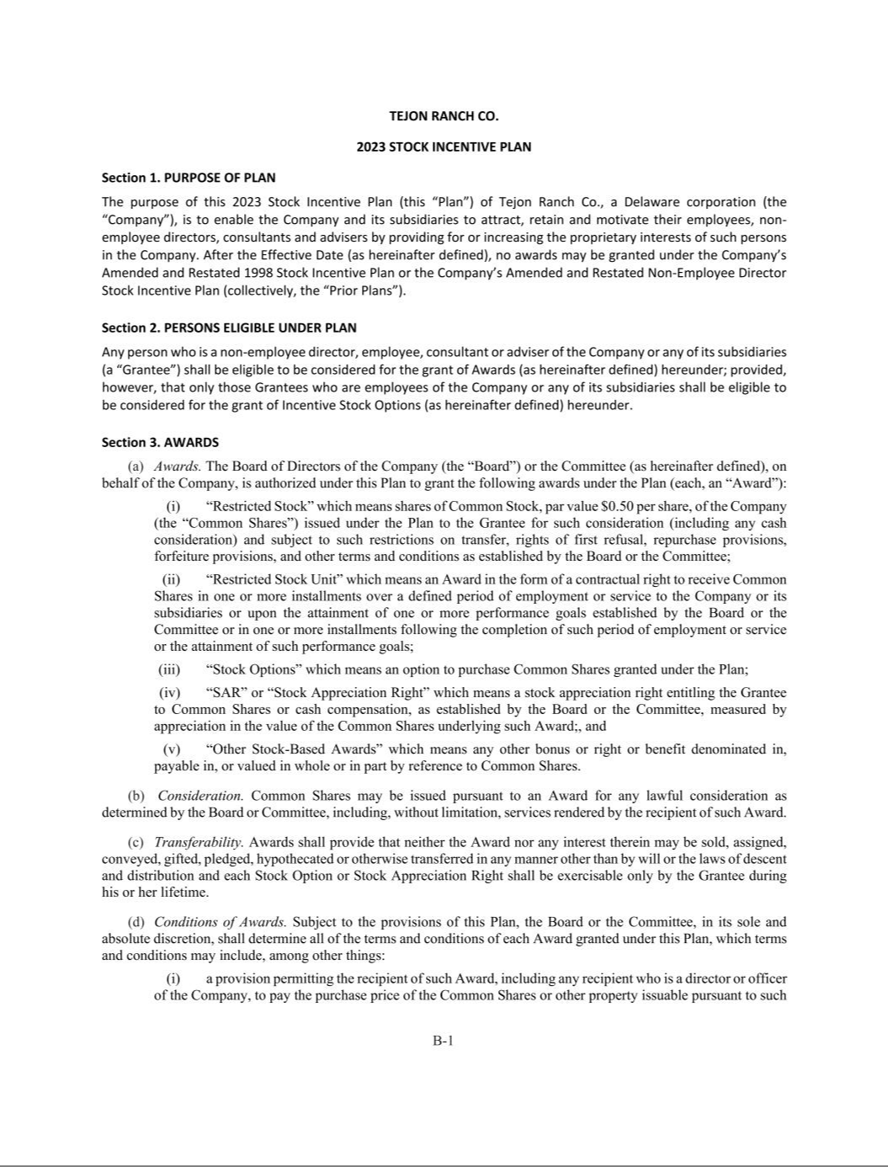

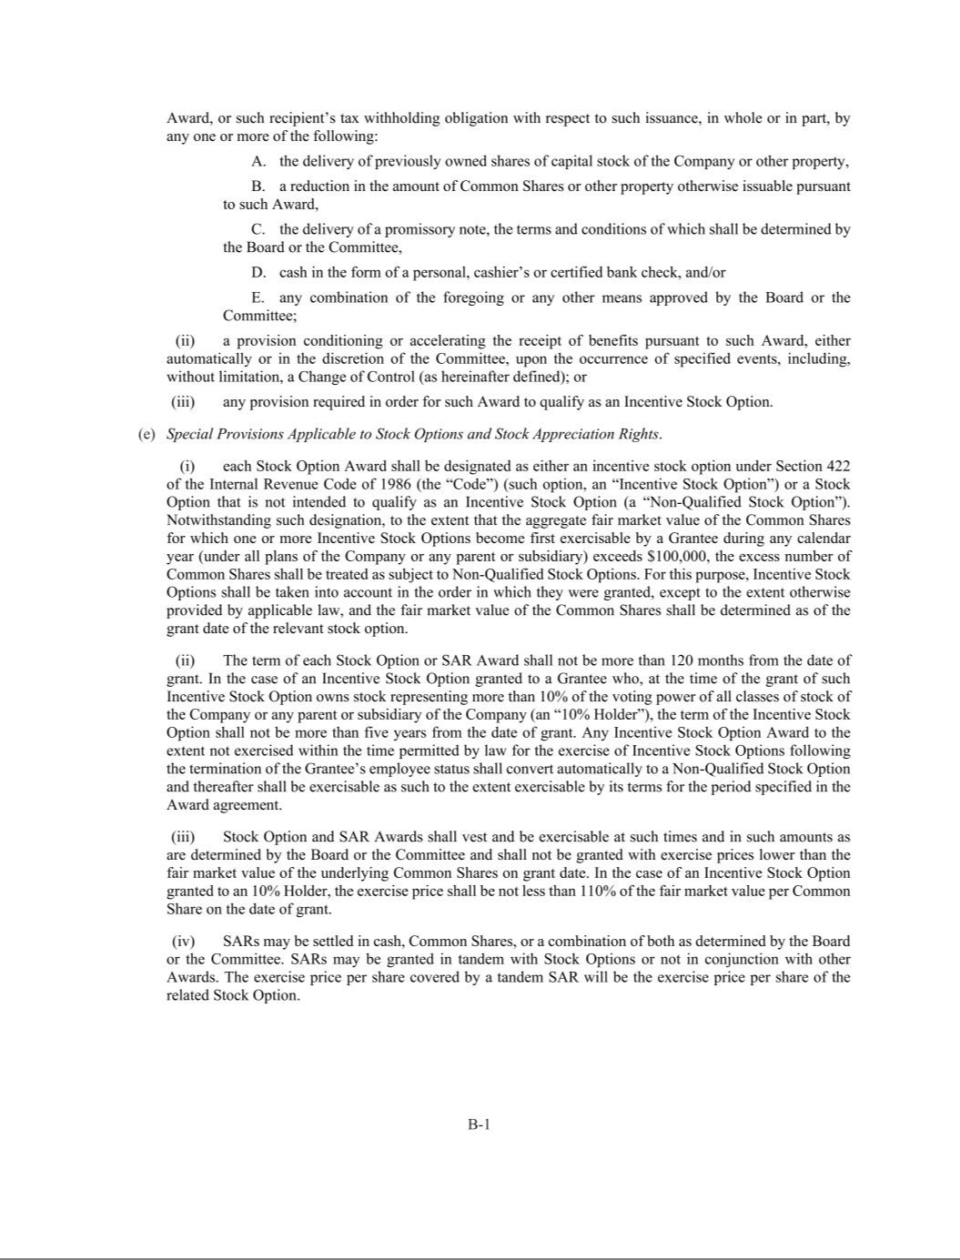

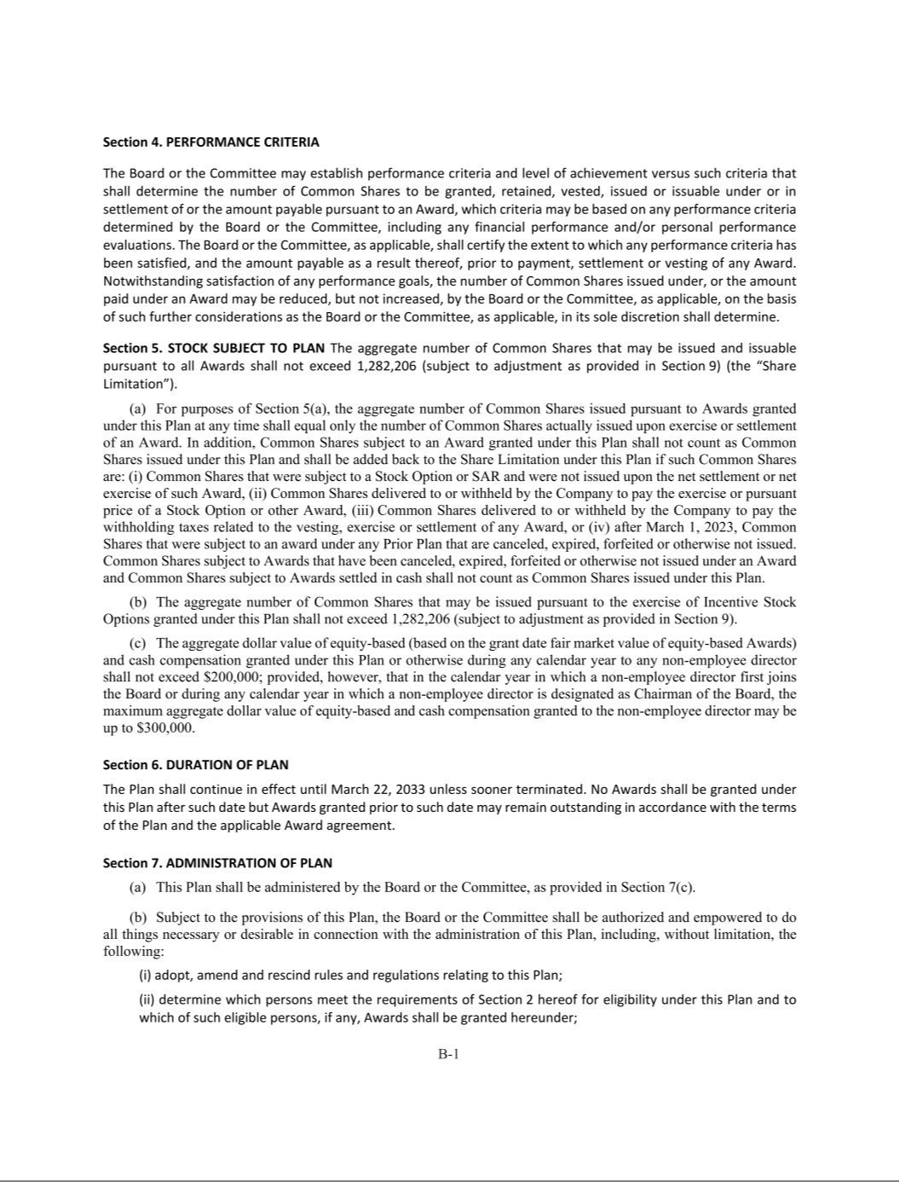

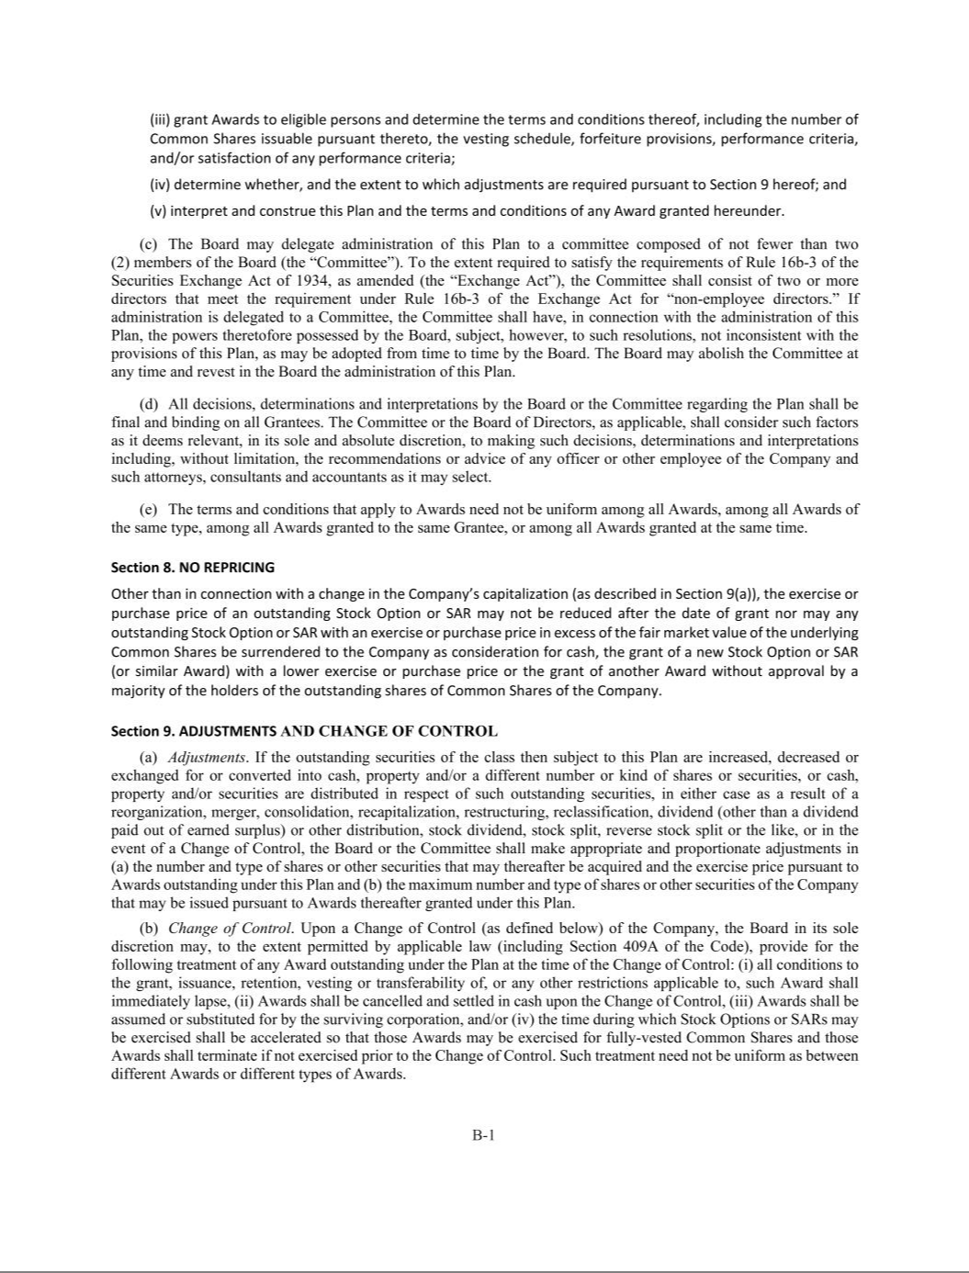

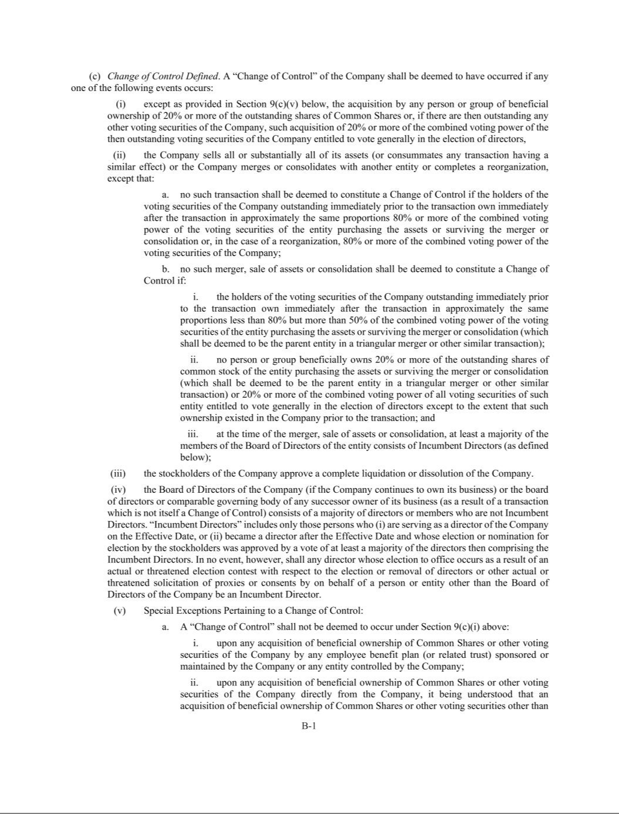

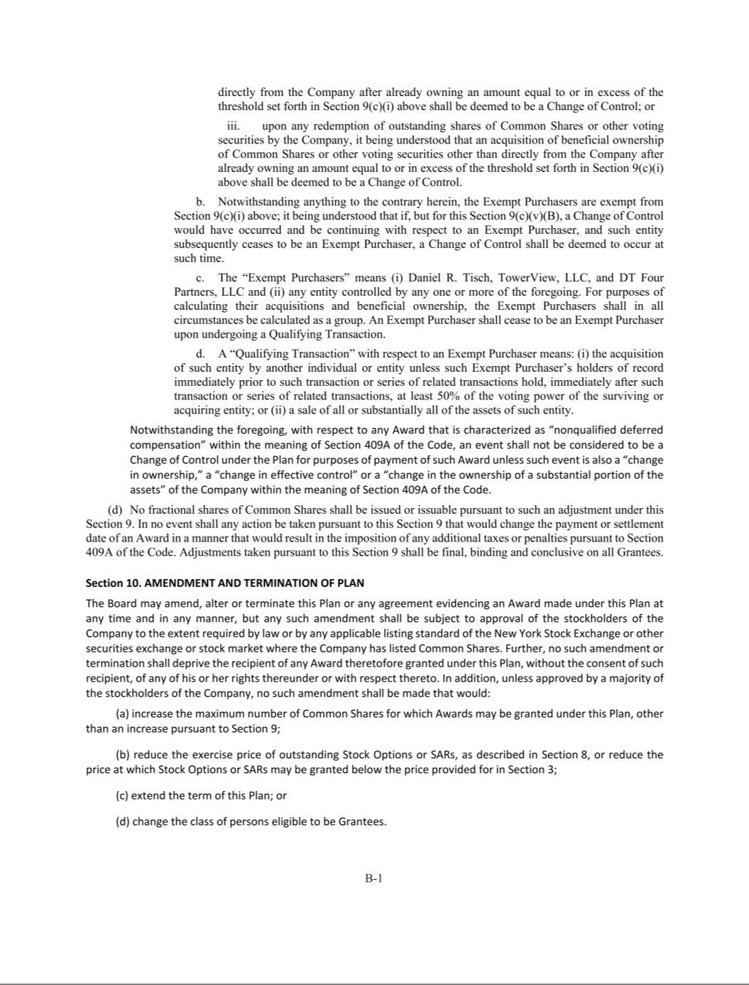

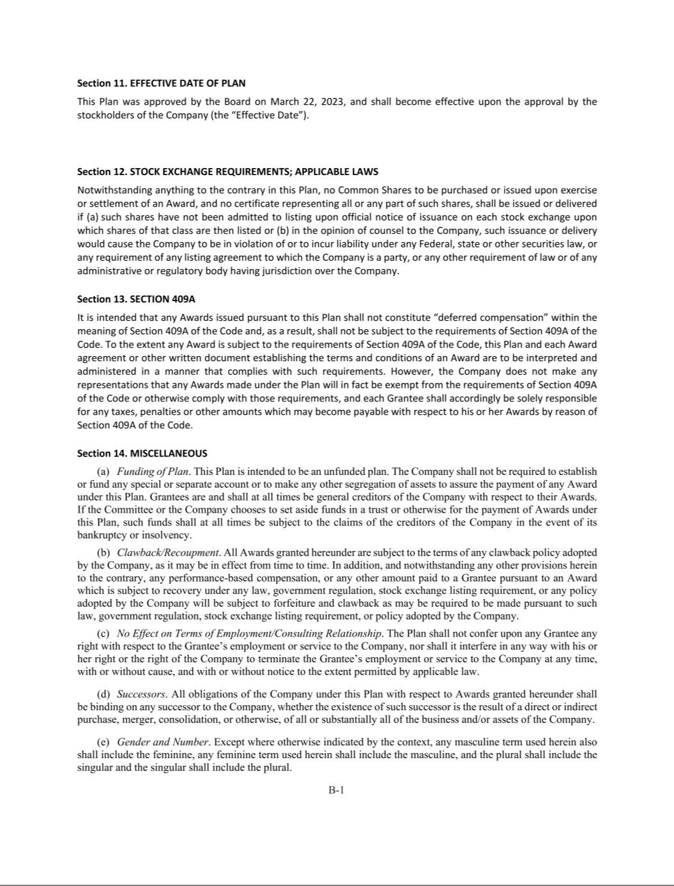

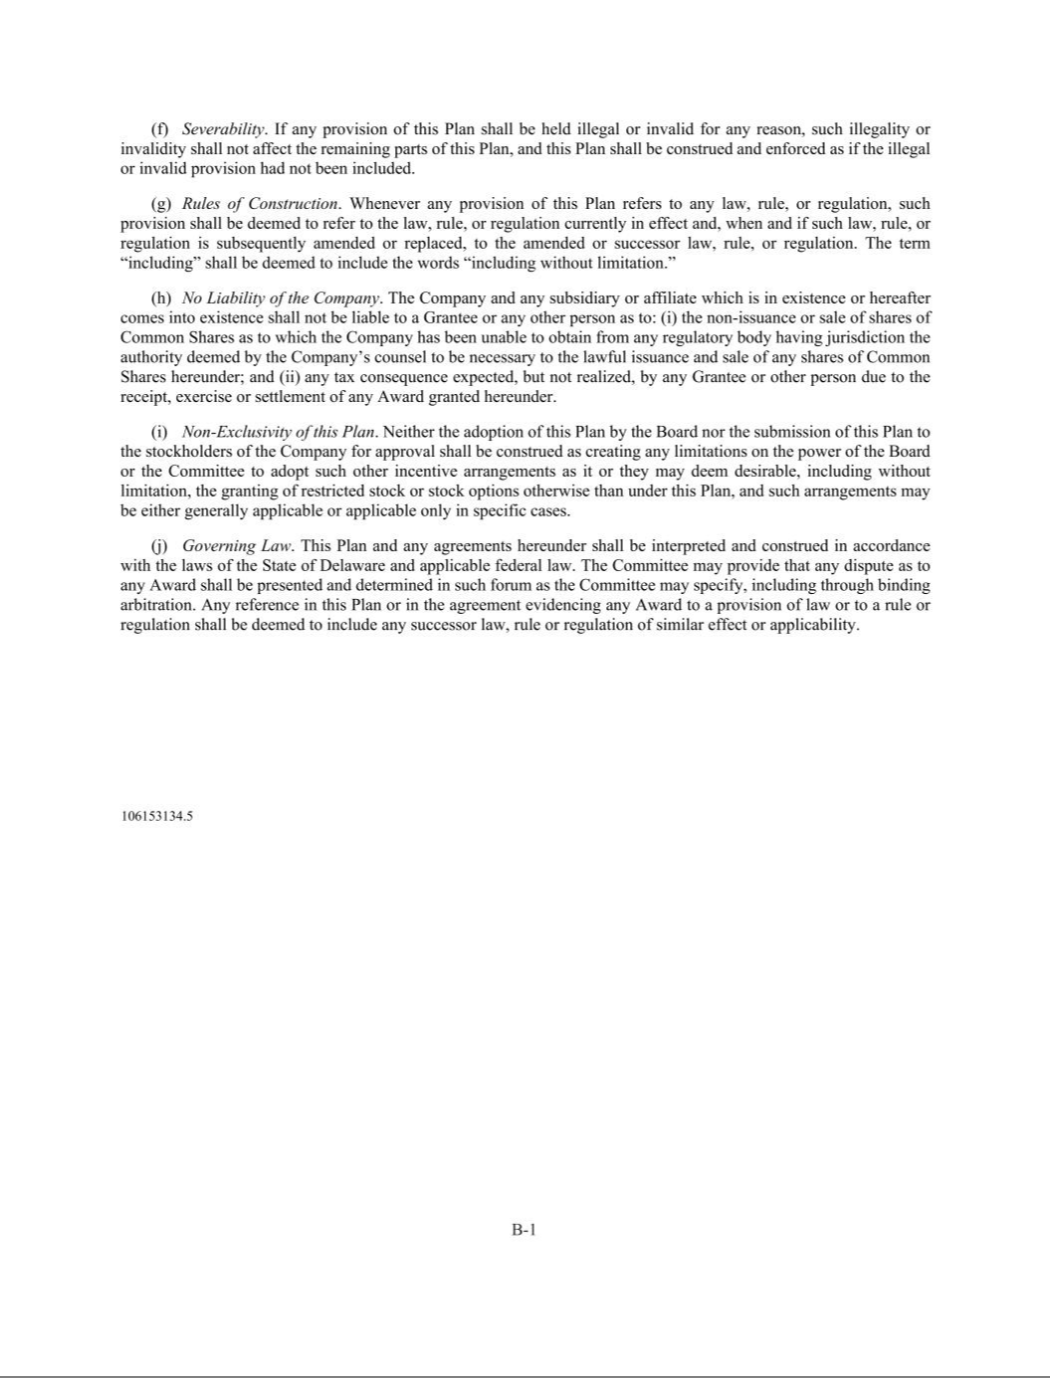

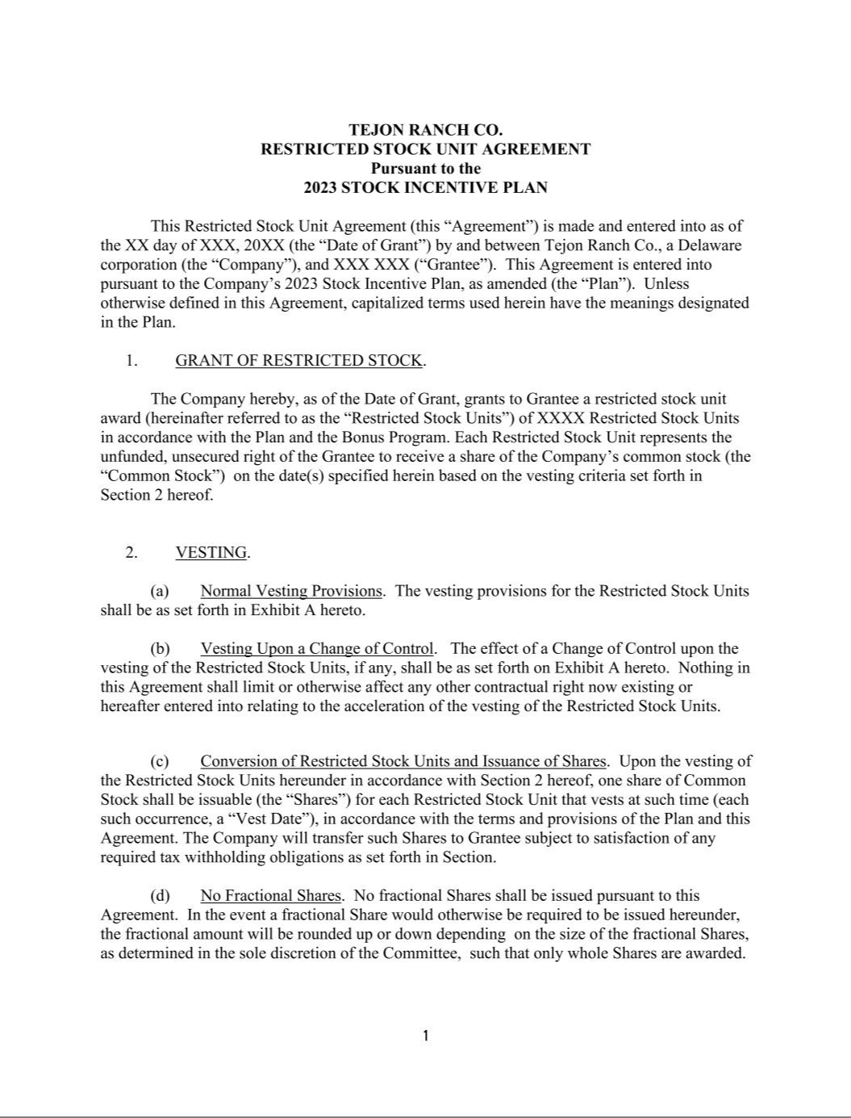

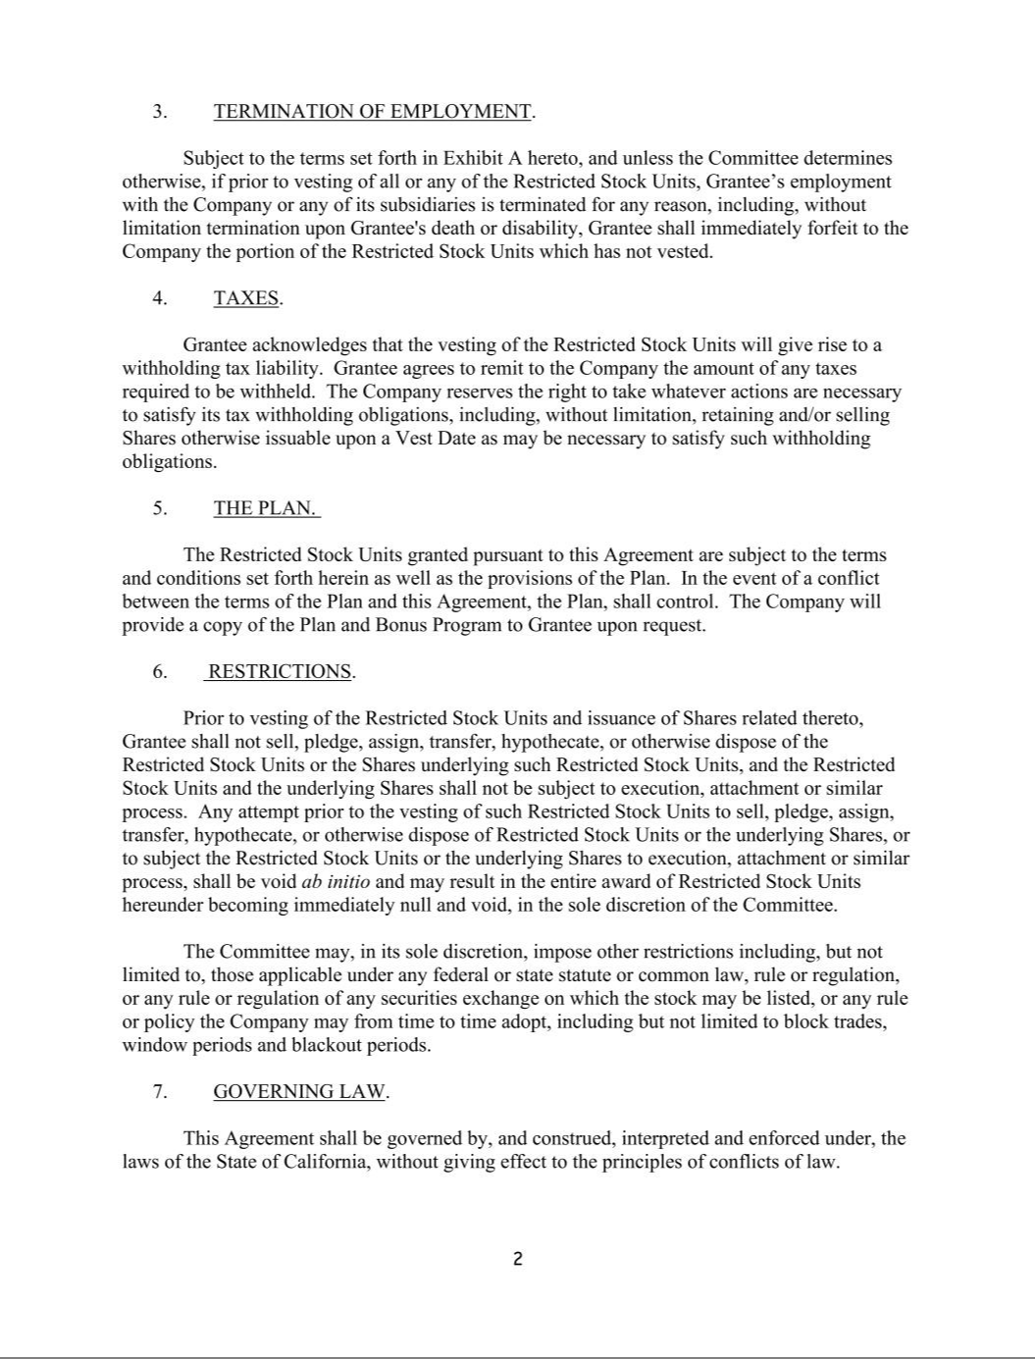

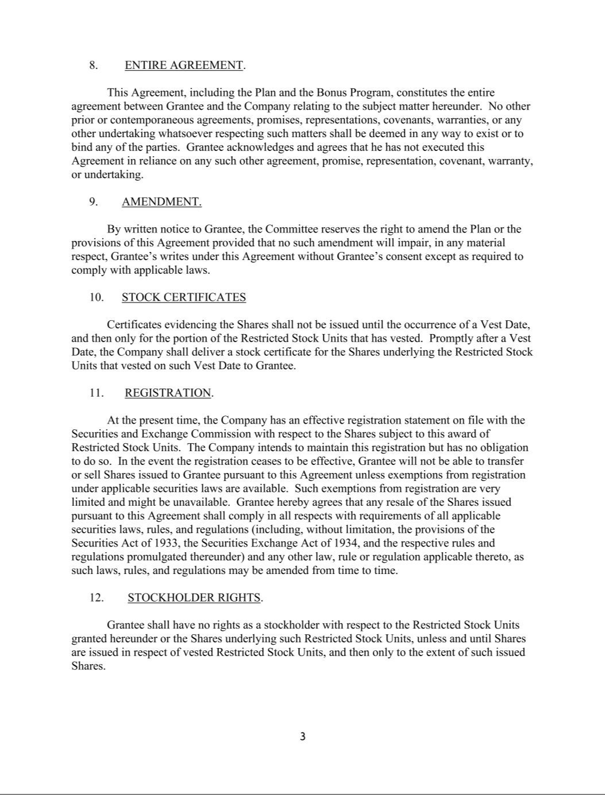





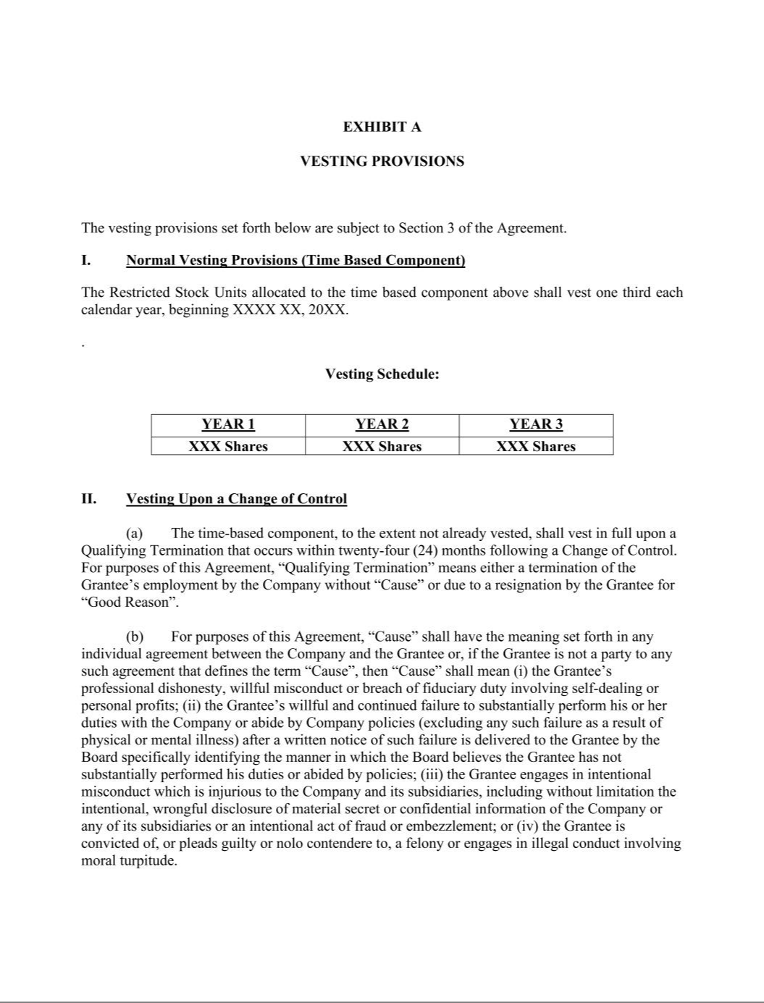

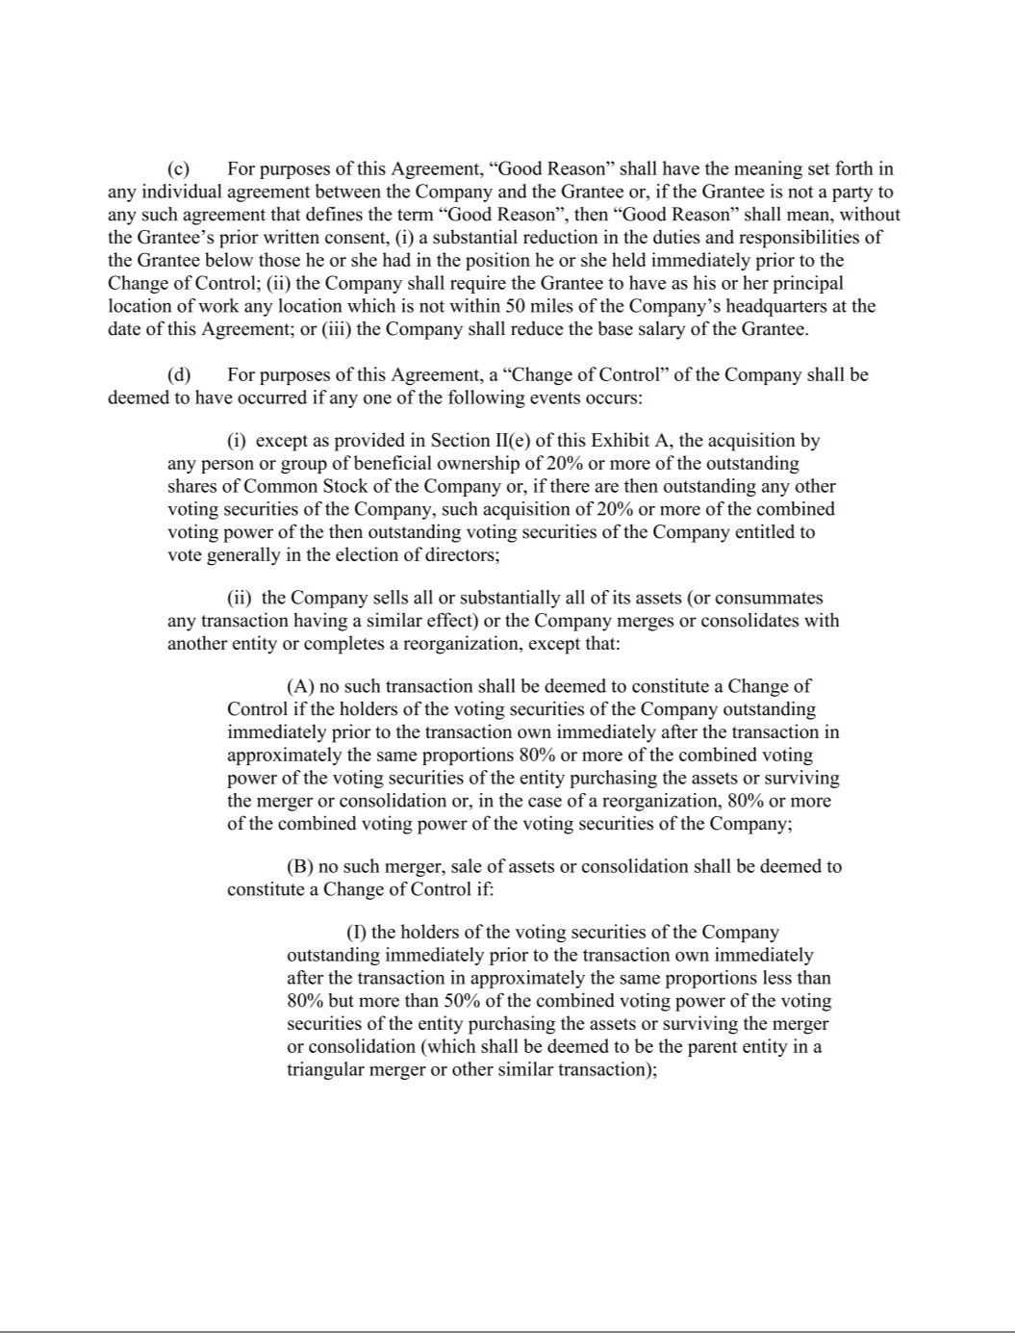

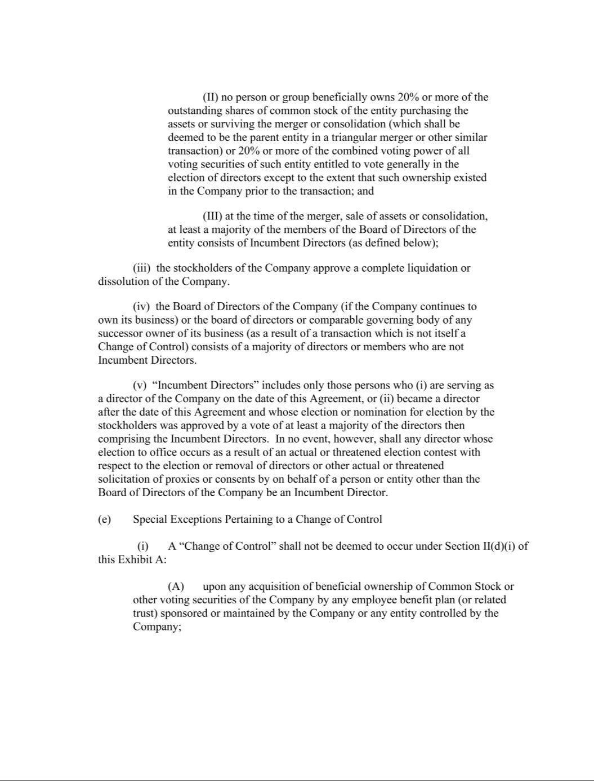

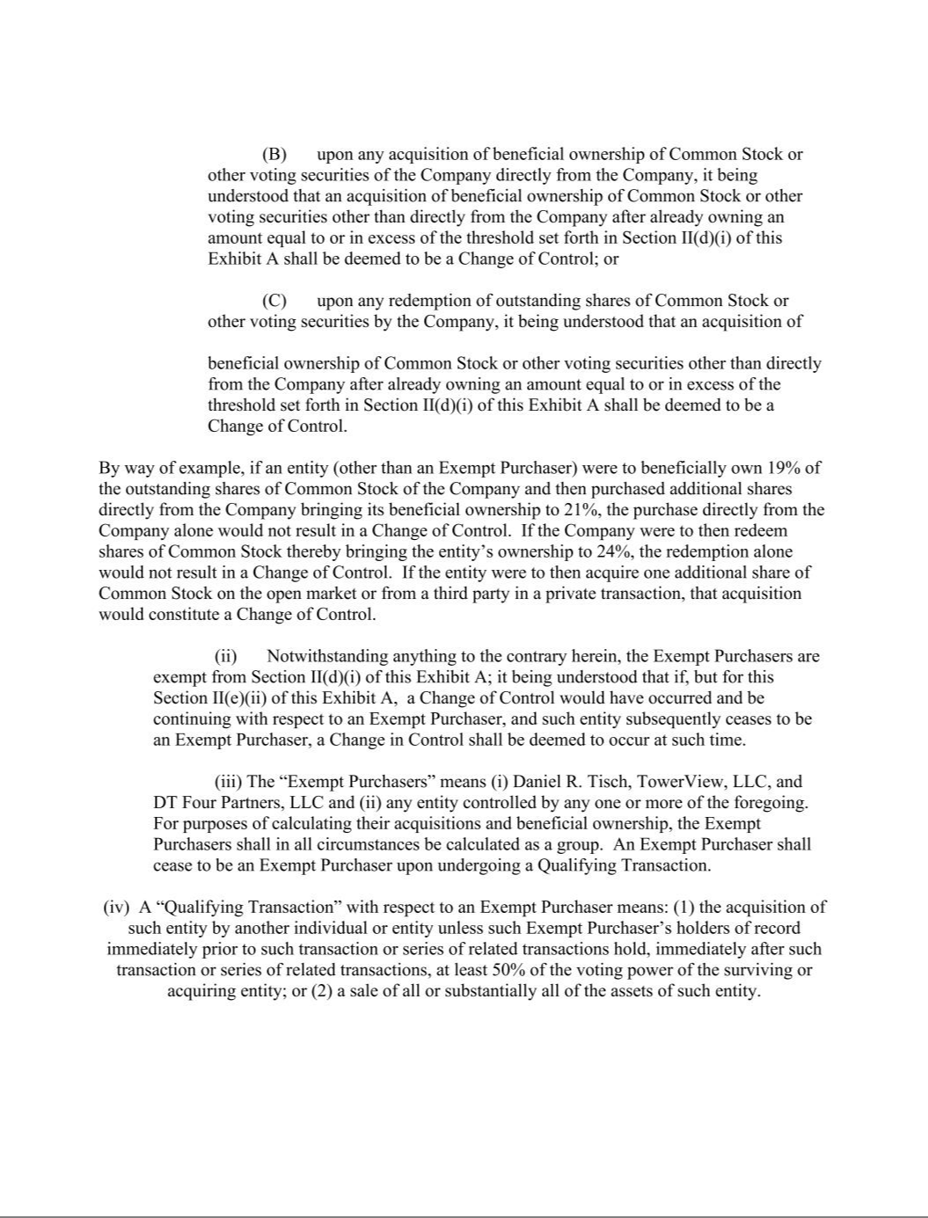

EXHIBIT 31.1

Certification of Chief Executive Officer Pursuant to

Securities Exchange Act Rules 13a-14(a) and 15d-14(a)

as Adopted Pursuant to

Section 302 of the Sarbanes-Oxley Act of 2002

I, Matthew H. Walker, certify that:

- I have reviewed this quarterly report on Form 10-Q of Tejon Ranch Co.;

- Based on my knowledge, this report does not contain any untrue statement of a material fact or omit to state a material fact necessary to make the statements made, in light of the circumstances under which such statements were made, not misleading with respect to the period covered by this report;

- Based on my knowledge, the financial statements, and other financial information included in this report, fairly present in all material respects the financial condition, results of operations and cash flows of the registrant as of, and for, the periods presented in this report;

- The registrant’s other certifying officer and I are responsible for establishing and maintaining disclosure controls and procedures (as defined in Exchange Act Rules 13a-15(e) and 15d-15(e)) and internal control over financial reporting (as defined in Exchange Act Rules 13a-15(f) and 15(d)-15(f)) for the registrant and have:

  - Designed such disclosure controls and procedures, or caused such disclosure controls and procedures to be designed under our supervision, to ensure that material information relating to the registrant, including its consolidated subsidiaries, is made known to us by others within those entities, particularly during the period in which this report is being prepared;

  - Designed such internal control over financial reporting, or caused such internal control over financial reporting to be designed under our supervision, to provide reasonable assurance regarding the reliability of financial reporting and the preparation of financial statements for external purposes in accordance with generally accepted accounting principles;

  - Evaluated the effectiveness of the registrant’s disclosure controls and procedures and presented in this report our conclusions about the effectiveness of the disclosure controls and procedures, as of the end of the period covered by this report based on such evaluation; and

  - Disclosed in this report any change in the registrant’s internal control over financial reporting that occurred during the registrant’s most recent fiscal quarter (the registrant’s fourth fiscal quarter in the case of an annual report) that has materially affected, or is reasonably likely to materially affect, the registrant’s internal control over financial reporting; and

- The registrant’s other certifying officer and I have disclosed, based on our most recent evaluation of internal control over financial reporting, to the registrant’s auditors and the audit committee of the registrant’s board of directors (or persons performing the equivalent functions):

  - All significant deficiencies and material weaknesses in the design or operation of internal control over financial reporting which are reasonably likely to adversely affect the registrant’s ability to record, process, summarize and report financial information; and

  - Any fraud, whether or not material, that involves management or other employees who have a significant role in the registrant’s internal control over financial reporting.

Dated: | August 7, 2025 | /s/ Matthew H. Walker
 |  | Matthew H. Walker
 |  | President and Chief Executive Officer

EXHIBIT 31.2

Certification of Chief Financial Officer Pursuant to

Securities Exchange Act Rules 13a-14(a) and 15d-14(a)

as Adopted Pursuant to

Section 302 of the Sarbanes-Oxley Act of 2002

I, Robert D. Velasquez, certify that:

- I have reviewed this quarterly report on Form 10-Q of Tejon Ranch Co.;

- Based on my knowledge, this report does not contain any untrue statement of a material fact or omit to state a material fact necessary to make the statements made, in light of the circumstances under which such statements were made, not misleading with respect to the period covered by this report;

- Based on my knowledge, the financial statements, and other financial information included in this report, fairly present in all material respects the financial condition, results of operations and cash flows of the registrant as of, and for, the periods presented in this report;

- The registrant’s other certifying officer(s) and I are responsible for establishing and maintaining disclosure controls and procedures (as defined in Exchange Act Rules 13a-15(e) and 15d-15(e)) and internal control over financial reporting (as defined in Exchange Act Rules 13a-15(f) and 15(d)-15(f)) for the registrant and have:

  - Designed such disclosure controls and procedures, or caused such disclosure controls and procedures to be designed under our supervision, to ensure that material information relating to the registrant, including its consolidated subsidiaries, is made known to us by others within those entities, particularly during the period in which this report is being prepared;

  - Designed such internal control over financial reporting, or caused such internal control over financial reporting to be designed under our supervision, to provide reasonable assurance regarding the reliability of financial reporting and the preparation of financial statements for external purposes in accordance with generally accepted accounting principles;

  - Evaluated the effectiveness of the registrant’s disclosure controls and procedures and presented in this report our conclusions about the effectiveness of the disclosure controls and procedures, as of the end of the period covered by this report based on such evaluation; and

  - Disclosed in this report any change in the registrant’s internal control over financial reporting that occurred during the registrant’s most recent fiscal quarter (the registrant’s fourth fiscal quarter in the case of an annual report) that has materially affected, or is reasonably likely to materially affect, the registrant’s internal control over financial reporting; and

- The registrant’s other certifying officer(s) and I have disclosed, based on our most recent evaluation of internal control over financial reporting, to the registrant’s auditors and the audit committee of the registrant’s board of directors (or persons performing the equivalent functions):

  - All significant deficiencies and material weaknesses in the design or operation of internal control over financial reporting which are reasonably likely to adversely affect the registrant’s ability to record, process, summarize and report financial information; and

  - Any fraud, whether or not material, that involves management or other employees who have a significant role in the registrant’s internal control over financial reporting.

Dated: | August 7, 2025 | /s/ Robert D. Velasquez
 |  | Robert D. Velasquez
 |  | Chief Financial Officer, Treasurer, Senior Vice President, Finance and Chief Accounting Officer

EXHIBIT 32

CERTIFICATION PURSUANT TO

18 U.S.C. SECTION 1350,

AS ADOPTED PURSUANT TO

SECTION 906 OF THE SARBANES-OXLEY ACT OF 2002

Each of the undersigned hereby certifies, in his capacity as an officer of Tejon Ranch Co. (the “Company”), for purposes of 18 U.S.C. Section 1350, as adopted pursuant to Section 906 of the

Sarbanes-Oxley Act of 2002, that to his own knowledge:

- The Quarterly Report of the Company on Form 10-Q for the period ended June 30, 2025 fully complies with the requirements of Section 13(a) of the Securities Exchange Act of 1934; and

- The information contained in such report fairly presents, in all material respects, the financial condition and results of operation of the Company.

A signed original of this written statement required by Section 906 has been provided to Tejon Ranch Co. and will be retained by Tejon Ranch Co., and furnished to the Securities and Exchange Commission or its staff upon request.

Dated: August 7, 2025

/s/ Matthew H. Walker

Matthew H. Walker

President and Chief Executive Officer

/s/ Robert D. Velasquez

Robert D. Velasquez

Chief Financial Officer, Treasurer, Senior Vice President, Finance and Chief Accounting Officer

